**Checklist for Writing**

1. I have run the **spelling checker** on my document.
2. I have run the **grammar checker** on my document.
3. I have used **passive voice** only to avoid first person, and have avoided other wordy constructions such as “there are … who.”
4. I have used the **equation editor** (*download MS Word file*) to format all equations.
5. All of the references in the **List of References** are explicitly cited in my report
6. All of the **figures and tables** have references to them in the text.
7. All **figure captions** appear at the *bottom* of the figure, and all **table captions** appear at the *top* of the figure.
8. The first **reference to each figure** or table must occur *before* the figure or table.
9. The words **“this,” “that,” “these,” and “those”** never occur without referencing a noun. (E.g., “This device is used to …” rather than “This is used to …”
10. All **acronyms or initialisms** are spelled out completely the first time they are used. For example, “A Magnetic Resonance Imager (MRI) is used for ….”
11. All **quoted material** relates to points that are subjective or a matter of opinion on the part of the quoted author.
12. I have not used any of the following **egregious words or phrases**: a lot, kids, kinds, big, kind of, due to the fact that, (or just “the fact that”), utilize, actually, obviously, rather (as in “It is rather surprising”), very, quite, essentially. That is, I have used the search feature of Word to look for the words and phrases in Tables 1 and 2.
13. My text has no **sentence fragment**s or **run-on sentences** (the grammar checker should find these errors).
14. My text has no **contractions** (do a global search for the apostrophe and make sure it occurs only in possessives).
15. The phrase **“*et al.*”** is correctly written, with no period after “et” and a period after “al.”
16. When the **semicolon** is used, it separates complete sentences, not sentence fragments or clauses.
17. I have eliminated **dangling participles**. Wherever a present participle is used at the beginning of a sentence, the noun performing the action is the first thing after the comma.
18. I have used **parallel constructions** in related phrases.
19. I have checked for **common typing errors**.

**Checklist for Graphs**

1. Where possible and appropriate, multiple related curves are plotted on the same graph so that they can be readily compared. (How?)
2. The graph background is white. (How?)
3. The “Smoothed line” option is turned *off*. If no theoretical curve or appropriate curve fit, I have not connected the symbols or have connected them with ***straight*** lines (How?).
4. Collected data are represented with symbols, and theoretical curves or digitized waveforms with lines (How?).
5. Line modes, line thicknesses or symbols distinguish data sets, ***not*** colors (How?).
6. The horizontal gridlines are removed from my plots (How?).
7. Major tick marks are included on the axes to indicate the positions corresponding to the number labels (How?).
8. The numbers on the x and y axes are large enough to read (How?).
9. The scales on the x and y axes follow the 1, 2, 5 rule (How?).
10. The x and y axes are labeled clearly with the information they represent and the correct units of the data (e.g. Frequency (Hz) or Pressure (dynes/cm2)) (How?).
11. The y-axis labels (title and numbers) run vertically from the bottom of the plot to the top, rather than horizontally (How?).
12. Greek letters, other special characters, or superscripts/subscripts are used, when necessary, in an axis title or elsewhere (How?).
13. The legend for each curve describes only the distinguishing characteristic of the curve (e.g. “With Fibrinogen”, “Without Fibrinogen,” ***not*** “Cell Growth With Fibrinogen,” “Cell Growth Without Fibrinogen,” ***not*** “first data set,” “second data set,” and ***certainly not*** “series 1,” “series 2.”) (How?).
14. No chart title is used unless multiple graphs appear in a single figure. (How?)
15. The legend is on the plot area at a location where it does not cover any of the data. (How?)
16. Where applicable, the legends appear in an order that follows the position of the curve on the plot (i.e., upper curve matches the topmost legend) (How?).
17. Legends highlight only the aspect of the given curve that distinguish it from the other curves. (Generally, if all legends have a phrase in common, that phrasecan be removed).
18. Unnecessary borders are removed, including:
    * + - 1. The border around the legend.
          2. The border around the plotting area.
          3. The border around the complete plot. (How?)
19. Where applicable, bars representing standard deviation or standard error of my collected data are included (How?).
20. Where reasonable, physical units for the axes allow the number labels to have a small number of digits (e.g. 10 GPa instead of 10E9 Pa or 10,000 MPa) (What?).

**Checklist for Figures and Tables Figures**

Each figure caption appears below the figure.

A consistent caption style is used for all figures.

Each figure is referenced within the narrative of the document.

A description of the figure follows the reference to that figure, usually before the picture appears.[1]

Each figure appears after the narrative paragraph that first introduces it.

Figures do not break across pages.

**Tables**

Each table caption appears above the table. (It’s a general rule. Don’t ask me why.)

Each table is referenced, by table number, within the narrative of the document.

Each table appears after the first reference to it within the narrative.

Each caption includes the word “Table,” followed by the table number.

A consistent style is used for all tables.

Tables that are less than one page long do not break across pages.

Tables that are longer than one page long include a separate table header for each page.

**Laboratory Member Roles**

Inzamam Haq

* -

Sunzid Hassan

* -

Dylan Guillory

**Laboratory 6:**

**The Instrumentation (EKG) Amplifier**



BIEN 325/510 - Bioinstrumentation

Inzamam Haq, Sunzid Hassan, Dylan Guillory

Feb 10, 2025

Roles:

Inzamam Haq:

Sunzid Hassan:

Dylan Guillory:

**Abstract**

**Introduction**

The main focus of this lab is to build a bioinstrumentation amplifier with active filter components to specifications suitable for electrocardiogram (EKG) recording. With this amplifier built, EKG signals with be evaluated and different types of signal artifacts will be observed. As with the previous lab, this type of circuit is well studied and the main purpose of this lab with not be at add on to any commonly held theory, but to prove that the common theory relating to voltage followers, differential op-amps, and active filters is still viable and useful.

With our goals for this lab in place, we believe that the currently accepted theory, equations, and methods surrounding the construction of the subcircuits built in this laboratory are still viable and that the results of our theoretical data should align very closely with our experimental data.

**Methods**

The following equipment was used in the laboratory:

1. Breadboard (MPJA Part No. 4445-TE)
2. Digital Multimeter (Agilent 34410A)
3. Oscilloscope (Tektronix TDS 1002B)
4. Power Supply (Agilent E3630A)
5. Signal Generator (Agilent 33220A)
6. Test leads for Oscilloscope (2), Multimeter (1)
7. Leads from power supply (Black for ground, Red for +20, Yellow for -20).
8. Miscellaneous wires (red, black, yellow, green).
9. OP07 operational amplifier
10. Various capacitors and resistors for filter construction

The following color code was used for wiring between components:

Wires from positive power supplies: Red

Wires to ground: Black

Wires from negative power supplies: Yellow

Wires that form interconnections within the circuit: Green

Figure (1) shows the basic setup of the laboratory workspace.

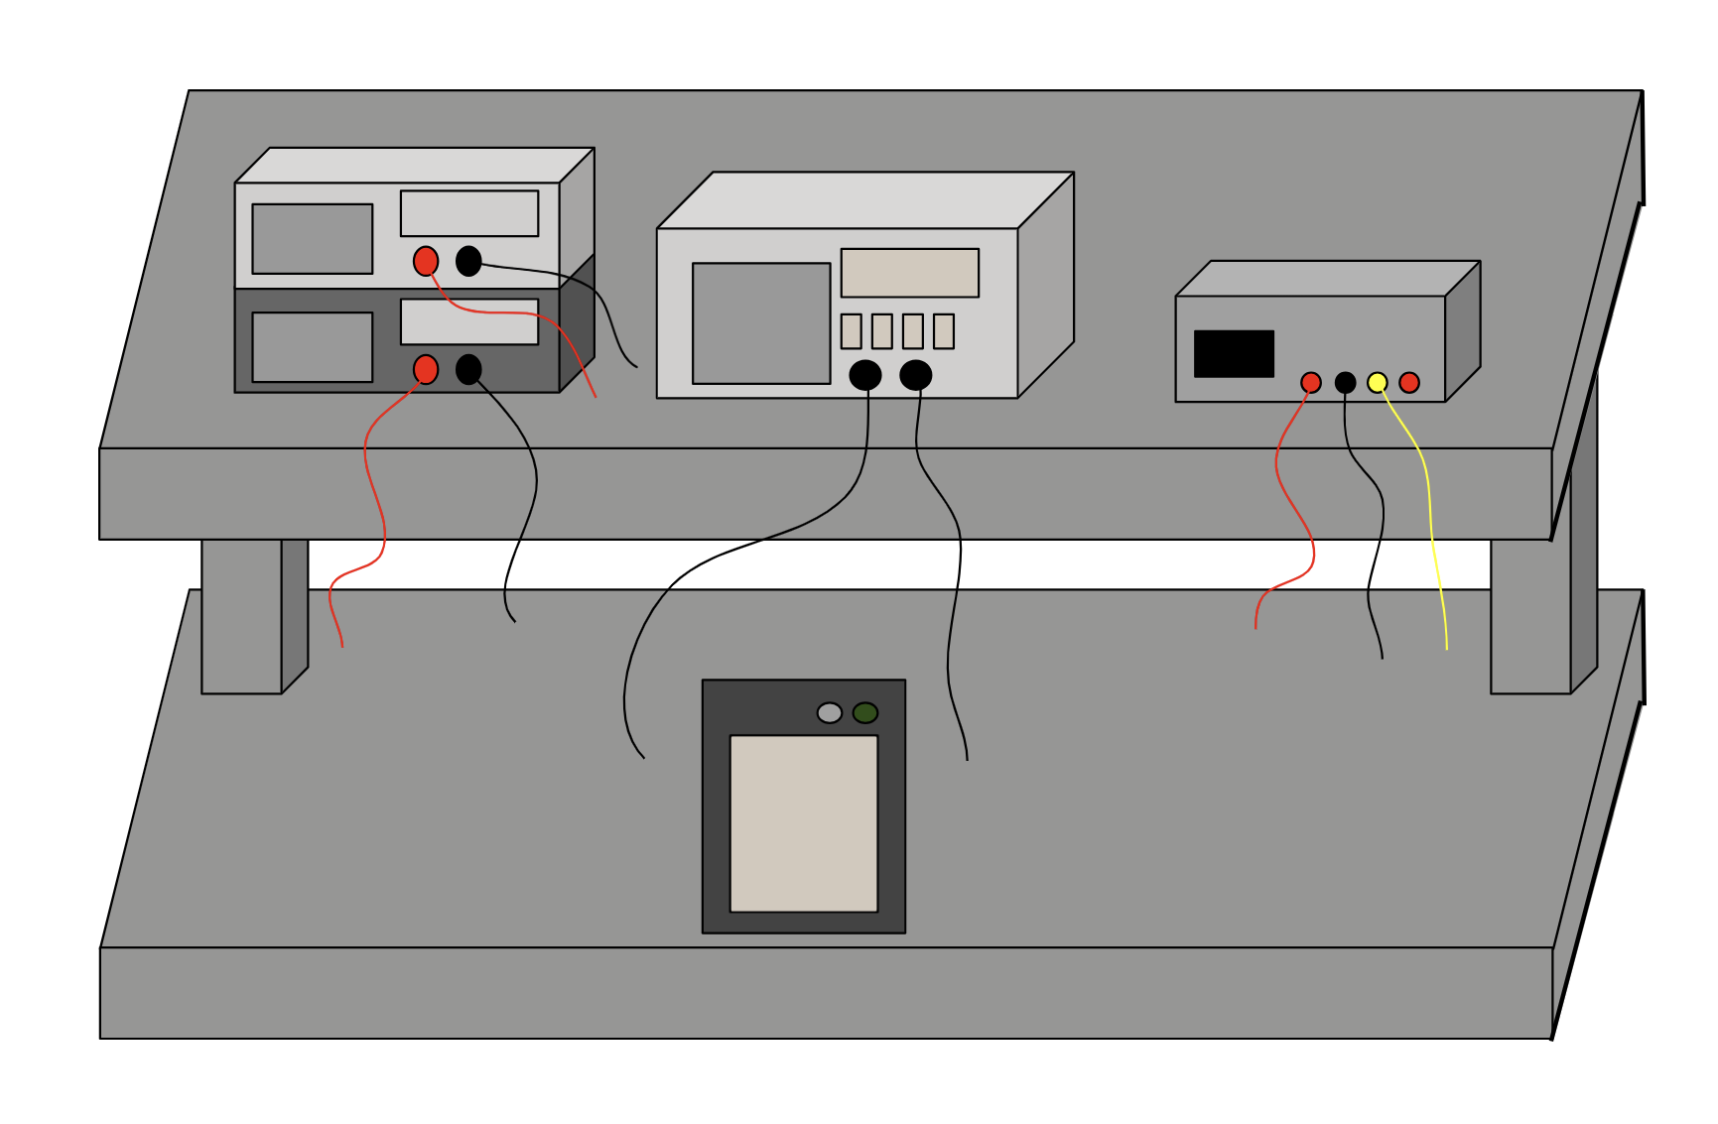

Figure (1): Workspace setup showing the digital multimeter and signal generator (left), the oscilloscope (middle), the power supply (right) and the breadboard (bottom).

For this experiment, the breadboard was used to connect the components used to build the filters, the digital multimeter was used to measure resistances and capacitances of components more accurately, the oscilloscope was used to measure the input and ouput voltages, the power supply was used to supply the voltage to the “+” and “-“ pins of the OP07, the signal generator was used to provide in input voltage, and the OP07 was used as the operational amplifier for each of the subcircuits constructed.

Figures (2) and (3) show the three main stages that were constructed to form the overall circuit.

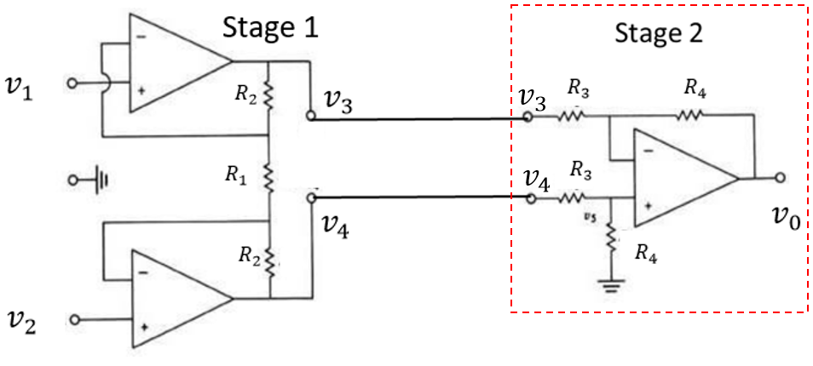

Figure (2): First Two Stages EKG Amplifier.

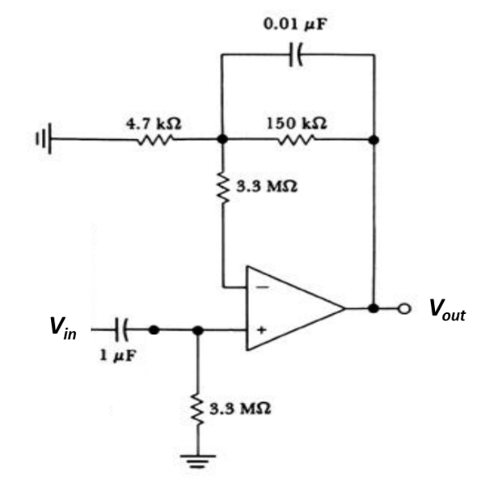

Figure (3): Filter for EKG Amplifier

Before this lab was started, LTSpice was used to simulate the band pass filter in figure (3). For this circuit. The LTSpice bode plot was compared with the theoretical corner frequencies and gain. The equations for the high pass, low pass, and gain respectively can be seen in equations, (1-3).

|  |  |  |
| --- | --- | --- |
|  |  | Equation (1) |
|  |  | Equation (2) |
|  |  | Equation (3) |

The transfer function for this band pass filter is shown in equation (4).

|  |  |  |
| --- | --- | --- |
|  |  | Equation (4) |

Where the magnitude of this transfer function is shown in equation (5) and the phase of this transfer function is shown in equation (6).

|  |  |  |
| --- | --- | --- |
|  |  | Equation (5) |
|  |  | Equation (4) |

The theoretical gain of the two subcircuits in figure (2) was also calculated. The equation for the gain of stage one can be seen in equation (7) and the gain of stage two can be seen in equation (8).

|  |  |  |
| --- | --- | --- |
|  |  | Equation (7) |
|  |  | Equation (8) |

**Procedure**

To begin this lab, the band pass filter from figure (3) was constructed and the experimental frequency was obtained. To do this, a 1Vpp input voltage was applied and the magnitude and phase lag of the output voltage was determined at 0.1, 10, 30, 100, and 300 Hz. This experimental data was compared with the theoretical data of this filter.

Following this, stage 2 from figure (2) was constructed separately from stage 1. Both the negative and the positive portion of this circuit were tested by connecting one side to a 100mVpp, 100Hz sine wave and grounding the other. The gains from both of these tests were compared with the theoretical gain. Finally, a 100mVpp signal was applied to both portions of the circuit to verify that the common mode gain for this stage is small.

Next, stage 1 was constructed separately from the other two stages and the gain of this circuit was compared with that of the theoretical gain. To verify the efficacy of the circuit, a 100mVpp 100Hz sine wave was connected to one of the inputs while the other was grounded. With this being the case, the circuit should act like non-inverting amplifier with a gain of 1+ R2/R1. This was verified to be correct for both sides of the circuit.

After each stage was verified to be working properly, stage 1 was connected to stage 2 and the output of the circuit was tested with one input grounded to verify that both subcircuits were working together. After this, the band pass filter was connected with the rest of the circuit and one of the inputs was connected to a 20mVpp sine wave while the other was grounded. For this full circuit, the magnitude and phase change at frequencies of 0.1, 10, 30, 100, and 300 Hz were collected and compared with the theoretical data. The common mode gain for the overall circuit was also collected at 30Hz.

After this, three silver/silver chloride electrodes were connected to the circuit with a 10Kohm resistor in between. Two were connected to the input and the other was connected to ground. The two input electrodes were placed on the wrists and the ground electrode was placed near the ankle. With this setup, the EKG signal was recorded for one of the group members. Using this EKG plot, the resting heart rates in beats per minute (BPM) was estimated.

In order to observe different types of artifacts on the signal, the subject the electrodes were on moved their arm, touched the electrode, and clenched their fists and the changes in the EKG signal were recorded.

**Results**

The theoretical band pass filter bode plot made from LTSpice is shown in figure (4).

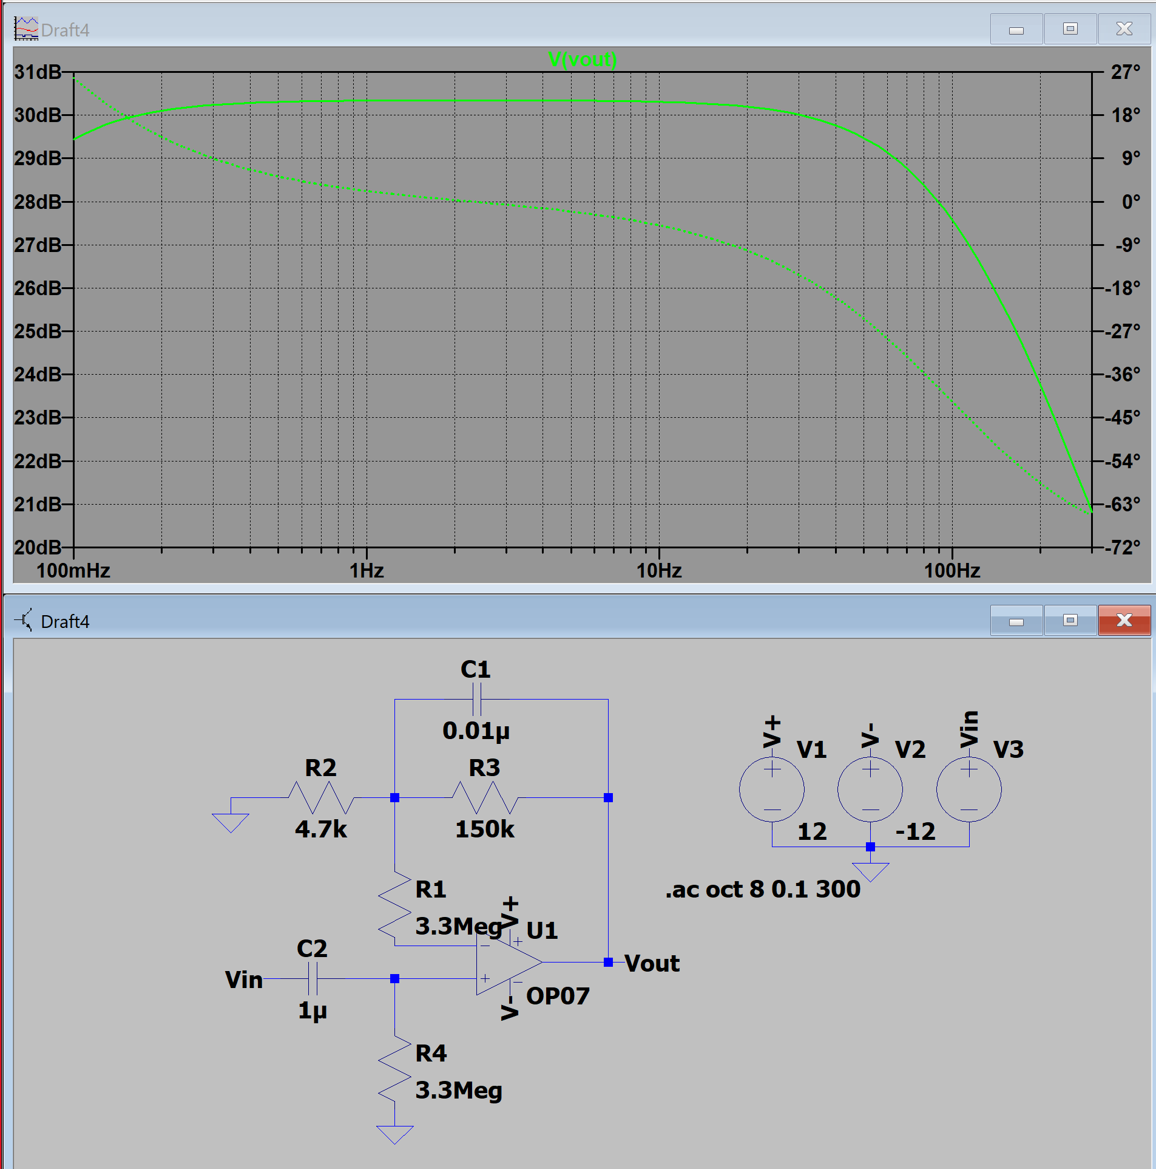

Figure (4): LTSpice Simulation of Band Pass Filter

Bode plot (magnitude and phase) for the BP filter (Step 1)

For stage 2, the theoretical gain was calculated using equation (7). The experimental gains for this circuit are shown in table (1). The oscilloscope plots of the tests of each side of the circuit can be seen in figures () and ().

Table (1): Data Associated with Stage 2

|  |  |
| --- | --- |
| **Expected Gain** | 4.7 |
| **Gain (-)** | -4.8 |
| **Gain (+)** | 4.9 |
| **Common Mode Gain** | 0.01 |
| **CMRR** | 470 |

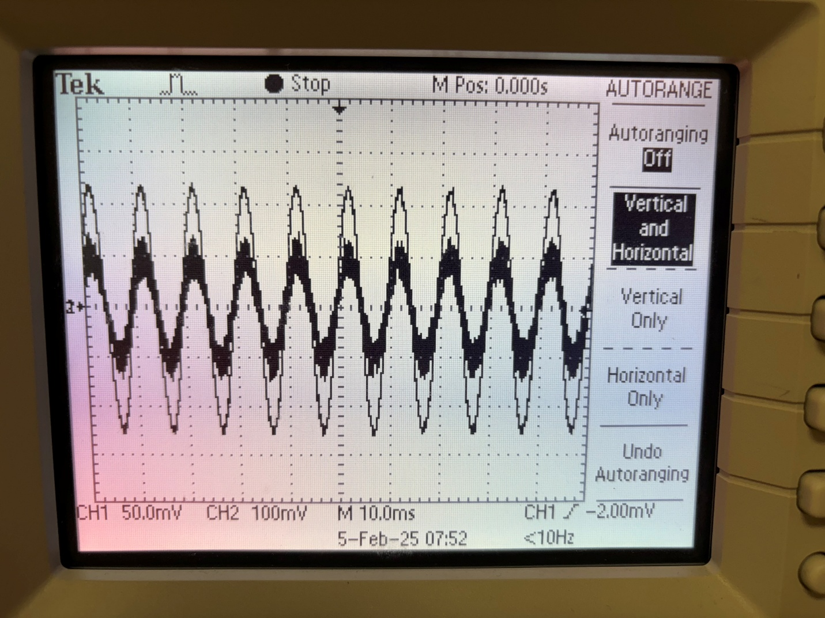

Figure (): Test of Positive Side of Stage 2

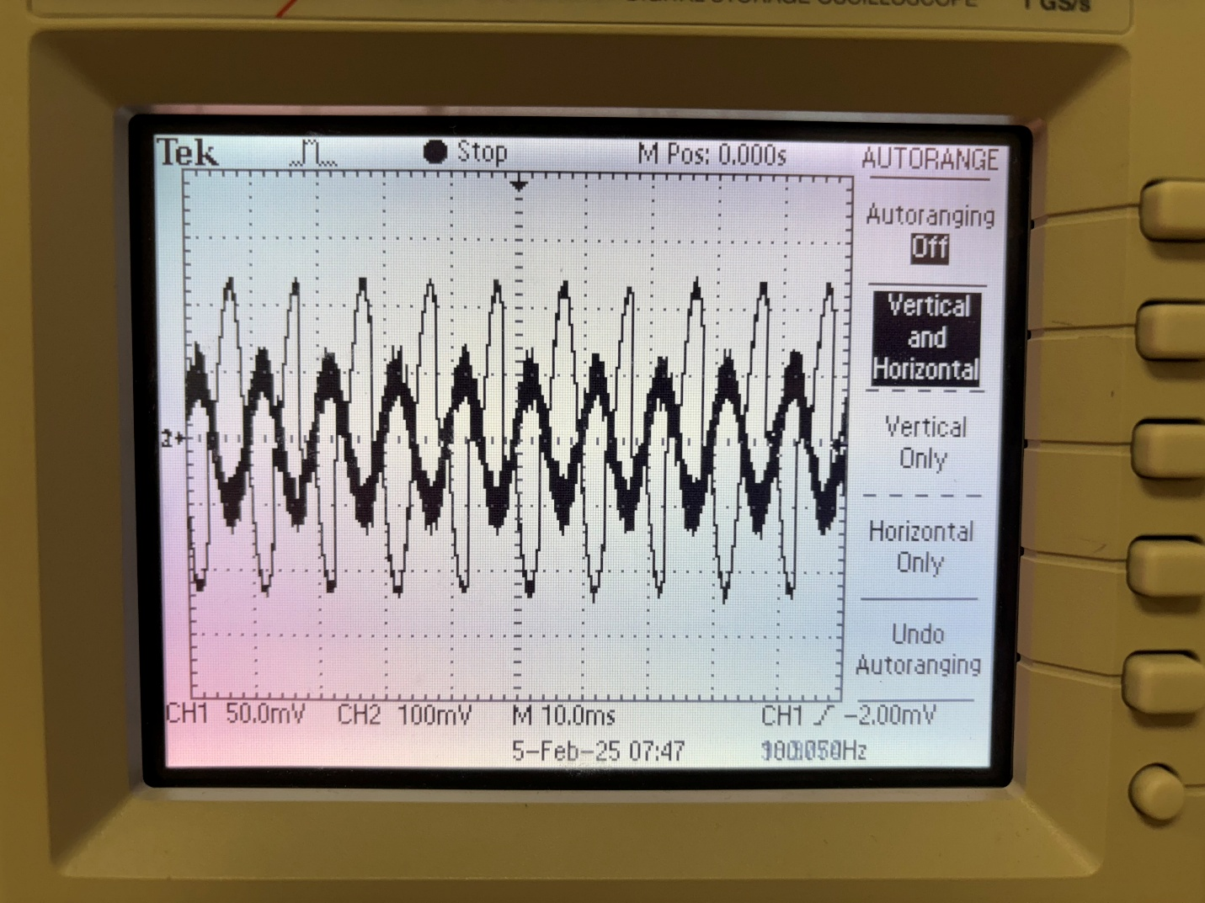

Figure (): Test of Negative Side of Stage 2

Common mode oscope plot if we have it

Data to verify the gain of the stage constructed in Step 3 (gain from and gain from ).

Data to verify that the gain for the overall circuit, with all stages connected, agrees with the theoretical value (Step 4).

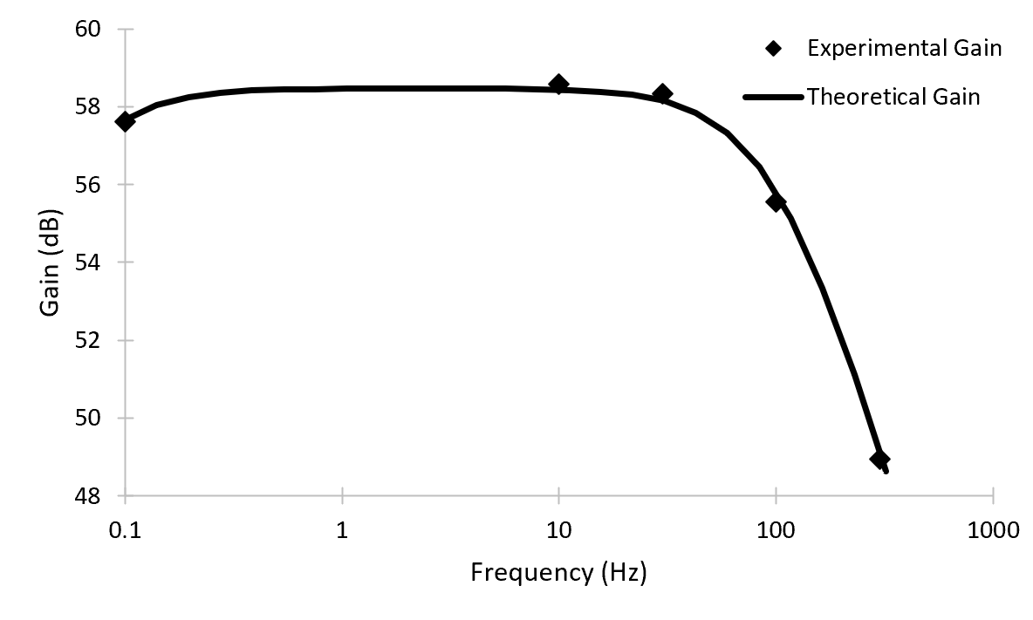

Figure (): Magnitude Bode Plot for Full Circuit

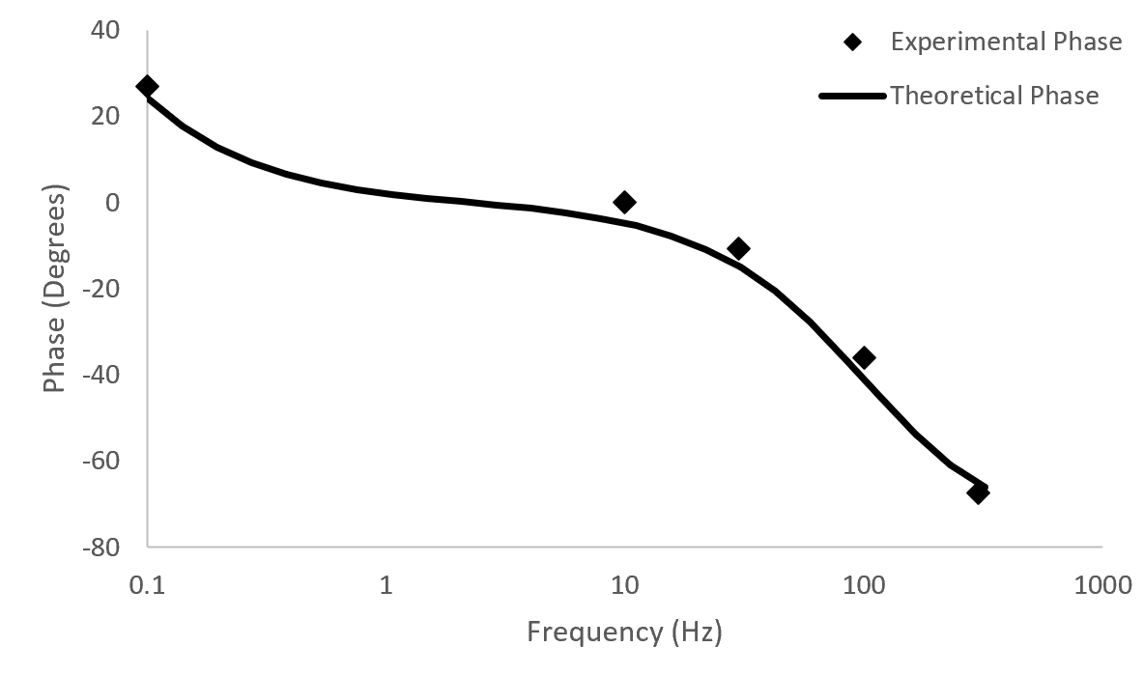

Figure (): Phase Bode Plot for Full Cirucit

**Discussion**

**Conclusion**

1.