1. **Introduction**

The purpose of this laboratory is to measure the transfer function of an inverting operational amplifier circuit and to compare magnitude and phase to a standard model of a single-pole system.

1. **Methods**

Figure 1 presents the circuit diagram utilized in this experiment. Initially, the wires were tested to ensure proper connectivity. After constructing the circuit, measurements were taken to verify that the circuit produced the desired gain. Amplitudes were subsequently recorded for input signals of 10 kHz, 100 kHz, and 1 MHz to analyze the diminishing gain at higher frequencies. Starting at 10 Hz, the input frequency was incrementally increased to identify the frequency corresponding to the -3 dB point. Finally, the differences in zero-crossings were measured to calculate the phase lag.

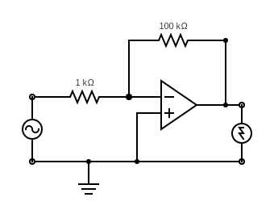

Figure 1: Circuit Diagram.

The theoretical model follows the following transfer function:

$$T\left(jω\right)=-\frac{100ω_{\text{3db}}}{jω+ω_{\text{3db}}}$$

Where the magnitude is

$$\left|T\left(jω\right)\right|=100\frac{ω_{\text{3db}}}{\sqrt{ω^{2}+ω_{\text{3db}}^{2}}}$$

And the phase lag is

$$ϕ=∠\left(-1\right)-\arctan\left(\frac{ω}{ω_{\text{3db}}}\right)=-180-\arctan\left(\frac{ω}{ω_{\text{3db}}}\right)$$