**ELEN 472: Introduction of Digital Control Systems**

**HW2**

Q1. Find the magnitude and phase at frequency $ω=10$ rad/s of a zero-order hold with sampling time $T=0.2$ s.

Q2. Known that the dynamic equation of a point mass ($m$) with force ($f$) as input and displacement ($x$) as output is

$$m\ddot{x}\left(t\right)=f(t)$$

Find $G_{ZAS}(z)$ for the system.

Q3. For a system:

Where is the time constant and $ε$ is a known parameter. If a delay is 25 ms and the sampling period is 10 ms, find the $G_{ZAS}(z)$ for the system.

Q4. Obtain expressions for the analog and sampled outputs from the following block diagram:

Q5. For the following system with unity feedback, find

* The position error constant.
* The velocity error constants.
* The steady state error due to a unit step input.
* The steady-state error due to a unit ramp input.

$$G\left(z\right)=\frac{0.5(z+0.2)}{(z-0.1)(z-0.8)}$$

Q6. Determine the BIBO stability of the following system

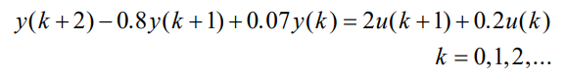

Q7. Biochemical reactors are used in different processes such as waste treatment and alcohol fermentation. By considering the dilution rate as the manipulated variable and the biomass concentration as the measured output, the biochemical reactor can be modeled by the following transfer function:

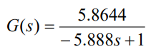

Determine $G_{ZAS}(z)$ with a sampling time $T=0.1$ s and then consider the feedback controller

$$C\left(z\right)=-\frac{z-1.017}{z-1}$$

Verify that the resulting feedback system is not internally stable.

Q8. Use the Jury Test to investigate the stability of the following system with the characteristic equation:

$$F\left(z\right)=z^{5}-0.25z^{4}+0.1z^{3}+0.4z^{2}+0.3z-0.1=0$$