**ELEN 472: Introduction to Digital Control Systems**

**HW3**

**Q1**. Sketch the root locus diagram for the following analog system with the loop gain:

Using rule 1, the function has three root locus branches,

By rule 2, the branches start at 0, -2, -5 and go to infinity.

By rule 4, we can find the breakaway points:

Making

The first value is a breakaway point since it lies between the poles. The second value is the break-in point.

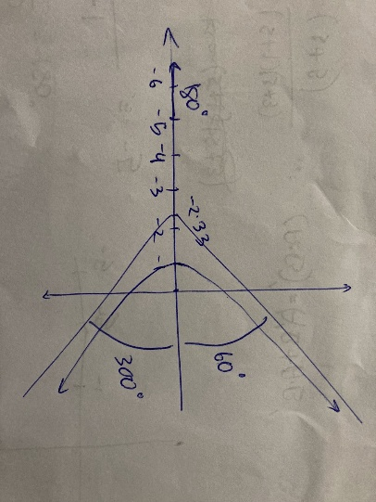

**Q2.1** Given damping ratio and natural frequency rad/s. Find the following time-domain specifications:

1. Percentage Overshoot
2. Peak Time
3. Settling time

**Q2.2** Fill the blank space:

For continuous time systems, the real part of the pole determines the rate of exponential change, and the imaginary part determines the frequency of oscillation.

**Q2.3** For a position control system with the continuous time transfer function:

Design a proportional controller to make the damping ratio

Closed-loop characteristic equation of system is given by

**Q3.** Find the critical gain of the following systems:

For the first-ordered system,

For the second order system, characteristic equation

Using the Jury test:

**Q4.1** Fill the blank space:

If the Laplace transform of a continuous-time function has a **pole** , then the z-transform of its sampled counterpart has a **pole** at

The Frequency of Oscillations () can be calculated with and by using the equation:

**Q4.2** Design proportional controllers for the digital system

to meet the following specifications separately (you need to find two values of to meet condition 1 and 2 separately):

1. A damping ratio of 0.7.
2. A steady-state error of 10% due to a unit step input (sampling period s).

Closed loop characteristic equation is given by

Equating the coefficients,

The system is Type 0, therefore the steady state error:

Steady-state error of 10% due to a unit step input:

**Q5.1** Apply the **forward difference** approximation of the following second-order analog controller:

to find the digital controller ( s).

Given

Transfer function using forward difference method

**Q5.2** Repeat the previous question with a **backward difference**.

For backward-difference

**Q6.1** Design a digital filter by applying the bilinear transformation to the analog filter

With s.

**Q6.2** Repeat the previous question and apply the prewarping at rad/s to find the new digital filter.

**Q7**. Answer the following questions to design a digital controller for the analog plant:

to

1. In order to obtain zero steady-state error, what kind of controller (i.e., PI, PD, or PID) should we choose?
2. To obtain a settling time less than s and the natural frequency of rad/s, what is the value of damping ratio ?
3. What is the range of suitable sampling frequency?
4. Find the bilinear transform of the analog controller that you selected in question 1 ( s).
5. To increase system type by 1, we should use PI controller.

PI controller’s transform function

So, loop gain

Now, characteristic equation

1. Equating coefficients,

Now

Sampling theorem,