**Checklist for Writing**

1. I have run the **spelling checker** on my document.
2. I have run the **grammar checker** on my document.
3. I have used **passive voice** only to avoid first person, and have avoided other wordy constructions such as “there are … who.”
4. I have used the **equation editor** (download MS Word file) to format all equations.
5. All of the references in the **List of References** are explicitly cited in my report
6. All of the **figures and tables** have references to them in the text.
7. All **figure captions** appear at the *bottom* of the figure, and all **table captions** appear at the *top* of the figure.
8. The first **reference to each figure** or table must occur *before* the figure or table.
9. The words **“this,” “that,” “these,” and “those”** never occur without referencing a noun. (E.g., “This device is used to …” rather than “This is used to …”
10. All **acronyms or initialisms** are spelled out completely the first time they are used. For example, “A Magnetic Resonance Imager (MRI) is used for ….”
11. All **quoted material** relates to points that are subjective or a matter of opinion on the part of the quoted author.
12. I have not used any of the following **egregious words or phrases**: a lot, kids, kinds, big, kind of, due to the fact that, (or just “the fact that”), utilize, actually, obviously, rather (as in “It is rather surprising”), very, quite, essentially. That is, I have used the search feature of Word to look for the words and phrases in Tables 1 and 2.
13. My text has no **sentence fragment**s or **run-on sentences** (the grammar checker should find these errors).
14. My text has no **contractions** (do a global search for the apostrophe and make sure it occurs only in possessives).
15. The phrase **“et al.”** is correctly written, with no period after “et” and a period after “al.”
16. When the **semicolon** is used, it separates complete sentences, not sentence fragments or clauses.
17. I have eliminated **dangling participles**. Wherever a present participle is used at the beginning of a sentence, the noun performing the action is the first thing after the comma.
18. I have used **parallel constructions** in related phrases.
19. I have checked for **common typing errors**.

**Checklist for Graphs**

1. Where possible and appropriate, multiple related curves are plotted on the same graph so that they can be readily compared. (How?)
2. The graph background is white. (How?)
3. The “Smoothed line” option is turned *off*. If no theoretical curve or appropriate curve fit, I have not connected the symbols or have connected them with ***straight*** lines (How?).
4. Collected data are represented with symbols, and theoretical curves or digitized waveforms with lines (How?).
5. Line modes, line thicknesses or symbols distinguish data sets, ***not*** colors (How?).
6. The horizontal gridlines are removed from my plots (How?).
7. Major tick marks are included on the axes to indicate the positions corresponding to the number labels (How?).
8. The numbers on the x and y axes are large enough to read (How?).
9. The scales on the x and y axes follow the 1, 2, 5 rule (How?).
10. The x and y axes are labeled clearly with the information they represent and the correct units of the data (e.g. Frequency (Hz) or Pressure (dynes/cm2)) (How?).
11. The y-axis labels (title and numbers) run vertically from the bottom of the plot to the top, rather than horizontally (How?).
12. Greek letters, other special characters, or superscripts/subscripts are used, when necessary, in an axis title or elsewhere (How?).
13. The legend for each curve describes only the distinguishing characteristic of the curve (e.g. “With Fibrinogen”, “Without Fibrinogen,” ***not*** “Cell Growth With Fibrinogen,” “Cell Growth Without Fibrinogen,” ***not*** “first data set,” “second data set,” and ***certainly not*** “series 1,” “series 2.”) (How?).
14. No chart title is used unless multiple graphs appear in a single figure. (How?)
15. The legend is on the plot area at a location where it does not cover any of the data. (How?)
16. Where applicable, the legends appear in an order that follows the position of the curve on the plot (i.e., upper curve matches the topmost legend) (How?).
17. Legends highlight only the aspect of the given curve that distinguish it from the other curves. (Generally, if all legends have a phrase in common, that phrasecan be removed).
18. Unnecessary borders are removed, including:
    * + 1. The border around the legend.
        2. The border around the plotting area.
        3. The border around the complete plot. (How?)
19. Where applicable, bars representing standard deviation or standard error of my collected data are included (How?).
20. Where reasonable, physical units for the axes allow the number labels to have a small number of digits (e.g. 10 GPa instead of 10E9 Pa or 10,000 MPa) (What?).

**Checklist for Figures and Tables**

**Figures**

Each figure has a caption that includes the word “Figure,” followed by the figure number, followed by a brief description of the figure (e.g. **Figure 14**: Schematic of the experimental system.).

Each figure caption appears below the figure.

A consistent caption style is used for all figures.

Each figure is referenced within the narrative of the document.

A description of the figure follows the reference to that figure, usually before the picture appears.[1]

Each figure appears after the narrative paragraph that first introduces it.

Figures do not break across pages.

**Tables**

Each table caption appears above the table. (It’s a general rule. Don’t ask me why.)

Each table is referenced, by table number, within the narrative of the document.

Each table appears after the first reference to it within the narrative.

Each caption includes the word “Table,” followed by the table number.

A consistent style is used for all tables.

Tables that are less than one page long do not break across pages.

Tables that are longer than one page long include a separate table header for each page.

**Homework 7:**

**Design Project**



BIEN 325/510 - Bioinstrumentation

Sunzid Hassan

Feb 27, 2025

**Abstract**

**Introduction**

Define problem – designing a biomedical device that can be used to sense pressure.

Design criteria:

1. It must be relatively thin, less than 1 cm.
2. It should measure forces up to 20 newtons.
3. The noise level should be less than 5% of full scale.
4. It should be inexpensive, less than $20 in total.
5. It should be durable such that an overload up to 100 newtons will not cause damage.

**Methods**

The first step of this project was to considering and testing initial design options. Specifically, three different designs based on pressure sensitive variable was tested for this project.

1. Option 1: gluing graphite from 6B pencil on copper tape: the first tried method was to extract graphite from 6B graphite pencil and using clear glue to stick it inside two copper tape layers. The copper tapes were connected with wires, which were used to take resistance reading. However, the end result didn’t show sensitivity to applied pressure.
2. Option 2: the second option was using a spring from pen to use as the pressure sensitive resistor. Initial testing showed that it resulted in predictive resistance change against applied pressure. However, the spring was more than an inch taller. Additionally, it was difficult to apply pressure without bending it. Thus, the design was discarded.
3. Option 3: the final design used pressure sensitive velostat as the semiconductive material sandwiched between two conductive copper tapes. The surface area of the sensor was about $2×2$ inch with a thickness of less than 1 cm.

Sketch:

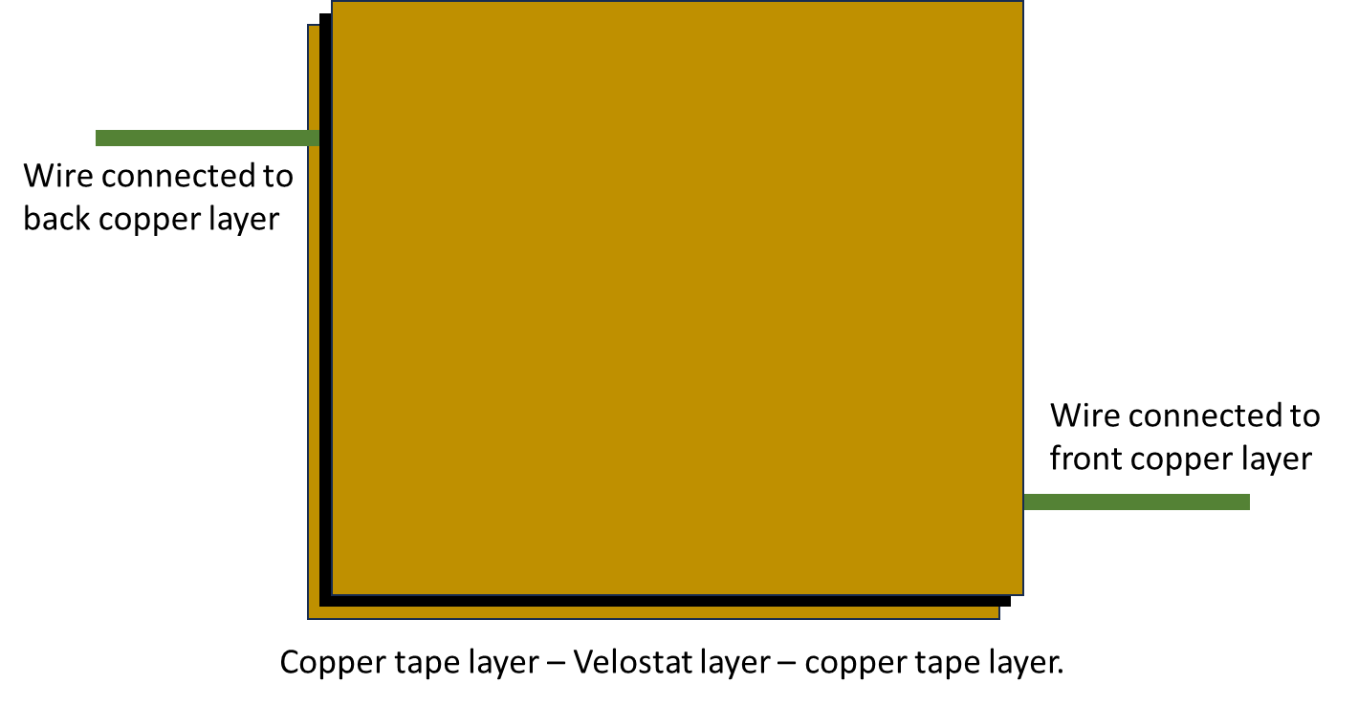

**Results**

LT Model:

Initially the sensor was showing a resistance of about 4 ohms. An LTSpice circuit was designed to get voltage difference after application of pressure. However, revised sensor showed resistance of about 2.4k ohms. The implemented circuit in LTSpice didn’t produce sufficient voltage difference for revised whetstone bridge.

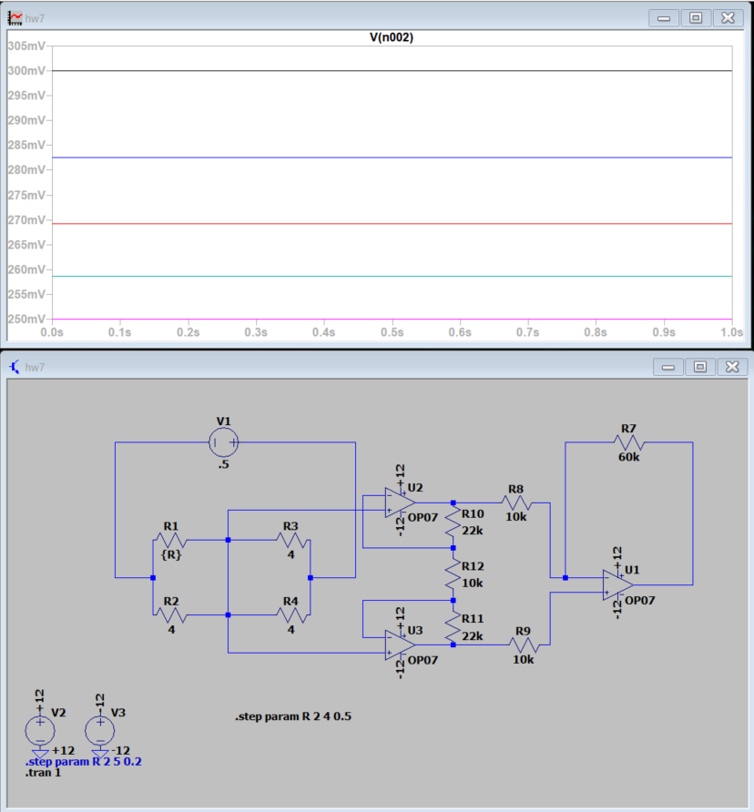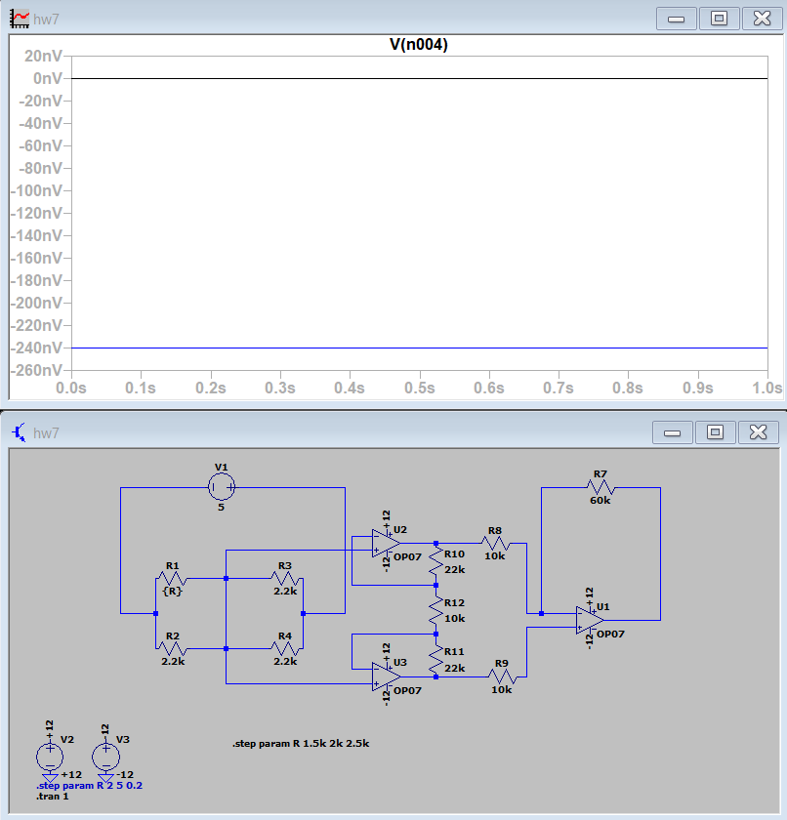

Actual reading:

The pressure sensor showed reduction in resistance after application of pressure. The resistance value without any pressure was fluctuating, I got about 2.6k ohms reading. After application of about 0.16 Newton pressure the resistance was about 2.4k ohms, and after application of about 0.29 Newton pressure the resistance was about 2.3k ohms. However, the sensor values were not very consistant.

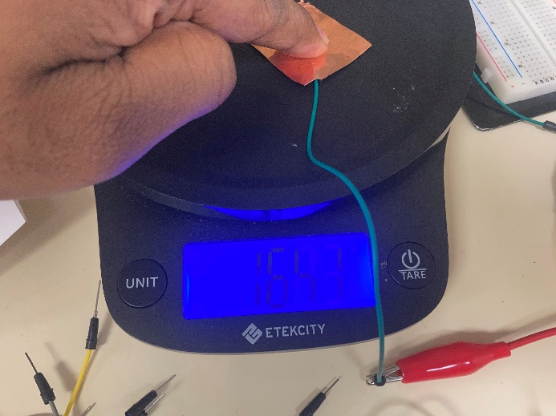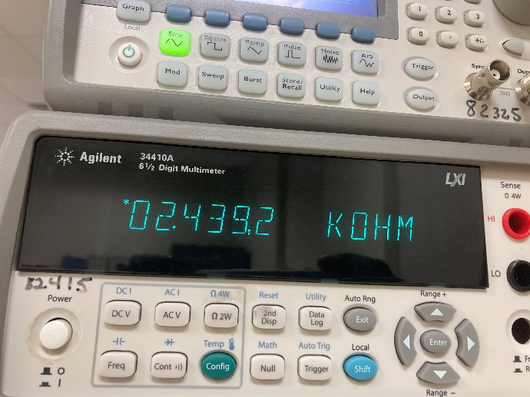

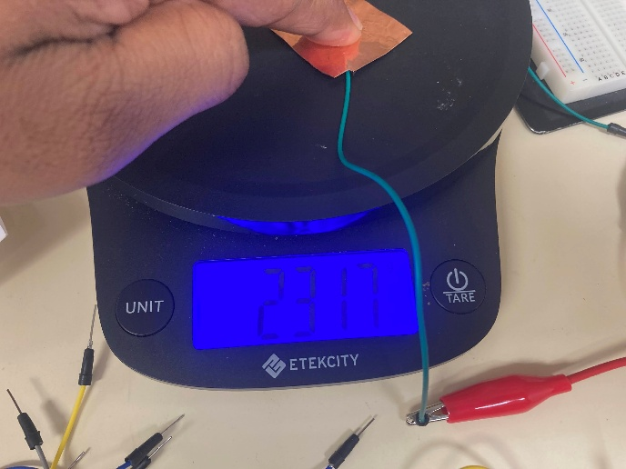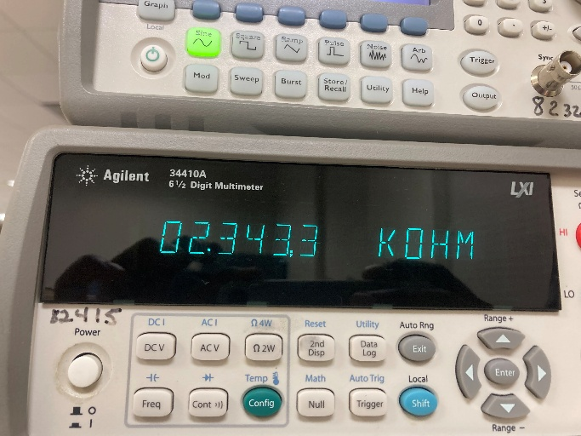

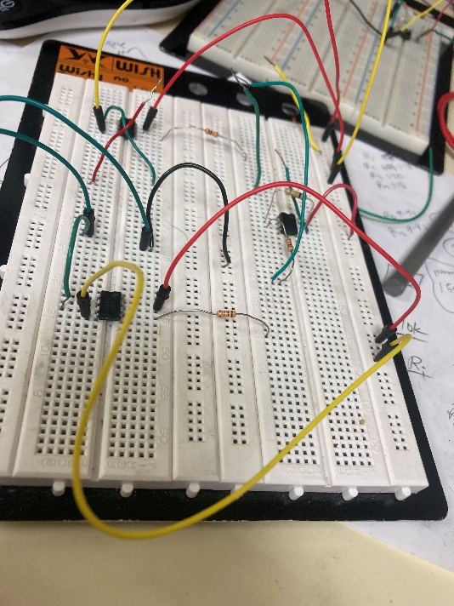

I tried to implement the circuit shown above in LTSpice. However the circuit did not produced good output.

**Discussion**

1. It must be relatively thin, less than 1 cm: the final sensor was less than 1 cm.
2. It should measure forces up to 20 newtons: I tested up to about 0.3 Newton force. The pressure reduced the resistance, but the change was not regular.
3. The noise level should be less than 5% of full scale: was not tested.
4. It should be inexpensive, less than $20 in total: Price of 11.00" x 11.00" velostat was $4.95. I used about 1.00" x 1.00" for the sensor, which cost about 4 cents. Similarly, the price of copper tape and wires were small.
5. It should be durable such that an overload up to 100 newtons will not cause damage: the sensor was made of copper tape. Applying large pressure will likely damage the sensor.

Factor analysis

**Conclusion**

1.