Lab3- Subnetting

Create an IP Addressing Scheme by following the provided network Scenario. Your task is to calculate the necessary subnets, subnet masks, and create an IP addressing scheme based on the given topology. Follow the steps outlined in the document and fill out the required tables accordingly.
Lab Scenario
In this activity, you are provided with the 192.168.100.0/24 network address to subnet and allocate IP addresses for the network illustrated in the topology. Each LAN in the network must accommodate at least 25 IP addresses for end devices, along with addresses for the switch and the router. Additionally, the connection between R1 and R2 requires an IP address for both ends of the link.
Topology: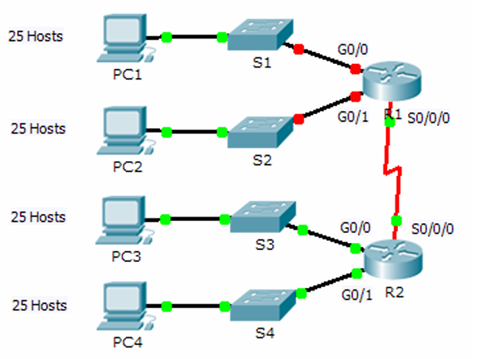

Part 1: Create an IP Addressing Scheme by following the Lab Scenario.
Divide the network 192.168.100.0/24 into smaller subnets as per the requirement, then answer the following:
- Given the network topology, how many subnets do you need?
- How many bits must you borrow to achieve the required number of subnets based on the topology?
- What number of subnets can you create with this configuration?
- How many usable IP addresses are available per subnet?
Keep in mind: if the number of usable hosts per subnet is less than 25, it means too many bits were borrowed.

- calculate the binary representation of the first five subnets. The binary value of the first subnet has been provided.
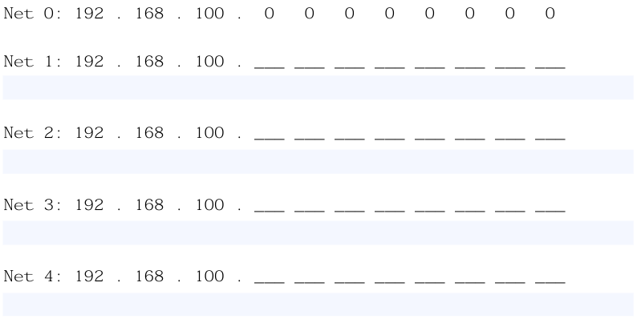

- compute the decimal and binary value of the newly created subnet mask.

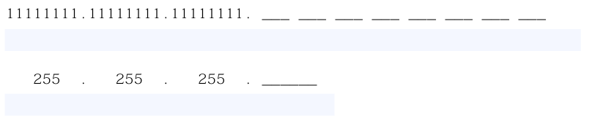

- Fill out the below subnet table, listing the decimal values of all usable subnets, the first usable host address, the last usable host address, and the broadcast address. Repeat until all addresses are listed.
Note: Maybe not all the rows are needed.

Subnet Table
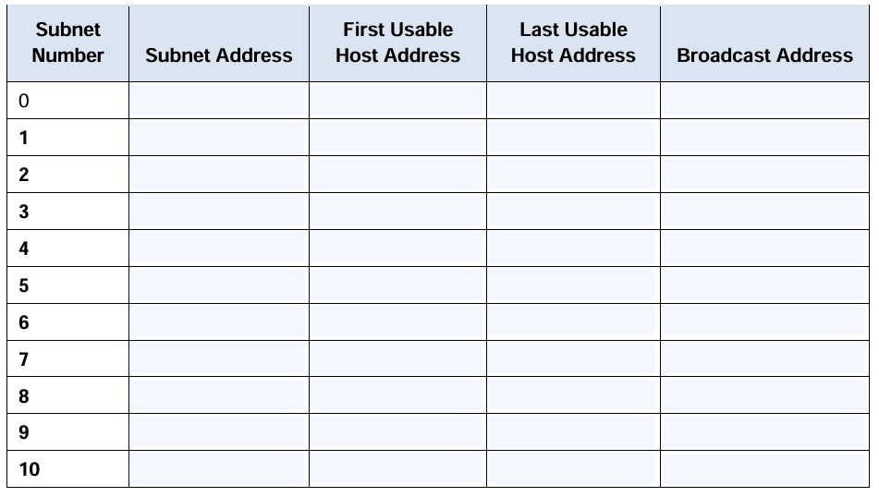

Part 2: Assign subnets:
- Allocate Subnet 0 to the LAN Linked with GigabitEthernet 0/0 interface of router R1:

- Allocate Subnet 1 to the LAN Linked with GigabitEthernet 0/1 interface of router R1:

- Allocate Subnet 2 to the LAN Linked with GigabitEthernet 0/0 interface of router R2:

- Allocate Subnet 3 to the LAN Linked with GigabitEthernet 0/1 interface of router R2:

- Allocate Subnet 4 to the WAN connected between routers R1 to R2:

Part 3: The addressing scheme.
Fill out the “Addressing Table” below and make sure to:

- Allocate the first usable IP addresses to router R1 for the WAN link and the 2 LAN links.

- Allocate the first usable IP addresses to router R2 for the 2 LAN links. Also, Allocate the last usable IP address for the WAN link.

- Allocate the switches the second usable IP addresses.

- Allocate the hosts the last usable IP addresses.

Addressing Table:

