27th June, 2024

**Brother Andu Arif**,

As-Salamu Alaikum Warahmatullah Wabarakatuhu,

**LETTER OF APPOINTMENT**

All praises and adorations are due to Allah, the lord of the world, the possessor of the kingdom, who gives the kingdom to whom he wills. We beseech his endless blessings upon the noblest of mankind, Prophet Muhammad, his household, companions and those who follow him on the path of righteousness till the day of recompense. Aameen.

We are pleased to inform you that you have been appointed as a/the **Member** of the **PROFESSIONAL SEMINAR COMMITTEE** for the 23/24 academic session.

This, we hope will be a way of contributing a quota of your Morals and Skills to the improvement of the Branch and as well help young Muslims.

We ask Almighty Allah in his infinite mercies to ease your affairs and may he accept this task from you as an act of Ibaadah.

Yours In Islam.

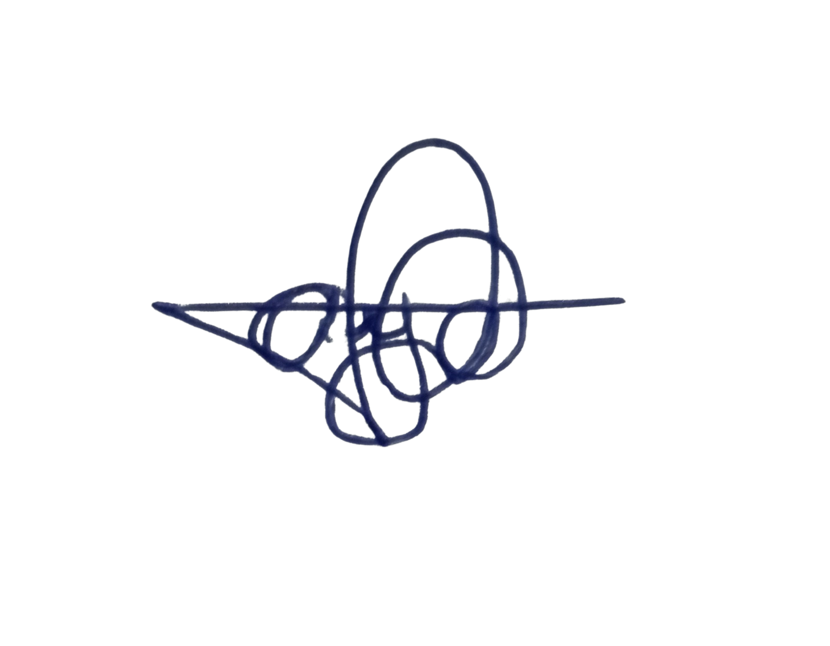

Ajibowu Abdulbasit

*Assistant General Secretary*

08061555189

[lasuepemssn@gmail.com](mailto:lasuepemssn@gmail.com)

