PROJECT REPORT
VENUEVISTA
EventPro Ticketing & Venue Management
HCL Industry Project – P_014
Submitted By
Supriya Kashyap
B.Tech – Computer Science and Engineering
III Year
ABES Engineering College
Academic Year: 2026–2027

Certificate
This is to certify that the project titled “VenueVista: EventPro Ticketing & Venue Management” has been developed by Supriya Kashyap, student of B.Tech Computer Science and Engineering, as a part of the Industry Project.
Project Guide Signature: ______________________________
HOD Signature: ______________________________________
Date: ______________________________________________

Declaration
I hereby declare that the project titled “VenueVista: EventPro Ticketing & Venue Management” is my academic/industry project work. The application was developed using Angular, Java Spring Boot, MySQL, Spring Data JPA, Hibernate and REST APIs. The implementation details described in this report correspond to the current project implementation.
Name: Supriya Kashyap
Roll No.: __________________________
Date: ______________________________
Signature: _________________________

Acknowledgement
I would like to express my sincere gratitude to ABES Engineering College, my project guide, faculty members and HCL for providing the opportunity and guidance required to develop this project. I also thank everyone who supported me during the planning, implementation, testing and documentation of VenueVista.

Abstract
VenueVista: EventPro Ticketing & Venue Management is a full-stack web application designed to simplify the management of venues, events, tickets and bookings. The current system provides REST APIs for users, venues, events, tickets and bookings. Users can browse events, view venue information, create bookings with seat numbers, and cancel bookings. The backend is implemented using Java Spring Boot, Spring Data JPA and Hibernate, with MySQL as the persistent database. The frontend is implemented using Angular 21 and communicates with the backend through HTTP REST APIs. Business rules in the booking service validate users, events, tickets, quantities and seat numbers, calculate the total amount, update ticket availability and support cancellation.
Keywords: Event Management, Venue Management, Ticket Booking, Angular, Spring Boot, MySQL, REST API, JPA, Hibernate.

Table of Contents
1. Introduction
2. Problem Statement
3. Objectives
4. Existing System
5. Proposed System
6. Feasibility Study
7. Requirements Analysis
8. System Design
9. Database Design
10. System Architecture
11. Technology Used
12. Module Description
13. Implementation
14. API Documentation
15. Security
16. Testing
17. Screenshots
18. Results
19. Future Scope
20. Conclusion
21. References
22. Appendix

1. Introduction

1.1 Background
Event organizers need to manage venues, scheduled events, ticket availability, bookings, cancellations and attendee seating. When these activities are handled separately, maintaining consistent information becomes difficult. VenueVista provides a centralized web application in which these operations can be managed through a common backend and database.

1.2 Project Overview
- User management
- Venue management
- Event management
- Ticket management
- Booking and cancellation
- Seat-number validation within bookings
- Angular frontend and Spring Boot REST API integration
- MySQL persistence

2. Problem Statement
Event and venue operations may require separate processes for scheduling events, maintaining venue information, tracking ticket availability and processing bookings. Users also need a convenient way to identify an event, select ticket quantities and provide seat numbers. VenueVista addresses these requirements through a single web-based application backed by REST APIs and a relational database.

3. Objectives
- Develop an online venue management system.
- Allow creation, viewing, updating and deletion of events.
- Allow users to view available events and venue information.
- Manage ticket types, prices and available quantities.
- Support booking with seat numbers and quantity validation.
- Calculate booking totals automatically.
- Support cancellation and restoration of ticket quantity.
- Demonstrate frontend-backend integration using Angular and Spring Boot.

4. Existing System
- Manual or disconnected booking processes
- Difficult ticket and seat tracking
- No centralized event and venue database
- Greater possibility of inconsistent booking information
- Manual calculation of booking amounts
- Limited visibility of booking status

5. Proposed System
VenueVista integrates users, venues, events, tickets and bookings. The Angular frontend communicates with Spring Boot REST endpoints. The service layer applies booking rules before data is stored through Spring Data JPA and Hibernate in MySQL. Booking cancellation restores the corresponding ticket quantity, helping keep availability consistent.

6. Feasibility Study

6.1 Technical Feasibility
The application uses Java, Spring Boot, Spring Data JPA, Hibernate, MySQL, Angular 21, TypeScript, Maven and REST APIs. These technologies support the required CRUD operations, relational persistence and frontend-backend communication.

6.2 Economic Feasibility
The project is developed primarily with freely available development tools and open-source frameworks, reducing software licensing requirements.

6.3 Operational Feasibility
The application can be operated through a web browser. The modular backend separates user, venue, event, ticket and booking responsibilities, making the system easier to maintain and extend.

7. Requirements Analysis

7.1 Functional Requirements
- Create and retrieve users
- Create, retrieve, update and delete venues
- Create, retrieve, update and delete events
- Create and manage tickets
- Create bookings with quantity and seat numbers
- Validate event dates and ticket availability
- Prevent duplicate active seat bookings for an event
- Calculate total booking amount
- Cancel bookings and restore ticket quantity

7.2 Non-Functional Requirements
- Usability
- Reliability
- Maintainability
- Data consistency
- Performance
- Basic API-level error handling

8. System Design
VenueVista follows a layered architecture. Angular provides the client-side interface. REST controllers receive HTTP requests. Services contain business rules, repositories communicate with the database through JPA/Hibernate, and MySQL provides persistent storage.
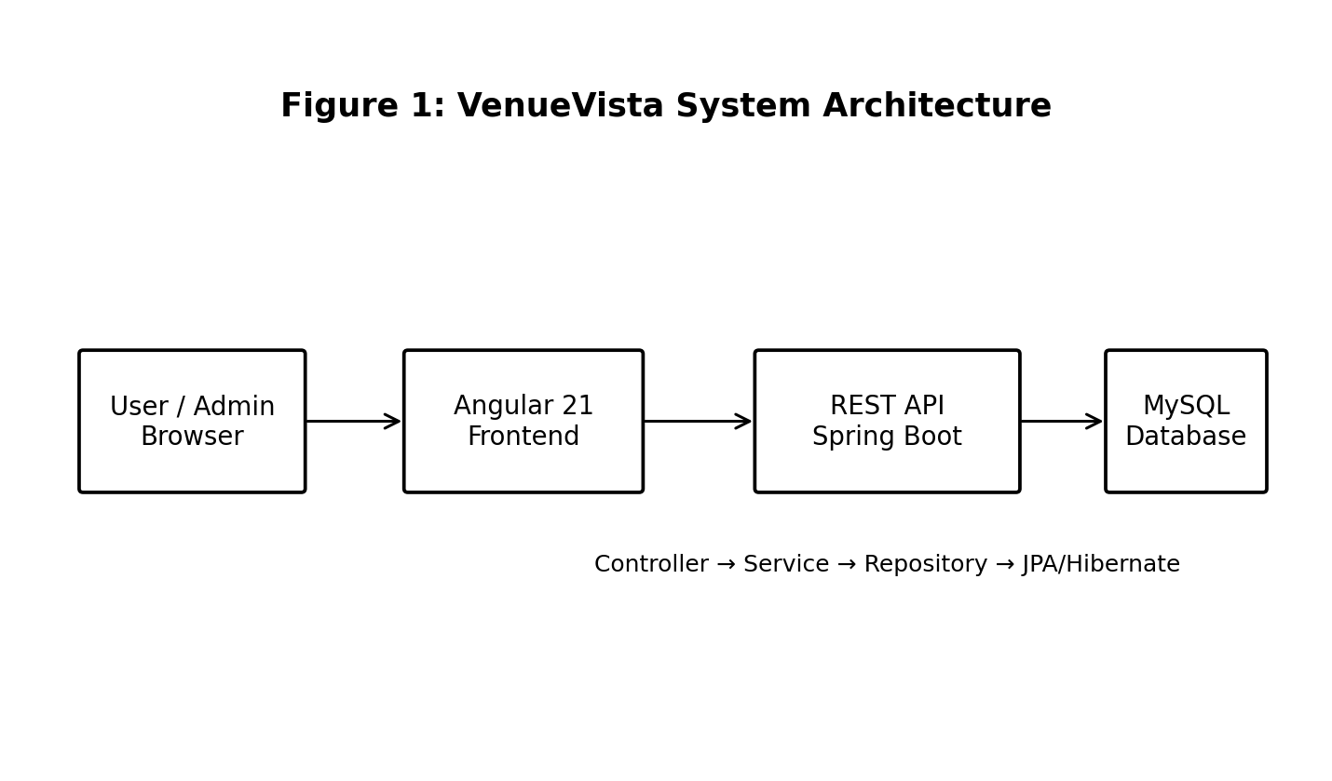
The architecture separates presentation, business logic and persistence responsibilities.

8.1 Backend Layer Design
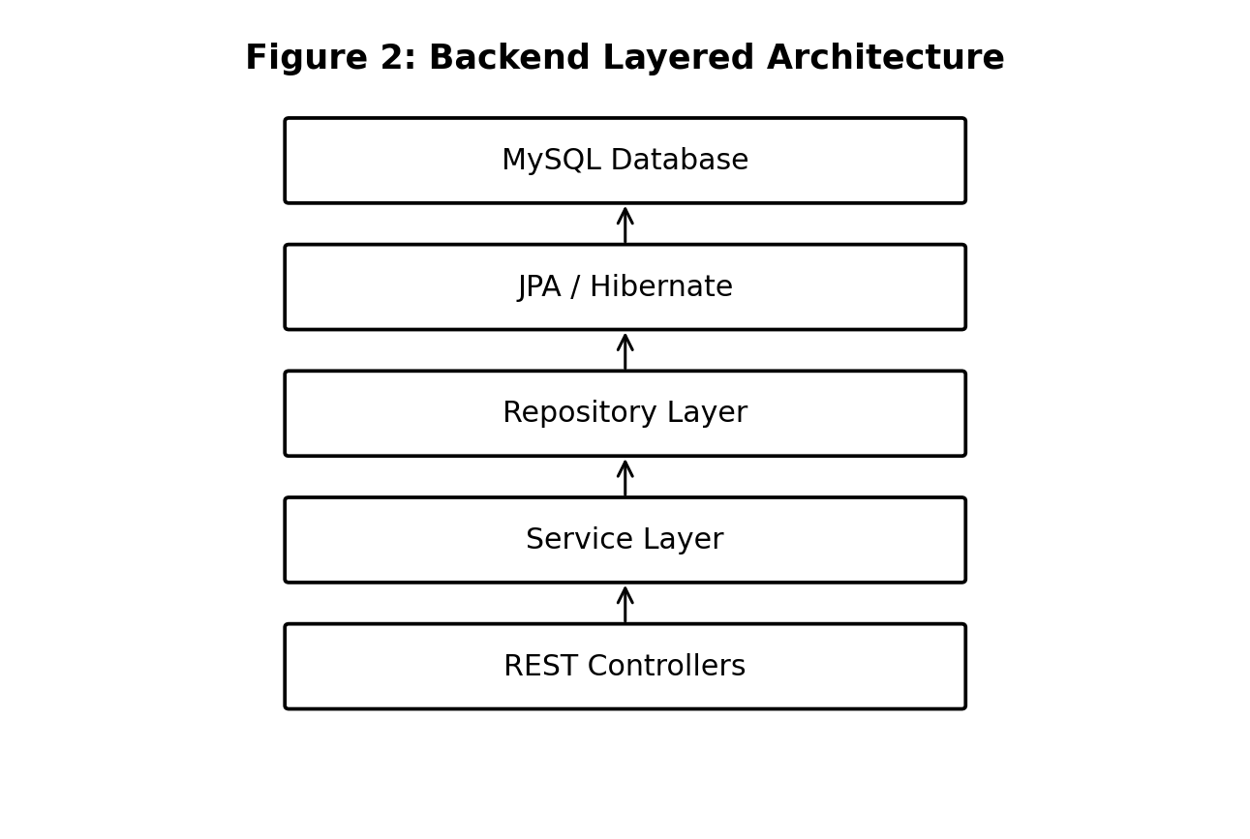

8.2 Booking Processing Flow
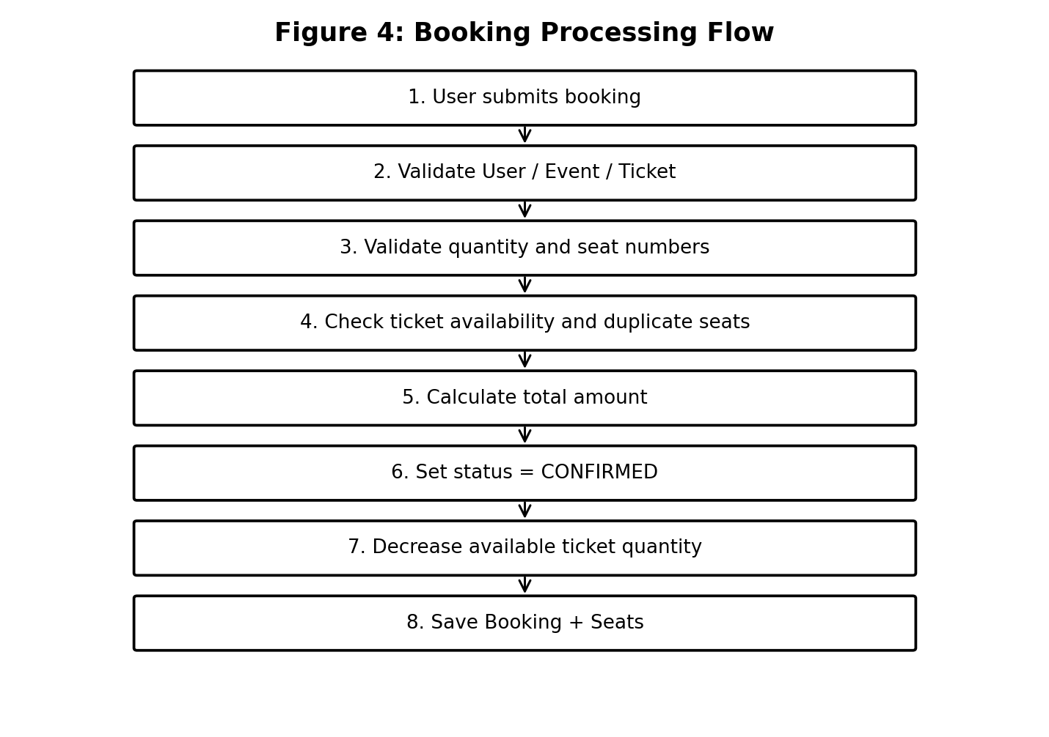

9. Database Design
The current database contains entities for User, Venue, Event, Ticket and Booking. Booking also stores seat numbers as an element collection in a separate booking_seats table. The current implementation does not use a separate Seat entity/table.
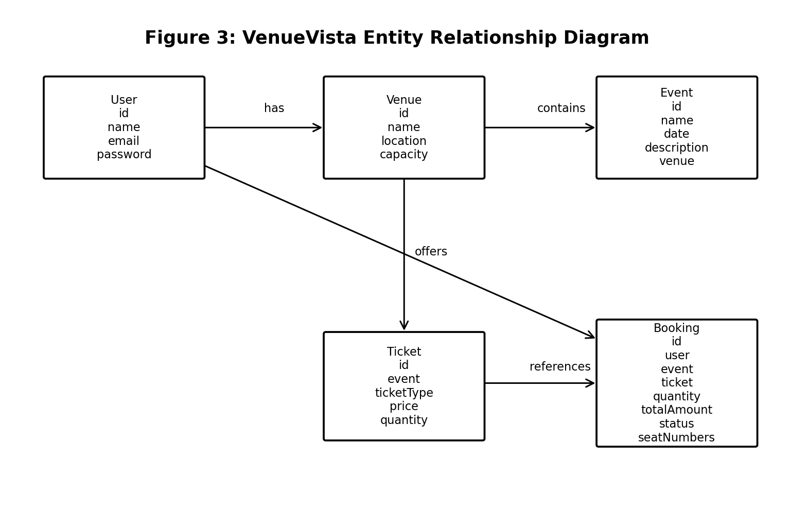
Entity | Important Fields | Relationship
User | id, name, email, password | User can have multiple bookings
Venue | id, name, location, capacity | One venue can have multiple events
Event | id, name, date, description, venue | Event belongs to a venue
Ticket | id, event, ticketType, price, quantity | Ticket belongs to an event
Booking | id, user, event, ticket, quantity, totalAmount, status, seatNumbers | Booking references user, event and ticket

10. System Architecture
The complete request path is: User → Angular Frontend → HTTP REST API → Spring Boot Controller → Service Layer → Repository Layer → JPA/Hibernate → MySQL. Responses travel back through the same layers to the Angular interface.
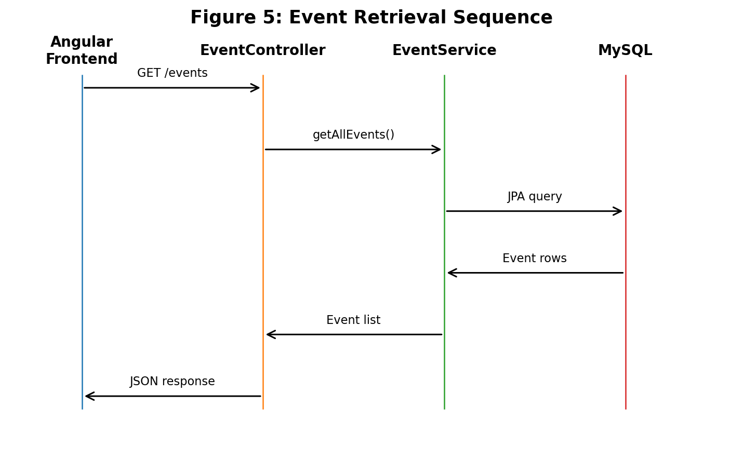

11. Technology Used
Technology | Purpose
Angular 21 / TypeScript | Frontend user interface
Java | Backend programming language
Spring Boot | Backend framework and REST API
Spring Data JPA | Database access
Hibernate | ORM and persistence
MySQL | Relational database
REST API | Frontend-backend communication
Maven | Build and dependency management
Thunder Client | API testing
VS Code | Development environment

12. Module Description

12.1 User Management
Provides user creation and retrieval. The current implementation stores user name, email and password fields; production authentication is a future enhancement.

12.2 Venue Management
Supports add, view, update and delete operations for venues, including name, location and capacity.

12.3 Event Management
Supports event creation, retrieval, updating and deletion. Each event can reference a venue and contains name, date and description.

12.4 Ticket Management
Maintains ticket type, price, quantity and event association. Booking and cancellation operations update available quantity.

12.5 Booking Management
Validates user, event, ticket, date, quantity and seat numbers; calculates total amount; prevents duplicate active seat numbers; supports confirmation and cancellation.

12.6 Frontend Integration
Angular uses HttpClient to call the Spring Boot REST API. The current event page displays event name, description, date and venue information from the backend.

13. Implementation
The backend is organized into model, repository, service and controller packages. JPA annotations map the Java entities to MySQL tables. The Event entity uses a Many-to-One relationship with Venue. Ticket references Event, while Booking references User, Event and Ticket. The BookingService contains transactional logic for validation, total calculation, ticket quantity updates and cancellation.
The Angular application contains the root App component and an Api service. The Api service uses Angular HttpClient to call the /events endpoint. Cross-origin access from http://localhost:4200 is enabled for the event controller so that the Angular development server can communicate with Spring Boot on port 8080.

14. API Documentation
Method | Endpoint | Purpose
GET | /users | Get all users
GET | /users/{id} | Get a user
POST | /users | Create a user
PUT | /users/{id} | Update a user
DELETE | /users/{id} | Delete a user
GET | /venues | Get all venues
GET | /venues/{id} | Get a venue
POST | /venues | Create a venue
PUT | /venues/{id} | Update a venue
DELETE | /venues/{id} | Delete a venue
GET | /events | Get all events
GET | /events/{id} | Get an event
POST | /events | Create an event
PUT | /events/{id} | Update an event
DELETE | /events/{id} | Delete an event
GET | /tickets | Get all tickets
GET | /tickets/{id} | Get a ticket
POST | /tickets | Create a ticket
PUT | /tickets/{id} | Update a ticket
DELETE | /tickets/{id} | Delete a ticket
GET | /bookings | Get all bookings
GET | /bookings/{id} | Get a booking
POST | /bookings | Create a booking
PUT | /bookings/{id} | Update booking status
PUT | /bookings/{id}/cancel | Cancel booking
DELETE | /bookings/{id} | Delete booking

15. Security
The current academic implementation includes basic validation and controller-level exception handling for booking operations. The BookingService validates referenced entities, quantity, ticket availability and seat numbers. Passwords are currently stored as a User field and full Spring Security/JWT authentication has not yet been implemented in the current codebase. JWT authentication, role-based authorization and password hashing are therefore listed as future enhancements rather than presented as completed functionality.

16. Testing
Test Case | Expected Result | Observed Result
GET /events | Return event list | Passed – Tech Fest 2026 and Cultural Fest 2026 returned
Create booking with quantity 2 | Booking confirmed and total calculated | Passed
Quantity 0 | Request rejected | Passed – HTTP 400
Quantity greater than available | Booking rejected | Passed – HTTP 400
Ticket from wrong event | Booking rejected | Passed
Duplicate active seat | Booking rejected | Passed
Cancel confirmed booking | Booking cancelled and quantity restored | Passed
Cancel already cancelled booking | Request rejected | Passed
Angular event retrieval | Events displayed in frontend | API verified; frontend browser display requires final client-side troubleshooting
CORS request from localhost:4200 | Allow Angular origin | Passed – Access-Control-Allow-Origin returned

17. Screenshots
Insert the following actual project screenshots in the final printed report:
- VenueVista Angular homepage
- Angular event listing after backend integration
- Spring Boot console showing application startup
- Browser/API response for GET /events
- Thunder Client user CRUD testing
- Thunder Client venue CRUD testing
- Thunder Client event CRUD testing
- Thunder Client ticket testing
- Thunder Client booking and cancellation testing
- MySQL venue_vista database tables
Note: Screenshots should be captured from the actual current project and inserted here rather than using screenshots from an unrelated React implementation.

18. Results
The implemented VenueVista backend successfully connects Spring Boot to MySQL and exposes REST APIs for users, venues, events, tickets and bookings. Event retrieval was verified directly through GET /events, returning Tech Fest 2026 and Cultural Fest 2026 with their associated ABES Auditorium venue. Booking tests verified quantity validation, ticket availability checks, event-ticket consistency, seat-number validation, duplicate-seat prevention, total amount calculation and cancellation with ticket restoration.
The Angular frontend successfully compiles and runs on http://localhost:4200 and the backend runs on http://localhost:8080. Cross-origin access for the Angular origin has also been verified through an HTTP response containing Access-Control-Allow-Origin: http://localhost:4200.

19. Future Scope
- Spring Security with JWT authentication
- Password hashing and secure credential handling
- USER/ADMIN role-based authorization
- Dedicated Seat entity and seat-layout management
- Payment gateway integration
- Email ticket confirmation
- QR-code and PDF ticket generation
- Admin analytics dashboard
- Advanced sales charts
- Password reset and notifications
- Cloud deployment
- Mobile application
- Search, filtering and sorting for events and venues

20. Conclusion
VenueVista demonstrates a practical full-stack event and venue management workflow using Angular, Java Spring Boot, REST APIs, Spring Data JPA, Hibernate and MySQL. The current implementation provides CRUD operations for core entities and a transactional booking workflow that validates tickets and seat numbers, calculates booking totals and restores availability during cancellation. The project also demonstrates frontend-backend integration and provides a clear foundation for future additions such as authentication, authorization, payments and analytics.

21. References
- Spring Boot Documentation
- Spring Data JPA Documentation
- Hibernate ORM Documentation
- Angular Documentation
- MySQL Documentation
- Maven Documentation
- REST API design references

22. Appendix
- Appendix A – Project source code
- Appendix B – API testing screenshots
- Appendix C – Database tables and SQL commands
- Appendix D – Frontend screenshots
- Appendix E – GitHub repository link

Diagram List
- Figure 1: VenueVista System Architecture
- Figure 2: Backend Layered Architecture
- Figure 3: VenueVista Entity Relationship Diagram
- Figure 4: Booking Processing Flow
- Figure 5: Event Retrieval Sequence

