

[Free Home Icon - Download in Glyph Style (iconscout.com)](https://iconscout.com/free-icon/home-796)

[CC BY 4.0 Deed | Attribution 4.0 International | Creative Commons](https://creativecommons.org/licenses/by/4.0/)



[File:Home free icon.svg - Wikimedia Commons](https://commons.wikimedia.org/wiki/File:Home_free_icon.svg)

[CC BY 3.0 Deed | Attribution 3.0 Unported | Creative Commons](https://creativecommons.org/licenses/by/3.0/)



[Free Settings Icon - Download in Glyph Style (iconscout.com)](https://iconscout.com/free-icon/settings-1912193)



[Free Visible Icon - Download in Glyph Style (iconscout.com)](https://iconscout.com/free-icon/visible-2451531)



[Free Notvisible Icon - Download in Glyph Style (iconscout.com)](https://iconscout.com/free-icon/notvisible-2451545)



[CC0 1.0 Deed | CC0 1.0 Universal | Creative Commons](https://creativecommons.org/publicdomain/zero/1.0/)

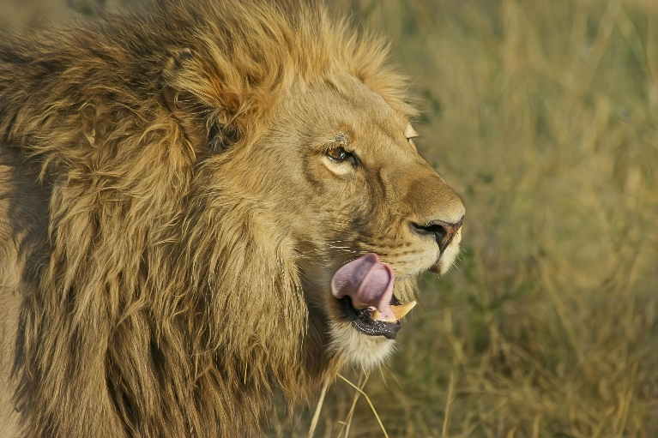

[Lion on Green Grass Field · Free Stock Photo (pexels.com)](https://www.pexels.com/photo/lion-on-green-grass-field-46522/)

[Public Domain - Creative Commons](https://creativecommons.org/public-domain/)

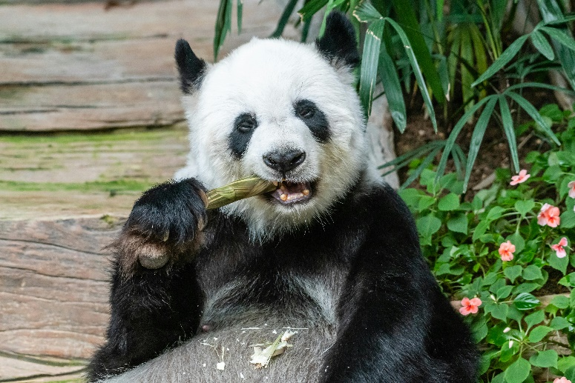

[Eating Panda Bear · Free Stock Photo (pexels.com)](https://www.pexels.com/photo/eating-panda-bear-14925845/)

[Public Domain - Creative Commons](https://creativecommons.org/public-domain/)

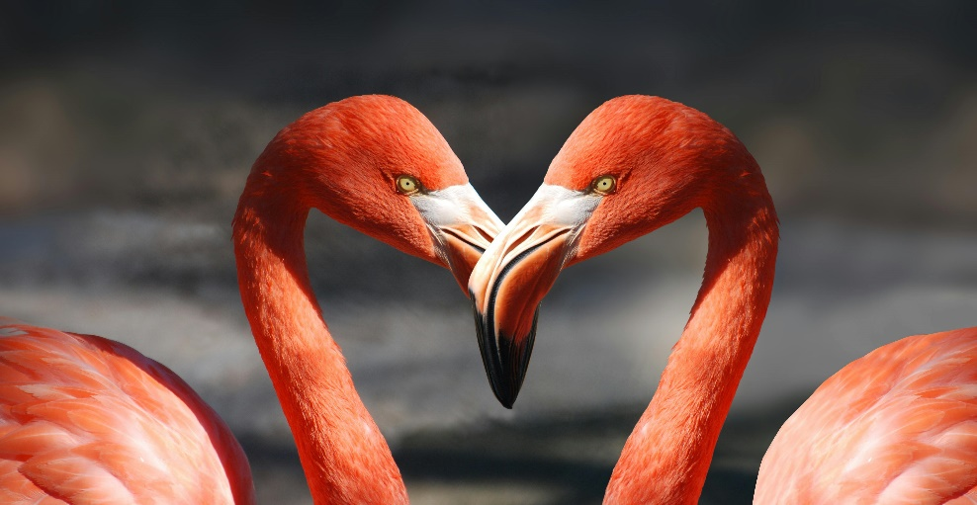

[Two Red Flamingos · Free Stock Photo (pexels.com)](https://www.pexels.com/photo/two-red-flamingos-39627/)

[Public Domain - Creative Commons](https://creativecommons.org/public-domain/)