NFC: Near-Field Communication
Bryan Cordes

Draft 2
3/28/2018

CEN 3078 Software Security
Instructor: Dr. Janusz Zalewski
Department of Software Engineering
Florida Gulf Coast University
Ft. Myers, FL 33965

Copyright © 2018 by Florida Gulf Coast University

- Introduction
“Near Field Communication (NFC) is a technology for contactless short-range communication. Based on the Radio Frequency Identification (RFID), it uses magnetic field induction to enable communication between electronic devices” [1]. The way society uses their mobile devices to interact with their environment has changed drastically over the years. Some technology, like NFC, is a hidden gem among all the current technologies for the mobile. NFC creates a two-way conversation between NFC devices and allows information, secured and non-secured to be transmitted from one device to another within a range, or span, of only a few centimeters from each other. NFC has been incorporated into many items that society uses on a daily basis. Currently, NFC has been heavily integrated into mobile smartphones, which has many benefits to the user. Technology, like NFC, can play an important role in changing how people utilize their smartphones in relation to their surrounding environment, as well as how their smartphones interacts with them. NFC wasn’t made to be a standalone interface, it’s often used to create a quick and easy way to connect devices to heavily used technologies like Bluetooth and WIFI [2]. This NFC technology requires two NFC compatible devices to be placed in an optimal range of 4cm, after which the signal starts to diminish to reduce eavesdropping. [3]. NFC communicates via magnetic field induction to create a physical space between the devices to allow data to be transferred. NFC strong selling point is that the cost for the necessary components is low and the setup time is negligible compare to other technologies. The actual components of NFC devices include a small circuit with an antenna attached to it, of which is used to receive and transmit data to a reader device, an example of this can be seen in Figure 1. However, not all NFC devices are the same. To elaborate, they can be broken down into two different types: active and passive. These two types of devices determine the type of communication that is conducted and how data is transmitted between them. NFC was based on RFID and uses the same type of technology, which is based on radio frequencies, but with some small differences. NFC passive devices are like RFID tags and are usually called NFC tags, which are also battery-less, and use the query signal to be powered. Unlike RFID where it is used only for identifying items, NFC allows responses to an active device request rather than just identification. An example of data and energy being sent from the active device, after the passive device reads the signal it will send a response to the active device signal rather than a number or identification can be seen in figure 2 [4] .
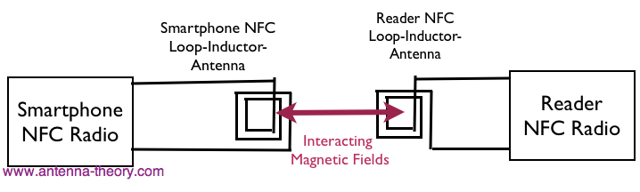
Figure 1, Antenna communicating, [5]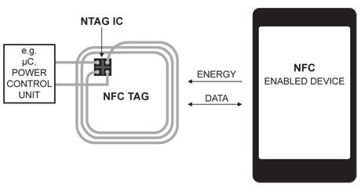
Figure 2: NFC Tags interaction with Phone

- Principles of technology
NFC operates at 13.56 MHz, which is an unlicensed radio frequency ISM band. Datum is transmitted information up to a maximum rate of 424 Kbits per second (848kbit/s is not a transfer speed that is compliant with standard ISO/IEC18092). When two NFC compatible devices are close enough (within range) to one another, the first device to start the communication is referred to as the initiator, which is an active device. The second device is called the target, which responds to requests made by the initiator and this device may be active or passive [6]. The communication is generated when an active device produces a 13.56 MHz magnetic field when it comes into close range of a target device. The magnetic field powers the target if it is a passive device, how the magnetic fields interact with the passive device can see seen in figure 3. After the initiator sends the request to the target, the target sends back its response, which is what makes NFC different than standard RFID.
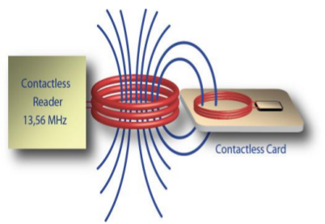
Figure 3 how passive devices receiving device
2.1 NFC Operation Modes
In NFC technology, there are two types of operation modes: active and passive. When a device creates its own radio frequency (RF) field and has a power-supply, this device will be called an active device. An active device is typically designated as the initiator E.g. Reader. The opposite of an active device, in which it receives power from the RF and transmits data using inductive coupling, is distinguished as a passive device and is typically referenced as target. An example of a passive device can be seen in figure 3 and figure 4 [7]. There are two different types of NFC communication modes that happen two NFC devices get near each other. These two modes are defined as active-active and active-passive. Whether a device is active or in passive mode determines how data is transmitted.
In active-active mode, both initiator and target must be active devices, which allows them to generate their own RF signal and transmit datum. This mode is also referred to as active mode. In active-passive mode, both an active device with a power-source with a generated RF field as well as a passive device without a power-source are in communication. This mode is referred to as passive mode. The passive relies on the signal being broadcasted by the active device to transmit data and to obtain its power to function. This basic concept is demonstrated in figure 2.
In addition to the two operating modes, there are three operating modes for device communication. These three modes depend on the individual application. A device can also switch between these modes depending on the type of device. These modes can be seen in figure 5 and are also the NFC technology standards communication modes.
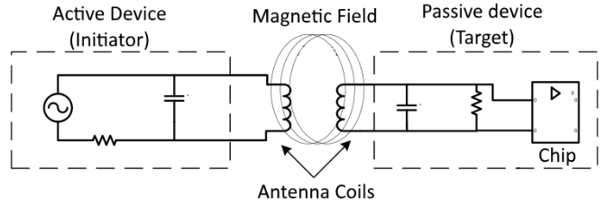
Figure 4 Active device and Passive device
2.1.1 Reader/Writer mode
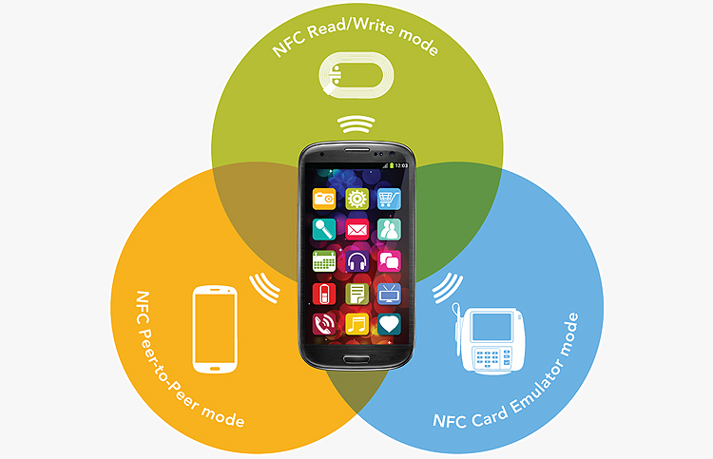
Figure 5 3 modes of nfc communication
In reader/writer mode, the active device behaves as a reader for passive devices, such as NFC tags, RFID tags, contactless smart cards. An active device can detect a tag immediately nearby using a mechanism called collision avoidance. When an active device is near a tag it is possible to read and write to the tag using the reader/writer mode. An example of this is shown in figure 1, where data can be sent both ways including energy to power the passive device. The read/writer mode defines two different modes which are read mode and write mode.
In read mode, the initiator will send a signal to the tag and wait for a response from that tag. This allows the active device to read data from the tag. The response from the tag holds the information that is stored on that tag.
In writer mode, the signal that the initiator sends out will contain data that will be written to any tag in its proximity. This also means that any data that is already stored on the tag will be overwritten. There are algorithms that allow the initiator to update the tag by modifying the existing data that is stored on the tag.
2.1.2 Peer to Peer mode
In peer to peer mode, communication is between two active devices, which allows them to exchange data. The mode has two standardized options: NFCIP-1 and LLCP. The data that is sent through this mode is secure because of this standardization.
NFCIP-1 defines who the initiator is as well as who the target is before the actual communication takes place by using the initiator-target paradigm. However, in LLCP, the devices are identical in communication. After the initial handshake of the communication, the application on the active device makes the decision on what to do. Data are sent over a bidirectional half duplex channel, this means that one device is in active mode transmitting data, while the other is listening. After the first device is done sending data, then it will go into passive mode and listen for the data being sent by the second device which was originally passive and switched to active mode.
2.1.3 Card Emulation Mode
Card emulation mode allows mobile devices to be used as a passive device, such as a contactless smart card. It is possible for a mobile device to hold multiple contactless smart card applications in one smart card. The types of cards that can be emulated with this includes credit cards, debit cards, reward cards, identity cards, tickets, transport cards and many more. This mode allows the user to forgo carrying around those cards and holds all the information in the phone’s memory. In this mode, the phone does not create its own RF field and acts as a passive device. This allows the imitator, or the reader, to read the data that is stored on the mobile device. The data is managed by the device so that only specific datum transmitted rather than all the data stored on the phone.
“Currently supported communication interfaces for the card emulation mode are ISO/IEC 14443 Type A and Type B, and FeliCa. Card emulation mode is an important mode since it enables payment and ticketing applications and is compatible with existing smart card infrastructure” [8].

2.2 Coding & modulation
When a device is in active mode, data will be sent using amplitude shift keying (ASK). NFC uses two different types of coding schemes to transfer data, which are Manchester and modified millers. If the baud rate is 106 kBaud, the coding scheme that will be used is a modified Miller code with a modulation of 100%. However, when the baud rate is above 106, Manchester code with 10% modulation will be used [4]. Meanwhile, in passive mode, datum is always encoded using Manchester with a modulation of 10%. See Table 1 to see what type of device uses which encoding scheme based on data rate.
DATA RATE  KBPS | ACTIVE DEVICE | PASSIVE DEVICE
106 | Modified Miller, 100%, ASK | Manchester, 10%, ASK
212 | Manchester, 10%, ASK | Manchester, 10%, ASK
424 | Manchester, 10%, ASK | Manchester, 10%, ASK
Table 1: Coding modulation based on device type
2.2.1 Modified Miller code
Modified Miller coding scheme is characterized by the pauses that are occurring in the carrier at different positions of a period. While a 1 is always encoded in the same way, 0 is encoded differently dependent of what was before it [9]. As seen in figure 6, each data bit has its own timeslot. Each timeslot is divided into two which are called half bit. In non-modified Miller coding, a zero is encoded with a low or pause in the first half bit and no pause in the second half bit seen in the figure 5 key as 0 after 0. A one is encoded with no pause in the first bit, but a pause in the second half bit. NFC uses a modified version of miller coding avoid the problem of a one followed by a zero, two subsequent half bits would have a pause. Modified Miller coding will encode a zero, which directly follows a one with two half bits with no pause [4, 10]. This can all be seen in figure 6 which shows the time slots and how the 1’s and 0’s are encoded.
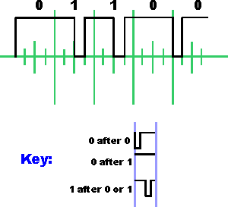
Figure 6 Modified millers with key
2.2.2 Manchester Code
Manchester code is dependent on transition at the midpoint of a period where there are two possible transitions. A low-to-high transition expresses a 0 bit, whereas a high-to-low transition stands for a 1 bit, seen in figure 7. The transitions will always be in the middle of each bit period, while any transition at the start or end will be disregard.
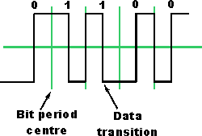
Figure 7 Manchester coding used for NFC data transfer, radio electronics
2.3 Collision Avoidance
With the devices needing to be near one another, it is hard for there to be misunderstandings, but they do exist. The Collision avoidance mechanism is based on: listen before talking. Being based on listening first, the initiator makes sure that there are no other external RF fields, this is to make sure that it does not disturb any other NFC communications in case there are other devices near. The initiator will wait for the external RF field to disappear before it starts looking for devices to transmit to. In case that there are two or more targets trying to respond at the same time, a collision will occur and be handled by the initiator. If there are more than two devices communicating, the devices would not be able to differentiate between the devices and their responses.
2.4 NFC Standards
To be accepted by the industry, NFC protocol needs standardization as to permit its commercialization. Standardization of NFC protocol is necessary because it allows compatibility between different devices and means stability of the infrastructure of NFC. A benefit that comes to standardization of NFC would include the fact that it allows the technology to be open to the masses, which in turn, allows new innovations to be created using NFC. The standards are published by ECMA International and ETSI Standards. “These standards specify the basic capabilities, such as the transfer speeds, the bit encoding schemes, modulation, the frame architecture, and the transport protocol” [1]. With these basic capabilities, the active and passive modes of NFC are described and the conditions that are specified to make sure collisions or avoid during initialization and to be handle correctly. “This Standard describes active and passive communication modes for NFC protocol and interface. This gives the specifications of coding, modulation schemes, frame format, transfer speeds of the RF interface, initialization schemes and surroundings required for data collision control through initialization.” [1]
There are many standardizations for NFC and some countries have their own standardization and then there is the international one. Most NFC implement NFCIP-1 (Near field communication interface and protocol 1), which is standardized in ISO 18092, ECMA 340 also in ETSI TS 102 190. Most devices not only implement NFCIP-1 but also NFCIP-2, which is defined in ISO 21481, ECMA 352 and ETSI TS 102 312.
NFCIP-2 allows selection into 3 modes which are NFC Data transfer which is (NFCIP-1), Proximity coupling(PCD), which is defined in ISO 14443, and vicinity coupling which is defined in ISO 15693. [1].
These 3 modes are important for devices as they assist in making the devices compatible with the main international standards for smartcard interoperability, ISO 14443, ISO 5693 and Sonys FeliCa contactless card system.
With the combination of serval technologies, like smartcard and contactless interconnection technology, NFC has been proven to be compatible with proven RFID-technology. This means that with the millions of contactless smartcards and scanners that already exist, NFC is compatible with all of them and requires no major upgrade in the industry.
  - NFC Security & Threats
With the usage of NFC being leaning more towards contactless money payment the demand for security is high to ensure card information is safe. The NFC security is part of the basic structure of NFC technology which means that NFC security is a great importance overall. There are several types of threats and security measures for these threats to NFC.
    - Eavesdropping
NFC technology is a form of contactless communication so the ability to eavesdrop is one of the major threats to security of NFC. As the NFC device broadcast the information from the active device to the passive devices listening to the information pushed and pulled is easy unless the security measures stopping or encrypting the information. It is difficult to stop people from listening on the communication between the devices. The only true way is to use a secure and encrypted communication channel. The communication is usually between 2 devices and doesn’t support multiple communication as the device wouldn’t know where the information came from and only receives information one device at a time. This doesn’t stop people from listening to the communications as they are using RF signals which spread from the active device.

    - Data Modification and Corruption
While using NFC, data is sent wirelessly between two devices. This means that there is specific formats the data needs to be in and the target devices needs to be able to decode the data to be able to read it. This means that when data is not encoded in the correct format the target device rejects the data. This is the reason standards were created and a set data scheme to allow all NFC devices to work with each other. NFC data is sent wirelessly allows attacker to corrupt or even modify the data that is being sent between the devices. Corruption can be as easy as changing the coding format of the data being sent which makes any data sent from the device rejected. The solution for this is to create a secure communication channel between the devices. This isn’t possible if the NFC attacker is a program running on the phone because it will override the coding scheme right before it is sent out.
    - Man in the middle attack
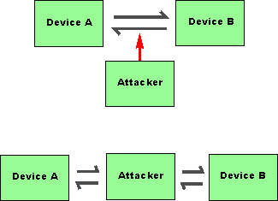
The man in the middle attack uses data modification and uses it to complete this attack. This attack on NFC involves an attacker which acts as a relay between the two devices. This can be seen in the figure 8 which demonstrates what man in the middle attack looks like. While the attacker is acting like a relay it can modify or corrupt or discard the data that is being sent. Due to the ability for NFC to only be able in one state at a time this is hard to achieve in NFC. As after the communication is done with the attacker the attacker needs to change the data and send it to the second device. The reason behind this being hard to accomplish is that most data is encrypted and the attacker needs to be within ten centimeters of two devices for him to successfully alter the data and rely it to the second device.
    - Solutions to Threats
The most basic solutions to these threats are building a secure communication channel for the devices to use for their data transfer. NFC has a big problem when it comes to eavesdropping and man in the middle attacks. By using 3DES and AES a key is shared between the send and receive and will create a secure connection between the devices that are taking part in the transaction. With an establishment of a secure connection allows eavesdropping and man in the middle attacks to become significantly harder as the listen device will be reject out of the communication as it doesn’t hold the AES key which is need to communication with the initiator.
- Applications of technology
- Conclusion

References

[1] | A. Paus, "Near Field Communication in Cell," 24 7 2007. [Online]. Available: https://www.emsec.rub.de/media/crypto/attachments/files/2011/04/near_field_communication_in_cell_phones.pdf.
[2] | "NFC-Forum," [Online]. Available: https://nfc-forum.org/.
[3] | "Near Field communication," [Online]. Available: http://nearfieldcommunication.org/.
[4] | M. M. A. Allah, "Global Journal of Computer Science and Technology," Strengths and Weaknesses of Near Field Communication (NFC), vol. 11, no. 3, p. 7, March 2011.
[5] | Antenna-Theory, "NFC Antennas," Antenna-Theory, 2015. [Online]. Available: http://www.antenna-theory.com/definitions/nfc-antenna.php.
[6] | J. W. Erick Macias, "NFC Active and Passive Peer-to-Peer Communication Using the TRF7970A," December 2016. [Online]. Available: http://www.ti.com/lit/an/sloa192a/sloa192a.pdf.
[7] | APC, "Inside NFC: how near field communication works," APCMAG, 17 August 2011. [Online]. Available: http://www.apcmag.com/inside-nfc-how-near-field-communication-works.htm/.
[8] | M. G. S. Ekta Desai, "A Review on the Operating Modes of Near Field," International Journal of Engineering and Advanced Technology (IJEAT), vol. 2, no. 2, pp. 322-325, 2012.
[9] | I. Poole, "NFC Modulation & RF Signal," Radio-Electronics, [Online]. Available: http://www.radio-electronics.com/info/wireless/nfc/near-field-communications-modulation-rf-signal-interface.php.
[10] | RF Wireless World, "NFC Modulation and Coding-NRZ coding, Manchester coding, Modified Miller coding, 10% ASK, 100% ASK, load modulation," RF Wireless World, [Online]. Available: http://www.rfwireless-world.com/Tutorials/NFC-Modulation-and-NFC-Coding.html.
[11] | T. Perdue, "Near Field Communications (NFC)," Lifewire, 22 October 2016. [Online]. Available: https://www.lifewire.com/near-field-communications-nfc-2495454.
[12] | NXP-rfid, "About nfc," NXP-rfid, 26 Jan 2018. [Online]. Available: https://nxp-rfid.com/products/ntag/about-nfc/.
[13] | V. Papkouskaya, "Developer Tips: NFC Tags in App Development," Dzone, 26 July 2017. [Online]. Available: https://dzone.com/articles/developers-tips-nfc-tags-in-app-development-1.
[14] | W. Standards, "NFC Technology Aspects," Wireless Standards, [Online]. Available: http://wireless.intgckts.com/nfc/nfc-technology-aspects/.
[15] | M. Clark, "NXP begins shipping NFC tags that can wake up a host device," NFC world, 14 August 2013. [Online]. Available: https://www.nfcworld.com/2013/08/14/325492/nxp-begins-shipping-nfc-tags-that-can-wake-up-a-host-device/.

