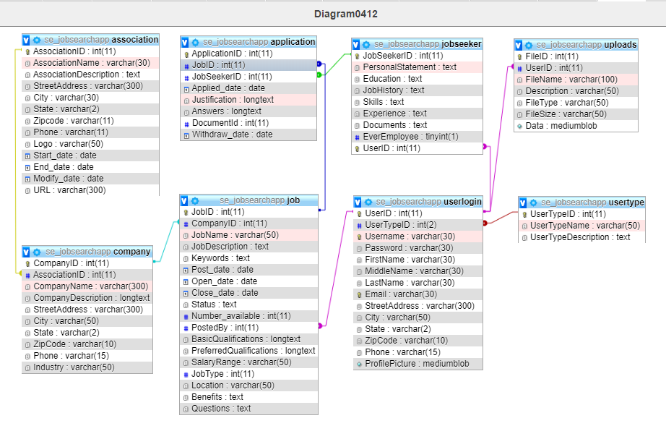

**application**

|  |  |  |  |  |
| --- | --- | --- | --- | --- |
| **Column** | **Type** | **Null** | **Default** | **Comments** |
| ApplicationID *(Primary)* | int(11) | No |  |  |
| JobID | int(11) | No |  |  |
| JobSeekerID | int(11) | No |  |  |
| Applied_date | date | No |  |  |
| Justification | longtext | Yes | *NULL* | for Job/Qualifications |
| Answers | longtext | Yes | *NULL* | for Job/Questions |
| DocumentId | int(11) | Yes | *NULL* |  |
| Withdraw_date | date | Yes | *NULL* |  |

**Indexes**

| **Keyname** | **Type** | **Unique** | **Packed** | **Column** | **Cardinality** | **Collation** | **Null** | **Comment** |
| --- | --- | --- | --- | --- | --- | --- | --- | --- |
| PRIMARY | BTREE | Yes | No | ApplicationID | 4 | A | No |  |
| JobSeekerID | BTREE | No | No | JobSeekerID | 2 | A | No |  |
| JobID | BTREE | No | No | JobID | 4 | A | No |  |

**association**

|  |  |  |  |  |
| --- | --- | --- | --- | --- |
| **Column** | **Type** | **Null** | **Default** | **Comments** |
| AssociationID *(Primary)* | int(11) | No |  |  |
| AssociationName | varchar(30) | No |  |  |
| AssociationDescription | text | No |  |  |
| StreetAddress | varchar(300) | No |  |  |
| City | varchar(30) | No |  |  |
| State | varchar(2) | No |  |  |
| Zipcode | varchar(11) | No |  |  |
| Phone | varchar(11) | No |  |  |
| Logo | varchar(50) | Yes | *NULL* |  |
| Start_date | date | No |  |  |
| End_date | date | Yes | *NULL* |  |
| Modify_date | date | Yes | *NULL* |  |
| URL | varchar(300) | Yes | *NULL* |  |

**Indexes**

| **Keyname** | **Type** | **Unique** | **Packed** | **Column** | **Cardinality** | **Collation** | **Null** | **Comment** |
| --- | --- | --- | --- | --- | --- | --- | --- | --- |
| PRIMARY | BTREE | Yes | No | AssociationID | 2 | A | No |  |

**company**

|  |  |  |  |  |
| --- | --- | --- | --- | --- |
| **Column** | **Type** | **Null** | **Default** | **Comments** |
| CompanyID *(Primary)* | int(11) | No |  |  |
| AssociationID | int(11) | No |  |  |
| CompanyName | varchar(300) | Yes | *NULL* |  |
| CompanyDescription | longtext | Yes | *NULL* |  |
| StreetAddress | varchar(300) | Yes | *NULL* |  |
| City | varchar(50) | Yes | *NULL* |  |
| State | varchar(2) | Yes | *NULL* |  |
| ZipCode | varchar(10) | Yes | *NULL* |  |
| Phone | varchar(15) | Yes | *NULL* |  |
| Industry | varchar(50) | Yes | *NULL* |  |

**Indexes**

| **Keyname** | **Type** | **Unique** | **Packed** | **Column** | **Cardinality** | **Collation** | **Null** | **Comment** |
| --- | --- | --- | --- | --- | --- | --- | --- | --- |
| PRIMARY | BTREE | Yes | No | CompanyID | 6 | A | No |  |
| AssociationId | BTREE | No | No | AssociationID | 6 | A | No |  |

**job**

|  |  |  |  |  |
| --- | --- | --- | --- | --- |
| **Column** | **Type** | **Null** | **Default** | **Comments** |
| JobID *(Primary)* | int(11) | No |  |  |
| CompanyID | int(11) | No |  |  |
| JobName | varchar(50) | No |  |  |
| JobDescription | text | No |  |  |
| Keywords | text | Yes | *NULL* |  |
| Post_date | date | Yes | *NULL* |  |
| Open_date | date | Yes | *NULL* |  |
| Close_date | date | Yes | *NULL* |  |
| Status | text | Yes | *NULL* |  |
| Number_available | int(11) | No | 1 |  |
| PostedBy | int(11) | Yes | *NULL* | subset of userID |
| BasicQualifications | longtext | Yes | *NULL* |  |
| PreferredQualifications | longtext | Yes | *NULL* |  |
| SalaryRange | varchar(50) | Yes | *NULL* |  |
| JobType | int(11) | Yes | *NULL* |  |
| Location | varchar(50) | Yes | *NULL* |  |
| Benefits | text | Yes | *NULL* |  |
| Questions | text | Yes | *NULL* |  |

**Indexes**

| **Keyname** | **Type** | **Unique** | **Packed** | **Column** | **Cardinality** | **Collation** | **Null** | **Comment** |
| --- | --- | --- | --- | --- | --- | --- | --- | --- |
| PRIMARY | BTREE | Yes | No | JobID | 6 | A | No |  |
| Postby | BTREE | No | No | PostedBy | 2 | A | Yes |  |
| CompanyID | BTREE | No | No | CompanyID | 6 | A | No |  |

**jobseeker**

|  |  |  |  |  |
| --- | --- | --- | --- | --- |
| **Column** | **Type** | **Null** | **Default** | **Comments** |
| JobSeekerID *(Primary)* | int(11) | No |  |  |
| PersonalStatement | text | Yes | *NULL* |  |
| Education | text | Yes | *NULL* |  |
| JobHistory | text | Yes | *NULL* |  |
| Skills | text | Yes | *NULL* |  |
| Experience | text | Yes | *NULL* |  |
| Documents | text | Yes | *NULL* |  |
| EverEmployee | tinyint(1) | No | 0 |  |
| UserID | int(11) | No |  |  |

**Indexes**

| **Keyname** | **Type** | **Unique** | **Packed** | **Column** | **Cardinality** | **Collation** | **Null** | **Comment** |
| --- | --- | --- | --- | --- | --- | --- | --- | --- |
| PRIMARY | BTREE | Yes | No | JobSeekerID | 16 | A | No |  |
| UserID | BTREE | Yes | No | UserID | 16 | A | No |  |

**uploads**

|  |  |  |  |  |
| --- | --- | --- | --- | --- |
| **Column** | **Type** | **Null** | **Default** | **Comments** |
| FileID *(Primary)* | int(11) | No |  |  |
| UserID | int(11) | No |  |  |
| FileName | varchar(100) | Yes | *NULL* |  |
| Description | varchar(50) | No |  |  |
| FileType | varchar(50) | Yes | *NULL* |  |
| FileSize | varchar(50) | Yes | *NULL* |  |
| Data | mediumblob | Yes | *NULL* |  |

**Indexes**

| **Keyname** | **Type** | **Unique** | **Packed** | **Column** | **Cardinality** | **Collation** | **Null** | **Comment** |
| --- | --- | --- | --- | --- | --- | --- | --- | --- |
| PRIMARY | BTREE | Yes | No | FileID | 0 | A | No |  |
| UserID | BTREE | No | No | UserID | 0 | A | No |  |

**userlogin**

|  |  |  |  |  |
| --- | --- | --- | --- | --- |
| **Column** | **Type** | **Null** | **Default** | **Comments** |
| UserID *(Primary)* | int(11) | No |  |  |
| UserTypeID | int(2) | No | 50 |  |
| Username | varchar(30) | No |  |  |
| Password | varchar(30) | No | 123 |  |
| FirstName | varchar(30) | No |  |  |
| MiddleName | varchar(30) | Yes | *NULL* |  |
| LastName | varchar(30) | No |  |  |
| Email | varchar(30) | No |  |  |
| StreetAddress | varchar(300) | Yes | *NULL* |  |
| City | varchar(50) | Yes | Baton Rouge |  |
| State | varchar(2) | Yes | LA |  |
| ZipCode | varchar(10) | Yes | *NULL* |  |
| Phone | varchar(15) | Yes | *NULL* |  |
| ProfilePicture | mediumblob | Yes | *NULL* |  |

**Indexes**

| **Keyname** | **Type** | **Unique** | **Packed** | **Column** | **Cardinality** | **Collation** | **Null** | **Comment** |
| --- | --- | --- | --- | --- | --- | --- | --- | --- |
| PRIMARY | BTREE | Yes | No | UserID | 16 | A | No |  |
| Username | BTREE | Yes | No | Username | 16 | A | No |  |
| Email | BTREE | Yes | No | Email | 16 | A | No |  |
| usertypeid | BTREE | No | No | UserTypeID | 2 | A | No |  |

**usertype**

|  |  |  |  |  |
| --- | --- | --- | --- | --- |
| **Column** | **Type** | **Null** | **Default** | **Comments** |
| UserTypeID *(Primary)* | int(11) | No | 50 |  |
| UserTypeName | varchar(50) | No |  |  |
| UserTypeDescription | text | Yes | *NULL* |  |

**Indexes**

| **Keyname** | **Type** | **Unique** | **Packed** | **Column** | **Cardinality** | **Collation** | **Null** | **Comment** |
| --- | --- | --- | --- | --- | --- | --- | --- | --- |
| PRIMARY | BTREE | Yes | No | UserTypeID | 5 | A | No |  |

[Open new phpMyAdmin window](http://localhost/phpmyadmin/db_datadict.php?db=se_jobsearchapp&table=usertype&server=1&target=)