**URS Functional**

- **Admin**

URS-01 : Admin can login to the website.

URS-02 : Admin can logout to the website.

URS-03 : Admin can update temple history.

URS-04 : Admin can update contact information on the website.

        URS-05 : Admin can update temple news in News page.

URS-06 : Admin can update temple pictures on the Home page.

URS-07 : Admin can add new gallery on the Gallery page.

URS-08 : Admin can add new pictures on the gallery.

URS-09 : Admin can edit details of each activity gallery.

URS-10 : Admin can delete pictures in the gallery.

URS-11 : Admin can receive questions from the user.

        URS-12 : Admin can answer the user’s question on the website.

URS-13 : Admin can send news to registered users’ email.

URS-14 : Admin can delete the user’s question.

- **Registered user**

   URS-15 : Registered user can login to the website.

        URS-16 : Registered user can log out to the website.

        URS-17 : Registered user can edit their own registered information.

       URS-18 : Registered user can get news from admin by their registered e-mail.

- **User**

URS-19 : User can register to the website.

URS-20 : User can view temple pictures on the Home page.

        URS-21 : User can view temple news

URS-22 : User can view the temple history.

URS-23 : User can select activity gallery.

URS-24 : User can view the gallery information of the selected gallery.

URS-25 : User can view pictures in the selected gallery.

URS-26 : User can select picture to view a big picture.

URS-27 : User can view others users’ question-answer on the Question-Answer page.

URS-28 : User can post questions on the Question-Answer page.

URS-29 : User can receive the answer from admin.

URS-30 : User can view temple location on Map page.

URS-31 : User can view the temple contact information.

URS-32 : User can contact temple by using email address.

        URS-33 : User can click link on website to like the Facebook page of the temple.

**URS description**

**URS-01 : Admin can login to the website.**

|  |  |  |  |
| --- | --- | --- | --- |
| **Use Case ID :** | | URS-01 | |
| **Use Case Name :** | | Admin can login to the website. | |
| **Created By :** | | Thitiworada Thongprasert 552115019 | |
| **Short Description :** | | Admin can login to the website by using username and password which are for admin only. | |
| **Related Use Cases :** | | - | |
| **Actors :** | | Admin | |
| **Input :** | | | |
| **Name** | **Type** | | **Remarks** |
| Username | String | | The username which is for admin only. |
| Password | String | | The password which is for admin only. |
| **Pre-condition :** | | | 1. Admin connects to the internet. |
| **Flow of events :** | | | 1. The system provides Login page to receive username and password. 2. Admin inputs username and password. 3. Admin clicks “เข้าสู่ระบบ” button. 4. The system verifies the username and password. 5. Admin accesses to the system. 6. The system redirects to the Home page. |
| **Alternative and Exceptional :** | | | **2.1 If the username or password is not correct, admin will get message "ชื่อผู้ใช้งาน หรือ รหัสผ่าน ไม่ถูกต้อง" from the system.** |
| **System Requirements :** | | | SRS-01 : The system shall provide Login page.  SRS-02 : The system shall provide text box for receiving username and password.  SRS-03 : The system shall provide “เข้าสู่ระบบ” button for accessing the system.  SRS-04 : The system shall receive username and password.  SRS-05 : The system shall check username and password format.  SRS-06 : The system shall verify the login account.  SRS-07 : The system shall display error message "ชื่อผู้ใช้งาน หรือ รหัสผ่าน ไม่ถูกต้อง".  SRS-08 : The system shall redirect to Home page. |

**URS-02 : Admin can logout to the website.**

|  |  |  |  |
| --- | --- | --- | --- |
| **Use Case ID :** | | URS-02 | |
| **Use Case Name :** | | Admin can logout to the website. | |
| **Created By :** | | Thitiworada Thongprasert 552115019 | |
| **Short Description :** | | Admin can logout to the website after finish working. | |
| **Related Use Cases :** | | URS-01 | |
| **Actors :** | | Admin | |
| **Input :** | | | |
| **Name** | **Type** | | **Remarks** |
| - | - | | - |
| **Pre-condition :** | | 1. Admin logins to the system. | |
| **Flow of events :** | | 1. Admin clicks the “ออกจากระบบ” button. 2. The system asks admin to confirm logout to the system. 3. Admin clicks “ยืนยัน”to confirm logout. 4. The system clears session. 5. The system redirects to the Login page. | |
| **Alternative and Exceptional :** | | **3.1 If admin doesn’t want to logout to the system, admin can select “ยกเลิก” button to cancel.** | |
| **System Requirements :** | | SRS-09 : The system shall provide "ออกจากระบบ" button.  SRS-10 : The system shall display message "คุณแน่ใจใช่ไหมว่าจะทำการออกจากระบบ?".  SRS-11 : The system shall provide “ยืนยัน” for confirming to logout from the system.  SRS-12 : The system shall provide “ยกเลิก” button to cancel.  SRS-13 : The system shall clear session when user log out.  SRS-14 : The system shall redirect to Login page. | |

**URS-03 : Admin can update temple history on the website.**

|  |  |  |  |
| --- | --- | --- | --- |
| **Use Case ID :** | | URS-03 | |
| **Use Case Name :** | | Admin can update temple history on the website. | |
| **Created By :** | | Thitiworada Thongprasert 552115019 | |
| **Short Description :** | | Admin can change the detail of temple history on the website. | |
| **Related Use Cases :** | | URS-01 | |
| **Actors :** | | Admin | |
| **Input :** | | | |
| **Name** | **Type** | | **Remarks** |
| historyDes | String | | The detail of the temple history. |
| historyPictureLocation | String | | The URL of the picture. |
| **Pre-condition :** | | 1. Admin logins to the system. | |
| **Flow of events :** | | 1. Admin clicks “แก้ไขหน้านี้” button on the History page. 2. Admin updates the detail of temple history. 3. Admin updates new pictures. 4. Admin clicks “บันทึก” button to update new temple history. 5. The system updates new temple history detail into the database. 6. The system displays confirmed message. | |
| **Alternative and Exceptional :** | | **3.1A If admin updates new pictures which their type are not correct, admin will get message “ไฟล์ไม่ได้รับอนุญาต” from the system.**  **3.1B If admin updates new pictures which is too big, admin will get message “ขนาดของรูปภาพใหญ่เกิน 600*800” from the system.**  **4.1 If admin doesn’t want to save the changed information, admin can select “ยกเลิก” button to cancel.** | |
| **System Requirements :** | | SRS-15 : The system shall provide History page for only admin.  SRS-16 : The system shall provide existing temple history.  SRS-17 : The system shall provide the UI for receiving new temple history from admin.  SRS-18 : The system shall provide “แก้ไข” button for editing the information on the website.  SRS-19 : The system shall provide the UI for receiving new pictures.  SRS-20 : The system shall provide “อัพโหลด” button for uploading the pictures.  SRS-21 : The system can check type of file picture.  SRS-22 : The system can check size of picture.  SRS-23 : The system shall display error message “ขนาดของรูปภาพใหญ่เกิน 600*800”.  SRS-24 : The system shall display error message “ไฟล์ไม่ได้รับอนุญาต”.  SRS-25 : The system shall provide “บันทึก” button for updating new information.  SRS-12 : The system shall provide “ยกเลิก” button to cancel.  SRS-27 : The system shall update new information into the database.  SRS-28 : The system shall display confirmed message “สำเร็จ”. | |

**URS-04 : Admin can update contact information on the website.**

|  |  |  |  |
| --- | --- | --- | --- |
| **Use Case ID :** | | URS-04 | |
| **Use Case Name :** | | Admin can update contact information on the website. | |
| **Created By :** | | Thitiworada Thongprasert 552115019 | |
| **Short Description :** | | Admin can change contact information which are place, telephone number and Facebook page. | |
| **Related Use Cases :** | | URS-01 | |
| **Actors :** | | Admin | |
| **Input :** | | | |
| **Name** | **Type** | | **Remarks** |
| contactPlace | String | | The address of the temple. |
| contactTel | String | | The telephone number of the temple. |
| contactFacebook | String | | The Facebook page which is another way to contact. |
| **Pre-condition :** | | 1. Admin logins to the system. | |
| **Flow of events :** | | 1. Admin clicks “แก้ไขหน้านี้” button on the Contact page. 2. Admin updates the detail of contact information. 3. Admin clicks “บันทึก” button to update new contact information. 4. The system updates new contact information into the database. 5. The system displays confirmed message. | |
| **Alternative and Exceptional :** | | **3.1 If admin doesn’t want to save the changed information, admin can select “ยกเลิก” button to cancel.** | |
| **System Requirements :** | | SRS-25 : The system shall provide Contact page for only admin.  SRS-26 : The system shall provide existing contact information.  SRS-18 : The system shall provide “แก้ไข” button for editing the information on the website.  SRS-27 : The system shall provide text box for receiving new contact information.  SRS-21 : The system shall provide “บันทึก” button for updating new information.  SRS-12 : The system shall provide “ยกเลิก” button to cancel.  SRS-23 : The system shall update new information into the database.  SRS-24 : The system shall display confirmed message “สำเร็จ”. | |

**URS-05 : Admin can update temple news on News page.**

|  |  |  |  |
| --- | --- | --- | --- |
| **Use Case ID :** | | URS-05 | |
| **Use Case Name :** | | Admin can update temple news on News page. | |
| **Created By :** | | Thitiworada Thongprasert 552115019 | |
| **Short Description :** | | Admin can change temple news pictures which are about activities of temple. | |
| **Related Use Cases :** | | URS-01 | |
| **Actors :** | | Admin | |
| **Input :** | | | |
| **Name** | **Type** | | **Remarks** |
| newsName | String | | The name of news.  Ex. “ขนทรายเข้าวัดปี๋ใหม่เมือง” |
| newsDate | date | | The date of the news. |
| newsTime | time | | The time of the news. |
| newsPlace | String | | The place that the news will occur.  Ex. “ณ วัดเจดีย์หลวง” |
| newsPictureLocation | String | | The URL of the news picture. |
| **Pre-condition :** | | 1. Admin logins to the system. | |
| **Flow of events :** | | 1. Admin clicks “แก้ไขหน้านี้” button on the Contact page. 2. Admin updates new activities of temple pictures. 3. Admin clicks “อัพโหลด” button. 4. The system checks file and size of pictures. 5. Admin clicks “บันทึก” button. 6. The system updates new temple history pictures into the database. 7. The system displays confirmed message. | |
| **Alternative and Exceptional :** | | **2.1A If admin updates new pictures which their type are not correct, admin will get message “ไฟล์ไม่ได้รับอนุญาต” from the system.**  **2.1B If admin updates new pictures which is too big, admin will get message “ขนาดของรูปภาพใหญ่เกิน 600*800” from the system.**  **5.1 If admin doesn’t want to save the changed information, admin can select “ยกเลิก” button to cancel.** | |
| **System Requirements :** | | SRS-28 : The system shall provide News page for only admin.  SRS-29 : The system shall provide existing news.  SRS-18 : The system shall provide “แก้ไข” button for editing the information on the website.  SRS-19 : The system shall provide the UI for receiving new pictures.  SRS-20 : The system shall provide “อัพโหลด” button for uploading the pictures.  SRS-30 : The system can check type of file picture.  SRS-31 : The system can check size of picture.  SRS-32 : The system shall display error message “ขนาดของรูปภาพใหญ่เกิน 600*800”.  SRS-33 : The system shall display error message “ไฟล์ไม่ได้รับอนุญาต”.  SRS-21 : The system shall provide “บันทึก” button for updating new information.  SRS-12 : The system shall provide “ยกเลิก” button to cancel.  SRS-23 : The system shall update new information into the database.  SRS-24 : The system shall display confirmed message “สำเร็จ”. | |

**URS-06 : Admin can update temple pictures on the Home page.**

|  |  |  |  |  |
| --- | --- | --- | --- | --- |
| **Use Case ID :** | | URS-06 | | |
| **Use Case Name :** | | Admin can update temple pictures in the Home page. | | |
| **Created By :** | | Thitiworada Thongprasert 552115019 | | |
| **Short Description :** | | Admin can update pictures of temple to show in the Home page. | | |
| **Related Use Cases :** | | URS-01 | | |
| **Actors :** | | Admin | | |
| **Input :** | | | | |
| **Name** | **Type** | | | **Remarks** |
| **-** | **-** | | | **-** |
| **Pre-condition :** | | | 1. Admin logins to the system. | |
| **Flow of events :** | | | 1. Admin clicks “แก้ไขหน้านี้” button on the Home page. 2. Admin updates new temple pictures. 3. Admin clicks “อัพโหลด” button. 4. The system checks file and size of pictures. 5. Admin clicks “บันทึก” button. 6. The system updates new temple pictures into the database. 7. The system displays confirmed message. | |
| **Alternative and Exceptional :** | | | **2.1A If admin updates new pictures which their type are not correct, admin will get message “ไฟล์ไม่ได้รับอนุญาต” from the system.**  **2.1B If admin updates new pictures which is too big, admin will get message “ขนาดของรูปภาพใหญ่เกิน 600*800” from the system.**  **5.1 If admin doesn’t want to update temple pictures, admin can select “ยกเลิก” button to cancel.** | |
| **System Requirements :** | | | SRS-33 : The system shall provide Home page for only admin.  SRS-34 : The system shall show existing pictures.  SRS-18 : The system shall provide “แก้ไขหน้านี้” button for editing the information on the website.  SRS-19 : The system shall provide the UI for receiving new pictures.  SRS-20 : The system shall provide “อัพโหลด” button for uploading the picture.  SRS-21 : The system can check type of file picture.  SRS-22 : The system can check size of picture.  SRS-23 : The system shall display error message “ขนาดของรูปภาพใหญ่เกิน 600*800”.  SRS-24 : The system shall display error message “ไฟล์ไม่ได้รับอนุญาต”.  SRS-25 : The system shall provide “บันทึก” button for updating new information  SRS-12 : The system shall provide “ยกเลิก” button to cancel.  SRS-26 : The system shall update new information into the database.  SRS-27 : The system shall display confirmed message “สำเร็จ”. | |

**URS-07 : Admin can add new gallery on the Gallery page.**

|  |  |  |  |
| --- | --- | --- | --- |
| **Use Case ID :** | | URS-07 | |
| **Use Case Name :** | | Admin can add new gallery in the Gallery page. | |
| **Created By :** | | Thitiworada Thongprasert 552115019 | |
| **Short Description :** | | Admin can add new gallery, which contains activity pictures, on the Gallery page. | |
| **Related Use Cases :** | | URS-01 | |
| **Actors :** | | Admin | |
| **Input :** | | | |
| **Name** | **Type** | | **Remarks** |
| galleryId | Long | | The number of the gallery. |
| gelleryName | String | | Ex. “งานทอดกฐิน” |
| gelleryDate | date | | The date of the gallery. |
| pictureList | List<Picture> | | The pictures in the gallery. |
| **Pre-condition :** | | 1. Admin logins to the system. | |
| **Flow of events :** | | 1. Admin clicks “เพิ่มอัลบั้ม” button. 2. Admin inputs name and detail of new album. 3. Admin clicks “บันทึก” button. 4. The system adds new album into the database. 5. The system displays confirmed message. | |
| **Alternative and Exceptional :** | | **4.1 If admin doesn’t want to add new album, admin can select “ยกเลิก” button to cancel.** | |
| **System Requirements :** | | SRS-35 : The system shall provide Gallery page for only admin.  SRS-36 : The system shall provide "เพิ่มอัลบั้ม" button.  SRS-37 : The system shall provide text box to receive the name and the detail of new album.  SRS-25 : The system shall provide “บันทึก” button for updating new information.  SRS-12 : The system shall provide “ยกเลิก” button to cancel.  SRS-26 : The system shall update new information into the database.  SRS-27 : The system shall display confirmed message “สำเร็จ”. | |

**URS-08 : Admin can add new pictures in the gallery.**

|  |  |  |  |
| --- | --- | --- | --- |
| **Use Case ID :** | | URS-08 | |
| **Use Case Name :** | | Admin can add new pictures in the gallery. | |
| **Created By :** | | Thitiworada Thongprasert 552115019 | |
| **Short Description :** | | Admin can add pictures with appropriate type and size in the gallery. | |
| **Related Use Cases :** | | URS-07 | |
| **Actors :** | | Admin | |
| **Input :** | | | |
| **Name** | **Type** | | **Remarks** |
| pictureId | Long | | The number of the picture. |
| pictureName | String | | The name of the picture. |
| pictureLocation | String | | The URL of the picture. |
| **Pre-condition :** | | 1. Admin logins to the system. 2. Admin must create gallery at least a gallery. | |
| **Flow of events :** | | 1. Admin clicks “เพิ่มรูปภาพ” button. 2. Admin updates new activity pictures. 3. Admin clicks “อัพโหลด” button. 4. The system checks file and size of pictures. 5. Admin clicks “บันทึก” button. 6. The system updates new temple pictures into the database. 7. The system displays confirmed message. | |
| **Alternative and Exceptional :** | | **2.1A If admin updates new pictures which their type are not correct, admin will get message “ไฟล์ไม่ได้รับอนุญาต” from the system.**  **2.1B If admin updates new pictures which is too big, admin will get message “ขนาดของรูปภาพใหญ่เกิน 600*800” from the system.**  **5.1 If admin doesn’t want to add new activity pictures, admin can select “ยกเลิก” button to cancel.** | |
| **System Requirements :** | | SRS-35 : The system shall provide Gallery page for only admin.  SRS-38 : The system shall provide “เพิ่มรูปภาพ” button for adding new pictures from the admin.  SRS-19 : The system shall provide the UI for receiving new pictures.  SRS-20 : The system shall provide “อัพโหลด” button for uploading the picture.  SRS-21 : The system can check type of file picture.  SRS-22 : The system can check size of picture.  SRS-23 : The system shall display error message “ขนาดของรูปภาพใหญ่เกิน 600*800”.  SRS-24 : The system shall display error message “ไฟล์ไม่ได้รับอนุญาต”.  SRS-25 : The system shall provide “บันทึก” button for updating new information  SRS-12 : The system shall provide “ยกเลิก” button to cancel.  SRS-26 : The system shall update new information into the database.  SRS-27 : The system shall display confirmed message “สำเร็จ”. | |

**URS-09 : Admin can edit details of each gallery.**

|  |  |  |  |
| --- | --- | --- | --- |
| **Use Case ID :** | | URS-09 | |
| **Use Case Name :** | | Admin can edit details of each gallery. | |
| **Created By :** | | Thitiworada Thongprasert 552115019 | |
| **Short Description :** | | Admin can change the details of each gallery which are Gallery ID, Gallery name and Gallery Date. | |
| **Related Use Cases :** | | - | |
| **Actors :** | | Admin | |
| **Input :** | | | |
| **Name** | **Type** | | **Remarks** |
| galleryId | Long | | The number of the gallery. |
| gelleryName | String | | Ex. “งานทอดกฐิน” |
| gelleryDate | Date | | The date of the gallery. |
| **Pre-condition :** | | 1. Admin logins to the system. 2. Admin must create gallery at least a gallery. | |
| **Flow of events :** | | 1. Admin clicks “แก้ไขหน้านี้” button. 2. Admin inputs new gallery details. 3. Admin clicks “บันทึก” button. 4. The system updates new gallery details into the database. 5. The system displays confirmed message. | |
| **Alternative and Exceptional :** | | **3.1 If admin doesn’t want to add new activity pictures, admin can select “ยกเลิก” button to cancel.** | |
| **System Requirements :** | | SRS-39 : The system shall provide Picture page.  SRS-40 : The system shall provide the existing detail of gallery from the database.  SRS-41 : The system shall provide text box for receiving new gallery details.  SRS-25 : The system shall provide “บันทึก” button for updating new information.  SRS-12 : The system shall provide “ยกเลิก” button to cancel.  SRS-26 : The system shall update new information into the database.  SRS-27 : The system shall display confirmed message “สำเร็จ”. | |

**URS-10 : Admin can delete pictures in the gallery.**

|  |  |  |  |
| --- | --- | --- | --- |
| **Use Case ID :** | | URS-10 | |
| **Use Case Name :** | | Admin can delete pictures in the gallery. | |
| **Created By :** | | Thitiworada Thongprasert 552115019 | |
| **Short Description :** | | Admin can delete pictures in the gallery. | |
| **Related Use Cases :** | | - | |
| **Actors :** | | Admin | |
| **Input :** | | | |
| **Name** | **Type** | | **Remarks** |
| galleryId | Long | | The number of the gallery. |
| **Pre-condition :** | | 1. Admin logins to the system. 2. Admin must create gallery at least a gallery. 3. The gallery must have picture at least a gallery. | |
| **Flow of events :** | | 1. Admin clicks “ลบ” button. 2. The system asks to confirm. 3. Admin clicks “ตกลง” button. 4. The system deletes selected pictures into the database. 5. The system displays confirmed message. | |
| **Alternative and Exceptional :** | | **3.1 If admin doesn’t want to delete the selected pictures, admin can select “ยกเลิก” button to cancel.** | |
| **System Requirements :** | | SRS-35 : The system shall provide Gallery page for only admin.  SRS-42 : The system shall provide “ลบ” button for deleting the picture in the gallery.  SRS-43 : The system shall display message “คุณแน่ใจใช่ไหมว่าจะลบรูปภาพนี้!?”.  SRS-44 : The system shall provide “ตกลง” button to confirm.  SRS-45 : The system shall delete selected pictures in the database.  SRS-12 : The system shall provide “ยกเลิก” button to cancel.  SRS-27 : The system shall display confirmed message “สำเร็จ”. | |

**URS-11: Admin can receive questions from the user.**

|  |  |  |  |
| --- | --- | --- | --- |
| **Use Case ID:** | | URS-11 | |
| **Use Case Name:** | | Admin can receive questions from the user. | |
| **Created By:** | | Pimpaporn Chaichompoo 552115052 | |
| **Short Description:** | | Admin can receive questions from the user by answering of the user on Question-Answer page. | |
| **Related Use Cases:** | | URS-28 | |
| **Actors:** | | Admin | |
| **Input:** | | | |
| **Name** | **Type** | | **Remarks** |
| questionId | String | | A number of question |
| questionDes | String | | Brief description of the question |
| **Pre-condition:** | | 1. Admin logins to the system. | |
| **Flow of events:** | | 1. Admin selects Question-Answer menu. 2. The system provides Question page to admin. 3. The system receives list of user’s question from the database. 4. Admin receives the question from the user. | |
| **Alternative and Exceptional:** | | - | |
| **System Requirements:** | | SRS-46 : The system shall provide Question page for only admin.  SRS-47 : The system shall receive questions from the database.  SRS-48 : The system shall display list of questions. | |

**URS-12: Admin can answer the user’s question on the website.**

|  |  |  |  |
| --- | --- | --- | --- |
| **Use Case ID:** | | URS-12 | |
| **Use Case Name:** | | Admin can answer the user’s question on the website. | |
| **Created By:** | | Pimpaporn Chaichompoo 552115052 | |
| **Short Description:** | | To answer the user’s question on the website. | |
| **Related Use Cases:** | | URS-11, URS-28 | |
| **Actors:** | | Admin | |
| **Input:** | | | |
| **Name** | **Type** | | **Remarks** |
| answerId | String | | A number of answer. |
| answerDes | String | | Brief description of the answer. |
| **Pre-condition:** | | 1. Admin logins to the system. 2. Admin receives the question from the user. | |
| **Flow of events:** | | 1. Admin selects Question-Answer menu 2. The system provides Question page to admin. 3. Admin clicks “ตอบ” button to answer the selected question. 4. The system provides Answer page that contains description of the selected question. 5. The system provides textbox to receive the answer from admin. 6. Admin clicks “ตกลง” button to send the answer to the user. 7. The system updates the answer into the database. 8. The system sends the answer to the user’s email. | |
| **Alternative and Exceptional:** | | **5.1 If admin clicks “ยกเลิก” to cancel sending the, the system will not add the answer to the database.** | |
| **System Requirements:** | | SRS-49 : The system shall provide Question page for only admin.  SRS-47 : The system shall receive questions from the database.  SRS-50 : The system shall display list of questions.  SRS-51 : The system shall provide "ตอบ" button for answering the user’s question.  SRS-52 : The system shall provide Answer page for answering the selected question.  SRS-53 : The system shall provide text box for only admin to answer the user’s question.  SRS-44 : The system shall provide “ตกลง” button to confirm.  SRS-12 : The system shall provide “ยกเลิก” button to cancel.  SRS-27 : The system shall display confirmed message “สำเร็จ”.  SRS-54: The system shall add the answer to the database.  SRS-55 : The system shall send the answer to the user's email. | |

**URS-13: Admin can send news to registered members’ email.**

|  |  |  |  |
| --- | --- | --- | --- |
| **Use Case ID:** | | URS-13 | |
| **Use Case Name:** | | Admin can send news to registered members’ email. | |
| **Created By:** | | Pimpaporn Chaichompoo 552115052 | |
| **Short Description:** | | Admin can send news to the member by using member’s email which is username. | |
| **Related Use Cases:** | | URS-05 | |
| **Actors:** | | Admin | |
| **Input:** | | | |
| **Name** | **Type** | | **Remarks** |
| newsName | String | | A name of the news. |
| newsDate | Date | | A date of the news. |
| **Pre-condition:** | | 1. Admin logins to the system. | |
| **Flow of events:** | | 1. Admin selects News menu. 2. The system provides checkbox for sending news to the user’ email on News page. 3. Admin clicks checkbox to send news information to the user. 4. Admin clicks “ตกลง” to send news information to the user. 5. The system sends temple news to user’s email. | |
| **Alternative and Exceptional:** | | **5.1 If the send email process fail, the system shall provide error message “การส่งผิดพลาด”.** | |
| **System Requirements:** | | SRS-31 : The system shall provide News page for only admin.  SRS-56 : The system shall provide the checkbox“ส่งข่าวสารให้สมาชิก”for selecting to send news to the member.  SRS-57 : The system shall provide UI for showing list of member’s email.  SRS-58 : The system shall provide confirm message “คุณแน่ใจใช่ไหมว่าจะส่งข่าวสารให้สมาชิกทุกคน?” to confirm sending news to member email.  SRS-59 : The system shall receive members’ email from database.  SRS-25 : The system shall provide “บันทึก” button for updating new information.  SRS-60 : The system shall send the news to all members’ email.  SRS-61 : The system shall provide error message “การส่งผิดพลาด” if send email process fail.  SRS-27 : The system shall display confirmed message “สำเร็จ”. | |

**URS-14 : Admin can delete the user's question.**

|  |  |  |  |
| --- | --- | --- | --- |
| **Use Case ID:** | | URS-14 | |
| **Use Case Name:** | | Admin can delete the user's question. | |
| **Created By:** | | Pimpaporn Chaichompoo 552115052 | |
| **Short Description:** | | Admin can delete the user’s question by click the button that the system provides for deleting. | |
| **Related Use Cases:** | | URS-11,URS-28 | |
| **Actors:** | | Admin | |
| **Input:** | | | |
| **Name** | **Type** | | **Remarks** |
| questionId | String | | A number of question |
| questionDes | String | | Brief description of the question |
| **Pre-condition:** | | 1. Admin receives the question from the user. | |
| **Flow of events:** | | 1. Admin selects Question-Answer menu. 2. The system provides Question page to admin. 3. Admin clicks “ลบ” button to delete the selected question. 4. The system deletes the selected question into the database. 5. The system updates the Question page. | |
| **Alternative and Exceptional:** | |  | |
| **System Requirements:** | | SRS-49 : The system shall provide Question page for only admin.  SRS-50 : The system shall receive questions from the database.  SRS-51 : The system shall display list of questions.  SRS-62 : The system shall provide “ลบ” button for deleting the question, which is  impolite question.  SRS-63 : The system shall display message "คุณแน่ใจใช่ไหมว่าจะลบคำถามนี้!?".  SRS-64 : The system shall delete the question in the database.  SRS-27 : The system shall display confirmed message “สำเร็จ”. | |

**URS-15 : Registered user can login to the website.**

|  |  |  |  |
| --- | --- | --- | --- |
| **Use Case ID:** | | URS-15 | |
| **Use Case Name:** | | Registered user can login to the website. | |
| **Created By:** | | Sornkom Yoohat 552115068 | |
| **Short Description:** | | Registered user can login to the website by putting their username and password. | |
| **Related Use Cases:** | | URS-19 | |
| **Actors:** | | Registered user | |
| **Input:** | | | |
| **Name** | **Type** | | **Remarks** |
| username | String | | Username must be email format.  **Example** “Sornkom_yoo@cmu.ac.th” |
| password | String | | The password must contain the small letter and number.  **Example**  “boss1nw” |
| **Pre-condition:** | | The registered user access to the system. | |
| **Flow of events:** | | 1. Registered user accesses to the website. 2. Registered user fills username and password for login. 3. Registered user clicks "เข้าสู่ระบบ" button for accessing to the system. 4. The system validates the information. 5. The system checks username and password 6. The system redirects to Home page. | |
| **Alternative and Exceptional:** | | **3.1 If the user cancels for login, the system will redirect to the login page.**  **4.1 If some information is not be correct to the user’s information format that the system define, the system will ask for receive the information again until correct to the user’s information format.**  **5.1 If the username or password is not correct .The system will display error message "ชื่อผู้ใช้งาน หรือ รหัสผ่านไม่ถูกต้อง"**  **5.2 The system will cancel for login** | |
| **System Requirements:** | | SRS-01 : The system shall provide Login page.  SRS-02 : The system shall provide text box for receiving username and password.  SRS-03 : The system shall provide “เข้าสู่ระบบ” button for accessing to the system.  SRS-04 : The system shall receive username and password.  SRS-05 : The system shall check username and password format.  SRS-06 : The system shall verify the login account.  SRS-07 : The system shall display error message "ชื่อผู้ใช้ หรือ รหัสผ่าน ไม่ถูกต้อง".  SRS-08 : The system shall redirect to Home page. | |

**URS-16 : Registered user can log out to the website.**

|  |  |  |  |
| --- | --- | --- | --- |
| **Use Case ID:** | | URS-16 | |
| **Use Case Name:** | | Registered user can log out to the website. | |
| **Created By:** | | Sornkom Yoohat 552115068 | |
| **Short Description:** | | To log out to the website. | |
| **Related Use Cases:** | | URS-15 | |
| **Actors:** | | Registered user | |
| **Input:** | | | |
| **Name** | **Type** | | **Remarks** |
| - | - | | - |
| **Pre-condition:** | | Registered user login to the system. | |
| **Flow of events:** | | 1. Registered user selects “ออกจากระบบ” button. 2. The system displays message "คุณแน่ใจใช่ไหมว่าจะทำการออกจากระบบ?". 3. Registered user clicks “ยืนยัน” button for confirm. 4. The system clears session when user log out. The system. 5. The system redirects to Login page. | |
| **Alternative and Exceptional:** | | **3.1 If the user cancels for log out, the system will cancel logout process.** | |
| **System Requirements:** | | SRS-09 : The system shall provide "ออกจากระบบ" button.  SRS-10 : The system shall display message "คุณแน่ใจใช่ไหมว่าจะทำการออกจากระบบ?".  SRS-11 : The system shall provide “ยืนยัน” for confirming to logout from the system.  SRS-12 : The system shall provide “ยกเลิก” button to cancel.  SRS-13 : The system shall clear session.  SRS-14 : The system shall redirect to Login page. | |

**URS-17: Registered user can edit their own registered information.**

|  |  |  |  |
| --- | --- | --- | --- |
| **Use Case ID:** | | URS-17 | |
| **Use Case Name:** | | Registered user can edit their own registered information. | |
| **Created By:** | | Sornkom Yoohat 552115068 | |
| **Short Description:** | | Registered user edit exit registered information. | |
| **Related Use Cases:** | | URS-15 | |
| **Actors:** | | Registered user | |
| **Input:** | | | |
| **Name** | **Type** | | **Remarks** |
| f_name | String | | A first name of the user.  **Example** “ศรคม” |
| l_name | String | | A last name of the user.  **Example** “อยู่หัตถ์” |
| username | String | | Username must be email format.  **Example** “Sornkom_yoo@cmu.ac.th” |
| Password | String | | The password must contain the small letter and number.  **Example**  “bosszeed” |
| **Pre-condition:** | | 1. Registered user must login to the system. | |
| **Flow of events:** | | 1. Registered user select “แก้ไขข้อมูล” button. 2. The system opens edit user page 3. The system shows user’s registered information in edit information textboxes. 4. Registered user edits the first name, last name, username, password and re-password for update user information. 5. Registered user click “บันทึก” button for confirm. 6. The system validates the information. 7. The system updates user’s information to the database. | |
| **Alternative and Exceptional:** | | **4.1 If some information are not be correct to the user’s information format that the system define, the system will ask for receive the information again until correct to the user’s information format.**  **5.1 If the registered user cancels for edit information, the system will redirect to the home page.** | |
| **System Requirements:** | | SRS-65 : The system shall provide profile page.  SRS-66 : The system shall provide user’s registered information.  SRS-67 : The system shall provide text box for receiving new user information.  SRS-25 : The system shall provide “บันทึก” button for updating new information.  SRS-12 : The system shall provide “ยกเลิก” button to cancel.  SRS-26 : The system shall update new information into the database.  SRS-68 : The system shall display the error message “ชื่อและนามสกุล ต้องเป็นตัวอักษรเท่านั้น!”.  SRS-69: The system shall display the error message “ชื่อผู้ใช้ต้องเป็นอีเมลล์”.  SRS-70 : The system shall display the error message “รหัสผ่านต้องมีความยาว 9-12 ตัวอักษร”.  SRS-71 : The system shall display the error message.  SRS-72 : The system shall display the error message “รหัสผ่าน-รหัสผ่านอีกครั้ง ไม่ตรงกัน”.  SRS-27 : The system shall display confirmed message “สำเร็จ”. | |

**URS-18 : Registered user can get news from admin by their registered e-mail.**

|  |  |  |  |
| --- | --- | --- | --- |
| **Use Case ID:** | | URS-18 | |
| **Use Case Name:** | | Registered user can get news from admin by their registered e-mail. | |
| **Created By:** | | Sornkom Yoohat 552115068 | |
| **Short Description:** | | Registered user get news from admin. | |
| **Related Use Cases:** | | URS-13 ,URS-19 | |
| **Actors:** | | Registered user | |
| **Input:** | | | |
| **Name** | **Type** | | **Remarks** |
| **-** | **-** | | **-** |
| **Pre-condition:** | | User want to register into the system. | |
| **Flow of events:** | | 1. The system sends the news to all members’ email. 2. Registered user receive news from e-mail. | |
| **Alternative and Exceptional:** | | **-** | |
| **System Requirements:** | | SRS-60 : The system shall receive members’ email from database. | |

**URS-19: User can register to the website.**

|  |  |  |  |
| --- | --- | --- | --- |
| **Use Case ID:** | | URS-19 | |
| **Use Case Name:** | | User can register to the website. | |
| **Created By:** | | Pimpaporn Chaichompoo 552115052 | |
| **Short Description:** | | To register to the system. | |
| **Related Use Cases:** | | - | |
| **Actors:** | | User | |
| **Input:** | | | |
| **Name** | **Type** | | **Remarks** |
| Id | String | | A number of user |
| f_name | String | | A first name of the user. **Example** “พิมพาภรณ์” |
| l_name | String | | A last name of the user.  **Example** “ไชยชมภู” |
| username | String | | Username must be email format.  **Example** “Pimpaporn_c@cmu.ac.th” |
| Password | String | | The password must contain the small letter and number.  **Example**  “pare2536” |
| TypeUser | String | | Type of the user which is admin and user. |
| **Pre-condition:** | | 1. User accesses to the website. | |
| **Flow of events:** | | 1. User selects “ลงทะเบียน” button. 2. User fills the first name and last name. 3. The system validates the first name and lass name format. 4. User fills username. 5. The system validates the username format. 6. User fills password and re-password. 7. The system validates password and re-password. 8. User clicks “ยืนยัน” button for confirm. 9. The system creates new user’s information to the database. | |
| **Alternative and Exceptional:** | | **3.1 If the first name and lass name are not correct with the first name and lass name format, the user can not click “ยืนยัน” button.**  **5.1  If the username is not correct with the username format, the user can not click “ยืนยัน” button.**  **5.2 If the username is already be used, the system will display error message “ชื่อผู้ใช้นี้มีคนใช้แล้ว”. 7.1 If the password is not correct with the password format, the user can not click “ยืนยัน” button.**  **7.2  If the password and re-password are not match, the system will display error message “รหัสผ่านและยืนยันรหัสผ่านไม่ตรงกัน”**  **8.1 If the user cancel for register, the system will redirect to the login page.** | |
| **System Requirements:** | | SRS-73 : The system shall provide Register page.  SRS-74 : The system shall provide a “ลงทะเบียน” button for register to the system.  SRS-75 : The system shall provide the UI which receive the first name, last name, username, password and re-password for the user registration.  SRS-76 : The system shall check first name and last name format.  The first name and last name format must be only character.  SRS-77 : The system shall check username format. The username format must be the e-mail format.  SRS-78 : The system shall check registered username which cannot be the same as existing username.  SRS-79 : The system shall check password format. The password must be 9-12 characters. The password must contain the small letter and number.  SRS-80: The system shall display the error message “ชื่อและนามสกุล ต้องเป็นตัวอักษรเท่านั้น!”.  SRS-81: The system shall display the error message “ชื่อผู้ใช้ต้องเป็นอีเมลล์”.  SRS-82 : The system shall display the error message “รหัสผ่านต้องมีความยาว 9-12 ตัวอักษร”.  SRS-83 : The system shall display the error message “รหัสผ่านต้องมีทั้งตัวอักษรพิมพ์เล็กและตัวเลข”.  SRS-84 : The system shall provide error message “ชื่อผู้ใช้นี้มีคนใช้แล้ว!”.  SRS-85 : The system shall display the error message “รหัสผ่าน-ยืนยันรหัสผ่าน ไม่ตรงกัน”.  SRS-86 : The system can validate the password field and re-password field are the same.  SRS-44 : The system shall provide “ตกลง” button to confirm.  SRS-12 : The system shall provide “ยกเลิก” button to cancel.  SRS-87 : The system shall add a new user information to the database using first name, last name, username and password.  SRS-27 : The system shall display confirmed message “สำเร็จ”. | |

**URS-20 : User can view temple pictures in the Home page.**

|  |  |  |  |
| --- | --- | --- | --- |
| **Use Case ID:** | | URS-20 | |
| **Use Case Name:** | | User can view temple pictures in the Home page. | |
| **Created By:** | | Sornkom Yoohat 552115068 | |
| **Short Description:** | | To view temple pictures in the Home page. | |
| **Related Use Cases:** | | - | |
| **Actors:** | | User | |
| **Input:** | | | |
| **Name** | **Type** | | **Remarks** |
| - | - | | - |
| **Pre-condition:** | | - | |
| **Flow of events:** | | 1. User accesses to the website. 2. User clicks on “หน้าแรก” menu. 3. The system loads temple picture from database. 4. User views temple pictures. | |
| **Alternative and Exceptional:** | | **-** | |
| **System Requirements:** | | SRS-88 : The system shall provide the Home page.  SRS-89 : The system shall receive the temple pictures from database.  SRS-90 : The system shall show the temple pictures on the Home page. | |

**URS-21 : User can view temple news.**

|  |  |  |  |
| --- | --- | --- | --- |
| **Use Case ID:** | | URS-21 | |
| **Use Case Name:** | | User can view temple news. | |
| **Created By:** | | Sornkom Yoohat 552115068 | |
| **Short Description:** | | To user view temple news. | |
| **Related Use Cases:** | | - | |
| **Actors:** | | User | |
| **Input:** | | | |
| **Name** | **Type** | | **Remarks** |
| **-** | **-** | | **-** |
| **Pre-condition:** | | - | |
| **Flow of events:** | | 1.User clicks on “ข่าวสาร” menu .  2.System receives the temple news from database.  3.System loads News page  4.User views news page | |
| **Alternative and Exceptional:** | | **-** | |
| **System Requirements:** | | SRS-91 : The system shall provide the News page.  SRS-92 : The system shall receive the temple news from database.  SRS-93 : The system shall show the temple news. | |

**URS-22 : User can view the temple history.**

|  |  |  |  |
| --- | --- | --- | --- |
| **Use Case ID:** | | URS-22 | |
| **Use Case Name:** | | User can view the temple history. | |
| **Created By:** | | Sornkom Yoohat 552115068 | |
| **Short Description:** | | To view the temple history. | |
| **Related Use Cases:** | | - | |
| **Actors:** | | User | |
| **Input:** | | | |
| **Name** | **Type** | | **Remarks** |
| - | - | | **-** |
| **Pre-condition:** | | 1. User clicks “ประวัติ” menu on the menu bar. | |
| **Flow of events:** | | 1. User accesses to the website. 2. User clicks on “ประวัติ” menu. 3. The system loads temple history from database. 4. User views temple history. | |
| **Alternative and Exceptional:** | | **-** | |
| **System Requirements:** | | SRS-94 : The system shall provide the History page.  SRS-95 : The system shall receive the temple history information from database.  SRS-96 : The system shall receive the history pictures of temple from database.  SRS-97  : The system shall provide the history pictures of temple.  SRS-98 : The system shall provide temple history. | |

**URS-23: User can select gallery.**

|  |  |  |  |
| --- | --- | --- | --- |
| **Use Case ID :** | | URS-23 | |
| **Use Case Name :** | | User can select gallery. | |
| **Created By :** | | Supakarn  Grisaard 552115072 | |
| **Short Description :** | | User can select gallery from the gallery page. | |
| **Related Use Cases :** | | - | |
| **Actors :** | | User | |
| **Input :** | | | |
| **Name** | **Type** | | **Remarks** |
| galleryId | Long | |  |
| **Pre-condition :** | |  | |
| **Flow of events :** | | 1. User click on "แกลเลอรี่" menu 2. The system provides Gallery page. 3. The system provides gallery in the database. 4. User selects gallery. | |
| **Alternative and Exceptional :** | |  | |
| **System Requirements :** | | SRS-99 : The system shall provide Gallery page.  SRS-100 : The system shall receive galleries from database.  SRS-101 : The system shall provide galleries. | |

**URS-24: User views the gallery information of the selected gallery.**

|  |  |  |  |
| --- | --- | --- | --- |
| **Use Case ID :** | | URS-24 | |
| **Use Case Name :** | | User can view the gallery information of the selected gallery. | |
| **Created By :** | | Supakarn  Grisaard 552115072 | |
| **Short Description :** | | User can view the gallery information of the selected gallery that provide name date and time of gallery. | |
| **Related Use Cases :** | | URS-23 | |
| **Actors :** | | User | |
| **Input :** | | | |
| **Name** | **Type** | | **Remarks** |
| galleryId | Long | | - |
| **Pre-condition :** | | 1. User selects gallery in Gallery page. | |
| **Flow of events :** | | 1. The system provides temple gallery information on the top of page. 2. User views the gallery information of the selected gallery which are name date and time of gallery. | |
| **Alternative and Exceptional :** | | - | |
| **System Requirements :** | | SRS-100 : The system shall provide Gallery page.  SRS-102 : The system shall receive the gallery information which are name, date, time and place from database.  SRS-103 : The system shall provide temple gallery information. | |

**URS-25: user can view pictures in the selected gallery.**

|  |  |  |  |
| --- | --- | --- | --- |
| **Use Case ID :** | | URS-25 | |
| **Use Case Name :** | | user can view pictures in the selected gallery. | |
| **Created By :** | | Supakarn  Grisaard 552115072 | |
| **Short Description :** | | user can view pictures in the selected gallery. | |
| **Related Use Cases :** | | URS-23 | |
| **Actors :** | | User | |
| **Input :** | | | |
| **Name** | **Type** | | **Remarks** |
| galleryId | Long | | - |
| pictureId | Long | | - |
| pictureName | String | | - |
| pictureLocation | String | | - |
| **Pre-condition :** | | 1. User selects gallery in Gallery page. | |
| **Flow of events :** | | 1. The system provides pictures in the selected gallery. 2. User views pictures in the select gallery | |
| **Alternative and Exceptional :** | | - | |
| **System Requirements :** | | SRS-100 : The system shall provide Gallery page.  SRS-101 : The system shall receive galleries from database.  SRS-104 : The system shall receive activity pictures from database.  SRS-105 : The system shall categorize pictures in the gallery.  SRS-106 : The system shall show pictures in the gallery. | |

**URS-26: User can select picture to view a big picture.**

|  |  |  |  |
| --- | --- | --- | --- |
| **Use Case ID :** | | URS-26 | |
| **Use Case Name :** | | User can select picture to view a big picture. | |
| **Created By :** | | Supakarn  Grisaard 552115072 | |
| **Short Description :** | | User can select picture to view a big picture and user can cancel to view big picture and view the previous picture and next picture. | |
| **Related Use Cases :** | | URS-25 | |
| **Actors :** | | User | |
| **Input :** | | | |
| **Name** | **Type** | | **Remarks** |
| galleryId | Long | | - |
| pictureId | Long | | - |
| pictureName | String | | - |
| pictureLocation | String | | - |
| **Pre-condition :** | | 1. User selects gallery in Gallery page. | |
| **Flow of events :** | | 1. The system provides pictures in the selected gallery. 2. User selects  picture in the selected gallery 3. User views the selected picture to view a big picture. | |
| **Alternative and Exceptional :** | | - | |
| **System Requirements :** | | SRS-107 : The system shall show pictures in the gallery.  SRS-108 : The system shall receive a selected picture from the user.  SRS-109 : The system shall show a selected picture as a big picture.  SRS-110 : The system shall provide “x” button for cancel to view a big picture.  SRS-111 : The system shall provide “<” button for view the previous picture.  SRS-112 : The system shall provide “>” button for view the next picture. | |

**URS-27: User can view others users’ question-answer in the Question-Answer page.**

|  |  |  |  |
| --- | --- | --- | --- |
| **Use Case ID :** | | URS-27 | |
| **Use Case Name :** | | User can view others users’ question-answer in the Question-Answer page. | |
| **Created By :** | | Supakarn  Grisaard 552115072 | |
| **Short Description :** | | User can view others users’ question-answer in the Question-Answer page. | |
| **Related Use Cases :** | | URS-28 | |
| **Actors :** | | User | |
| **Input :** | | | |
| **Name** | **Type** | | **Remarks** |
| questionId | String | | - |
| questionDes | String | | - |
| answerId | String | | - |
| answerDes | String | | - |
| **Pre-condition :** | | - | |
| **Flow of events :** | | 1. User clicks on "ถาม-ตอบ" menu 2. The system provides Question-Answer page. 3. The system shows others users’ question-answer lists. 4. User views the other users’ questions and answers in the Question-Answer page. | |
| **Alternative and Exceptional :** | | - | |
| **System Requirements :** | | SRS-113 : The system shall provide Question-Answer page.  SRS-50 : The system shall receive questions from the database.  SRS-114 : The system shall receive answers from the database.  SRS-115 : The system shall display questions and answers in the Question-Answer page. | |

**URS-28: User can post questions on the Question-Answer page.**

|  |  |  |  |
| --- | --- | --- | --- |
| **Use Case ID :** | | URS-28 | |
| **Use Case Name :** | | User can post questions on the Question-Answer page. | |
| **Created By :** | | Supakarn  Grisaard 552115072 | |
| **Short Description :** | | User can post questions on the Question-Answer page. | |
| **Related Use Cases :** | | - | |
| **Actors :** | | Registered User | |
| **Input :** | | | |
| **Name** | **Type** | | **Remarks** |
| questionId | String | | - |
| questionDes | String | | - |
| answerId | String | | - |
| answerDes | String | | - |
| **Pre-condition :** | | 1. User must login to the system. | |
| **Flow of events :** | | 1. The system provides Question-Answer page. 2. User posts question into text box. 3. User inputs email in to text box 4. User clicks “ตกลง” button to confirm. 5. The system will send user’s question to admin | |
| **Alternative and Exceptional :** | | **3.1 If the user input wrong e-mail format, the user cannot post question.** | |
| **System Requirements :** | | SRS-116 : The system shall provide Question-Answer page.  SRS-117 : The system shall provide text box for receiving question from user.  SRS-118 : The system shall provide text box for receiving email from user.  SRS-119 : The system shall check email format.  SRS-12 : The system shall provide “ยกเลิก” button to cancel.  SRS-49 : The system shall provide “ตกลง” button to confirm.  SRS-27 : The system shall display confirmed message “สำเร็จ”.  SRS-120 : The system shall add the user's question to the database. | |

**URS-29: User can receive the answer from admin.**

|  |  |  |  |
| --- | --- | --- | --- |
| **Use Case ID :** | | URS-29 | |
| **Use Case Name :** | | User can receive the answer from admin. | |
| **Created By :** | | Supakarn  Grisaard 552115072 | |
| **Short Description :** | | User can receive the answer from admin. | |
| **Related Use Cases :** | | URS-28,URS-10 | |
| **Actors :** | | User | |
| **Input :** | | | |
| **Name** | **Type** | | **Remarks** |
| questionId | String | | - |
| questionDes | String | | - |
| answerId | String | | - |
| answerDes | String | | - |
| **Pre-condition :** | | 1. User must pose the question on the Question-Answer page. | |
| **Flow of events :** | | 1. User click on "แก้ไขข้อมูล" button 2. The system provides profile page 3. User click on link "คำถามส่วนตัว" 4. The system provides Own-question page. 5. User get owner question with the answer from admin. | |
| **Alternative and Exceptional :** | | - | |
| **System Requirements :** | | SRS-65 : The system shall provide profile page.  SRS-121 : The system shall provide Own-question page.  SRS-114 : The system shall receive answers from the database.  SRS-122 : The system shall display the user’s own question with the answer. | |

**URS-30: user can view temple location on Map page.**

|  |  |  |  |
| --- | --- | --- | --- |
| **Use Case ID :** | | URS-30 | |
| **Use Case Name :** | | User can view temple location on Map page. | |
| **Created By :** | | Supakarn  Grisaard 552115072 | |
| **Short Description :** | | User can view temple location on Map page that provide HERE map. | |
| **Related Use Cases :** | | - | |
| **Actors :** | | User | |
| **Input :** | | | |
| **Name** | **Type** | | **Remarks** |
| - | - | | - |
| **Pre-condition :** | | - | |
| **Flow of events :** | | 1. The system provides the Map page. 2. User views temple location on Map page. | |
| **Alternative and Exceptional :** | | - | |
| **System Requirements :** | | SRS-123 : The system shall provide the Map page.  SRS-124 : The system shall link HERE Map.  SRS-125 : The system shall display the location of temple. | |

**URS-31: User can view the temple contact information.**

|  |  |  |  |
| --- | --- | --- | --- |
| **Use Case ID :** | | URS-31 | |
| **Use Case Name :** | | User can view the temple contact information. | |
| **Created By :** | | Supakarn  Grisaard 552115072 | |
| **Short Description :** | | User can view the temple contact information. | |
| **Related Use Cases :** | | - | |
| **Actors :** | | User | |
| **Input :** | | | |
| **Name** | **Type** | | **Remarks** |
| **-** | **-** | | **-** |
| **Pre-condition :** | | - | |
| **Flow of events :** | | 1. The system provides the temple contact information. 2. User views the temple contact information. | |
| **Alternative and Exceptional :** | | - | |
| **System Requirements :** | | SRS-126 : The system shall provide the Contact page.  SRS-127 : System shall receive the temple contact information from database.  SRS-128 : The system shall provide the temple contact information. | |

**URS-32: User can contact temple by using email address.**

|  |  |  |  |
| --- | --- | --- | --- |
| **Use Case ID :** | | URS-32 | |
| **Use Case Name :** | | User can contact temple by using email address. | |
| **Created By :** | | Supakarn  Grisaard 552115072 | |
| **Short Description :** | | User can contact temple by using email address. | |
| **Related Use Cases :** | | URS-31 | |
| **Actors :** | | User | |
| **Input :** | | | |
| **Name** | **Type** | | **Remarks** |
| Email | e-mail | | - |
| **Pre-condition :** | | 1. User must login in to system | |
| **Flow of events :** | | 1. The system provides Contact  page. 2. User posts contact information into text box. 3. User inputs email in to text box 4. User clicks “ตกลง” button to confirm. 5. The system sends user’s contact to admin | |
| **Alternative and Exceptional :** | | **3.1 If the user input wrong e-mail format, the user cannot post question.** | |
| **System Requirements :** | | SRS-126 : The system shall provide the Contact page.  SRS-117 : The system shall provide text box for receiving question from user.  SRS-118 : The system shall provide text box for receiving email from user.  SRS-119 : The system shall check email format.  SRS-12 : The system shall provide “ยกเลิก” button to cancel  SRS-49 : The system shall provide “ตกลง” button to confirm.  SRS-129 : The system shall add the user's contact to the database. | |

**URS-33: User can click link on website to like the Facebook page of the temple.**

|  |  |  |  |
| --- | --- | --- | --- |
| **Use Case ID :** | | URS-31 | |
| **Use Case Name :** | | User can click link on website to like the Facebook page of the temple. | |
| **Created By :** | | Supakarn  Grisaard 552115072 | |
| **Short Description :** | | User can click link on website to like the Facebook page of the temple. | |
| **Related Use Cases :** | | URS- | |
| **Actors :** | | User | |
| **Input :** | | | |
| **Name** | **Type** | | **Remarks** |
| **-** | **-** | | **-** |
| **Pre-condition :** | | - | |
| **Flow of events :** | | 1. The system provides link on website to like the Facebook page of the temple. 2. User clicks link on website to like the Facebook page of the temple. | |
| **Alternative and Exceptional :** | | - | |
| **System Requirements :** | | SRS-130 : The system shall provide link on website to like the Facebook page of the temple. | |

**Execution Flow**

**URS-01 : Admin can login to the website.**

***Introduction***

        The system should allow admin to login to the system before updating information.

***Precondition and Input***

Admin must have an account that consists of username and password before starting the system.

***Processing***

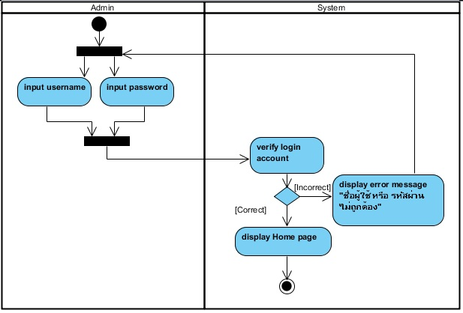

**Figure 1 : Activity Diagram of URS-01**

**Output**

Admin access to the system.

**System Requirement Specification**

SRS-01 : The system shall provide Login page.

SRS-02 : The system shall provide text box for receiving username and password.

SRS-03 : The system shall provide “เข้าสู่ระบบ” button for accessing the system.

SRS-04 : The system shall receive username and password.

SRS-05 : The system shall check username and password format.

SRS-06 : The system shall verify the login account.

SRS-07 : The system shall display error message "ชื่อผู้ใช้ หรือ รหัสผ่าน ไม่ถูกต้อง".

SRS-08 : The system shall redirect to Home page.

**URS-02 : Admin can logout to the website.**

***Introduction***

        The system should allow admin to logout to the system after finished updating information.

***Precondition and Input***

Admin must login to the system.

***Processing***

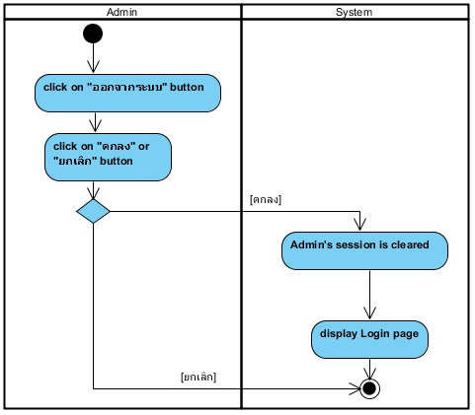

**Figure 2 : Activity Diagram of URS-02**

**Output**

Admin’s session is cleared.

**System Requirement Specification**

SRS-09 : The system shall provide "ออกจากระบบ" button.

SRS-10 : The system shall display message "คุณแน่ใจใช่ไหมว่าจะทำการออกจากระบบ?".

SRS-11 : The system shall provide “ยืนยัน” for confirming to logout from the system.  
SRS-12 : The system shall provide “ยกเลิก” button to cancel.

SRS-13 : The system shall clear session when user log out.

SRS-14 : The system shall redirect to Login page.

**URS-03 : Admin can update temple history.**

***Introduction***

        The system should allow admin to update temple history by input new information and save into the database.

***Precondition and Input***

Admin must login to the system and link to History page for updating the temple history. Admin also input temple history information and temple history picture, which is not greater than 600*800 and type of the picture should be jpg.

***Processing***

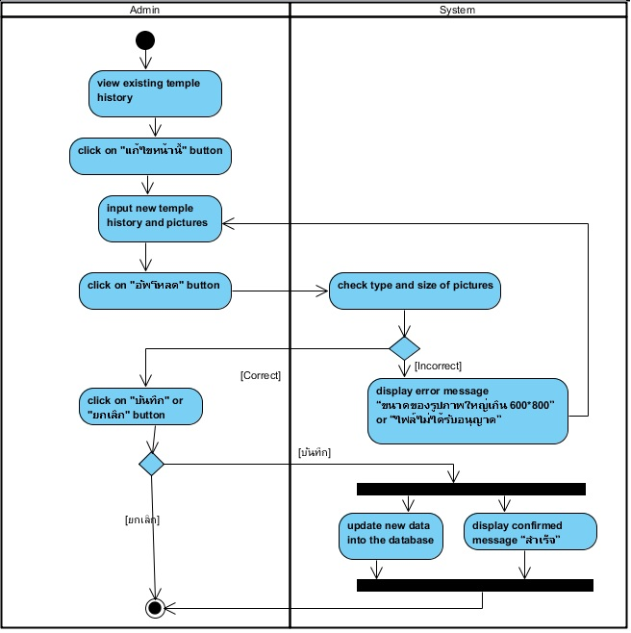

**Figure 3 : Activity Diagram of URS-03**

**Output**

Update new temple history information into the database.

**System Requirement Specification**

SRS-15 : The system shall provide History page for only admin.

SRS-16 : The system shall provide existing temple history.

SRS-17 : The system shall provide the UI for receiving new temple history from admin.

SRS-18 : The system shall provide “แก้ไขหน้านี้” button for editing the information on the website.

SRS-19 : The system shall provide the UI for receiving new pictures.

SRS-20 : The system shall provide “อัพโหลด” button for uploading the pictures.

SRS-21 : The system can check type of file picture.

SRS-22 : The system can check size of picture.

SRS-23 : The system shall display error message “ขนาดของรูปภาพใหญ่เกิน 600*800”.

SRS-24 : The system shall display error message “ไฟล์ไม่ได้รับอนุญาต”.

SRS-25 : The system shall provide “บันทึก” button for updating new information

SRS-12 : The system shall provide “ยกเลิก” button to cancel.

SRS-27 : The system shall update new information into the database.

SRS-28 : The system shall display confirmed message “สำเร็จ”.

**URS-04 : Admin can update contact information on the website**.

***Introduction***

        The system should allow admin to update contact information by input new contact then save into the database.

***Precondition and Input***

Admin must login to the system and link to Contact page for updating the contact information. Admin also input contact information which consists of telephone number, place and Facebook.

***Processing***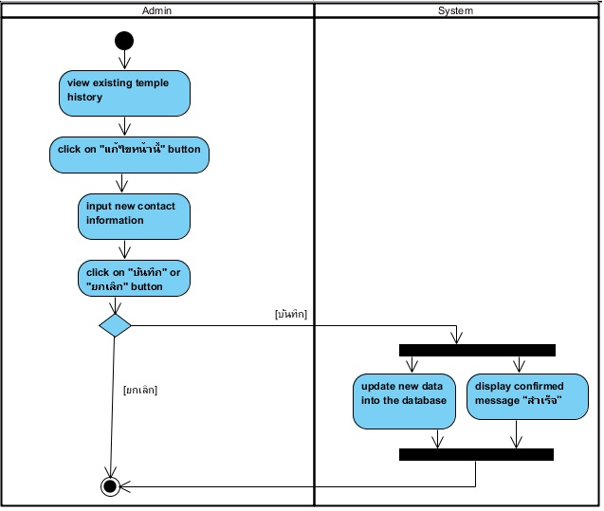

**Figure 4 : Activity Diagram of URS-04**

**Output**

Update new contact information into the database.

**System Requirement Specification**

SRS-29 : The system shall provide Contact page for only admin.

SRS-30 : The system shall provide existing contact information.

SRS-18 : The system shall provide “แก้ไขหน้านี้” button for editing the information on the website.

SRS-31 : The system shall provide text box for receiving new contact information.

SRS-25 : The system shall provide “บันทึก” button for updating new information.

SRS-12 : The system shall provide “ยกเลิก” button to cancel.

SRS-27 : The system shall update new information into the database.

SRS-28 : The system shall display confirmed message “สำเร็จ”.

**URS-05 : Admin can update temple news in News page**.

***Introduction***

        The system should allow admin to update temple by input news as a picture that telling about the activity of the temple and save into the database.

***Precondition and Input***

Admin must login to the system and link to News page for updating the news. Admin also input news as a picture, which is not greater than 600*800 and type of the picture should be jpg.

***Processing***

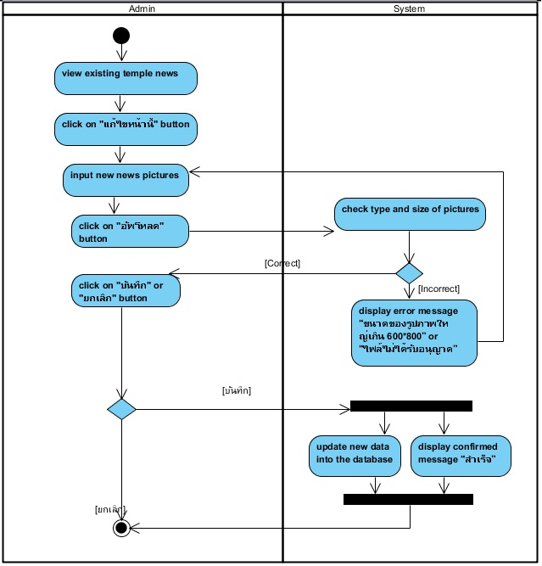

**Figure 5 : Activity Diagram of URS-05**

**Output**

Update new news into the database.

**System Requirement Specification**

SRS-32 : The system shall provide News page for only admin.

SRS-33 : The system shall provide existing news.

SRS-18 : The system shall provide “แก้ไขหน้านี้” button for editing the information on the website.

SRS-19 : The system shall provide the UI for receiving new news pictures.

SRS-20 : The system shall provide “อัพโหลด” button for uploading the pictures.

SRS-21 : The system can check type of file picture.

SRS-22 : The system can check size of picture.

SRS-23 : The system shall display error message “ขนาดของรูปภาพใหญ่เกิน 600*800”.

SRS-24 : The system shall display error message “ไฟล์ไม่ได้รับอนุญาต”.

SRS-25 : The system shall provide “บันทึก” button for updating new information

SRS-12 : The system shall provide “ยกเลิก” button to cancel.

SRS-27 : The system shall update new information into the database.

SRS-28 : The system shall display confirmed message “สำเร็จ”.

**URS-07 : Admin can update temple pictures on the Home page.**

***Introduction***

        The system should allow admin to update pictures on the Home page by input new pictures and save into the database.

***Precondition and Input***

Admin must login to the system and link to Home page. Admin also input pictures, which are not greater than 600*800 and type of the picture should be jpg.

***Processing***

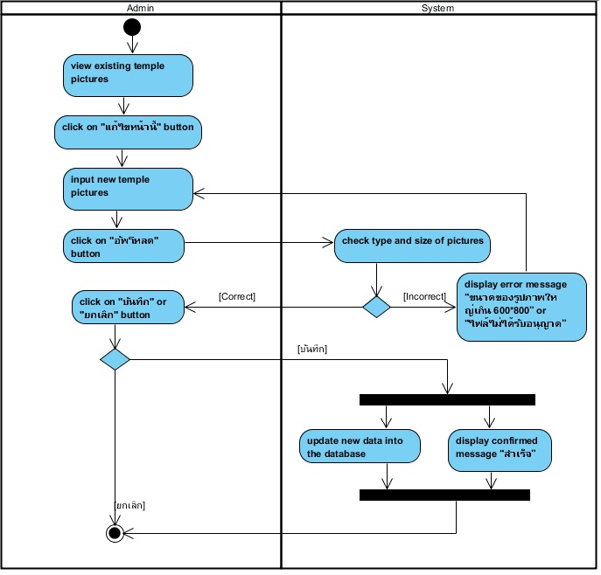

**Figure 7 : Activity Diagram of URS-07**

**Output**

Update new pictures into the database.

**System Requirement Specification**

SRS-37 : The system shall provide Home page for only admin.

SRS-38 : The system shall show existing pictures.

SRS-18 : The system shall provide “แก้ไขหน้านี้” button for editing the information on the website.

SRS-19 : The system shall provide the UI for receiving new pictures.

SRS-20 : The system shall provide “อัพโหลด” button for uploading the picture.

SRS-21 : The system can check type of file picture.

SRS-22 : The system can check size of picture.

SRS-23 : The system shall display error message “ขนาดของรูปภาพใหญ่เกิน 600*800”.

SRS-24 : The system shall display error message “ไฟล์ไม่ได้รับอนุญาต”.

SRS-25 : The system shall provide “บันทึก” button for updating new information

SRS-12 : The system shall provide “ยกเลิก” button to cancel.

SRS-27 : The system shall update new information into the database.

SRS-28 : The system shall display confirmed message “สำเร็จ”.

**URS-08: Admin can add new activity gallery on the Gallery page.**

***Introduction***

        The system should allow admin to add new activity gallery into the database for updating temple activity.

***Precondition and Input***

Admin must login success to the system and link to the Gallery page. Admin input the information of gallery, which is name and description, and then submit to create new gallery into the database.

***Processing***

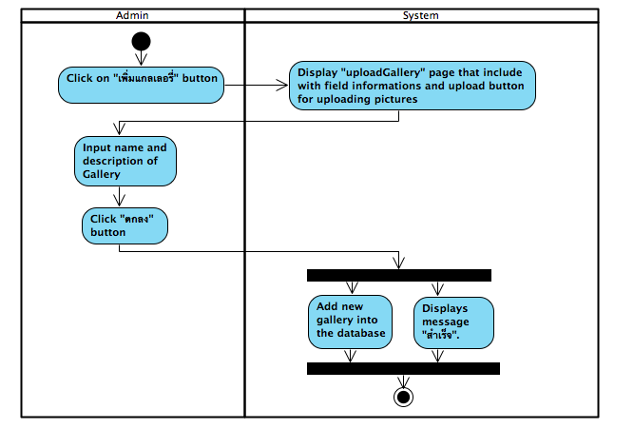  
**Figure8: Activity Diagram of URS-08**

**Output**

Add new gallery into the database

**System Requirement Specification**

**URS-09: Admin can add new pictures in the gallery.**

***Introduction***

The system should allow admin to add a temple picture into the gallery for updating temple gallery.

***Precondition and Input***

Admin must login success to the system and admin select a gallery on the Gallery page for adding a temple picture into the gallery. Admin can upload pictures, which is not greater than 600*800 and type of the picture should be jpg.

***Processing***

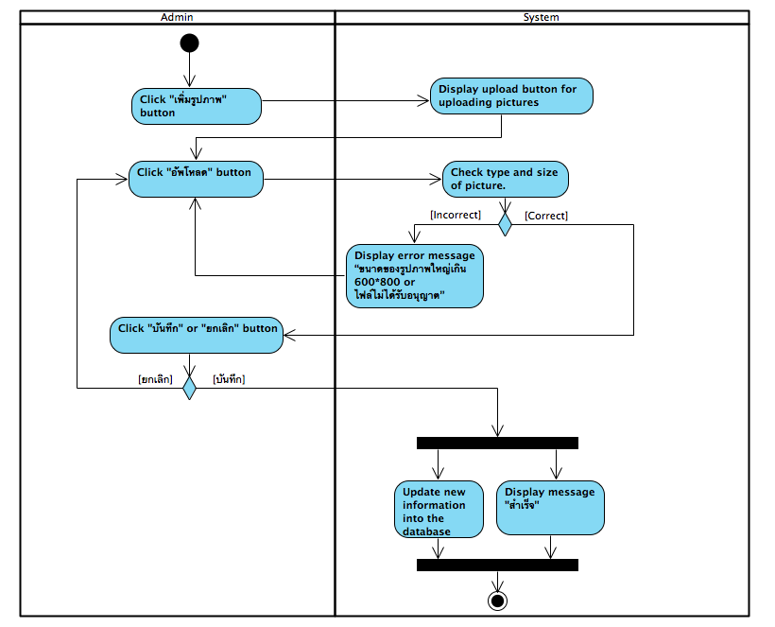

**Figure9 : Activity Diagram of URS-09**

**Output**

Add a new picture into the database

**System Requirement Specification**

**URS-10: Admin can edit details of each gallery.**

***Introduction***

The system should allow admin to edit details of the gallery that are gallery name and gallery date.

***Precondition and Input***

Admin must login success to the system and click “แก้ไขหน้านี้” button for edit

details of gallery. Admin input new gallery details that are gallery name and gallery date.

***Processing***

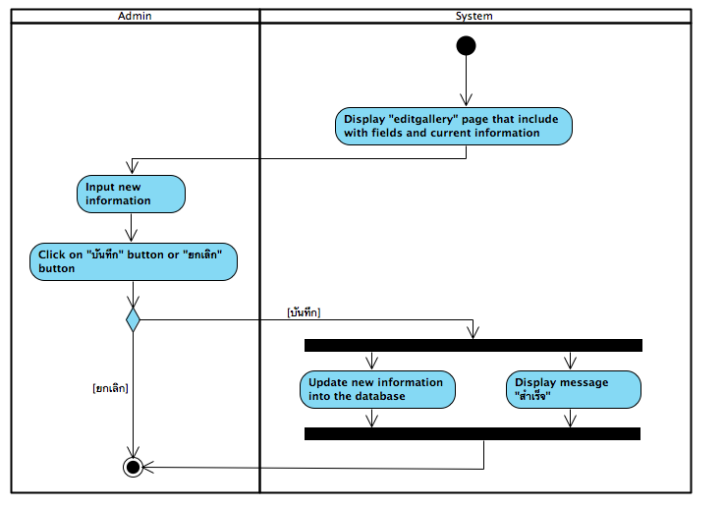

**Figure10: Activity Diagram of URS-10**

**Output**

Admin edit details of gallery from the database

**System Requirement Specification**

**URS-11: Admin can delete pictures in the gallery.**

***Introduction***

The system should allow admin to delete picture in the gallery by admin click “ลบ” button for deleting a picture from the database.

***Precondition and Input***

Admin must login success to the system and link to the Gallery page. Admin must click ”ลบ” button for deleting a picture from the database.

***Processing***

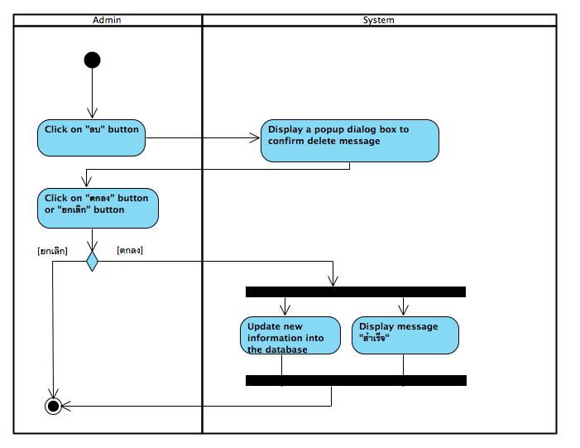

**Figure11: Activity Diagram of URS-11**

**Output**

Admin delete picture in the gallery from the database

**System Requirement Specification**

**URS-12: Admin can receive questions from the user.**

***Introduction***

The system should allow admin to receive the user’s question.

***Precondition and Input***

Admin must login success to the system and link to the Question page for receiving the user’s question.

***Processing***

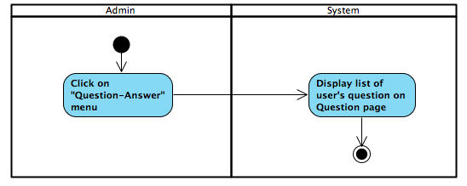

**Figure12: Activity Diagram of URS-12**

**Output**

Admin receive the user’s question.

**System Requirement Specification**

**URS-13: Admin can answer the user’s question on the website.**

***Introduction***

The system should allow admin to answer the user’s question by selecting the user’s question from the Question page and admin input the answer on the Answer page.

***Precondition and Input***

Admin must login success to the system and link to the Question page for selecting the question to answer. Admin input the answer in textbox that the system provides and admin click “ส่ง” button for sending answer to the user.

***Processing***

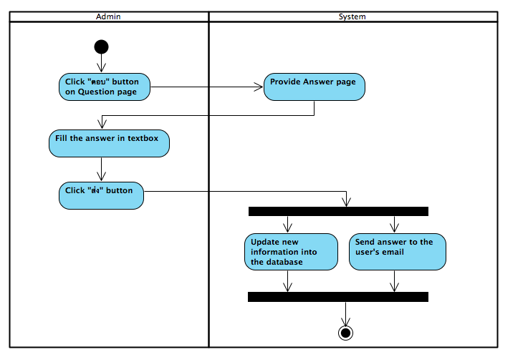

**Figure13: Activity Diagram of URS-13**

**Output**

Admin send the answer to the user.

**System Requirement Specification**

**URS-14: Admin can send news to registered users’ email.**

***Introduction***

The system should allow admin to send news to the registered user by their email.

***Precondition and Input***

Admin must login success to the system and link to the News page for selecting checkbox to send news to the registered user. Admin clicks ”ตกลง” button to confirm sending news.

***Processing***

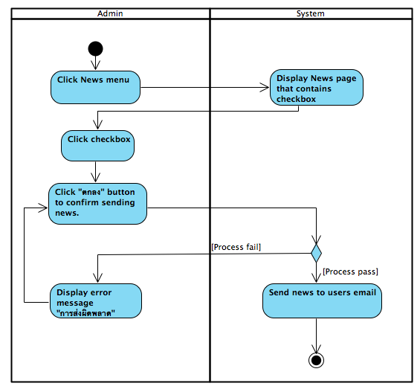

**Figure14: Activity Diagram of URS-14**

**Output**

Admin send news to the registered user.

**System Requirement Specification**

**URS-15: Admin can delete the user’s question.**

***Introduction***

The system should allow admin to delete the user’s question which is impolite question.

***Precondition and Input***

Admin must login success to the system and link to the Question page for selecting the impolite question to delete.

***Processing***

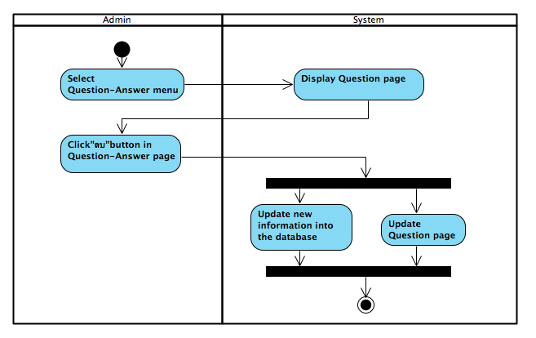

**Figure15: Activity Diagram of URS-15**

**Output**

Admin delete impolite question from the database.

**System Requirement Specification**

**URS-21: User can register to the website.**

***Introduction***

The system should allow user to create a new user account in the Register page by user input a data and save it into the database.

***Precondition and Input***

User must access on the Register page and input a first name, lass name, password and re-password for create user account information.

***Processing***

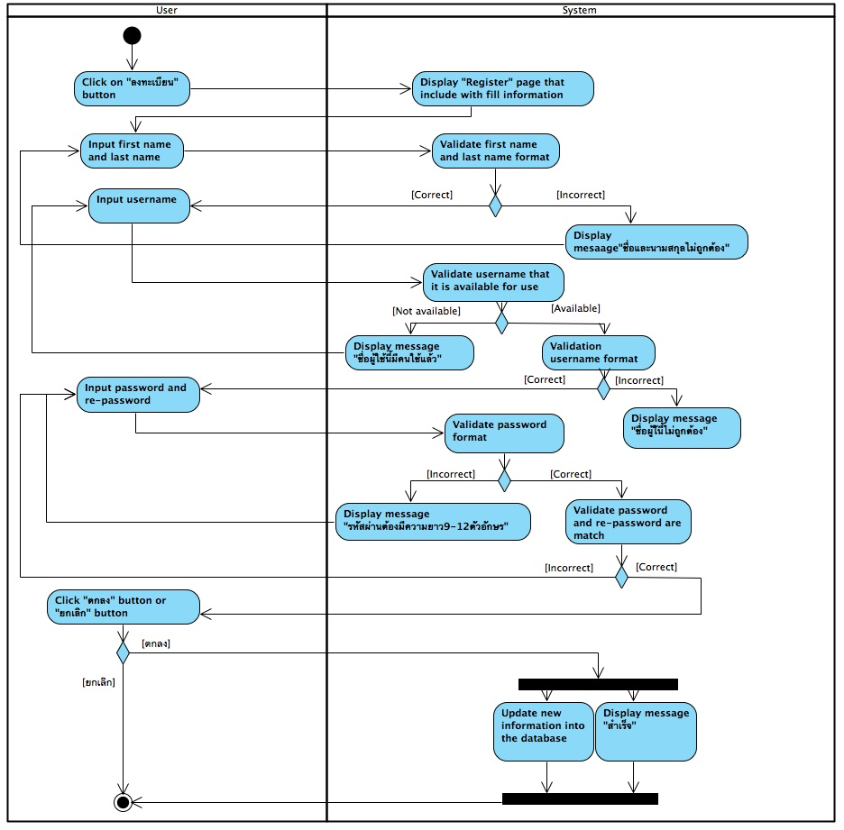

**Figure: Activity Diagram of URS-21**

**Output**

Add new user account information into the database.

**System Requirement Specification**

URS-17 : Registered user can login to the website.

***Introduction***

The system should allow registered user to login to the website.

***Precondition and Input***

User access to the website.

***Processing***

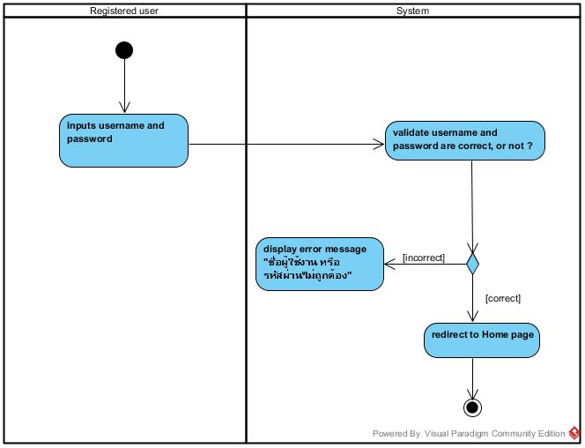

Figure : Activity Diagram of URS-17

***Output***

access in to the system and redirect to Home page

***System Requirement Specification***

***(รอเลขนิ่งค่อยใส่)***

URS-18 : Registered user can log out to the website.

***Introduction***

The system should allow registered user to logout to the website.

***Precondition and Input***

The registered user access to the system.

***Processing***

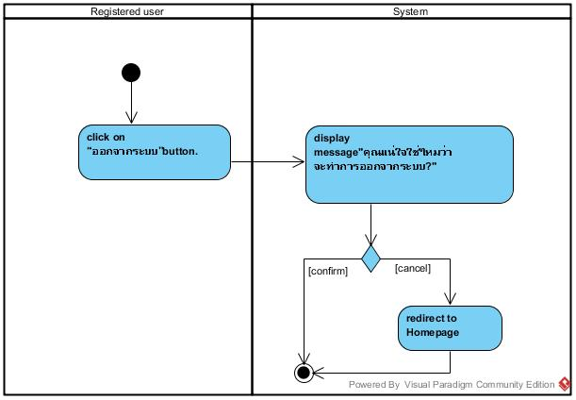

Figure : Activity Diagram of URS-18

***Output***

log out to the system

***System Requirement Specification***

***(รอเลขนิ่งค่อยใส่)***

URS-19 : Registered user can edit their own registered information.

***Introduction***

The system should allow registered user to can edit their own registered information.

***Precondition and Input***

The registered user must login success to the system. Registered user also input name, surname, username, password and re-password for editing their own registered information.

***Processing***

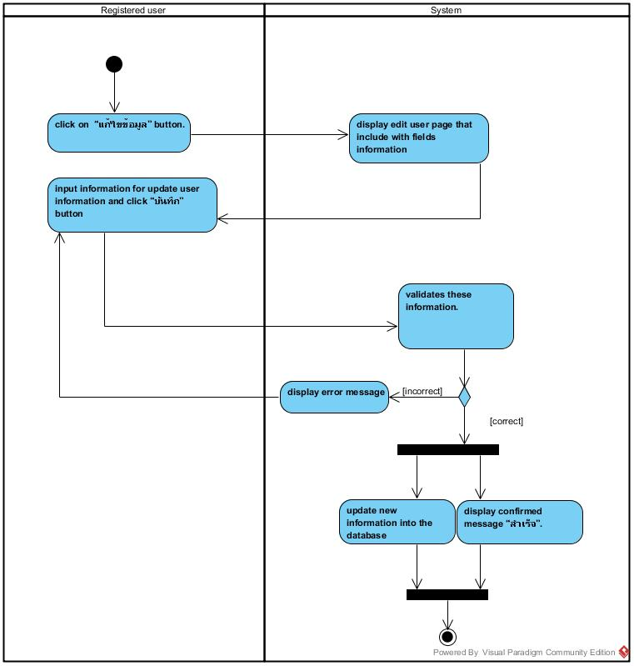

Figure : Activity Diagram of URS-19

***Output***

update information and display confirmed message “สำเร็จ”.

***System Requirement Specification***

***(รอเลขนิ่งค่อยใส่)***

URS-20 : Registered user can get news from admin by their registered e-mail.

***Introduction***

The system should allow registered user to get news from admin by their registered e-mail.

***Precondition and Input***

The registered user must register to the system.

***Processing***

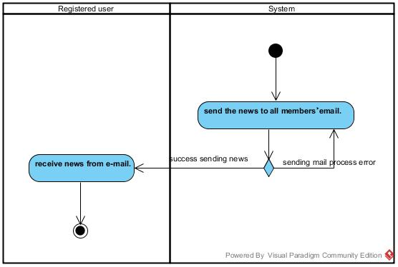

// เผื่อแก้  urs

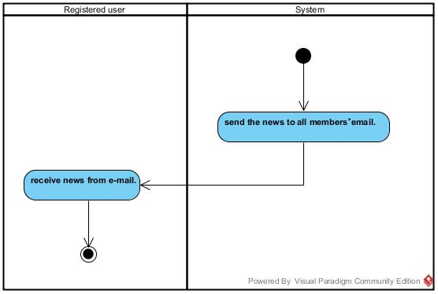

Figure : Activity Diagram of URS-20

***Output***

receive news from e-mail.

***System Requirement Specification***

***(รอเลขนิ่งค่อยใส่)***

URS-22 : User can view temple pictures on the Home page.

***Introduction***

The system should allow user to view temple pictures on the Home page.

***Precondition and Input***

User access to the system.

***Processing***

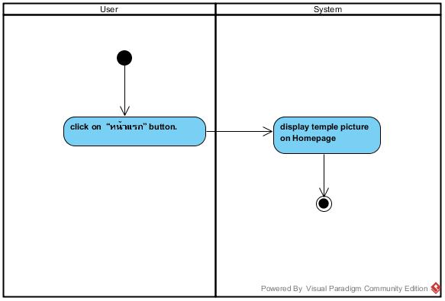

Figure : Activity Diagram of URS-22

***Output***

display temple picture on Homepage

***System Requirement Specification***

***(รอเลขนิ่งค่อยใส่)***

URS-23 : User can view temple news

***Introduction***

The system should allow user to view temple news.

***Precondition and Input***

User access to the system.

***Processing***

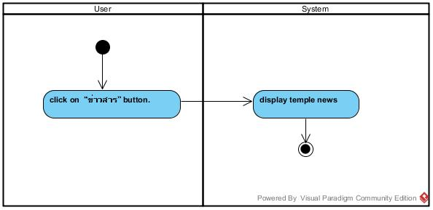

Figure : Activity Diagram of URS-23

***Output***

display temple news.

***System Requirement Specification***

***(รอเลขนิ่งค่อยใส่)***

URS-24 : User can view the temple history.

***Introduction***

The system should allow user to view the temple history.

***Precondition and Input***

User access to the system.

***Processing***

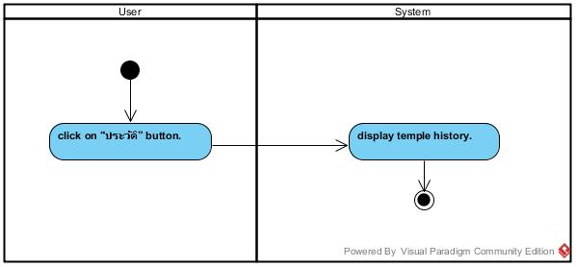

Figure : Activity Diagram of URS-24

***Output***

display temple history.

***System Requirement Specification***

***(รอเลขนิ่งค่อยใส่)***

URS-25 : User can select activity gallery.

***Introduction***

The system should allow user to select activity gallery.

***Precondition and Input***

User access to the system.

***Processing***

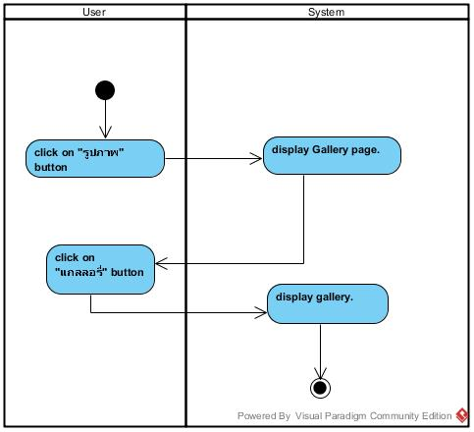

Figure : Activity Diagram of URS-25

***Output***

display gallery.

***System Requirement Specification***

***(รอเลขนิ่งค่อยใส่)***

URS-26 : User can view the gallery information of the selected gallery.

***Introduction***

The system should allow user to view the gallery information of the selected gallery.

***Precondition and Input***

User access to the system.

***Processing***

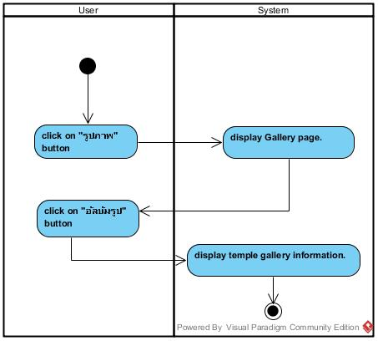

Figure : Activity Diagram of URS-26

***Output***

display temple gallery information.

***System Requirement Specification***

***(รอเลขนิ่งค่อยใส่)***

URS-27 : User can view pictures in the selected gallery.

***Introduction***

The system should allow user to view the pictures in the selected gallery.

***Precondition and Input***

-User selects gallery in Gallery page.

***Processing***

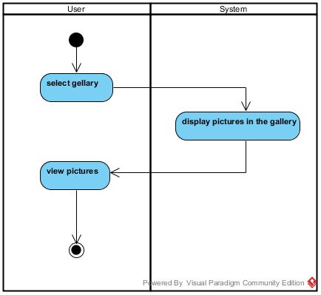

Figure : Activity Diagram of URS-27

***Output***

display temple gallery information.

***System Requirement Specification***

***(รอเลขนิ่งค่อยใส่ นิ่งเมื่อไรดี)***

URS-28 : User can select picture to view a big picture.

***Introduction***

The system should allow user to view big picture of the selected picture.

***Precondition and Input***

User selects gallery in Gallery page.

***Processing***

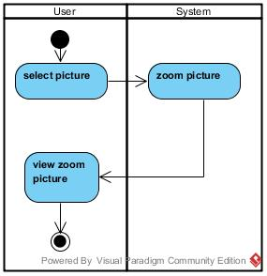

Figure : Activity Diagram of URS-28

***Output***

display selected big picture.

***System Requirement Specification***

***(รอเลขนิ่งค่อยใส่ นิ่งเมื่อไรดี)***

URS-29 : User can view others users’ question-answer in the Question-Answer page.

***Introduction***

The system should allow user to view others users’ question-answer in the Question-Answer page.

***Precondition and Input***

-

***Processing***

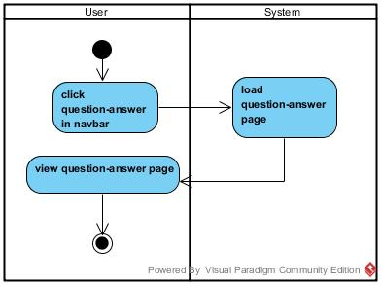

Figure : Activity Diagram of URS-29

***Output***

display question-answer page.

***System Requirement Specification***

***(รอเลขนิ่งค่อยใส่ นิ่งเมื่อไรดี)***

URS-30 : User can post questions on the Question-Answer page.

***Introduction***

The system should allow registered user to post questions on the Question-Answer page.

***Precondition and Input***

User must login to the system.

***Processing***

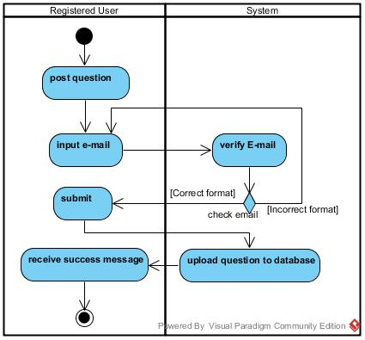

Figure : Activity Diagram of URS-30

***Output***

-if user submit question to the system ,the system will return success message to user

-The question which user post will store in the database.

***System Requirement Specification***

***(รอเลขนิ่งค่อยใส่ นิ่งเมื่อไรดี)***

URS-31 : User can receive the answer from admin.

***Introduction***

The system should allow user to receive the answer from admin by view on the own question page.

***Precondition and Input***

User must pose the question on the Question-Answer page.

***Processing***

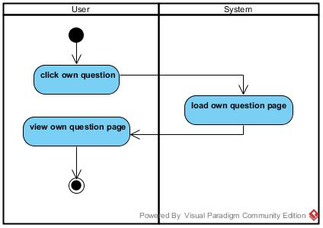

Figure : Activity Diagram of URS-31

***Output***

-display own question page

***System Requirement Specification***

***(รอเลขนิ่งค่อยใส่ นิ่งเมื่อไรดี)***

URS-32 : User can view temple location on Map page.

***Introduction***

The system should allow user to view temple location on Map pag.

***Precondition and Input***

-

***Processing***

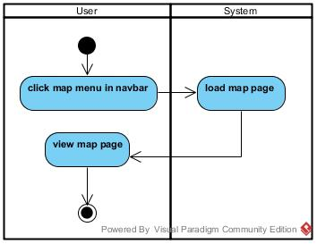

Figure : Activity Diagram of URS-32

***Output***

-display map page

***System Requirement Specification***

***(รอเลขนิ่งค่อยใส่ นิ่งเมื่อไรดี)***

URS-33 : User can view the temple contact information.

***Introduction***

The system should allow user to view the temple contact information.

***Precondition and Input***

-

***Processing***

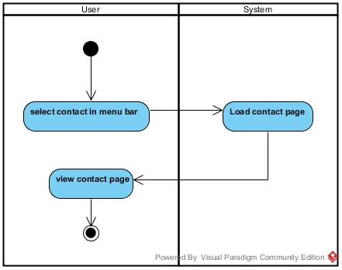

Figure : Activity Diagram of URS-33

***Output***

-display contact page

***System Requirement Specification***

***(รอเลขนิ่งค่อยใส่ นิ่งเมื่อไรดี)***

URS-34 : User can contact temple by using email address.

***Introduction***

The system should allow user to contact temple by using email address.

***Precondition and Input***

-

***Processing***

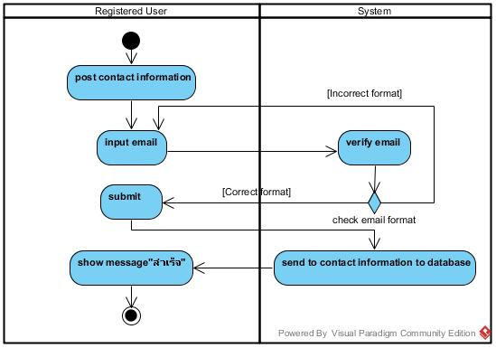

Figure : Activity Diagram of URS-34

***Output***

-the system receive contact information from user

-the user receive success message.

***System Requirement Specification***

***(รอเลขนิ่งค่อยใส่ นิ่งเมื่อไรดี)***

URS-35 : User can click link on website to like the Facebook page of the temple.

***Introduction***

The system should allow user to click icon facebook and pop up temple facebook page to the browser.

***Precondition and Input***

User access to the system.

***Processing***

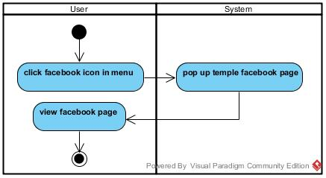

Figure : Activity Diagram of URS-35

***Output***

-display temple facebook page

***System Requirement Specification***

***(รอเลขนิ่งค่อยใส่ นิ่งเมื่อไรดี)***

**System Requirement Specification (SRS)**

URS-01 : Admin can login to the website.

SRS-01 : The system shall provide Login page.

SRS-02 : The system shall provide text box for receiving username and password.

SRS-03 : The system shall provide “เข้าสู่ระบบ” button for accessing the system.

SRS-04 : The system shall receive username and password.

SRS-05 : The system shall check username and password format.

SRS-06 : The system shall verify the login account.

SRS-07 : The system shall display error message "ชื่อผู้ใช้ หรือ รหัสผ่าน ไม่ถูกต้อง".

SRS-08 : The system shall redirect to Home page.

URS-02 : Admin can logout to the website.

SRS-09 : The system shall provide "ออกจากระบบ" button.

SRS-10 : The system shall display message "คุณแน่ใจใช่ไหมว่าจะทำการออกจากระบบ?".

SRS-11 : The system shall provide “ยืนยัน” for confirming to logout from the system.  
SRS-12 : The system shall provide “ยกเลิก” button to cancel.

SRS-13 : The system shall clear session.

SRS-14 : The system shall redirect to Login page.

URS-03 : Admin can update temple history on the website.

SRS-15 : The system shall provide History page for only admin.

SRS-16 : The system shall provide existing temple history.

SRS-17 : The system shall provide the UI for receiving new temple history from admin.

SRS-18 : The system shall provide “แก้ไขหน้านี้” button for editing the information on the website.

SRS-19 : The system shall provide the UI for receiving new pictures.

SRS-20 : The system shall provide “อัพโหลด” button for uploading the pictures.

SRS-21 : The system can check type of file picture.

SRS-22 : The system can check size of picture.

SRS-23 : The system shall display error message “ขนาดของรูปภาพใหญ่เกิน 600*800”.

SRS-24 : The system shall display error message “ไฟล์ไม่ได้รับอนุญาต”.

SRS-25 : The system shall provide “บันทึก” button for updating new information

SRS-12 : The system shall provide “ยกเลิก” button to cancel.

SRS-26 : The system shall update new information into the database.

SRS-27 : The system shall display confirmed message “สำเร็จ”.

URS-04 : Admin can update contact information on the website.

SRS-28 : The system shall provide Contact page for only admin.

SRS-29 : The system shall provide existing contact information.

SRS-18 : The system shall provide “แก้ไขหน้านี้” button for editing the information on the website.

SRS-30 : The system shall provide text box for receiving new contact information.

SRS-25 : The system shall provide “บันทึก” button for updating new information.

SRS-12 : The system shall provide “ยกเลิก” button to cancel.

SRS-26 : The system shall update new information into the database.

SRS-27 : The system shall display confirmed message “สำเร็จ”.

URS-05 : Admin can update temple news in News page.

SRS-31 : The system shall provide News page for only admin.

SRS-32 : The system shall provide existing news.

SRS-18 : The system shall provide “แก้ไขหน้านี้” button for editing the information on the website.

SRS-19 : The system shall provide the UI for receiving new pictures.

SRS-20 : The system shall provide “อัพโหลด” button for uploading the pictures.

SRS-21 : The system can check type of file picture.

SRS-22 : The system can check size of picture.

SRS-23 : The system shall display error message “ขนาดของรูปภาพใหญ่เกิน 600*800”.

SRS-24 : The system shall display error message “ไฟล์ไม่ได้รับอนุญาต”.

SRS-25 : The system shall provide “บันทึก” button for updating new information

SRS-12 : The system shall provide “ยกเลิก” button to cancel.

SRS-26 : The system shall update new information into the database.

SRS-27 : The system shall display confirmed message “สำเร็จ”.

URS-06 : Admin can update temple pictures in the Home page.

SRS-33 : The system shall provide Home page for only admin.

SRS-34 : The system shall show existing pictures.

SRS-18 : The system shall provide “แก้ไขหน้านี้” button for editing the information on the website.

SRS-19 : The system shall provide the UI for receiving new pictures.

SRS-20 : The system shall provide “อัพโหลด” button for uploading the picture.

SRS-21 : The system can check type of file picture.

SRS-22 : The system can check size of picture.

SRS-23 : The system shall display error message “ขนาดของรูปภาพใหญ่เกิน 600*800”.

SRS-24 : The system shall display error message “ไฟล์ไม่ได้รับอนุญาต”.

SRS-25 : The system shall provide “บันทึก” button for updating new information

SRS-12 : The system shall provide “ยกเลิก” button to cancel.

SRS-26 : The system shall update new information into the database.

SRS-27 : The system shall display confirmed message “สำเร็จ”.

URS-07 : Admin can add new gallery on the Gallery page.

SRS-35 : The system shall provide Gallery page for only admin.

SRS-36 : The system shall provide "เพิ่มอัลบั้ม" button.

SRS-37 : The system shall provide text box to receive the name and the detail of new album.

SRS-25 : The system shall provide “บันทึก” button for updating new information.

SRS-12 : The system shall provide “ยกเลิก” button to cancel.

SRS-26 : The system shall update new information into the database.

SRS-27 : The system shall display confirmed message “สำเร็จ”.

URS-08 : Admin can add new pictures in the gallery.

SRS-35 : The system shall provide Gallery page for only admin.

SRS-38 : The system shall provide “เพิ่มรูปภาพ” button for adding new pictures from the admin.

SRS-19 : The system shall provide the UI for receiving new pictures.

SRS-20 : The system shall provide “อัพโหลด” button for uploading the picture.

SRS-21 : The system can check type of file picture.

SRS-22 : The system can check size of picture.

SRS-23 : The system shall display error message “ขนาดของรูปภาพใหญ่เกิน 600*800”.

SRS-24 : The system shall display error message “ไฟล์ไม่ได้รับอนุญาต”.

SRS-25 : The system shall provide “บันทึก” button for updating new information

SRS-12 : The system shall provide “ยกเลิก” button to cancel.

SRS-26 : The system shall update new information into the database.

SRS-27 : The system shall display confirmed message “สำเร็จ”.

URS-09 : Admin can edit details of each gallery.

SRS-39 : The system shall provide Picture page.

SRS-40 : The system shall provide the existing detail of gallery from the database.

SRS-41 : The system shall provide text box for receiving new gallery details.

SRS-25 : The system shall provide “บันทึก” button for updating new information.

SRS-12 : The system shall provide “ยกเลิก” button to cancel.

SRS-26 : The system shall update new information into the database.

SRS-27 : The system shall display confirmed message “สำเร็จ”.

URS-10 : Admin can delete pictures in the gallery.

SRS-35 : The system shall provide Gallery page for only admin.

SRS-42 : The system shall provide “ลบ” button for deleting the picture in the gallery.

SRS-43 : The system shall display message “คุณแน่ใจใช่ไหมว่าจะลบรูปภาพนี้!?”.

SRS-44 : The system shall provide “ตกลง” button to confirm.

SRS-45 : The system shall delete selected pictures in the database.

SRS-12 : The system shall provide “ยกเลิก” button to cancel.

SRS-27 : The system shall display confirmed message “สำเร็จ”.

URS-11 : Admin can receive questions from the user.

SRS-46 : The system shall provide Question page for only admin.

SRS-47 : The system shall receive questions from the database.

SRS-48 : The system shall display list of questions.

URS-12 : Admin can answer the user’s question on the website.

SRS-49 : The system shall provide Question page for only admin.

SRS-47 : The system shall receive questions from the database.

SRS-50 : The system shall display list of questions.

SRS-51 : The system shall provide "ตอบ" button for answering the user’s question.

SRS-52 : The system shall provide Answer page for answering the selected question.

SRS-53 : The system shall provide text box for only admin to answer the user’s question.

SRS-44 : The system shall provide “ตกลง” button to confirm.

SRS-12 : The system shall provide “ยกเลิก” button to cancel.

SRS-27 : The system shall display confirmed message “สำเร็จ”.

SRS-54: The system shall add the answer to the database.

SRS-55 : The system shall send the answer to the user's email.

URS-13 : Admin can send news to registered members’ email.

SRS-31 : The system shall provide News page for only admin.

SRS-56 : The system shall provide the checkbox“ส่งข่าวสารให้สมาชิก”for selecting to send news to the member.

SRS-57 : The system shall provide UI for showing list of member’s email.

SRS-58 : The system shall provide confirm message “คุณแน่ใจใช่ไหมว่าจะส่งข่าวสารให้สมาชิกทุกคน?” to confirm sending news to member email.

SRS-59 : The system shall receive members’ email from database.

SRS-25 : The system shall provide “บันทึก” button for updating new information.

SRS-60 : The system shall send the news to all members’ email.

SRS-61 : The system shall provide error message “การส่งผิดพลาด” if send email process fail.

SRS-27 : The system shall display confirmed message “สำเร็จ”.

URS-14 : Admin can delete the user's question.

SRS-49 : The system shall provide Question page for only admin.

SRS-50 : The system shall receive questions from the database.

SRS-51 : The system shall display list of questions.

SRS-62 : The system shall provide “ลบ” button for deleting the question, which is  impolite question.

SRS-63 : The system shall display message "คุณแน่ใจใช่ไหมว่าจะลบคำถามนี้!?".

SRS-64 : The system shall delete the question in the database.

SRS-27 : The system shall display confirmed message “สำเร็จ”.

URS-15 : Registered user can login to the website.

SRS-01 : The system shall provide Login page.

SRS-02 : The system shall provide text box for receiving username and password.

SRS-03 : The system shall provide “เข้าสู่ระบบ” button for accessing to the system.

SRS-04 : The system shall receive username and password.

SRS-05 : The system shall check username and password format.

SRS-06 : The system shall verify the login account.

SRS-07 : The system shall display error message "ชื่อผู้ใช้ หรือ รหัสผ่าน ไม่ถูกต้อง".

SRS-08 : The system shall redirect to Home page.

URS-16 : Registered user can log out to the website.

SRS-09 : The system shall provide "ออกจากระบบ" button.

SRS-10 : The system shall display message "คุณแน่ใจใช่ไหมว่าจะทำการออกจากระบบ?".

SRS-11 : The system shall provide “ยืนยัน” for confirming to logout from the system.

SRS-12 : The system shall provide “ยกเลิก” button to cancel.

SRS-13 : The system shall clear session.

SRS-14 : The system shall redirect to Login page.

URS-17 : Registered user can edit their own registered information.

SRS-65 : The system shall provide User info page. ******เดี๊ยวดูชื่อหน้ามาอีกที****

SRS-66 : The system shall provide user’s registered information.

SRS-67 : The system shall provide text box for receiving new user information.

SRS-25 : The system shall provide “บันทึก” button for updating new information.

SRS-12 : The system shall provide “ยกเลิก” button to cancel.

SRS-26 : The system shall update new information into the database.

SRS-68 : The system shall display the error message “ชื่อและนามสกุล ต้องเป็นตัวอักษรเท่านั้น!”.

SRS-69: The system shall display the error message “ชื่อผู้ใช้ต้องเป็นอีเมลล์”.

SRS-70 : The system shall display the error message “รหัสผ่านต้องมีความยาว 9-12 ตัวอักษร”.

SRS-71 : The system shall display the error message.

SRS-72 : The system shall display the error message “รหัสผ่าน-รหัสผ่านอีกครั้ง ไม่ตรงกัน”.

SRS-27 : The system shall display confirmed message “สำเร็จ”.

URS-18 : Registered user can get news from admin by their registered e-mail.

SRS-60 : The system shall receive members’ email from database.****

// อันนที่ส่งได้ไม่ได้ไม่ได้อยู่ในเฉพาะ admin หรอ user แค่รับอย่างเดียวป่ะ

URS-19 : User can register to the website.

SRS-73 : The system shall provide Register page.

SRS-74 : The system shall provide a “ลงทะเบียน” button for register to the system.

SRS-75 : The system shall provide the UI which receive the first name, last name, username, password and re-password for the user registration.

SRS-76 : The system shall check first name and last name format.  The first name and last name format must be only character.

SRS-77 : The system shall check username format. The username format must be the e-mail format.

SRS-78 : The system shall check registered username which cannot be the same as existing username.

SRS-79 : The system shall check password format. The password must be 9-12 characters. The password must contain the small letter and number.

SRS-80: The system shall display the error message “ชื่อและนามสกุล ต้องเป็นตัวอักษรเท่านั้น!”.

SRS-81: The system shall display the error message “ชื่อผู้ใช้ต้องเป็นอีเมลล์”.

SRS-82 : The system shall display the error message “รหัสผ่านต้องมีความยาว 9-12 ตัวอักษร”.

SRS-83 : The system shall display the error message “รหัสผ่านต้องมีทั้งตัวอักษรพิมพ์เล็กและตัวเลข”.

SRS-84 : The system shall provide error message “ชื่อผู้ใช้นี้มีคนใช้แล้ว!”.

SRS-85 : The system shall display the error message “รหัสผ่าน-ยืนยันรหัสผ่าน ไม่ตรงกัน”.

SRS-86 : The system can validate the password field and re-password field are the same.

SRS-44 : The system shall provide “ตกลง” button to confirm.

SRS-12 : The system shall provide “ยกเลิก” button to cancel.

SRS-87 : The system shall add a new user information to the database using first name, last name, username and password.

SRS-27 : The system shall display confirmed message “สำเร็จ”.

URS-20 : User can view temple pictures in the Home page.

SRS-88 : The system shall provide the Home page.

SRS-89 : The system shall receive the temple pictures from database.

SRS-90 : The system shall show the temple pictures on the Home page.

URS-21 : User can view temple news.

SRS-91 : The system shall provide the News page.

SRS-92 : The system shall receive the temple news from database.

SRS-93 : The system shall show the temple news.

URS-22 : User can view the temple history.  
SRS-94 : The system shall provide the History page.

SRS-95 : The system shall receive the temple history information from database.

SRS-96 : The system shall receive the history pictures of temple from database.

SRS-97  : The system shall provide the history pictures of temple.

SRS-98 : The system shall provide temple history.

URS-23 : User can select gallery.

SRS-99 : The system shall provide Gallery page.

SRS-100 : The system shall receive galleries from database.

SRS-101 : The system shall provide galleries.

URS-24 : User can view the gallery information of the selected gallery.

SRS-100 : The system shall provide Gallery page.

SRS-102 : The system shall receive the gallery information which are name, date, time and place from database.

SRS-103 : The system shall provide temple gallery information.

URS-25 : User can view pictures in the selected gallery.

SRS-100 : The system shall provide Gallery page.

SRS-101 : The system shall receive galleries from database.

SRS-104 : The system shall receive activity pictures from database.

SRS-105 : The system shall categorize pictures in the gallery.

SRS-106 : The system shall show pictures in the gallery.

URS-26 : User can select picture to view a big picture.

SRS-107 : The system shall show pictures in the gallery.

SRS-108 : The system shall receive a selected picture from the user.

SRS-109 : The system shall show a selected picture as a big picture.

SRS-110 : The system shall provide “x” button for cancel to view a big picture.

SRS-111 : The system shall provide “<” button for view the previous picture.

SRS-112 : The system shall provide “>” button for view the next picture.

URS-27 : User can view others users’ question-answer in the Question-Answer page.

SRS-113 : The system shall provide Question-Answer page.

SRS-50 : The system shall receive questions from the database.

SRS-114 : The system shall receive answers from the database.

SRS-115 : The system shall display questions and answers in the Question-Answer page.

URS-28 : User can post questions on the Question-Answer page.

SRS-116 : The system shall provide Question-Answer page.

SRS-117 : The system shall provide text box for receiving question from user.

SRS-118 : The system shall provide text box for receiving email from user.

SRS-119 : The system shall check email format.

SRS-12 : The system shall provide “ยกเลิก” button to cancel.

SRS-49 : The system shall provide “ตกลง” button to confirm.

SRS-27 : The system shall display confirmed message “สำเร็จ”.

SRS-120 : The system shall add the user's question to the database.

URS-29 : User can receive the answer from admin.

SRS-121 : The system shall provide Own-question page.

SRS-114 : The system shall receive answers from the database.

SRS-122 : The system shall display the user’s own question with the answer.

URS-30 : User can view temple location on Map page.

SRS-123 : The system shall provide the Map page.

SRS-124 : The system shall link HERE Map.

SRS-125 : The system shall display the location of temple.

URS-31 : User can view the temple contact information.

SRS-126 : The system shall provide the Contact page.

SRS-127 : System shall receive the temple contact information from database.

SRS-128 : The system shall provide the temple contact information.

URS-32 : User can contact temple by using email address.

SRS-126 : The system shall provide the Contact page.

SRS-117 : The system shall provide text box for receiving question from user.

SRS-118 : The system shall provide text box for receiving email from user.

SRS-119 : The system shall check email format.

SRS-12 : The system shall provide “ยกเลิก” button to cancel

SRS-49 : The system shall provide “ตกลง” button to confirm.

SRS-129 : The system shall add the user's contact to the database.

URS-33 : User can click link on website to like the Facebook page of the temple.  
SRS-130 : The system shall provide link on website to like the Facebook page of the temple.

**Class Diagram**

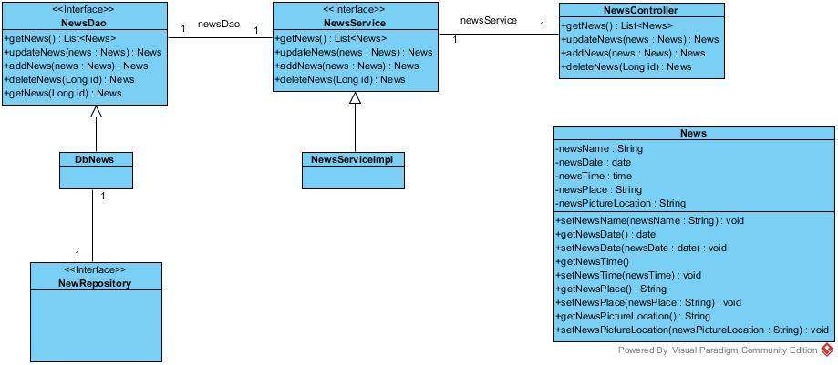

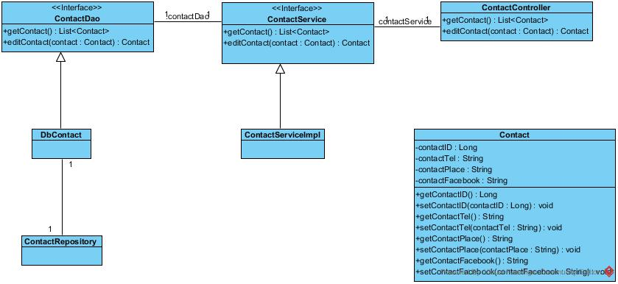

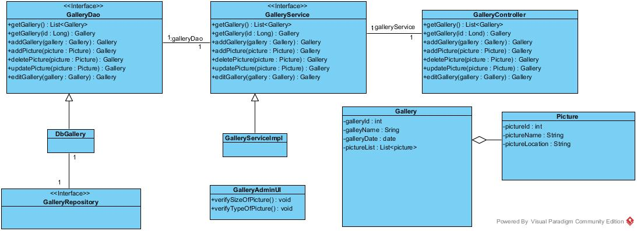

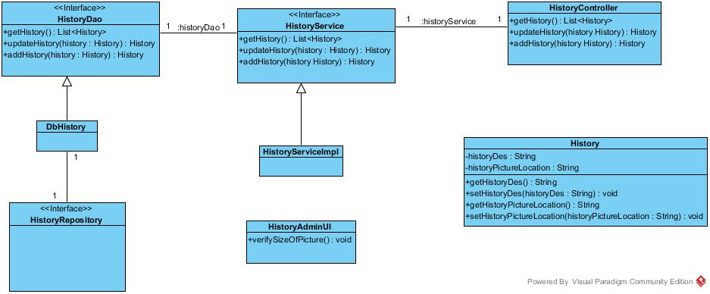

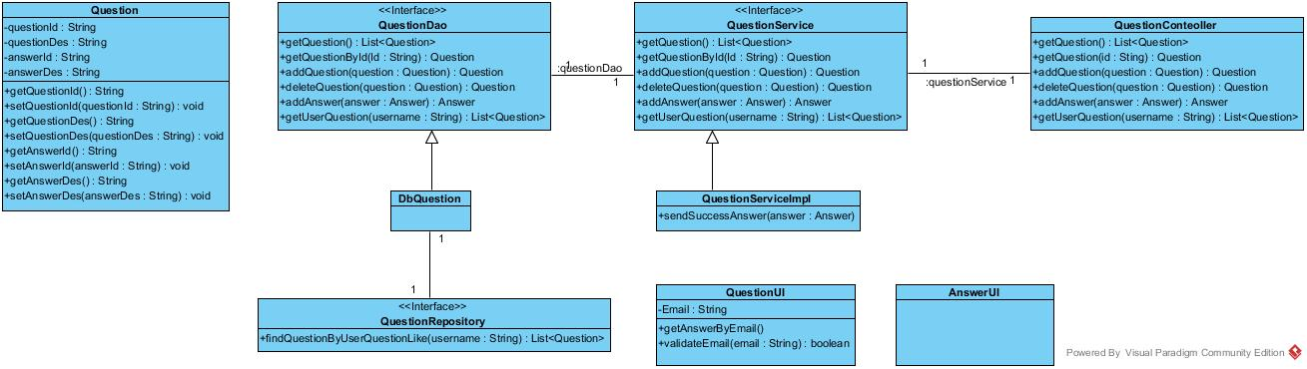  
**Sequence Diagram**

URS-01 : Admin can login to the website.

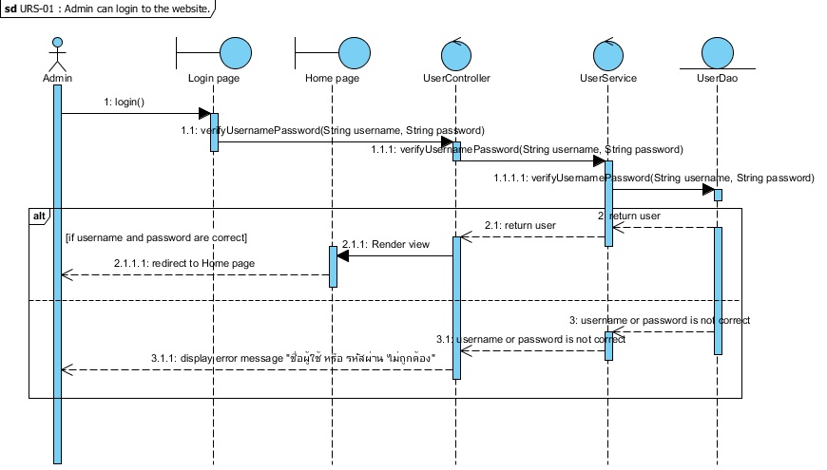

Figure 1 : Sequence Diagram of SD-01

The admin can input username and password, which are for admin only to the login page for access to the system. After the system gets username and password, the function login() will verify login account with the database. If the inputs are correct and match with database, the system will redirect to Home page. If the input are wrong, the system will display error message "ชื่อผู้ใช้งาน หรือ รหัสผ่านไม่ถูกต้อง"

URS-02 : Admin can logout to the website.

Figure 2 : Sequence Diagram of SD-02

The admin can logout by click on “ออกจากระบบ” button. Then the system asks the admin to confirm logout. If the admin selects “ตกลง” button, the system will clear admin’s session  in the method and redirect to Login page.

URS-03 : Admin can update temple history.

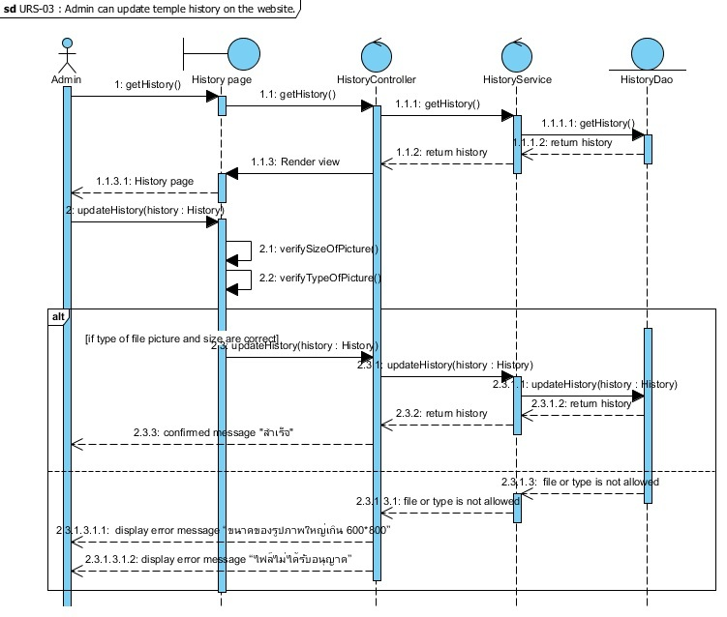

Figure 3 : Sequence Diagram of SD-03

The admin can view existing history that the system gets from the database by using getHistory(). The admin can update temple history by putting pictures then the system will verify type and size of pictures by using verifySizeOfPicture() and verifySizeOfPicture(). If the pictures are correct, the system will add new updated data into the database by using updateHistory() and display the confirmed message “สำเร็จ”. But if the pictures are not correct, the system will display message “ขนาดของรูปภาพใหญ่เกิน 600*800” or “ไฟล์ไม่ได้รับอนุญาต”.

URS-04 : Admin can update contact information on the website.

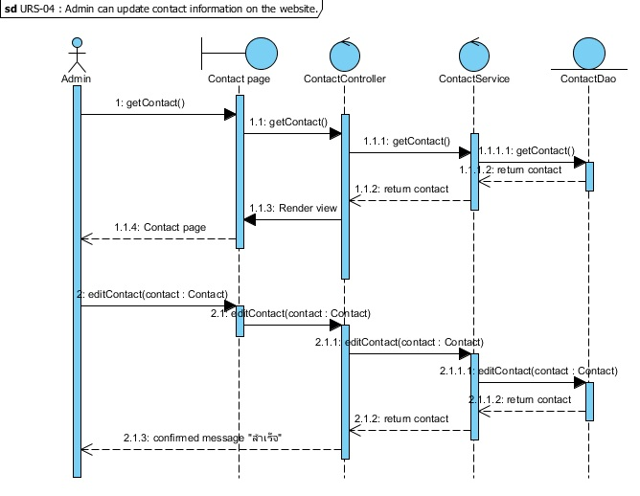

Figure 4 : Sequence Diagram of SD-04

The admin can view existing contact information that the system gets from the database by using getContact(). The admin can change contact information then the system will add new updated data into the database by using editContact() and display the confirmed message “สำเร็จ”.

URS-05 : Admin can update temple news in News page.

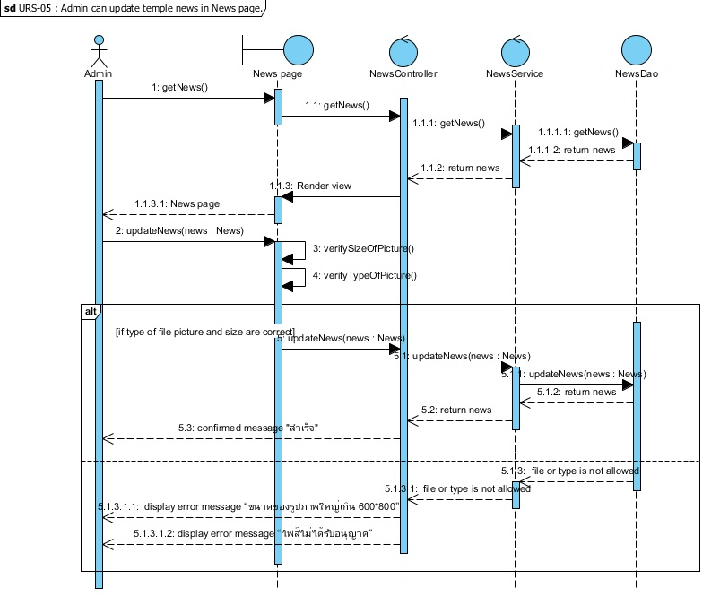

Figure 5 : Sequence Diagram of SD-05

The admin can view existing temple news that the system gets from the database by using getNews(). The admin can update temple news by putting news pictures then the system will verify type and size of pictures by using verifySizeOfPicture() and verifySizeOfPicture(). If type and size of pictures are correct, the system will add new updated data into the database by using updateNews() and display the confirmed message “สำเร็จ”. But if type and size of pictures are not correct, the system will display message “ขนาดของรูปภาพใหญ่เกิน 600*800” or “ไฟล์ไม่ได้รับอนุญาต”.

URS-07 : Admin can update temple pictures on the Home page.

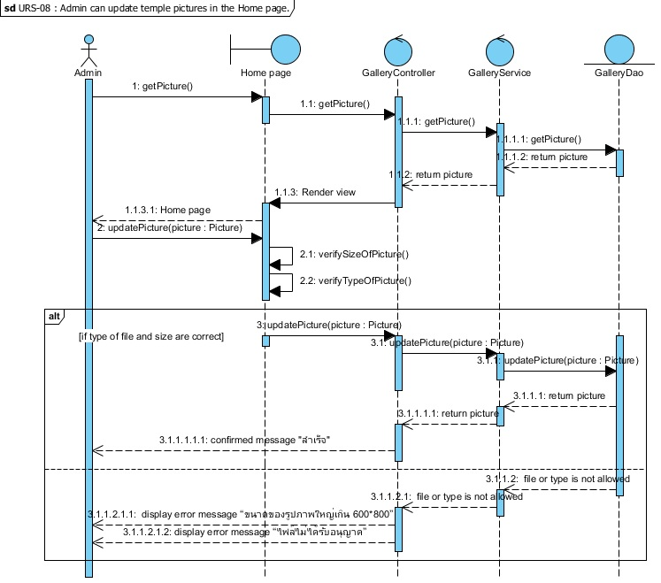

Figure 7 : Sequence Diagram of SD-07

The admin can view existing temple pictures on the Home page that the system gets from the database by using getPicture(). The admin can update temple pictures by putting new  temple pictures then the system will verify type and size of pictures by using verifySizeOfPicture() and verifySizeOfPicture(). If type and size of pictures are correct, the system will add new updated data into the database by using updatePicture() and display the confirmed message “สำเร็จ”. But if type and size of pictures are not correct, the system will display message “ขนาดของรูปภาพใหญ่เกิน 600*800” or “ไฟล์ไม่ได้รับอนุญาต”.

URS-09 : Admin can add new gallery on the Gallery page.

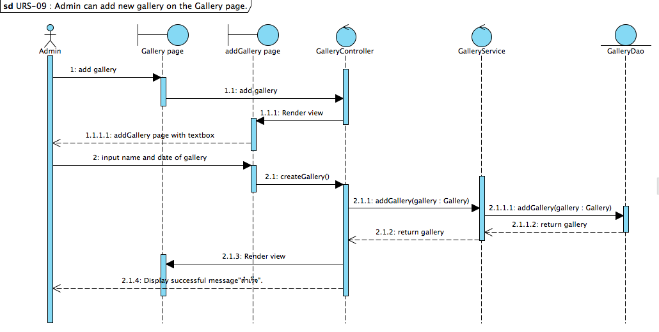

Figure 9 : Sequence Diagram of SD-09

In part of admin management, the admin can add new gallery by click on “เพิ่มอัลบั้ม” button on the Gallery page and input name and date of the gallery. After the system get name and date of gallery, the function createGallery() will add new gallery into the database and display new gallery on the Gallery page to the admin.

URS-10 : Admin can add new pictures in the gallery.

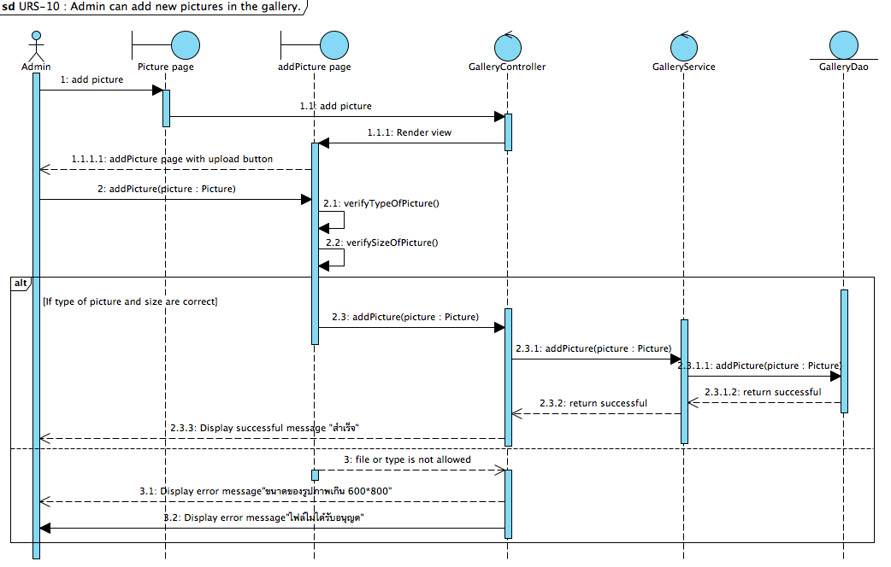

Figure 10 : Sequence Diagram of SD-10

In part of admin management, the admin can add new pictures in the gallery by select one from a list of gallery in the Gallery page and click on “เพิ่มรูปภาพ” button on Picture and upload pictures. After admin completed to upload new picture, the system will check size of picture which are not greater than 600*800 and type of picture must be only jpg. If all pictures is correct the system will add new picture into the database and display “สำเร็จ” message, but if founded some picture is incorrect the system will display error message that are”ขนาดรูปภาะเกิน600*800” or”ไฟล์ของรูปภาพไม่ได้รับอนุญาต”.

URS-11 : Admin can edit details of each gallery.

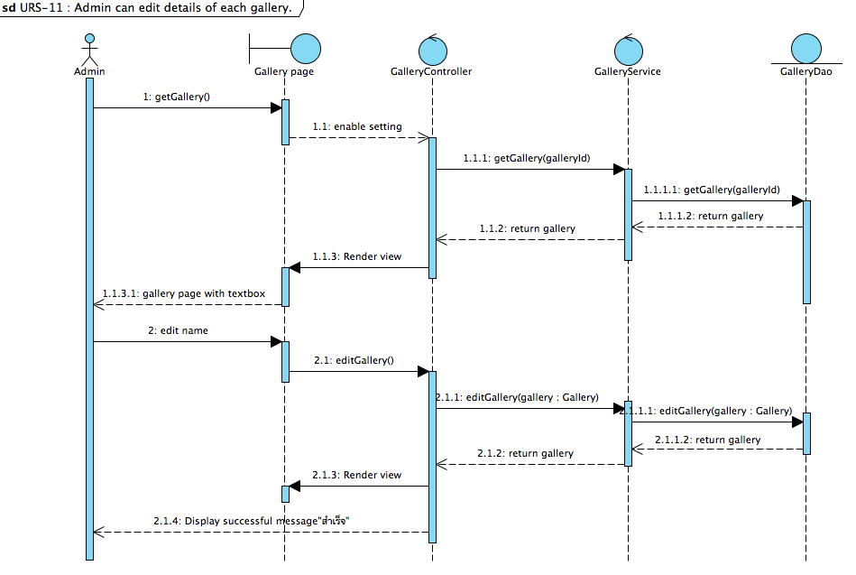

Figure 11 : Sequence Diagram of SD-11

        In the part of admin management, the admin can edit details of each gallery by clik “แก้ไข” on the Picture page. The system will display editPicture page that include with textbox and current information of selected gallery. After the admin input new information of gallery and click on”บันทึก” button, the system will call a function editGallery() to update new information into the database and display  successful message “สำเร็จ”.

URS12- Admin can delete picture in gallery

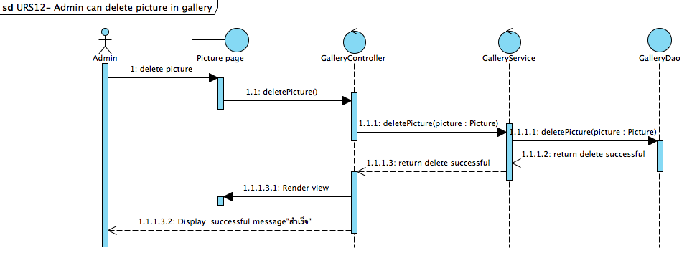

Figure 12 : Sequence Diagram of SD-12

In the part of admin management, the admin can delete pictures in the gallery by click “ลบ” button on the editPicture page. After the admin click “ลบ” button, the system will call a function deletePicture() to delete the selected picture from the database.

URS-13 : Admin can receive questions from the user.

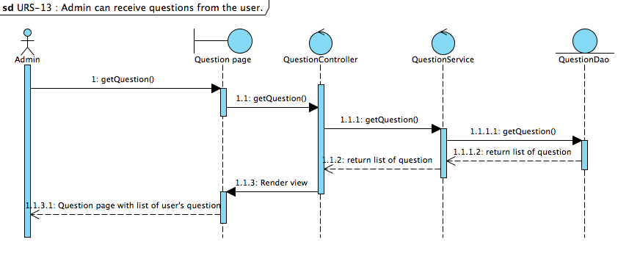

Figure 13 : Sequence Diagram of SD-13

In the part of admin management, the admin can receive questions from the user by click on Question-Answer menu. After the admin access to the Question-Answer menu, the system will call a function getQuestion() to receive the user’s questions from the database and display list of the user’s questions to admin on the Question page.

URS-14 Admin can answer the question.

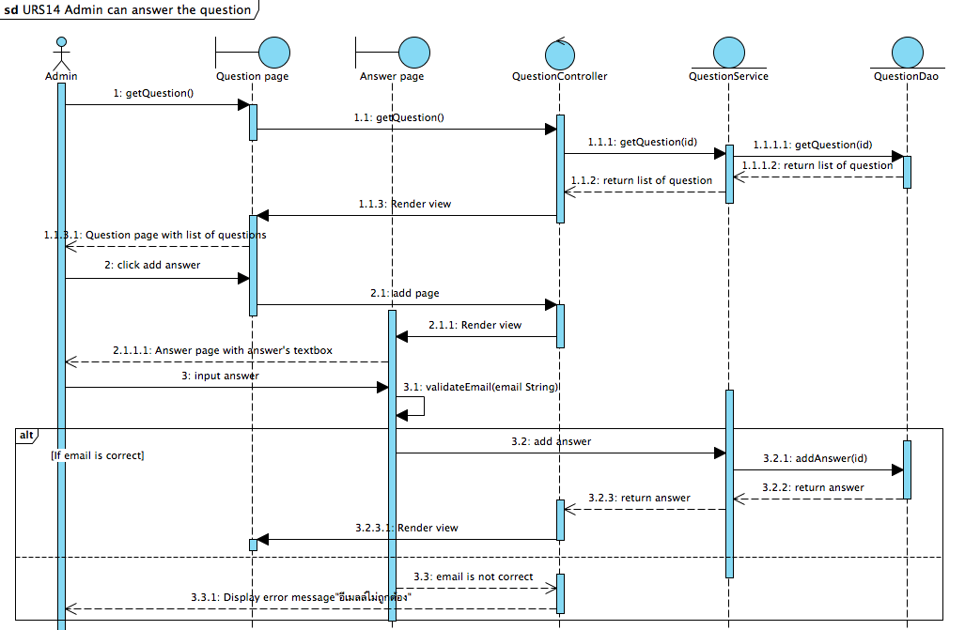

Figure 14 : Sequence Diagram of SD-14

In the part of admin management, the admin can answer the user’s question on the website by click on ”ตอบ” button and then the system will provide Answer page that include with textboxes for admin to input the answer and input the user’s email. After the admin completed to input the answer and the user’s email and click “ส่ง” button, the system will check the email format. If the email’s format is correct, the system will call a function addAnswer() to add the answer into the database. If the email format is not correct, the system will display error message “อีเมลล์ไม่ถูกต้อง” to the admin.

URS-15 : Admin can send news to registered users’ email.

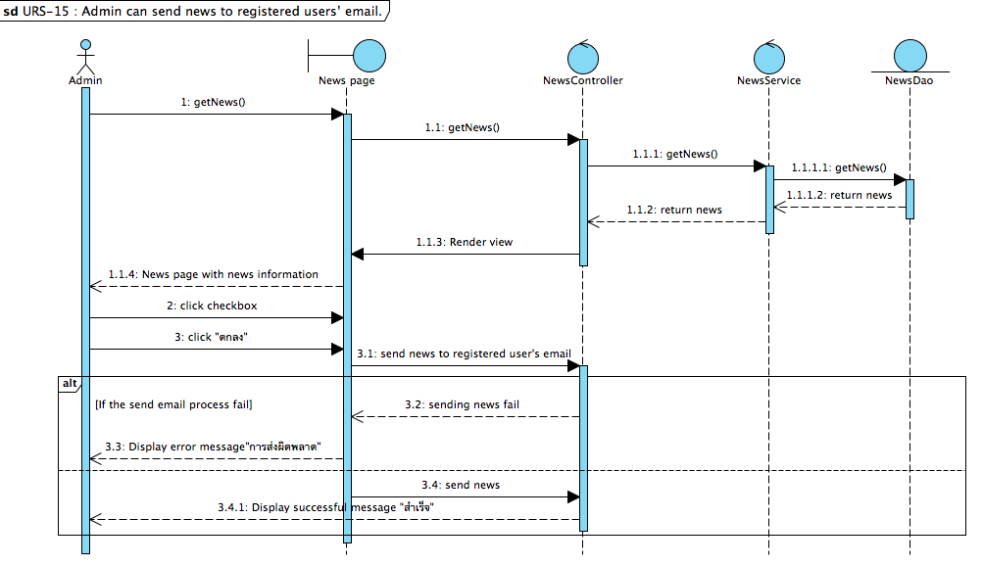

Figure 15: Sequence Diagram of SD-15

In the part of admin management, the admin can send news to registered user’s email by click checkbox on the News page and then the system will display confirm message “คุณยืนยันที่จะส่งข่าวสาร ถึงสมาชิก”. After the admin view list of the registered user’s email and click “ยืนยัน” button, the system will send news information to the user. If the process is fails, the system will show error message “การส่งผิดพลาด”. If the process is pass, the system will send the news to the registered user.

URS-16- Admin can delete the user's question on the website.

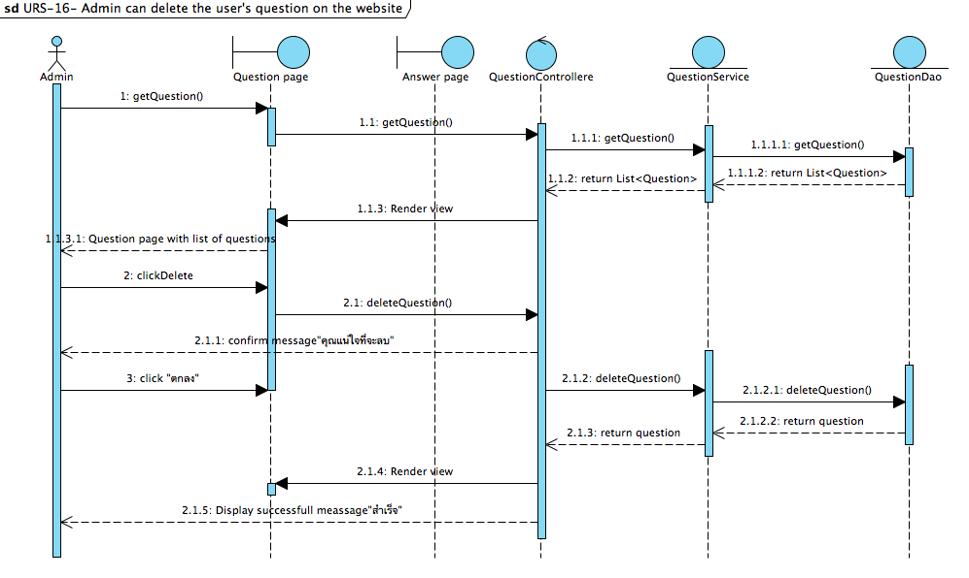

Figure 16 : Sequence Diagram of SD-16

In the part of admin management, the admin can delete the user’s question by click “ลบ” button on the Question page. After the admin click ”ลบ” button, the system will call a function deleteQuestion() to delete the question from the database and display successful message “สำเร็จ”.

URS-21 : User can register to the website

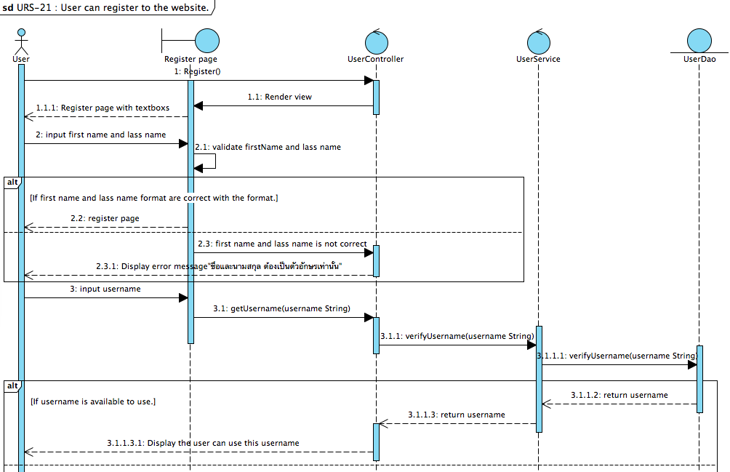

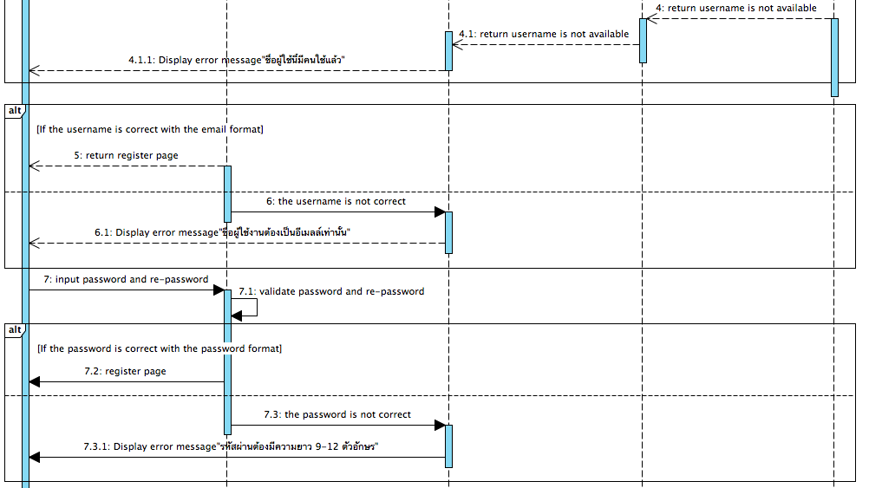

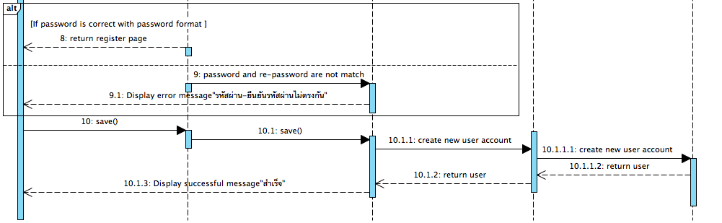

Figure 21 : Sequence Diagram of SD-21

The user can register to the system by click ”ลงทะเบียน” button on an any page and then the system will provide textboxes for receive first name, last name, password and re-password of the user.

After the user completed to input the first name and last name, the system will validate first name and last name format. If the first name and last name format are correct, the system will allow the user to click ”ตกลง” button for register to the system. If the first name and last name are not correct, the system will display error message “ืชื่อและนามสกุล ต้องเป็นตัวอักษรเท่านั้น”.

After the user completed to input the username, the system will verify the username format. If the username format is correct and available for use, the system will allow the user to click ”ตกลง” button for register to the system. If the username is not correct or unavailable for use, the system will display error message “ชื่อผู้ใช้ต้องเป็นอีเมลล์เท่านั้น” or “ชื่อผู้ใช้นี้มีคนใช้แล้ว”.

After the user completed to input the password and re-password, the system will validate password format and re-password. If the password is correct and match with the re-password, the system will allow the user to click ”ตกลง” button for register to the system. If the password is not correct and password is not match with the re-password, the system will display error message “รหัสผ่านต้องมีความยาว9-12ตัวอักษร”or “รหัสผ่านและยืนยันรหัสผ่านไม่ตรงกัน”.

After the user completed to input all information and click”ตกลง” button, the system will call a function save() to create new user account into the database and display successful message “สำเร็จ” to the user.

URS-17 : Registered user can login to the website.

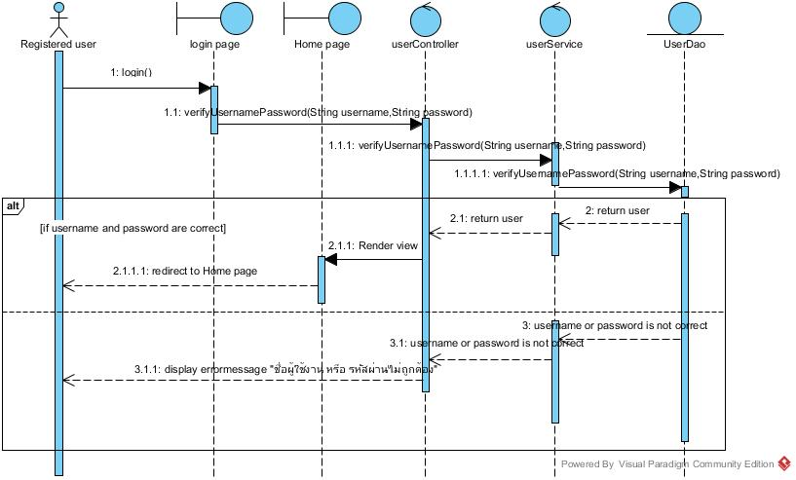

Figure : Sequence Diagram of SD-17

The user can input username and password to the login page for access to the system.

After the system get username and password,the function login() will verify user account with the database.If the inputs are correct and match with database; the system will redirect to Home page.If the input are wrong; the system will display error message "ชื่อผู้ใช้งาน หรือ รหัสผ่านไม่ถูกต้อง"

URS-18 : Registered user can log out to the website.

Figure : Sequence Diagram of SD-18

The Registered user can log out to the website. After the system get logout command ,the function logout() will clear session with the controller and the system will redirect to Login page.

URS-19 : Registered user can edit their own registered information. 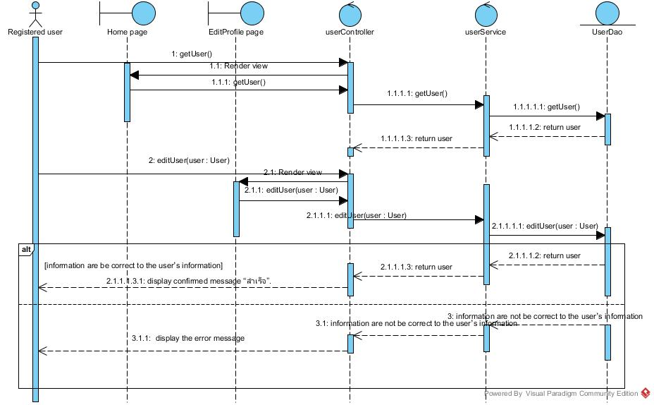

Figure : Sequence Diagram of SD-19

In the part of user management, the user can edit their own registered information.

by click on "แก้ไขข้อมูล" button and the system will call function editUser() to display Userpage that include with field and current user account information,After user complete to input new information to the field and click "ตกลง" button,the system will check validation all fields; if all fields information is correct the system will update information into the database and  display     “สำเร็จ” message,but if founded some field is incorrect the system will display an error message

URS-20 : Registered user can get news from admin by their registered e-mail.

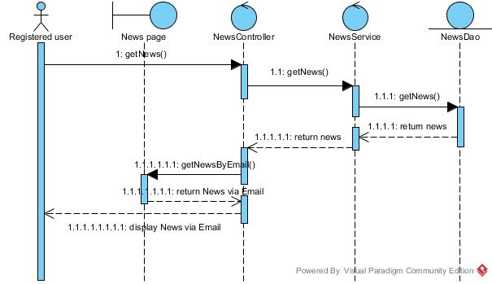

Figure : Sequence Diagram of SD-20

The registered user can get news from admin by their registered e-mail.The system will call function getNews() to get News from database.Then, the system will call getNewsByEmail() to send news to list of members’ email.

URS-22 : User can view temple pictures on the Home page.

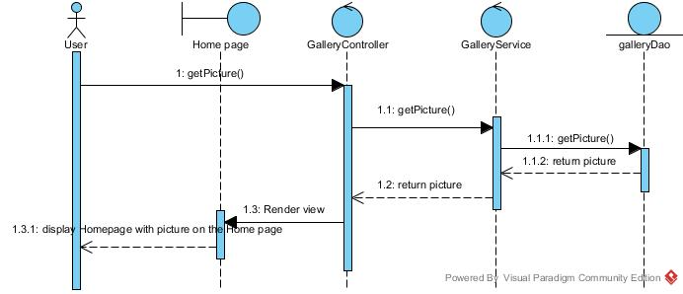

Figure : Sequence Diagram of SD-22

The user can view temple pictures on the Home page. The system will call getPicture() to display temple pictures on the Home page.

URS-23 : User can view temple news .

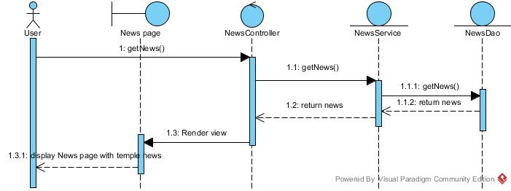

Figure : Sequence Diagram of SD-23

The user can view temple news. The system will call getNews() of News Controller, and News Controller will call getNews() to get news from the database to display temple news.

URS-24 : User can view the temple history.

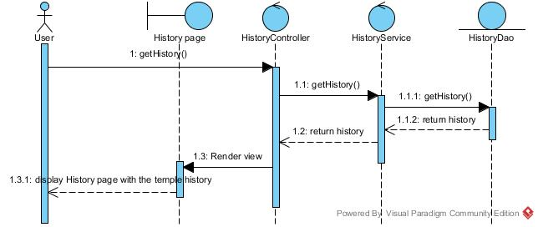

Figure : Sequence Diagram of SD-24

The user can view temple news. The system will call getHistory() of History Controller, and History Controller will call getHistory() of History Service to get the temple history from the database to display the temple history.

URS-25 : User can select gallery.

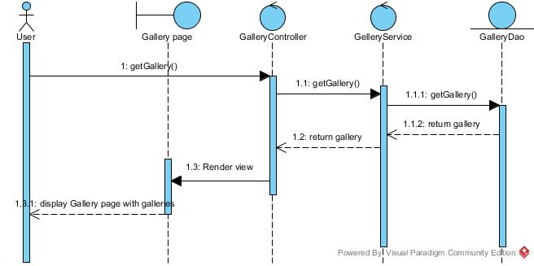

Figure : Sequence Diagram of SD-25

URS-26 : User can view the gallery information of the selected gallery.

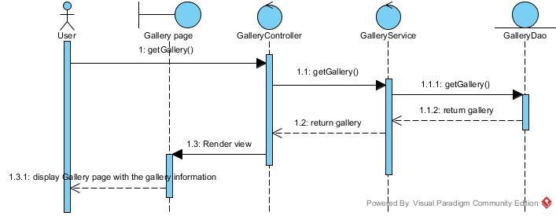

Figure : Sequence Diagram of SD-26

The user can  the gallery information of the selected gallery. The system will call getGallery() of Gallery Controller, and Gallery Controller will call getGallery() of Gallery Service to get the gallery information of the selected gallery from the database to display the gallery information of the selected gallery.

URS-27 : User can view pictures in the selected gallery.

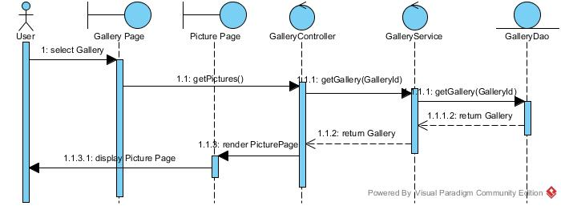

Figure : Sequence Diagram of SD-27

The user can view picture in the selected gallery. The system will call getPictures() of gallery controller, and Gallery Controller will call getGallery(GalleryId) of Gallery Service to get Gallery by of the selected gallery from the database to display pictures of the selected gallery.

URS-28 : User can select picture to view a big picture.

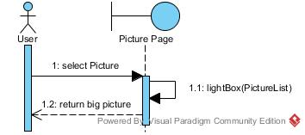

Figure : Sequence Diagram of SD-28

The user can select picture to view a big picture. The system will call listBox(PictureList) and then the system will display big picture.

URS-29 : User can view others users’ question-answer on the Question-Answer page.

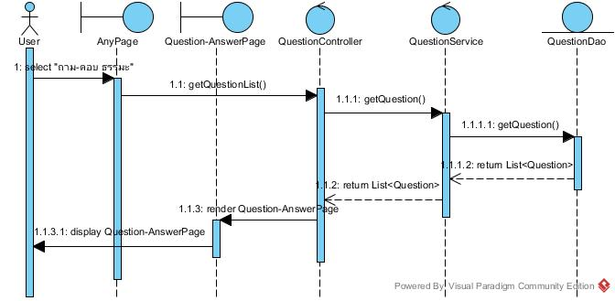

Figure : Sequence Diagram of SD-29

The user can view others users’ question-answer on the Question-Answer page. The system will call listBox(PictureList) and then the system will display big picture.

URS-30 : User can post questions on the Question-Answer page. // 9-12 คือไรอะ

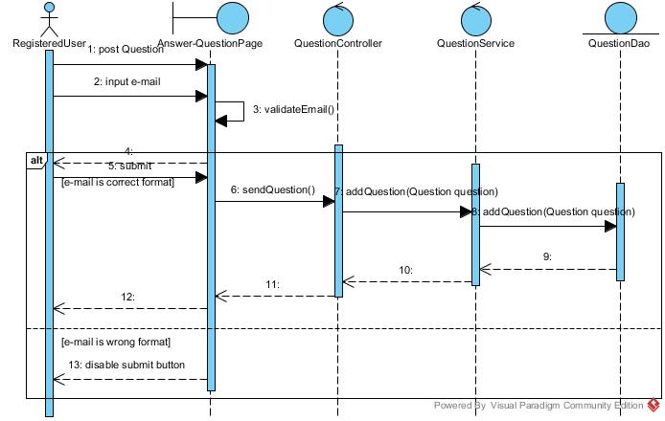

Figure : Sequence Diagram of SD-30

The User can post questions on the Question-Answer page. The user input question and input e-mail then click submit in first step system will call sendQuestion() and send question information to the question service .After that question service will add question to database .

URS-31 : User can receive the answer from admin.

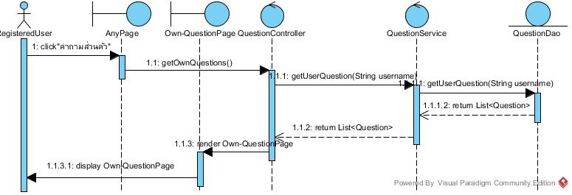

Figure : Sequence Diagram of SD-31

The user can receive the answer from admin. The system will call getOwnquestion() of question controller, and Question Controller will call getUserQuestion(String username) of question service to get List<Question> and then return to own question page and render it to display to the user.

URS-32 : User can view temple location on Map page.

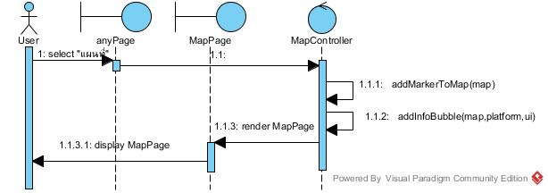

Figure : Sequence Diagram of SD-32

The user can view picture in the selected gallery. The system will call addMarkerToMap(map) for add track temple to map and call addInfoBubble for input temple info bubble to map and then display to the user

URS-33 : User can view the temple contact information.

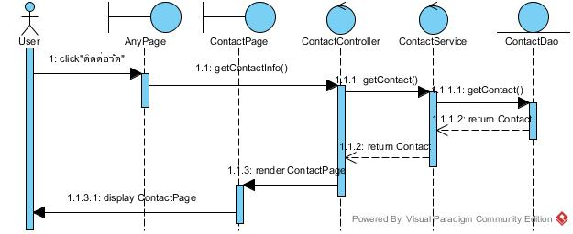

Figure : Sequence Diagram of SD-33

The user can view the temple contact information. The system will call getContactInfo() of Contact Controller, and Contact Controller will call getContact() of Contact Service to get Contact from the database to display contact page.

URS-34 : User can contact temple by using email address.

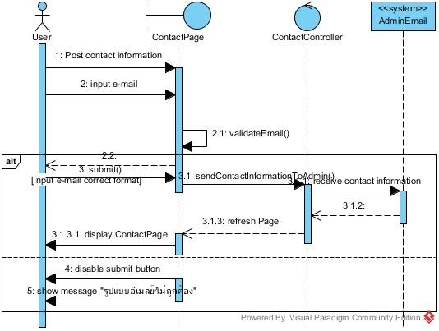

Figure : Sequence Diagram of SD-34

The user can contact temple by using email address. The user input contact information and input e-mail then click submit in first step system will call sendContactInformationToAdmin() and send contact information to the admin email .After that contact page will refresh page.

URS-35 : User can click link on website to like the Facebook page of the temple.

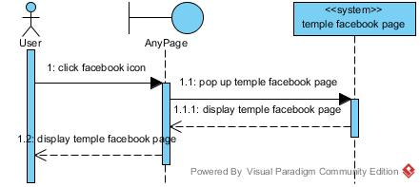

Figure : Sequence Diagram of SD-35

The user can click link on website to like the Facebook page of the temple. The system will pop up temple Facebook page after the user click on Facebook icon in the menu bar.

**Method Description**

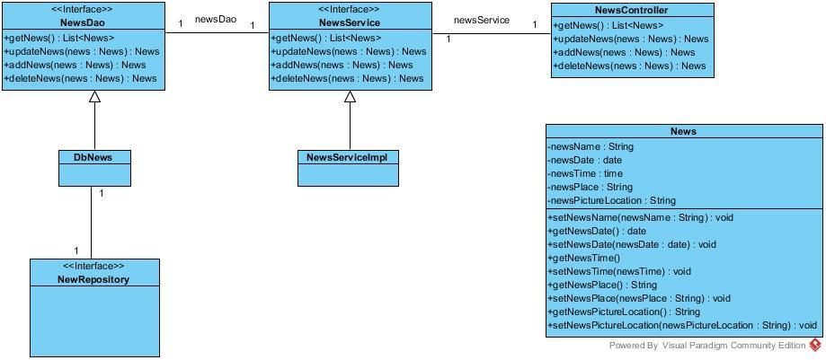

Figure : Model News Class Diagram

Attributes

|  |  |  |  |
| --- | --- | --- | --- |
| ID | Name | Description | Remarks |
| 1 | newsName | A variable of name | Return type : String |
| 2 | newsDate | A variable of date | Return type : date |
| 3 | newsTime | A variable of time | Return type : time |
| 4 | newsPlace | A variable of place | Return type : String |
| 5 | newsPictureLocation | A variable of picture location | Return type : String |

Methods

|  |  |  |  |
| --- | --- | --- | --- |
| ID | Name | Description | Remarks |
| 1 | setNewsName(newsName : String) | Set name of news | Return type : void |
| 2 | getNewsName() | Get name of news | Return type : String |
| 3 | setNewsDate(newsDate : date) | Set date of news | Return type : void |
| 4 | getNewsDate() | Get date of news | Return type : date |
| 5 | setNewsTime(newsTime : time) | Set time of news | Return type : void |
| 6 | getNewsTime() | Get time of news | Return type : time |
| 7 | setNewsPlace(newsPlace : String) | Set place of news | Return type : void |
| 8 | getNewsPlace() | Get place of news | Return type : String |
| 9 | setNewsPictureLocation(newsPictureLocation : String) | Set location of news picture | Return type : void |
| 10 | getNewsPictureLocation() | Set location of news picture | Return type : String |

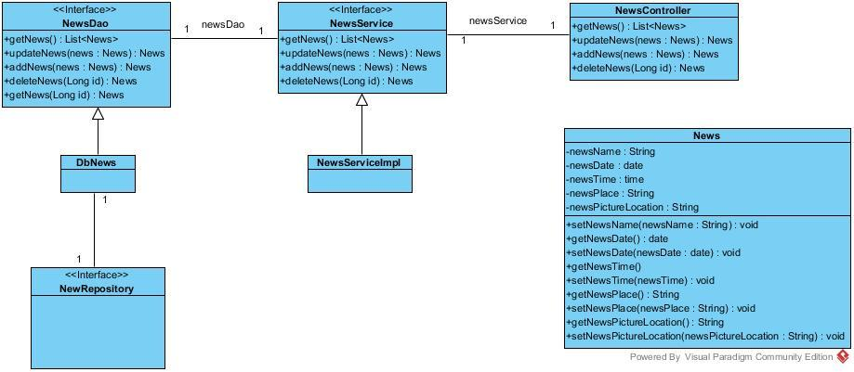

Figure :

Methods

|  |  |  |  |
| --- | --- | --- | --- |
| ID | Name | Description | Remarks |
| 1 | getNews() | Return list of news | Return type : List<News> |
| 2 | getNews(Long id) | Return news by getting news id | Return type : News |
| 3 | updateNews(news : News) | Update news into the database | Return type : News |
| 4 | addNews(news : News) | Add news into the database | Return type : News |
| 5 | deleteNews(Long id) | Delete news from received id into the database | Return type : News |



Figure :

Methods

|  |  |  |  |
| --- | --- | --- | --- |
| ID | Name | Description | Remarks |
| 1 | getNews() | Return list of news | Return type : List<News> |
| 2 | getNews(Long id) | Return news by getting news id | Return type : News |
| 3 | updateNews(news : News) | Update news into the database | Return type : News |
| 4 | addNews(news : News) | Add news into the database | Return type : News |
| 5 | deleteNews(Long id) | Delete news from received id into the database | Return type : News |



Figure :

|  |  |  |  |
| --- | --- | --- | --- |
| ID | Name | Description | Remarks |
| 1 | getNews() | Return list of news | Return type : List<News> |
| 2 | getNews(Long id) | Return news by getting news id | Return type : News |
| 3 | updateNews(news : News) | Update news into the database | Return type : News |
| 4 | addNews(news : News) | Add news into the database | Return type : News |
| 5 | deleteNews(Long id) | Delete news from received id into the database | Return type : News |

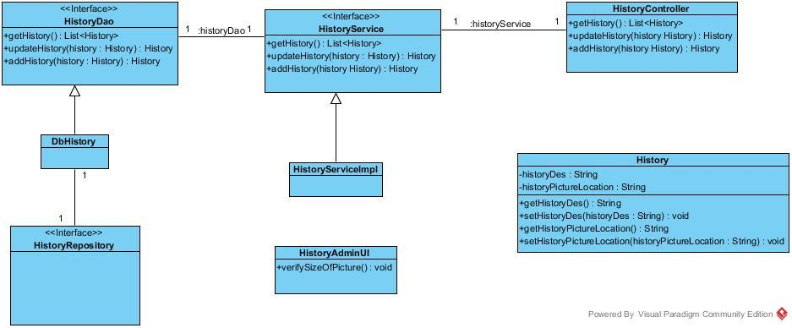  
Figure :

Attributes

|  |  |  |  |
| --- | --- | --- | --- |
| ID | Name | Description | Remarks |
| 1 | historyDes | A variable of history description | Return type : String |
| 2 | historyPictureLocation | A variable of picture location | Return type : String |

Methods

|  |  |  |  |
| --- | --- | --- | --- |
| ID | Name | Description | Remarks |
| 1 | setHistoryDes(historyDes : String) | Set history description | Return type : void |
| 2 | getHistoryDes () | Get history description | Return type : String |
| 3 | setHistoryPictureLocation(historyPictureLocation : String) | Set picture location | Return type : void |
| 4 | getHistoryPictureLocation() | Get picture location | Return type : String |



Figure :

|  |  |  |  |
| --- | --- | --- | --- |
| ID | Name | Description | Remarks |
| 1 | getHistory() | Return list of history information | Return type : List<History> |
| 2 | updateHistory(history : History) | Update history into the database | Return type : History |
| 3 | addHistory(history : History) | Add new history into the database | Return type : History |

  
Figure :

|  |  |  |  |
| --- | --- | --- | --- |
| ID | Name | Description | Remarks |
| 1 | getHistory() | Return list of history information | Return type : List<History> |
| 2 | updateHistory(history : History) | Update history into the database | Return type : History |
| 3 | addHistory(history : History) | Add new history into the database | Return type : History |

  
Figure :

|  |  |  |  |
| --- | --- | --- | --- |
| ID | Name | Description | Remarks |
| 1 | getHistory() | Return list of history information | Return type : List<History> |
| 2 | updateHistory(history : History) | Update history into the database | Return type : History |
| 3 | addHistory(history : History) | Add new history into the database | Return type : History |

  
Figure :

|  |  |  |  |
| --- | --- | --- | --- |
| ID | Name | Description | Remarks |
| 1 | verifySizeOfPicture() | Verify size of pictures in part of UI | Return type : void |

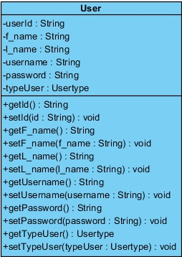

**Figure : Class Diagram**

**Attributes**

|  |  |  |  |
| --- | --- | --- | --- |
| **ID** | **Name** | **Description** | **Remarks** |
| 1 | userId | A variable of user id | Return Type : String |
| 2 | f_name | A variable of first name | Return Type : String |
| 3 | l_name | A variable of last name | Return Type : String |
| 4 | username | A variable of username | Return Type : String |
| 5 | password | A variable of password | Return Type : String |
| 6 | typeUser | A variable of type of user | Return Type : String |

**Methods**

|  |  |  |  |
| --- | --- | --- | --- |
| **ID** | **Name** | **Description** | **Remarks** |
| 1 | getId(): String | Get id of user | Return Type : String |
| 2 | setId(id : String) : void | Set id of user | Return Type : String |
| 3 | getF_name() : String | Get first name of user | Return Type : String |
| 4 | setF_name(f_name : String) : void | Set first name of user | Return Type : String |
| 5 | getL_name() : String | Get last name of user | Return Type : String |
| 6 | setL_name(l_name : String) : void | Set first name of user | Return Type : String |
| 7 | getUsername() : String | Get username of user | Return Type : String |
| 8 | setUsername(username : String) : void | Set username of user | Return Type : String |
| 9 | getPassword() : String | Get password of user | Return Type : String |
| 10 | setPassword(password : String) : void | Set password of user | Return Type : String |
| 11 | getTypeUser() : String | Get type of user | Return Type : String |
| 12 | setTypeUser(typeUser : Usertype) | Set type of user | Return Type : String |
|  |  |  |  |

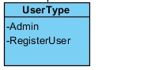

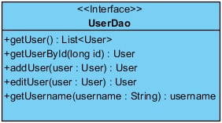

**Methods**

|  |  |  |  |
| --- | --- | --- | --- |
| **ID** | **Name** | **Description** | **Remarks** |
| 1 | getUser() : List<User> | Method for get a list of all user account to display | Display a list of all user account |
| 2 | getUserById(long id) : User | Method for search user’s information by id from the database | Searching user’s information |
| 3 | addUser(user : User) : User | Method for add user info into the database | Added new record |
| 4 | editUser(user : User) : User | Method for edit user from the database | Updated record |



**Methods**

|  |  |  |  |
| --- | --- | --- | --- |
| **ID** | **Name** | **Description** | **Remarks** |
| 1 | getUser() : List<User> | Method for get a list of all user account to display | Display a list of all user account |
| 2 | getUserById(long id) : User | Method for search user’s information by id from the database | Searching user’s information |
| 3 | addUser(user : User) : User | Method for add user info into the database | Added new record |
| 4 | editUser(user : User) : User | Method for edit user from the database | Updated record |

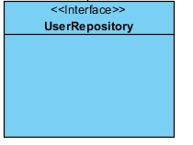

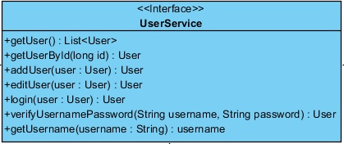

**Methods**

|  |  |  |  |
| --- | --- | --- | --- |
| **ID** | **Name** | **Description** | **Remarks** |
| 1 | getUser() : List<User> | Method for get a list of all user account to display | Display a list of all user account |
| 2 | getUserById(long id) : User | Method for search user’s information by id from the database | Searching user’s information |
| 3 | addUser(user : User) : User | Method for add user info into the database | Added new record |
| 4 | editUser(user : User) : User | Method for edit user from the database | Updated record |
| 5 | login(user : User):User | Method for login to the system | Login to the system |
| 6 | verifyUsernamePassword(String username, String password) : User | Method for verify username and password are matching from the database | Verify username and password |

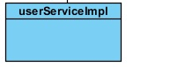

**Methods**

|  |  |  |  |
| --- | --- | --- | --- |
| **ID** | **Name** | **Description** | **Remarks** |
| 1 | getUser() : List<User> | Method for get a list of all user account to display | Display a list of all user account |
| 2 | getUserById(long id) : User | Method for search user’s information by id from the database | Searching user’s information |
| 3 | addUser(user : User) : User | Method for add user info into the database | Added new record |
| 4 | editUser(user : User) : User | Method for edit user from the database | Updated record |
| 5 | login(user : User):User | Method for login to the system | Login to the system |
| 6 | verifyUsernamePassword(String username, String password) : User | Method for verify username and password are matching from the database | Verify username and password |

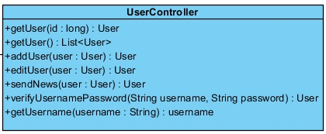

**Methods**

|  |  |  |  |
| --- | --- | --- | --- |
| **ID** | **Name** | **Description** | **Remarks** |
| 1 | getUser() : List<User> | Method for get a list of all user account to display | Display a list of all user account |
| 2 | getUserById(long id) : User | Method for search user’s information by id from the database | Searching user’s information |
| 3 | addUser(user : User) : User | Method for add user info into the database | Added new record |
| 4 | editUser(user : User) : User | Method for edit user from the database | Updated record |
| 5 | sendNews(user:User):User | Method for get a list of all users ‘email from the database | Get users ‘email |
| 6 | verifyUsernamePassword(String username, String password) : User | Method for verify username and password are matching from the database | Verify username and password |

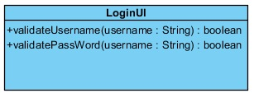

**Methods**

|  |  |  |  |
| --- | --- | --- | --- |
| **ID** | **Name** | **Description** | **Remarks** |
| 1 | +validateUsername(username : String) : Boolean | Method for validate username is correct format. |  |
| 2 | +validatePassWord(username : String) : boolean | Method for validate password is correct format. |  |

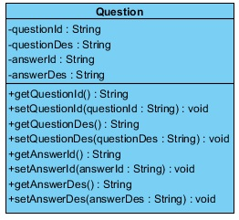

**Attributes**

|  |  |  |  |
| --- | --- | --- | --- |
| **ID** | **Name** | **Description** | **Remarks** |
| 1 | questionId | A variable of question id | Return Type : String |
| 2 | questionDes | A variable of question description | Return Type : String |
| 3 | answerId | A variable of answer id | Return Type : String |
| 4 | answerDes | A variable of answer description | Return Type : String |

**Methods**

|  |  |  |  |
| --- | --- | --- | --- |
| **ID** | **Name** | **Description** | **Remarks** |
| 1 | getQuestionId() : String | Get id of question | Return Type : String |
| 2 | setQuestionId(questionId : String) : void | Set id of question | Return Type : String |
| 3 | getQuestionDes() : String | Get description of question | Return Type : String |
| 4 | setQuestionDes(questionDes : String) : void | Set description of question | Return Type : String |
| 5 | getAnswerId() : String | Get id of answer | Return Type : String |
| 6 | setAnswerId(answerId : String) : void | Set id of answer | Return Type : String |
| 7 | getAnswerDes() : String | Get answer of question | Return Type : String |
| 8 | setAnswerDes(answerDes : String) : void | Set answer of question | Return Type : String |

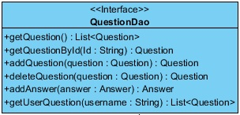

**Methods**

|  |  |  |  |
| --- | --- | --- | --- |
| **ID** | **Name** | **Description** | **Remarks** |
| 1 | +getQuestion() : List<Question> | Method for get a list of all question to display | Display a list of all question |
| 3 | getQuestionById(Id : String) : Question | Method for search question by id from the database | Searching question |
| 4 | addQuestion(question : Question) : Question | Method for add question info into the database | Added new record |
| 5 | deleteQuestion(question : Question) : Question | Method for delete question from the database | Deleted record |
| 6 | addAnswer(answer : Answer) : Answer | Method for add answet info into the database | Added new record |
| 7 | getUserQuestion(username : String): List<Question> | Method for get a list of all question from user’s email to display | Display a list of all question |



**Methods**

|  |  |  |  |
| --- | --- | --- | --- |
| **ID** | **Name** | **Description** | **Remarks** |
| 1 | +getQuestion() : List<Question> | Method for get a list of all question to display | Display a list of all question |
| 3 | getQuestionById(Id : String) : Question | Method for search question by id from the database | Searching question |
| 4 | addQuestion(question : Question) : Question | Method for add question info into the database | Added new record |
| 5 | deleteQuestion(question : Question) : Question | Method for delete question from the database | Deleted record |
| 6 | addAnswer(answer : Answer) : Answer | Method for add answet info into the database | Added new record |
| 7 | getUserQuestion(username : String): List<Question> | Method for get a list of all question from user’s email to display | Display a list of all question |



**Methods**

|  |  |  |  |
| --- | --- | --- | --- |
| **ID** | **Name** | **Description** | **Remarks** |
| 1 | +findQuestionByUserQuestionLike(username : String) : List<Question> | Method for find question by | Display a list of all question |

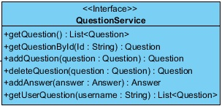

**Methods**

|  |  |  |  |
| --- | --- | --- | --- |
| **ID** | **Name** | **Description** | **Remarks** |
| 1 | +getQuestion() : List<Question> | Method for get a list of all question to display | Display a list of all question |
| 3 | getQuestionById(Id : String) : Question | Method for search question by id from the database | Searching question |
| 4 | addQuestion(question : Question) : Question | Method for add question info into the database | Added new record |
| 5 | deleteQuestion(question : Question) : Question | Method for delete question from the database | Deleted record |
| 6 | addAnswer(answer : Answer) : Answer | Method for add answet info into the database | Added new record |
| 7 | getUserQuestion(username : String): List<Question> | Method for get a list of all question from user’s email to display | Display a list of all question |



**Methods**

|  |  |  |  |
| --- | --- | --- | --- |
| **ID** | **Name** | **Description** | **Remarks** |
| 1 | +getQuestion() : List<Question> | Method for get a list of all question to display | Display a list of all question |
| 2 | getQuestionById(Id : String) : Question | Method for search question by id from the database | Searching question |
| 3 | addQuestion(question : Question) : Question | Method for add question info into the database | Added new record |
| 4 | deleteQuestion(question : Question) : Question | Method for delete question from the database | Deleted record |
| 5 | addAnswer(answer : Answer) : Answer | Method for add answet info into the database | Added new record |
| 6 | getUserQuestion(username : String): List<Question> | Method for get a list of all question from user’s email to display | Display a list of all question |
| 7 | +sendSuccessAnswer(answer : Answer) |  |  |

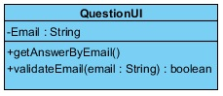

**Attributes**

|  |  |  |  |
| --- | --- | --- | --- |
| **ID** | **Name** | **Description** | **Remarks** |
| 1 | Email | A variable of user email | Return Type : String |

**Methods**

|  |  |  |  |
| --- | --- | --- | --- |
| **ID** | **Name** | **Description** | **Remarks** |
| 1 | getAnswerByEmail() | Method for get a list of all question to display | Display a list of all question |
| 2 | validateEmail(email : String) : boolean | Method for search question by id from the database | Searching question |

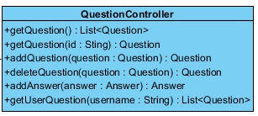

**Methods**

|  |  |  |  |
| --- | --- | --- | --- |
| **ID** | **Name** | **Description** | **Remarks** |
| 1 | +getQuestion() : List<Question> | Method for get a list of all question to display | Display a list of all question |
| 2 | getQuestionById(Id : String) : Question | Method for search question by id from the database | Searching question |
| 3 | addQuestion(question : Question) : Question | Method for add question info into the database | Added new record |
| 4 | deleteQuestion(question : Question) : Question | Method for delete question from the database | Deleted record |
| 5 | addAnswer(answer : Answer) : Answer | Method for add answet info into the database | Added new record |
| 6 | getUserQuestion(username : String): List<Question> | Method for get a list of all question from user’s email to display | Display a list of all question |