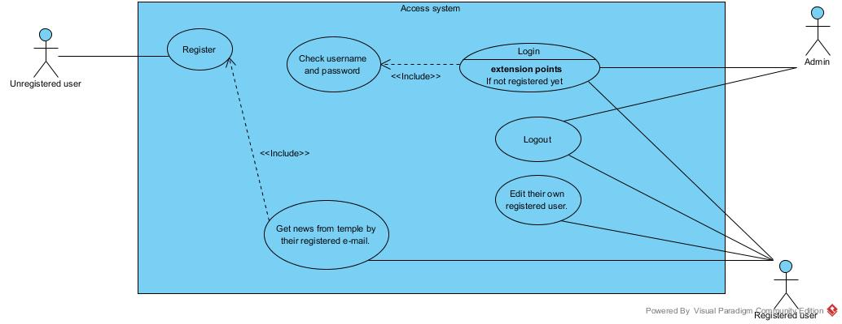Use case diagram

**Figure 1: Use Case diagram of Access System**

Figure 1 shows actor is the unregistered user. The Unregistered user has the responsibility to register to system.

Figure 1 shows the admin actor. The admin must check username and password before using this system and after he/she has the responsibility to login to system and has the responsibility to login and he/she has the responsibility to log out.

Figure 1 shows actor is the registered user. The registered user must register to system before using the system and after that he/she has the responsibility to get news from temple by their registered e-mail,

The registered user must check username and password before using this system and after he/she has the responsibility to login and the registered user has the responsibility logout

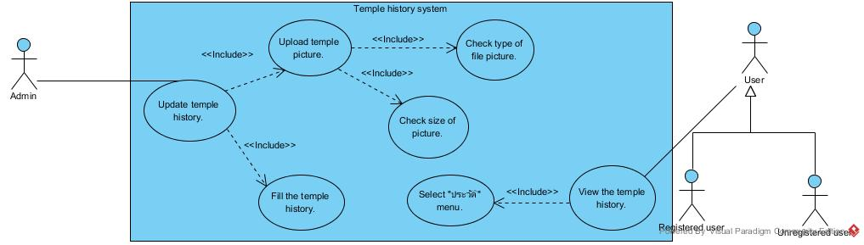

**Figure 2: Use Case diagram of Temple History System**

Figure 2 shows the admin actor. The admin must check size of picture and check type of file picture before using this system and after he/she has the responsibility to upload temple picture and the admin must upload temple picture and fill the temple history before using this system and after he/she has the responsibility to update temple history.

Figure 2 shows actor is the user that consists of registered user and registered user. The user must select "ประวัติ" menu format before using the system and after that he/she has the responsibility to view the temple history.

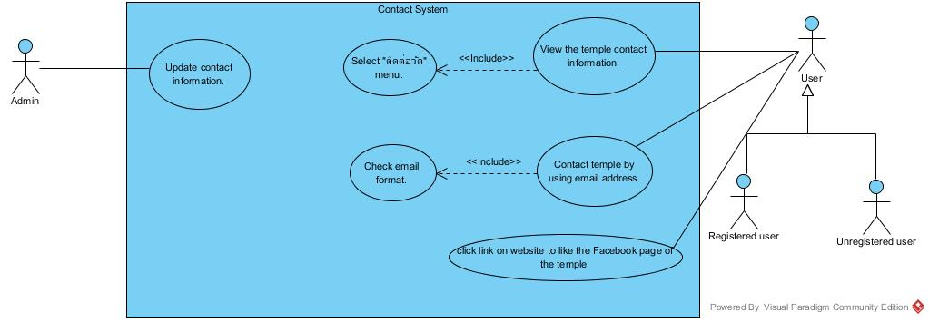

**Figure 3: Use Case diagram of Contact System**

Figure 3 shows the admin actor. The admin has the responsibility to update contact information.

Figure 3 shows actor is the user that consists of registered user and registered user. The user must select "ติดต่อวัด" menu before using the system and after that he/she has the responsibility to view the temple contact information and the user must input correct email format before using the system and after that he/she has the responsibility to contact temple by using email address and user can click link on website to like the Facebook page of the temple.

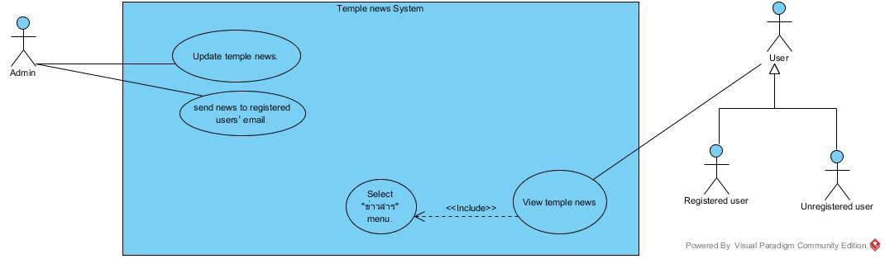**Figure 4: Use Case diagram of Temple News System**

Figure 4 shows the admin actor. The admin has the responsibility to update temple picture and admin can send news to registered users’ email.

Figure 4 shows actor is the user that consists of registered user and registered user. The user must select "หน้าแรก" menu before using the system and after that he/she has the responsibility to view temple pictures in the Homepage.

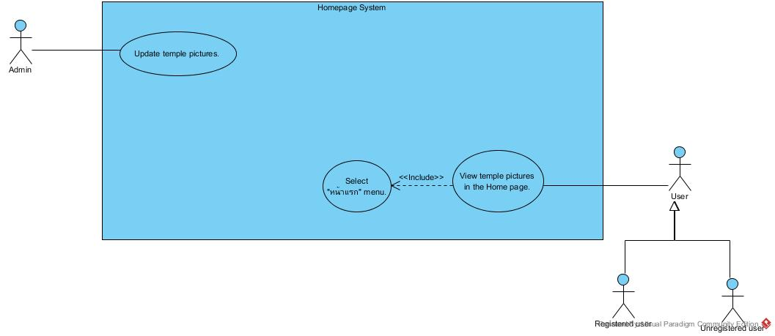

**Figure 5: Use Case diagram of Home Page System**

      Figure 5 shows the admin actor. The admin must view preview Home Page before using this system and after he/she has the responsibility to update temple picture.

Figure 5 shows actor is the user that consists of registered user and registered user .The user must select "หน้าแรก" menu before using the system and after that he/she has the responsibility to view temple pictures in the Homepage.

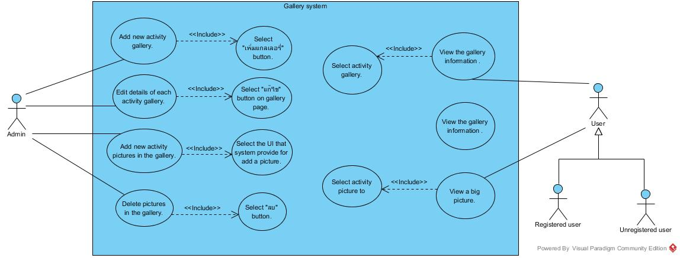

**Figure 6: Use Case diagram of Gallery System**

Figure 6 shows the admin actor. The admin must select "เพิ่มแกลเลอรี่" button before using this system and after that he/she has the responsibility to add new activity gallery, the admin must select "แก้ไข" button on gallery page before using this system and after that he/she has the responsibility to edit details of each activity gallery, the admin must select the UI that system provide for add a picture before using this system and after that he/she has the responsibility to add new activity pictures in the gallery and the admin must select "ลบ" button before using this system and after that he/she has the responsibility to delete pictures in the gallery.

Figure 6 shows actor is the user that consists of registered user and unregistered user .The user must select activity gallery before using the system and after that he/she has the responsibility to view the gallery information and activity picture and The user must select activity before using the system and after that he/she has the responsibility to picture to view a big picture.

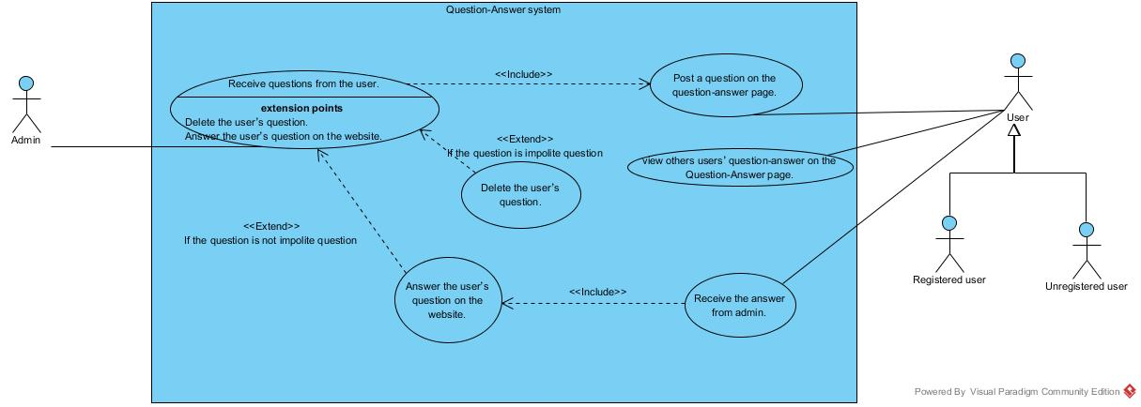

**Figure 7: Use Case diagram of Question-Answer System**

Figure 7 shows actor is the user that consists of registered user and unregistered user .The user has the responsibility to post a question on the question-answer page, view others users’ question-answer on the Question-Answer page and receive the answer from admin.

For the admin receive questions from the user. If the question is impolite question, the admin can delete the user’s question and if the question is not impolite question, the admin can answer the user’s question on the website and

The admin must answer the user’s question on the website before using the system and after that the user has the responsibility to receive the answer from admin.

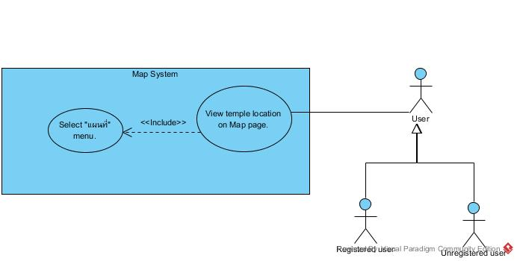

**Figure 8: Use Case diagram of Map System**

Figure 8 shows actor is the user that consists of registered user and unregistered user. The user must select “แผนที่” menu before using this system and after he/she has the responsibility to view temple location on Map page.