Two-sensor resonance reader comparison — review report
Setup A · NanoVNA and Red Pitaya STEMlab 125-14 Gen 2 · 29 September 2026
Status (updated 30 September): static frequency-noise and frame-rate results complete for the saved captures. Sensor signal and SNR were not measured.

1. Objective and scope
This experiment compares repeated resonance-frequency estimates and complete two-sensor frame rates from the NanoVNA-derived reader and the Red Pitaya resonance tracker. The updated Setup A metadata describes antenna 1 as a small antenna with “Cser 10pF” and geometry entered as 240mm(D) (75cm length), sensor custom 1 at 6 cm and custom 2 at 7 cm from reference p1, 0.15 m MMCX coax, no CMC, and a 50 Ω bridge reference. The geometry entry is internally ambiguous and is preserved verbatim. Both readers scanned 20–26 MHz and found resonances near 21.12 and 24.69 MHz. Physical matching during the reader swap has not been independently verified, so these are nominal Setup A results.
The comparison uses a 20-second Red Pitaya WINDOW_SHIFT=20 capture and the NanoVNA COM11 capture at 100 Hz tracking bandwidth, saved at 12:35 UTC on 28 September 2026. Each used one baseline to run five-point tracking followed by three-point tracking.

2. Acquisition and operating point
Item | Red Pitaya main run | NanoVNA fresh run
Time (UTC, 28 Sep 2026) | Approximately 12:30 | 12:35–12:36
Coarse scan | 20–26 MHz, 151 points | 20–26 MHz, 101 points
Coarse/refinement averaging | 3 / 3 complex averages | 3 / 3 complex averages
Refinement | 21 points per selected candidate | 21 points per selected candidate
Tracking | Two sensors; five points, then middle three points from the same baseline | Two sensors; five points, then middle three points from the same baseline
Integration/bandwidth | FPGA WINDOW_SHIFT=20: 2²⁰ samples at 125 MS/s per point; effective noise bandwidth not calibrated here | 100 Hz configured tracking bandwidth; 16 kHz IF reported by baseline record
Source setting | User reports 800 mV peak into 50 Ω at amplitude register 0x10; app writes 0x0800 | User reports DDS 8 mA into 50 Ω, 400 mV RMS at source, 200 mV RMS at antenna
Display state | No local display in the reader path | User confirms no visible screen content during the selected capture and later matrix; firmware display state and LCD bus activity were not logged
Calibration/plane | Raw coherent incident/reflected I/Q ratio, no absolute S11 calibration claimed | Metadata says calibrated at coax output; tracker uses raw measurement/reference ratio before the usual NanoVNA calibration/error-term path
Received level / ADC %FS / TX-RX gain | Not recorded with a validated voltage or full-scale conversion | Not recorded
For a sinusoid actually measuring 800 mV peak across 50 Ω, the Red Pitaya setting corresponds to 0.566 V RMS or 6.4 mW (+8.06 dBm). The stated NanoVNA DDS level of 400 mV RMS across 50 Ω corresponds to 3.2 mW (+5.05 dBm). These are conversions of user-supplied levels, not independent measurements. The reported NanoVNA level at the antenna is 200 mV RMS; the corresponding Red Pitaya antenna level is unknown. The source levels therefore differ, and the receivers’ voltage scales and reflection-ratio conventions have not been cross-calibrated. Their complex values are not compared as absolute S11.
The configured source-voltage ratio Red Pitaya/NanoVNA at their respective 50 Ω outputs is 0.566/0.400 = 1.414 in RMS voltage. The reported NanoVNA antenna/source ratio is 0.200/0.400 = 0.5. No Red Pitaya voltage at the antenna was captured, so there is no measured antenna-level amplitude ratio between readers.
The selected two-sensor NanoVNA capture used 100 Hz tracking bandwidth. A 4 kHz NanoVNA file exists in an older one-sensor context dataset, but it did not use a verified matching setup and is excluded from the platform comparison. The baseline 16 kHz IF setting and 100 Hz tracking bandwidth describe different acquisition stages. On Red Pitaya, WINDOW_SHIFT=20 means 1,048,576 samples per complex point at 125 MS/s, or 8.388608 ms per point. Ten point acquisitions for a five-point, two-sensor frame have an ideal window-time floor of 83.88608 ms, before settling, readout, and processing. The observed mean interval was 87.13 ms. This integration time is not an experimentally measured equivalent noise bandwidth and should not be equated directly to NanoVNA’s 100 Hz setting.
The NanoVNA baseline fitted sensor 1 at 21,121,256 Hz, Q 106.36, model quality 0.9866, and sensor 2 at 24,692,258 Hz, Q 91.335, quality 0.9900. The Red Pitaya shift-20 baseline fitted 21,119,826 Hz, Q 107.42, quality 0.9971, and 24,689,838 Hz, Q 86.85, quality 0.9931. These centers agree within a few kilohertz; this supports the intended sensor correspondence but does not prove unchanged geometry or equal excitation. Both baselines reported frequency SE of zero. Their estimator searches have finite center resolution, and zero should not be interpreted as zero physical uncertainty.

3. Static frequency noise
For each unchanged tracking interval, dF RMS is the population root-mean-square deviation from that interval’s mean frequency, dividing by N. Sample SD divides by N−1. Internal SE is the estimator’s per-frame quantity averaged over the interval; it is kept separate from measured repeatability. The table gives kilohertz except for mean frequency.
Reader and mode | Sensor | Complete estimates used | Mean frequency (MHz) | dF RMS (kHz) | Sample SD (kHz) | Mean internal SE (kHz)
NanoVNA, five-point | 1 | 106 | 21.121501 | 4.132 | 4.151 | 7.015
NanoVNA, five-point | 2 | 106 | 24.688131 | 4.674 | 4.696 | 6.994
Red Pitaya, five-point, shift 20 | 1 | 230 | 21.120793 | 3.466 | 3.473 | 2.243
Red Pitaya, five-point, shift 20 | 2 | 230 | 24.687462 | 3.939 | 3.947 | 5.662
NanoVNA, three-point | 1 | 169 | 21.121597 | 5.851 | 5.868 | 12.754
NanoVNA, three-point | 2 | 169 | 24.695524 | 4.085 | 4.097 | 6.681
Red Pitaya, three-point, shift 20* | 1 | 250 of 383 backend sequences | 21.119167 | 1.283 | 1.286 | 3.333
Red Pitaya, three-point, shift 20* | 2 | 250 of 383 backend sequences | 24.687334 | 3.800 | 3.808 | 2.904
*The Red Pitaya three-point SD and dF RMS use only sequence-matched WebSocket frames (65.3% of backend sequences). They are observed-subset statistics, not established full-backend repeatability. Its apparent sensor-1 improvement over five-point tracking must not be treated as a mode effect.
In the two complete five-point records, the Red Pitaya dF RMS was about 0.84 times the NanoVNA value for each sensor, at the settings above. That describes these recordings; source level, effective bandwidth, and exact geometry are not controlled well enough to attribute the difference to the platform. Visible NanoVNA screen rendering was absent by user observation.
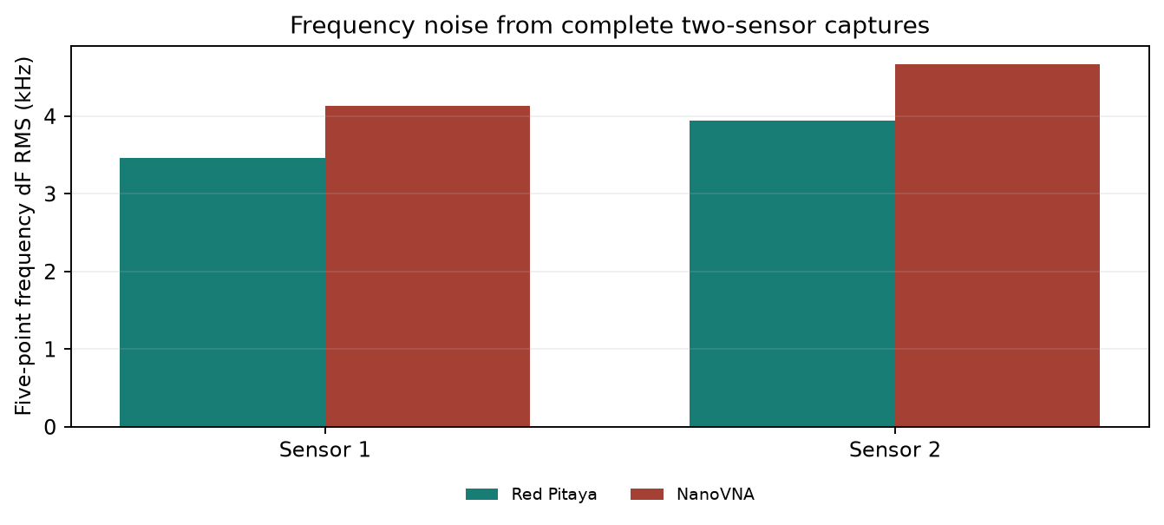
Five-point frequency noise by reader
Figure 1. Population dF RMS of every complete five-point frequency estimate in the selected captures.
Define the frequency-noise ratio as NanoVNA five-point dF RMS divided by Red Pitaya shift-20 five-point dF RMS for the same sensor. It is 1.192 / 1.187 for sensors 1 / 2. A ratio above one means higher observed frequency scatter in the selected NanoVNA capture. It is not sensor SNR, a complex reflection-ratio noise statistic, or an intrinsic reader-noise ratio; excitation, effective bandwidth, and physical matching remain uncontrolled. User confirmation removes visible screen rendering as an explanation for this observed difference, while LCD bus activity remains unknown.
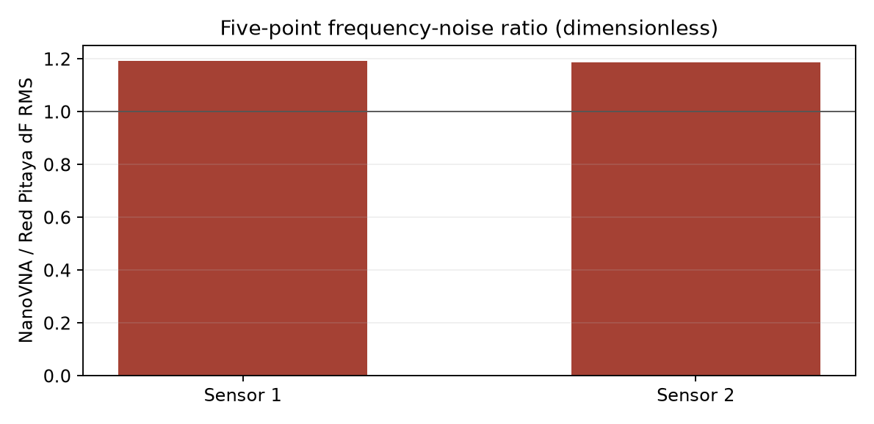
NanoVNA to Red Pitaya frequency-noise ratio
Figure 2. Dimensionless NanoVNA/Red Pitaya dF RMS ratio, computed from the selected five-point captures. Exact values are in the ratio CSV.
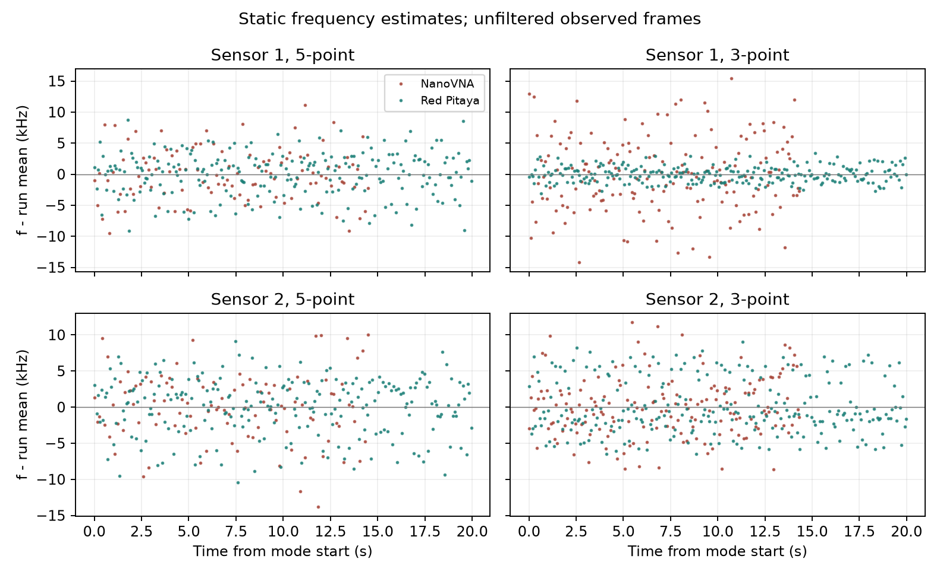
Frequency deviations over each static capture
Figure 3. Frequency deviation from each capture’s own mean. Every plotted estimate is retained. The Red Pitaya three-point plot contains only sequence-matched telemetry frames.

Complex amplitude ratio and phase noise
For each complex tracking point, the Red Pitaya reports Γ = reflected / incident from coherent raw I/Q. The NanoVNA debug record is its raw measurement/reference ratio before calibration. The amplitude ratio is |Γ| = hypot(Re Γ, Im Γ) and phase is atan2(Im Γ, Re Γ) in degrees. At tracker offset zero, each frame samples a moving center frequency; the noise below includes any change caused by tracker motion or drift. Amplitude noise is the population RMS deviation of |Γ| from its mean. Relative amplitude noise divides that RMS by mean |Γ|. Phase noise is the population RMS of wrapped phase residuals around the phase of the mean complex ratio.
Reader, five-point center sample | Sensor | Mean amplitude ratio |Γ| | Amplitude noise RMS | Relative amplitude noise | Mean phase (°) | Phase noise RMS (°)
Red Pitaya, shift 20 | 1 | 2.209694 | 0.00005649 | 0.00256% | 59.319 | 0.01038
Red Pitaya, shift 20 | 2 | 2.286308 | 0.00013868 | 0.00607% | 73.145 | 0.01475
NanoVNA, debug frame | 1 | 2.004477 | unavailable | unavailable | −36.128 | unavailable
NanoVNA, debug frame | 2 | 2.000058 | unavailable | unavailable | −44.330 | unavailable
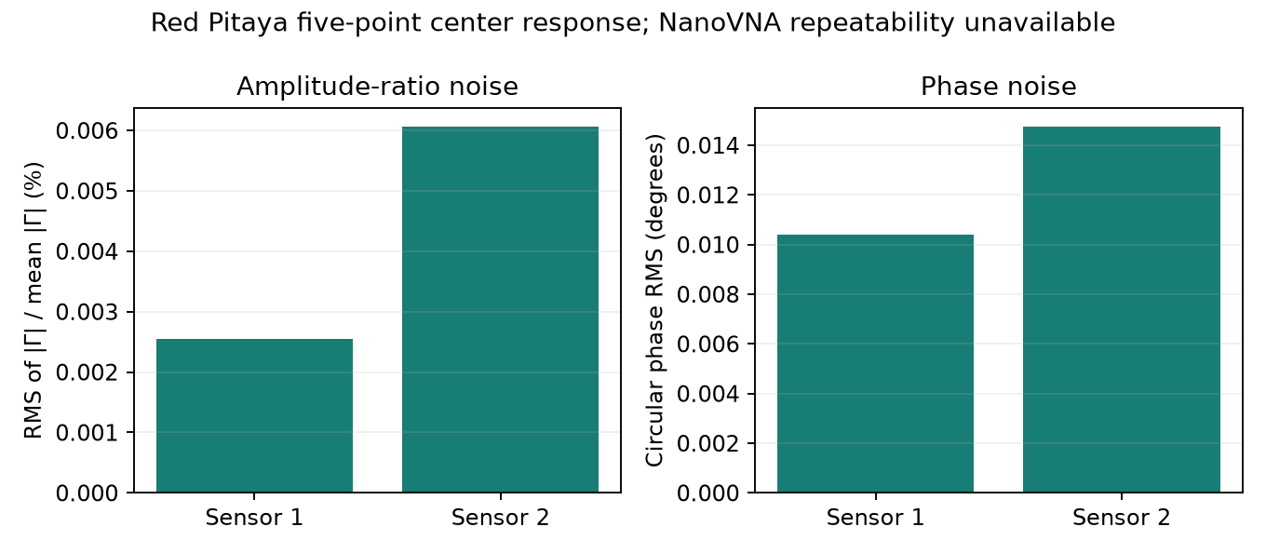
Red Pitaya complex amplitude and phase scatter
Figure 4. Complex amplitude-ratio and phase noise from the complete Red Pitaya five-point series at offset zero. The complex statistics CSV also includes its incomplete-coverage three-point subset and the selected NanoVNA capture’s single debug frame. The NanoVNA timed tracking did not save repeated complex points, so NanoVNA amplitude and phase noise cannot be estimated. Ratios above unity and the different phase origins reflect uncalibrated internal response conventions; these values are not absolute reflection coefficients or directly comparable across readers.

4. Complete two-sensor frame rate
Reader and mode | Rate (frames/s) | Mean observed interval (ms) | Interval sample SD (ms) | Timing basis
NanoVNA, five-point | 7.25 | 137.98 | 26.08 | 106 consecutive timestamped RTD records
NanoVNA, three-point | 11.73 | 85.26 | 24.14 | 169 consecutive timestamped RTD records
Red Pitaya shift 20, five-point | 11.48 | 87.13 | 28.01 | 230 consecutive, sequence-matched WebSocket frames; backend reports ~11.5/s
Red Pitaya shift 20, three-point | about 19.1 | unavailable | unavailable | Backend sequence growth during the requested 20 s; WebSocket retained 250/383 sequences
Rates refer to a complete pair of sensor estimates, not the per-sensor point-acquisition rate. NanoVNA timestamps are serial receipt times; Red Pitaya five-point timestamps are WebSocket receipt times. Their interval SDs include host and transport jitter and are not pure hardware-acquisition jitter. The Red Pitaya five-point sequence was consecutive, and its observed 11.48 frames/s agrees with the backend’s roughly 11.5 frames/s. At these settings, that is about 1.58 times the NanoVNA five-point rate. The Red Pitaya three-point rate is less directly timed because individual backend-frame timestamps were not exported.
The frequency-noise versus frame-rate plot is retained as a supplementary analysis figure. Its hollow Red Pitaya three-point markers identify noise calculated from a sampled WebSocket subset.

5. Signal, SNR, and measurement artifacts
No controlled second physical sensor state was available. Sensor signal Δf, complex contrast |ΔΓ|, and sensor SNR are therefore unavailable. Changing WINDOW_SHIFT or averaging changes the reader’s acquisition conditions; it is not a sensor-state signal. The machine-readable comparison table leaves these fields blank. When a repeatable state change is available, the specified frequency SNR is |mean(f_state2) − mean(f_state1)| / sample_SD(f_state1) under fixed geometry and settings. Internal SE must not replace the denominator.
The selected NanoVNA timed records contain frequency estimates but no repeated complex Γ points; its separate debug capture has one complex frame. Thus a matched complex reflection-ratio noise comparison cannot be calculated from these records. The frequency-noise ratio graph above is explicitly a ratio of frequency noise values.
The Red Pitaya setting sweep exposed a candidate-selection risk. At shift 17 with one coarse/refinement average, one baseline selected 24.729 and 24.895 MHz, missing the ~21.12 MHz lobe, yet the backend marked it valid; the second fit’s model quality was 0.277. That run’s tracking records are preserved but excluded from the sensor comparison. With three averages, the intended two lobes were recovered. This is one observed failure, not an estimated failure probability. At shift 17 and three averages the tracker ran near 67 five-point and 75 three-point backend frames/s, but only 34 and 97 complete matched WebSocket frames were retained; those noise estimates are not directly comparable to the complete shift-20 series.
The NanoVNA live mean Q changed from about 81/92 in five-point mode to 159/182 in three-point mode without a deliberate physical change. This sparse live Q diagnostic should not be interpreted as a physical Q shift. NanoVNA and Red Pitaya baseline SE values of zero also need an explicit validity/resolution indicator before use as uncertainty evidence. A known response feature near 25 MHz may affect candidate selection; these captures do not distinguish an antenna response from a reader artifact.

6. Conclusions and review items
The saved data support a descriptive static comparison: both readers tracked the two intended frequency regions, and the selected five-point captures contain consecutive complete two-sensor frames. In those captures the NanoVNA produced 7.25 frames/s with dF RMS 4.132/4.674 kHz, while the Red Pitaya at shift 20 produced 11.48 frames/s with dF RMS 3.466/3.939 kHz. This single near-time capture pair is insufficient for a robust platform ranking. The three-point Red Pitaya noise estimate has incomplete WebSocket coverage.
The user confirms no visible NanoVNA display content in both the selected comparison capture and the 30 September NanoVNA matrix. Visible screen rendering therefore does not explain the selected NanoVNA’s observed 19% higher five-point frequency scatter or lower frame rate. Under the same no-display observation, 192 ksample/s tracking had no relocks, while 384 and 768 ksample/s tracking relocked frequently and 768k baseline fits often degraded. The later matrix does not supply a matched Red Pitaya comparison at those rates, and tracker loss/relock motion prevents treating its frequency spread as stationary reader noise. The confirmation does not establish whether LCD SPI traffic continued.
The platform comparison remains descriptive because source level, effective noise bandwidth, and physical matching are not established as equal. The observation concerns visible content, not a verified LCD power or SPI state.
Before treating this as a matched performance result, verify whether antenna/sensor positions and the recorded 0.15 m MMCX RF path stayed fixed when swapping readers, and clarify the geometry entry 240mm (75cm). The metadata records calibration at the coax output, but this does not establish calibration of the tracker’s raw ratio. Measured source, received, and ADC levels are still needed to compare operating points. A controlled physical sensor change is required for signal and SNR. None of these pending quantities has been filled with an inferred value.

Reproducibility and source files
- Machine-readable comparison, frequency-noise ratio values, complex amplitude/phase statistics, and plot/CSV generator.
- Selected NanoVNA raw serial log and summary. Other NanoVNA captures are preserved but excluded from this analysis.
- Red Pitaya shift-20 raw WebSocket log, sequence-matched estimates, complex points, and summary.
- Updated setup metadata and comparison protocol.
All analysis retains the raw files. No outlier rejection or smoothing of frequency estimates was applied. The existing validation script passes its reference-statistics and synthetic two-sensor checks; the live capture files were additionally checked for sequence continuity and expected point counts.

