Member
6622780805 Rachata Theerapraphotphanu
6622782348 Supawit Omsin

Project : CARTHUB
22th November 2025

1. Introduction

1.1 Background and Problem statement
Nowadays, people tend to live in condominiums or apartments much more than in the past, and public carts have become an essential facility provided for residents to borrow when needed. However, several issues frequently occur, such as residents not returning carts to the designated area or carts going missing entirely. These problems lead to inconvenience for other residents, reduced overall satisfaction, and unnecessary waste of staff time and resources spent searching for the carts.
To address these issues, we introduce our project “CartHub”, a system designed to track the real-time status of each cart through an administration website, along with a resident website that enables easy and efficient borrowing.

1.2 Objectives
- To develop a system for borrowing and returning carts using QR code scanning.
- To display the real-time status of each cart.
- To establish a penalty system for residents who violate the borrowing rules.
- To develop an administrative system that allows staff to effectively manage carts and users.
- To reduce issues related to improperly returned or missing carts.

1.3 Project Scope
This project consists of two main components:
Resident:
A website that allows residents to borrow carts. Residents can also manage their personal profiles, such as updating personal information or changing their avatar.
Admin:
A website designed for administrators to manage and control the entire system, including monitoring cart status, managing user accounts, viewing borrowing history, and overseeing payment or penalty records.

2. System Requirements

2.1 Functional Requirement
This part provides the features and functions that the system must include:
Resident:
- The system must allow residents to register and log in.
- The system must allow residents to choose an available cart to borrow.
- The system must use a QR code system for borrowing carts.
- The system must track the borrowing time while residents are using the cart.
- The system must allow residents to return a cart by pressing a button.
- The system must allow residents to edit their personal information.

Admin Features:
- The system must allow admins to log in to the administrative page.
- The system must allow admins to navigate to different pages via the dashboard.
- The system must allow admins to view the real-time status of each cart.
- The system must allow admins to view the user list and manage it, including creating new users, updating user information, and deleting users.
- The system must allow admins to change the penalty status of each user.
- The system must allow admins to filter users based on specific details.
- The system must allow admins to view the list of bills, which are penalties from users.
- The system must allow admins to update the status of each bill.
- The system must allow admins to view the history of cart borrowings.
- The system must allow admins to filter the history page by specific details.
2.2 Non-Functional Requirement
This part provides the system’s quality and how the system will perform:
Usability:
- The system should have a user-friendly UX and UI.
- Both residents and admins should be able to use the website with minimal or no training.
Performance:
- The system must be able to handle multiple users simultaneously, with the capacity to support up to ten million users.
- The system should respond within a minimal amount of time for any action.
Security:
- The system must secure sensitive data, such as passwords, by encrypting them using hash functions.
- The system must allow only admin accounts to access the admin panel.
- Communication between the website and the server should be encrypted.

3. System Architecture
This part provides the overall structure of the system, focusing on how the system is organized and what programming language we use in this project.
3.1 Technology Stack
This part provides a list of the technologies, programming languages, and frameworks used in this project. These are :
- Frontend :
  - HTML
  - CSS
  - JavaScript
- Backend :
  - PHP
  - MySQL
- Database :
  - MySQL
- Hosting :
  - Hostinger

4. Database Design
4.1 ER Diagram

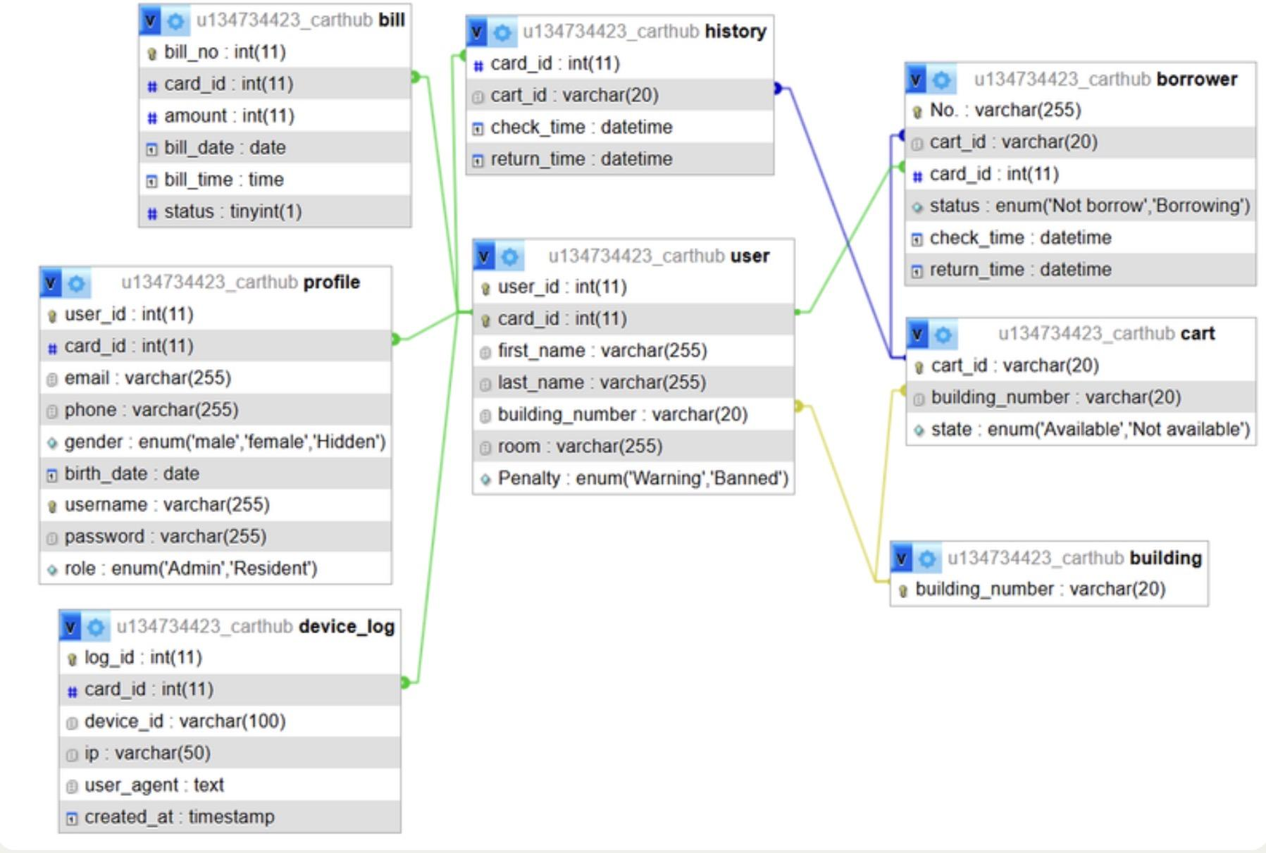

4.2 Table Description
This project consists of 8 tables those are :
- bill
- borrower
- building
- cart
- device_log
- history
- profile
- User

5. System Workflow
5.1 Resident Workflow
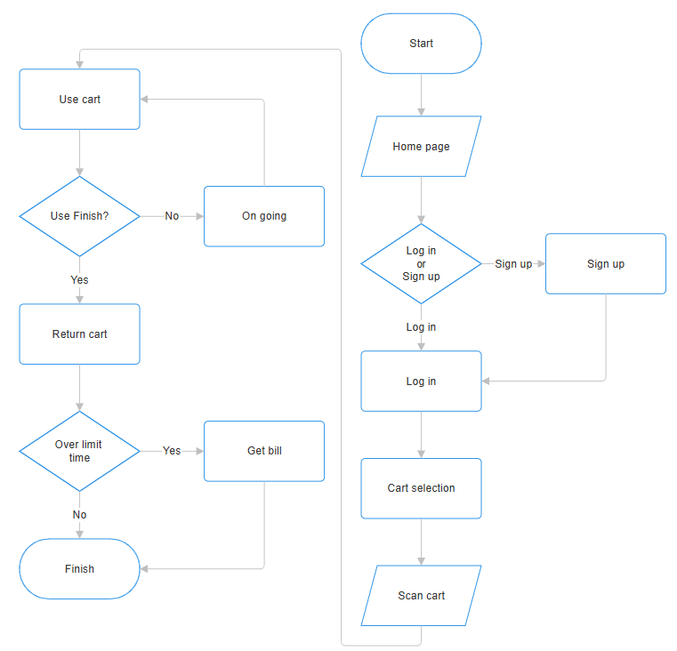
5.2 Admin Workflow
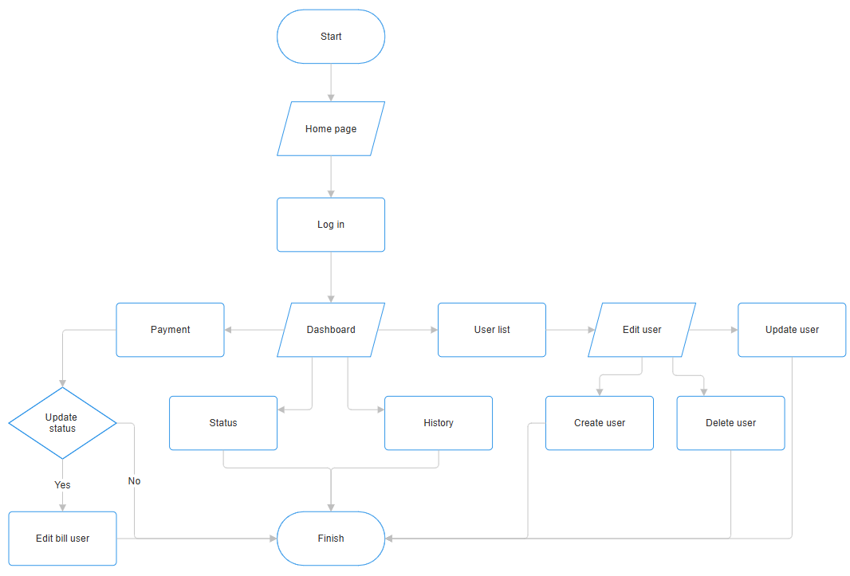
6. UX/UI Design
- Resident
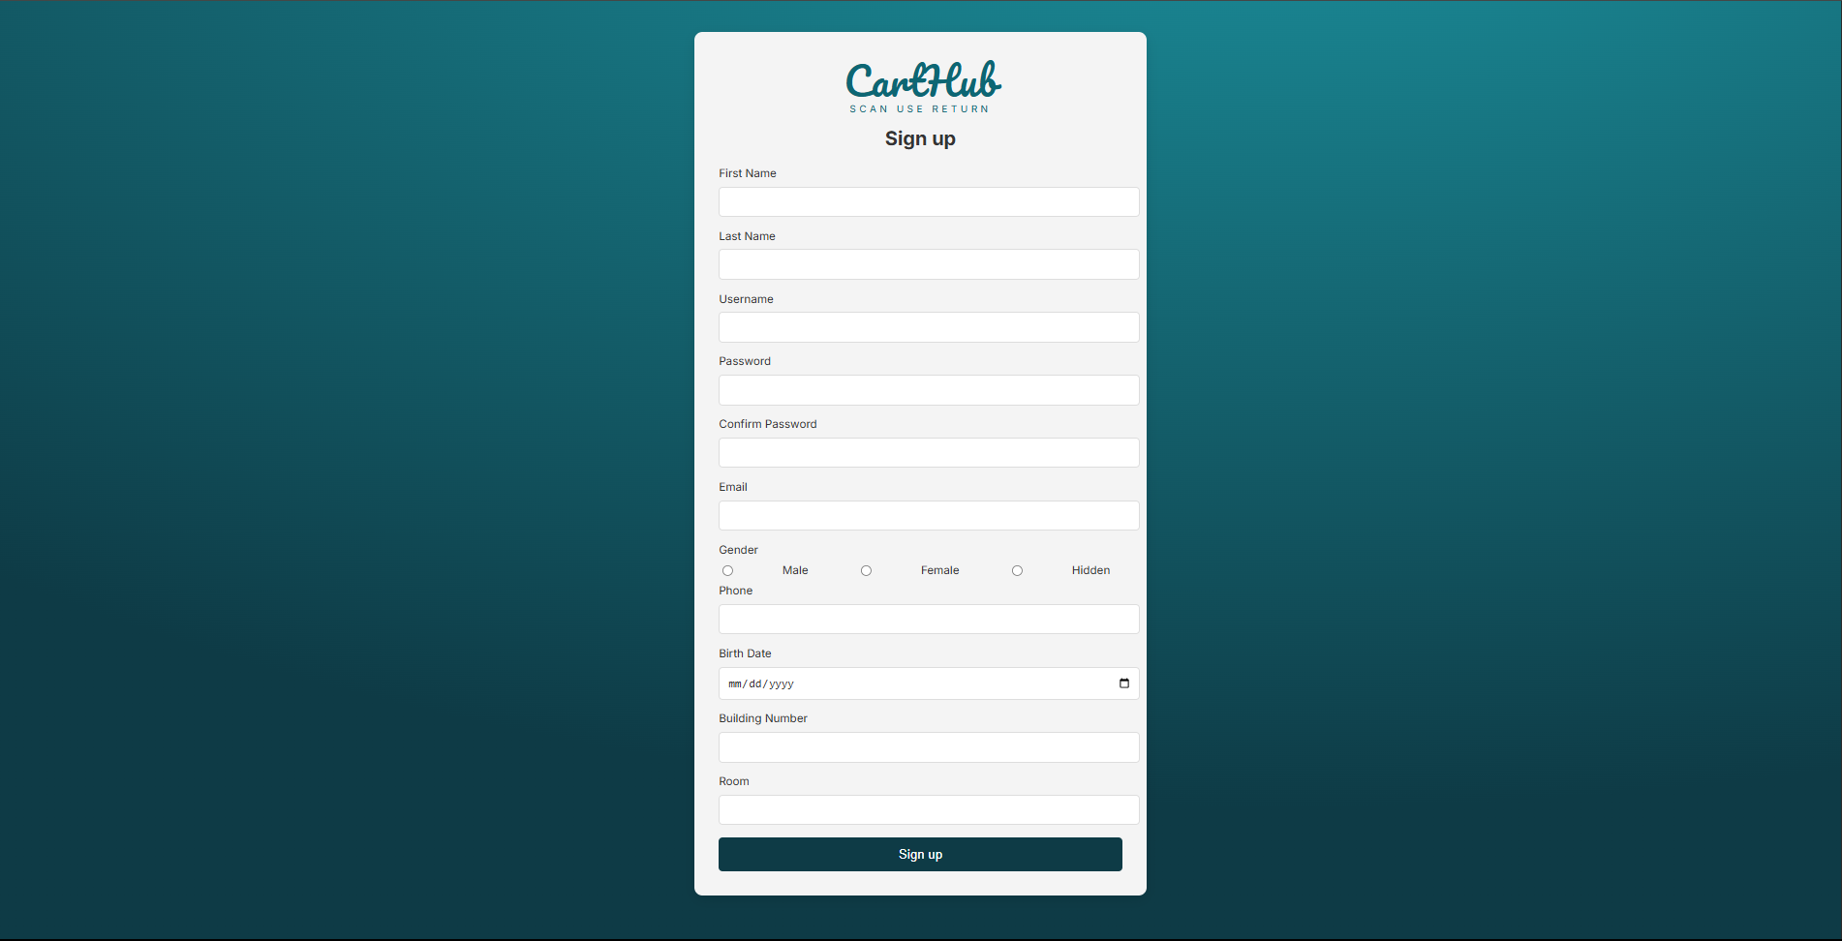
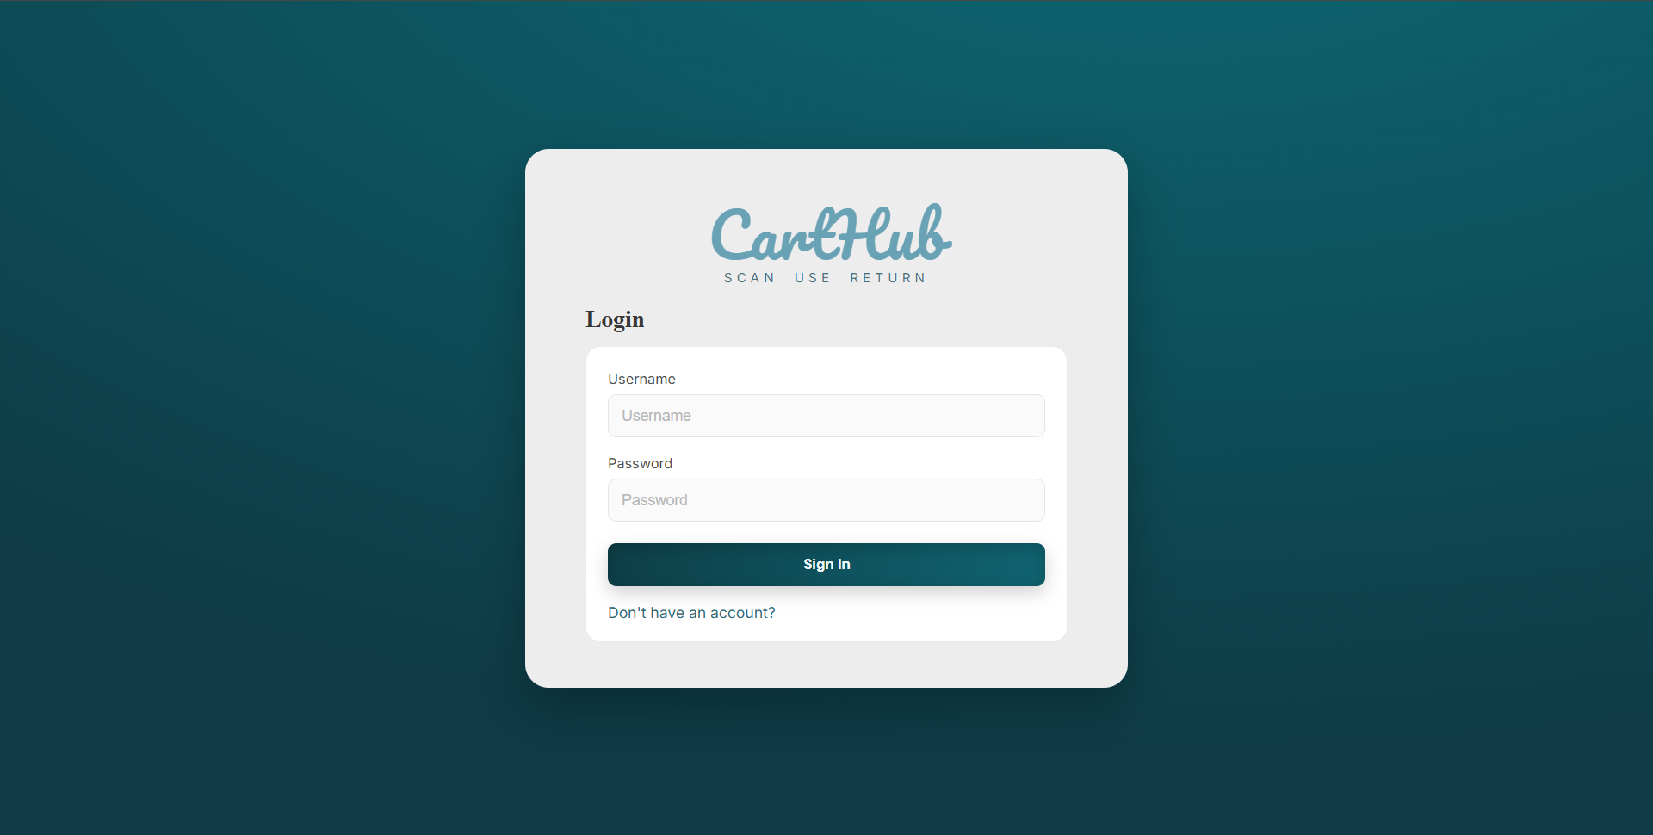
Login & Register
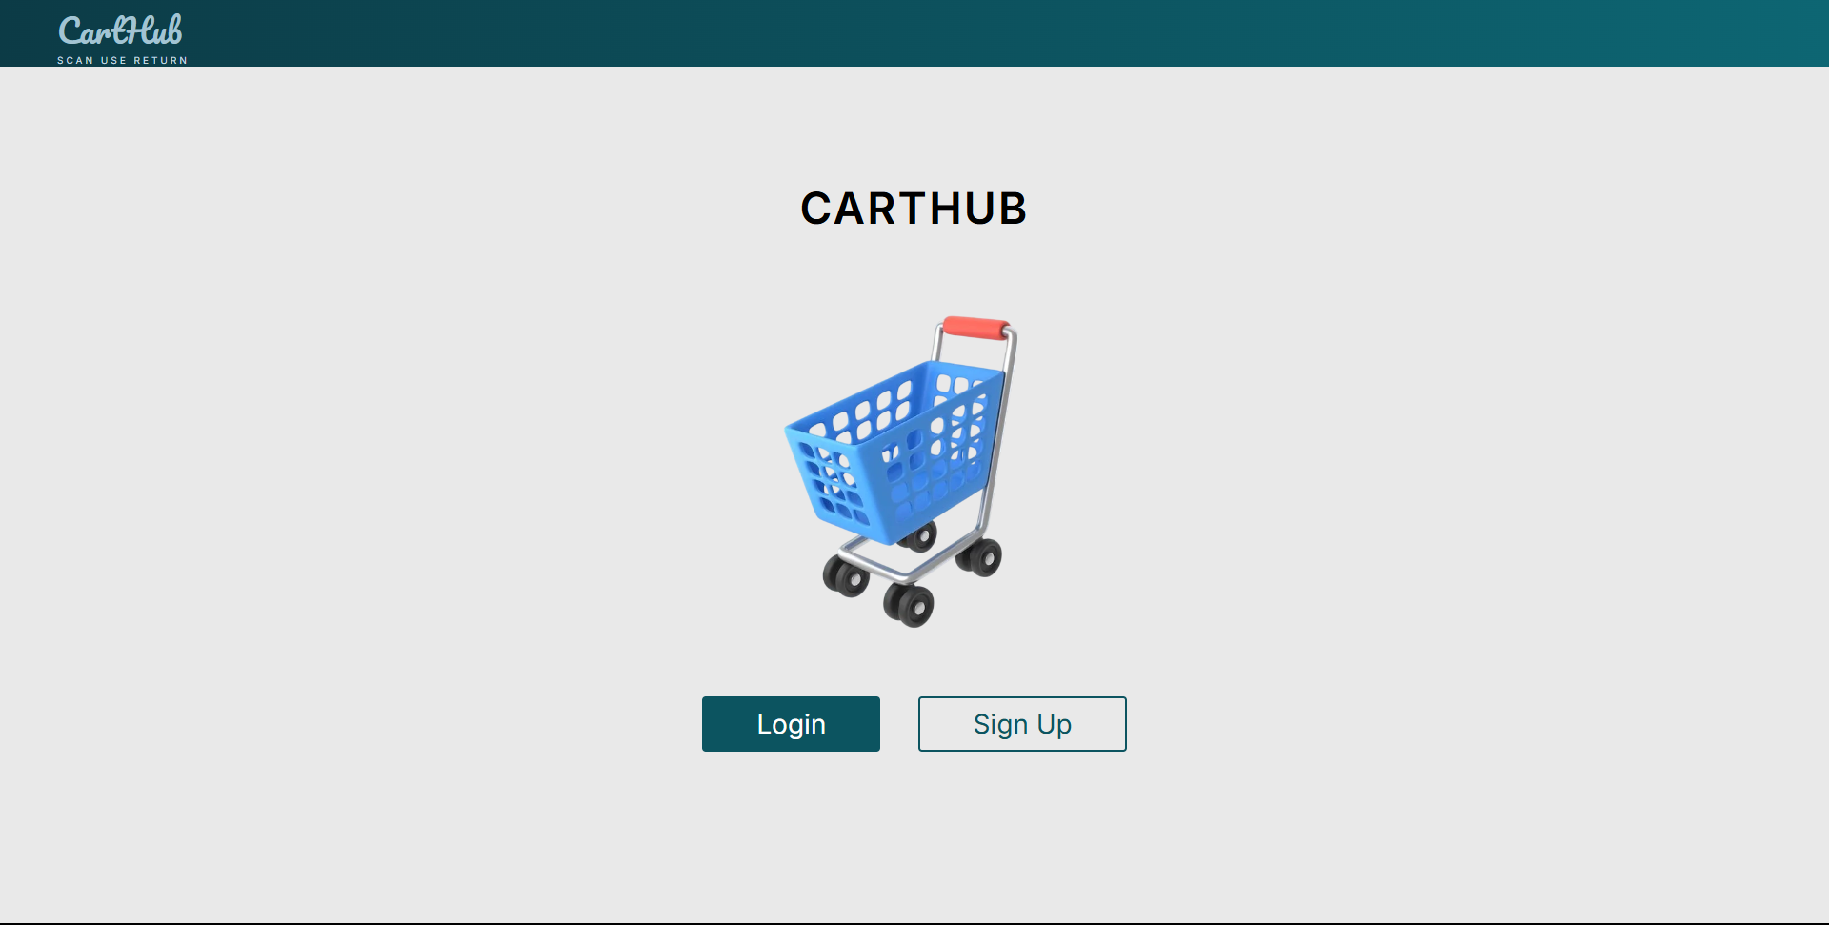
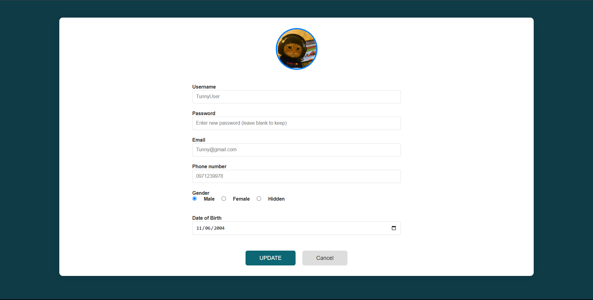
Home & Profile
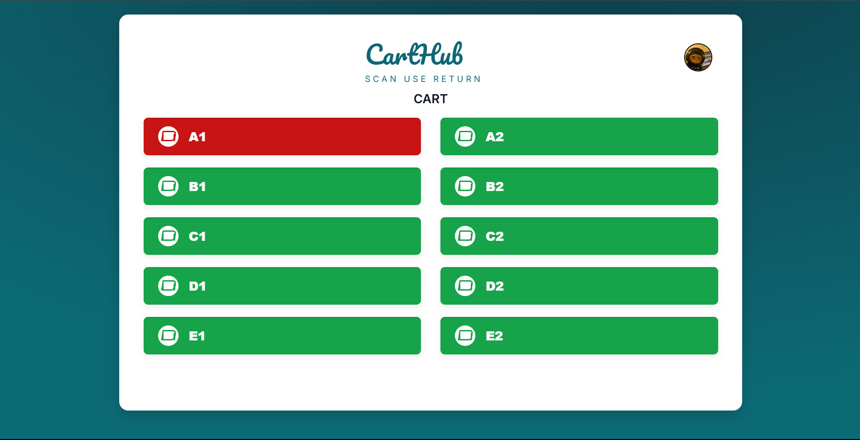
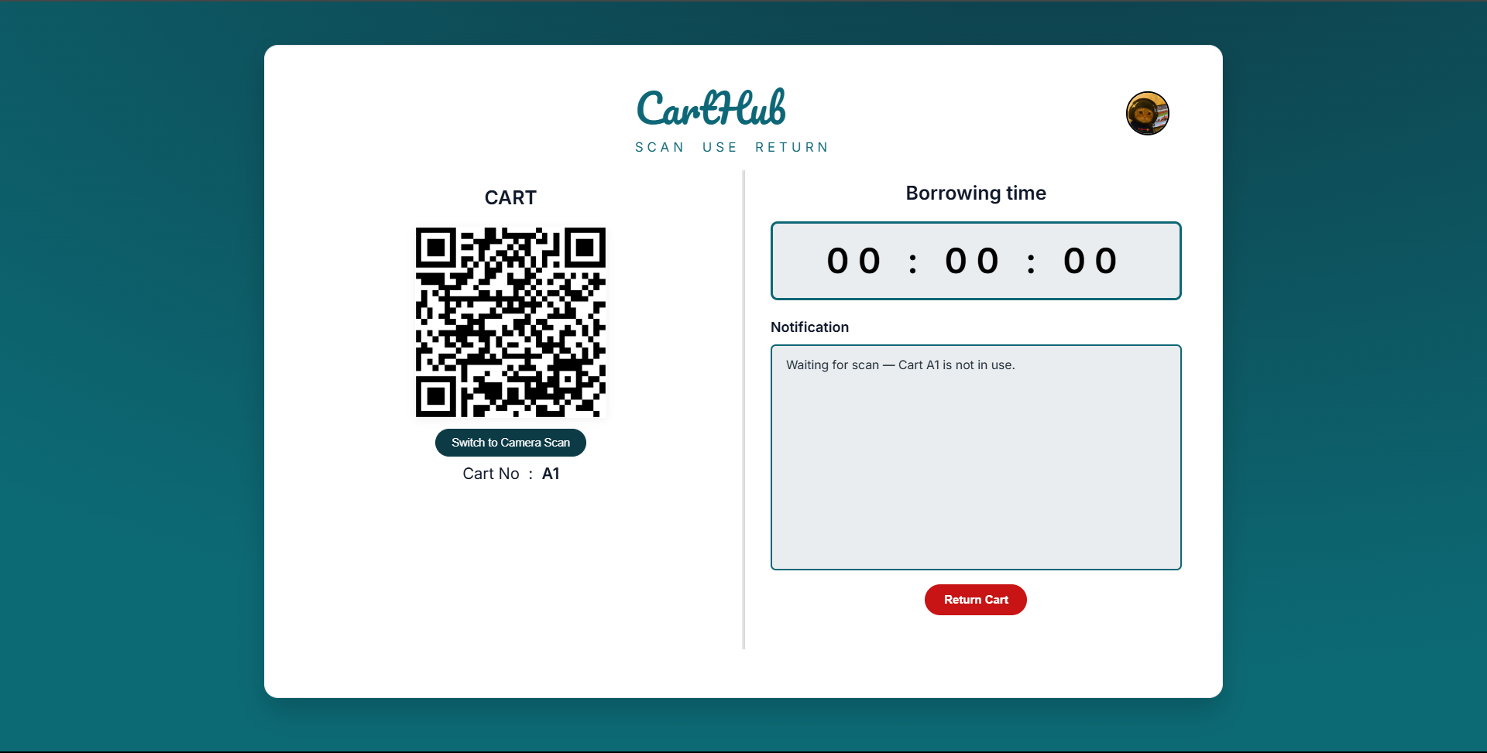
Selection & QRcode for borrowing

- Admin
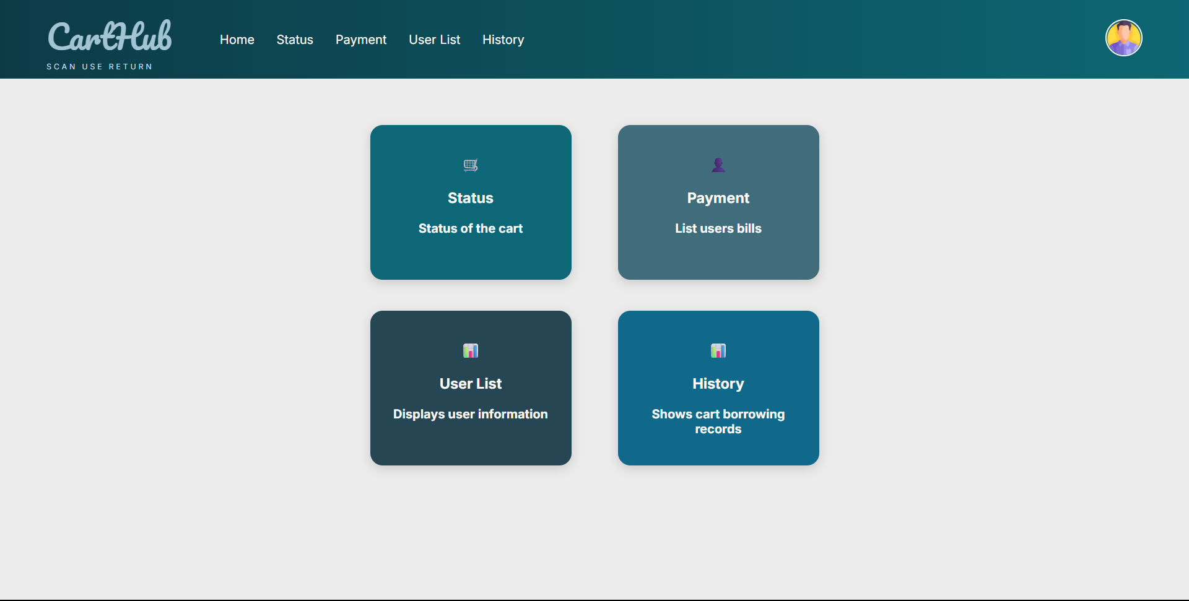
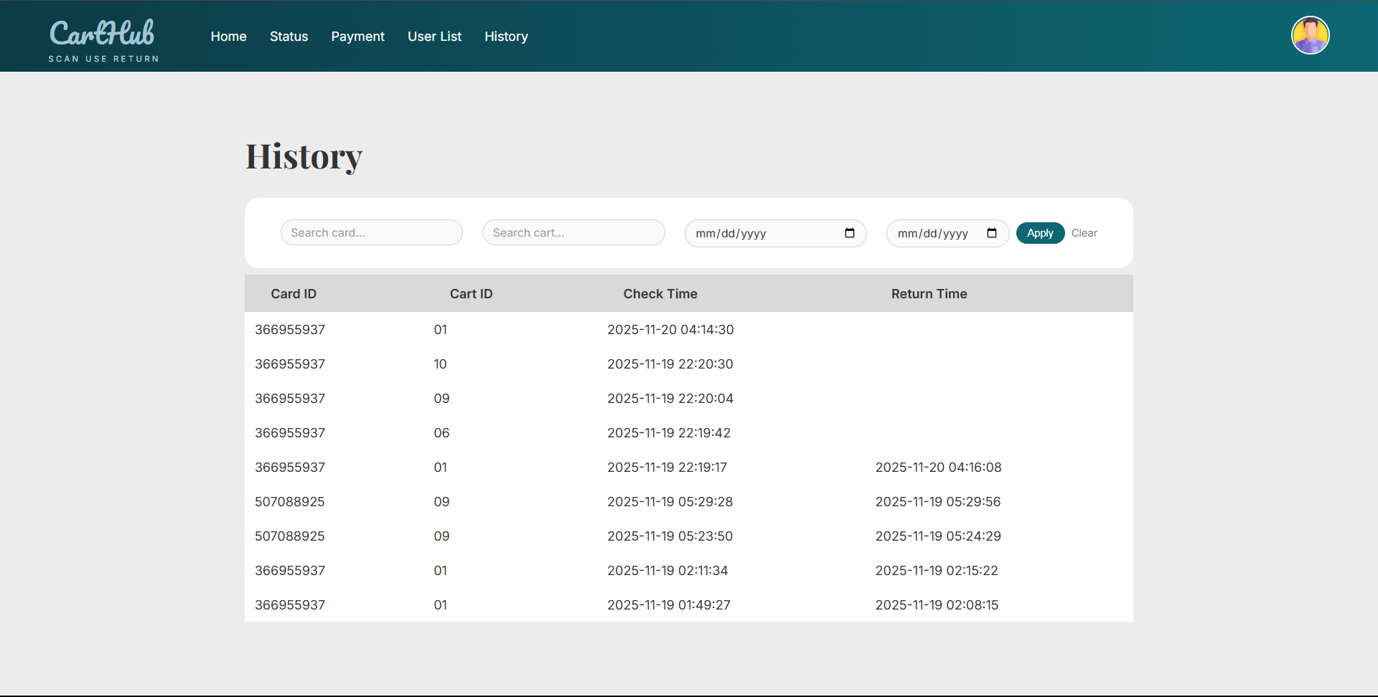
Dashboard & History
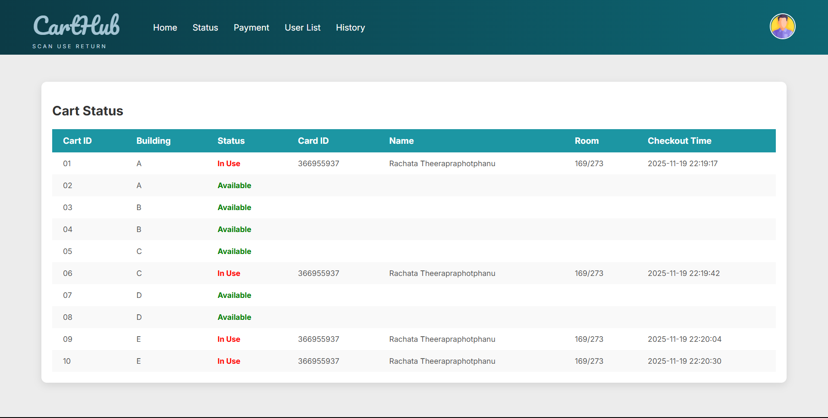
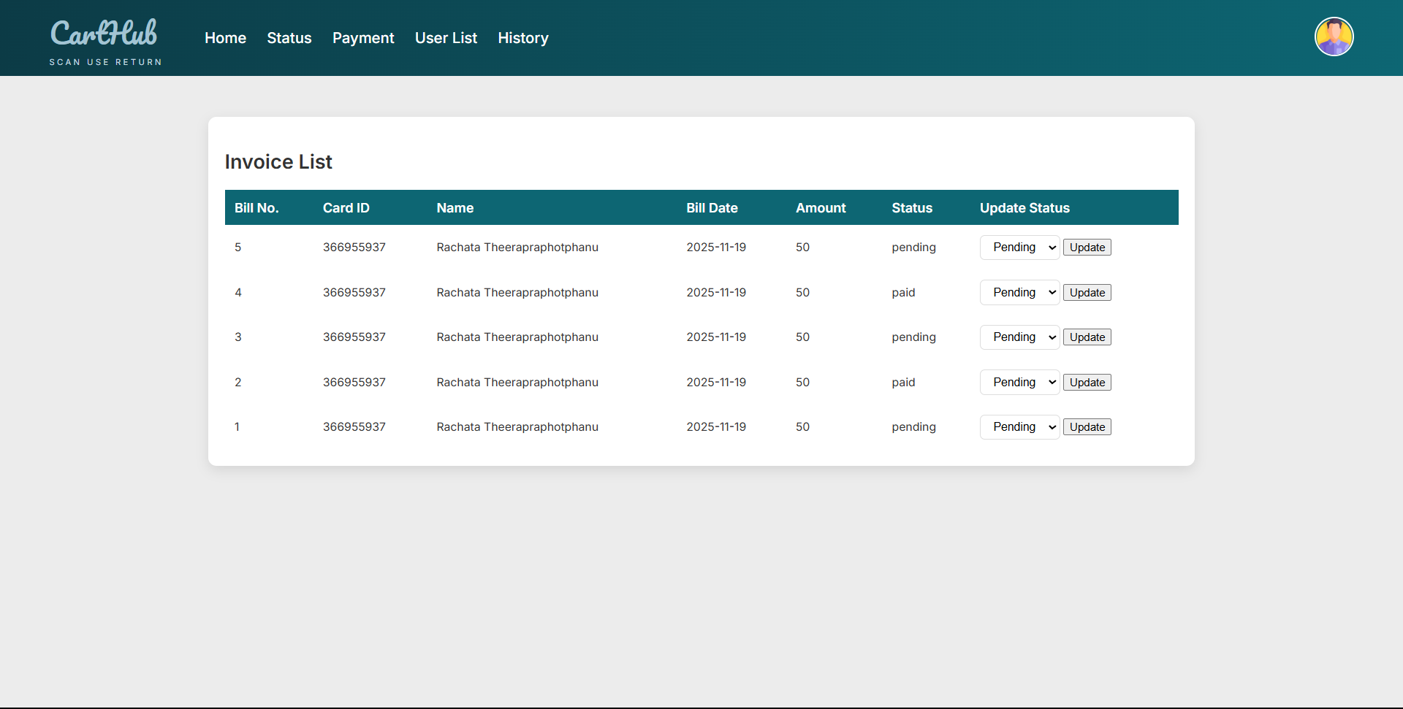
Cart Status & Payment
User List & Update User
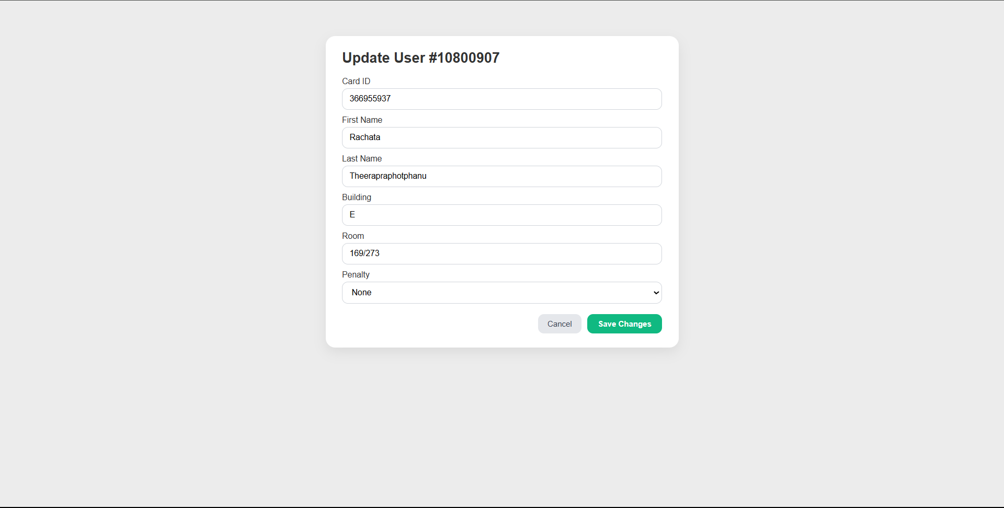
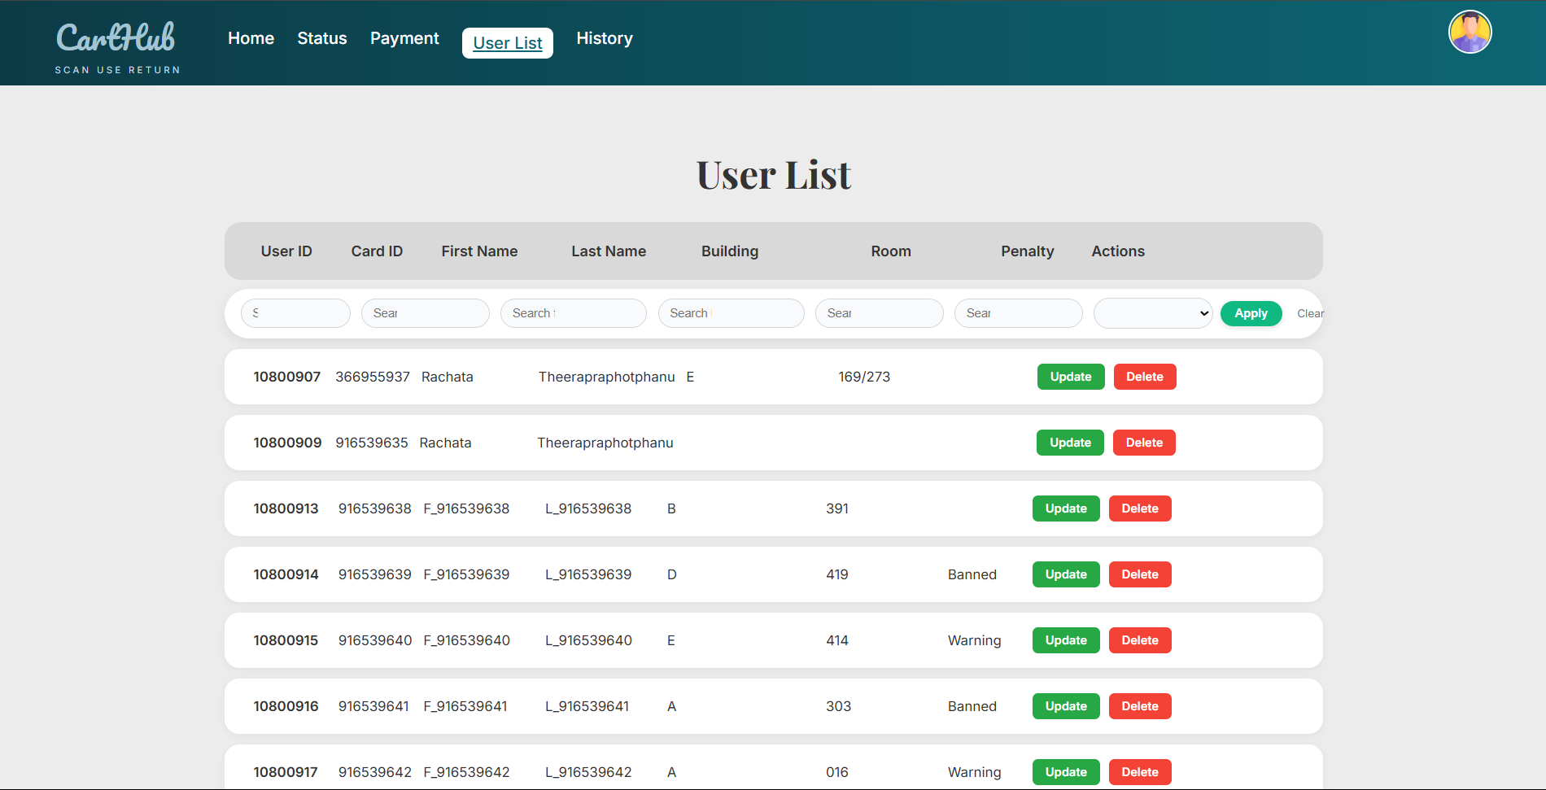

7. Deployment
7.1 Hosting Setup
- Source Code File
- Database

7.2 Problem & Solutions
This part outlines some of the problems faced during this project.
- Error 403
  - Since this is a permission issue, please recheck all settings and ensure that the hosting has the correct permissions.
- Failed to connect or edit database
  - Most of it is caused by an incorrect script with the table in the database, so make sure to correct it.
- Incorrect UX/UI layout
  - Sometimes, the issue is caused by an incorrect path from the PHP file to the CSS file. Change it to the correct one. Additionally, the problem may be caused by the cache from the previous CSS version still being on the website. Performing a full refresh (Shift + F5) can solve this issue.
8. Conclusion
8.1 Summary
As a result, this project helps improve the quality of life for both residents and staff by reducing the number of improperly returned and missing carts. Moreover, the project increases convenience for both residents and staff, reduces costs for the condominium, and is easy to use for everyone.
8.2 Limitations
- There is no notification after overtime usage for users.
- There is no mobile application.
- There is sometimes an improper layout on different browsers.
8.3 Future Improvements
- Develop a mobile application version.
- Add an OTP system to the login process.
- Implement data analysis for easier analytics.
- Improve the UX/UI design.

Note : AI assistance in this document was limited to grammar, structural refinement, and minor guidance. All content and insights are the work of the project team.

