Computational Analysis of Neuronal Responses to Diverse Current Injection Waveforms
Four neuron models × eight waveform families in NEURON
Group 9
[Group member names and roll numbers]
Computational Neuroscience – Semester 3
Amrita Vishwa Vidyapeetham
October 2026

Abstract
How a neuron transforms an injected current depends on both the input waveform and the ion channels the cell expresses. We simulated four published neuron models in NEURON – a single-compartment Hodgkin–Huxley (HH) neuron, a subthalamic nucleus (STN) neuron, a cerebellar Purkinje cell and a hippocampal CA1 pyramidal cell – with eight current waveforms covering steps, ramps, periodic, pulse-train, stochastic and synaptic-like input (979 simulations). Amplitudes were normalised to each cell's rheobase, pulse trains to a separately measured single-pulse threshold, and spontaneously active STN was studied both natively and held silent at −70 mV. Every model was first validated against published behaviour, and channel contributions were tested causally by in-silico blockade.
The cells sorted along clear mechanistic lines. STN produced T-type Ca²⁺-dependent rebound bursts once hyperpolarised below ≈ −78 mV, in line with experimental data, and the strongest subthreshold resonance (5.2 Hz, Q = 2.53), which the T-current amplified. CA1 showed Ih- and M-current-dependent theta resonance (10 Hz) and strong adaptation. The Purkinje cell was a low-pass filter whose firing was governed by P-type Ca²⁺ dendritic spikes; removing a D-type K⁺ current made it a spontaneous 50 Hz burster, as reported for Kv1 block. HH behaved as a type-II resonator. With brief pulses, STN followed 1:1 up to 200 Hz whereas CA1 and HH failed in the deep-brain-stimulation (DBS) range, and charge-balanced biphasic pulses were markedly less effective. We discuss implications for DBS waveform design and the limits of intracellular injection as a model of DBS.

1. Introduction
Neurons are often characterised with a single protocol – a long current step that yields a rheobase and an f–I curve. Real inputs, and the waveforms used therapeutically, are far more varied: slowly changing currents, rhythmic drive, brief pulses at high rates, fluctuating background and synaptic transients. Each probes a different aspect of membrane dynamics: threshold accommodation, resonance, refractoriness, spike-time precision. Because these properties arise from specific ion channels, comparing how different cell types respond to the same set of waveforms is a direct way to connect channel composition to input–output function.
We chose four models spanning single-compartment to detailed morphology and threshold-based to pacemaking firing. The HH model is the textbook reference and validates the pipeline. The STN neuron is a pacemaker with rebound bursting (T-type Ca²⁺, Ih) and the main target of DBS in Parkinson's disease. The Purkinje cell has a large dendritic tree supporting dendritic Ca²⁺ spikes and allows somatic versus dendritic injection. The CA1 pyramidal neuron has well-documented theta-range resonance and spike-frequency adaptation that can be checked against experiments.
Our aims were to (i) quantify each cell's response to eight waveform families using standard, comparable metrics; (ii) attribute response differences to specific channels using in-silico channel blockade; (iii) compare key results with published data; and (iv) draw implications for stimulation waveform design, in particular for DBS of the STN.

2. Methods

2.1 Simulation platform and reproducibility
Simulations used NEURON 9.0 with its Python interface, together with numpy, scipy, matplotlib and pandas, run under WSL2 (Ubuntu) on a 12-core PC. All simulations used fixed-step integration with dt = 0.025 ms; a convergence check at dt = 0.0125 ms changed first-spike times by ≤ 0.04 ms and spike counts not at all for every model. Every model ran in its own Python process because several models define mechanisms with the same name. The full pipeline runs end to end from a single script (main.py); all random seeds, parameter values, software versions and MD5 checksums of every model file are logged automatically (Appendix B).

2.2 Neuron models
The three morphologically detailed models were obtained from ModelDB and used unmodified apart from removing graphical-interface code (Table 1). Each model was simulated at the temperature at which it was published and validated.
Table 1. Neuron models.
Cell | Source (ModelDB) | Size | Temp. | Key channels | Note
HH | Hodgkin & Huxley 1952 (NEURON built-in) | 1 compartment | 6.3 °C | Na⁺, K⁺ (delayed rectifier), leak | Reference / pipeline validation
STN | Gillies & Willshaw 2006 (74298) | 35 sections, 189 segments | 37 °C | Na⁺, persistent Na⁺, Kv3.1, KDR, sKCa, T-, N-, L-type Ca²⁺, Ih | Spontaneous pacemaker
Purkinje | Miyasho et al. 2001 (17664) | 1088 sections | 37 °C | NaF, NaP, P-, T-, E-type Ca²⁺, KA, KD, KC, KM, Kh | Silent at rest in this model
CA1 | Migliore R et al. 2018 (244688), cell CA1PCcAC_sig6 | 165 sections, 507 segments | 34 °C | Nax, KDR, KA (prox./dist.), M-current, Ih gradient, Ca²⁺, BK/SK | Fitted to CA1 recordings

Model choice involved trade-offs that we tested rather than assumed. A spontaneously active Purkinje model (Masoli et al. 2015) was about 100 times too slow for a batch of this size, so the Miyasho model – which keeps full morphology and dendritic Ca²⁺ spikes but is silent at rest – was used. For CA1, four candidates were screened on resonance (time-domain chirp), firing rate and adaptation; only Migliore et al. (2018) combined theta resonance with realistic, strongly adapting firing (an older model fired at 72 Hz without adaptation). We also found that NEURON's linearised impedance calculation did not capture Ih gating in these mechanisms (it showed no resonance even in a test cell with a clear time-domain resonance), so impedance was measured from time-domain chirps only.

2.3 Model validation
Before any experiment, each model had to reproduce published behaviour (Table 2). Where a channel is known to cause a behaviour, we also blocked it and confirmed the behaviour disappeared.
Table 2. Validation results (all criteria passed).
Cell | Published behaviour reproduced | Causal check
HH | Rest −65 mV; spike peak +40 mV; repetitive firing from 6.5 µA/cm² with abrupt onset at 56 Hz (class-2 excitability) | –
STN | Regular spontaneous firing 9.6 Hz (CV 0.007) at 37 °C; 14-spike rebound burst at 159 Hz after −0.25 nA, 500 ms | T-type Ca²⁺ block → no rebound
Purkinje | Silent at −69 mV; 110 Hz somatic spiking and dendritic Ca²⁺ spikes with a 2 nA somatic step (Miyasho et al. Fig. 2) | P-type Ca²⁺ block → no dendritic Ca²⁺ spikes
CA1 | Rin 29 MΩ; sag ratio 0.77; somatic resonance 10 Hz (Q 1.35), higher in the dendrite (13 Hz); 19 Hz firing with adaptation index 3.0 | Ih block → Q falls by 0.28

2.4 Cell characterisation and amplitude normalisation
Each cell was settled to steady state once and the state saved (h.SaveState) and restored before every run, giving identical initial conditions and removing the settling period from each simulation. Input resistance and the apparent membrane time constant were measured with a ≈ 3 mV hyperpolarising step, and rheobase by bisection on a 1 s step (to 1 %). Because the STN fires spontaneously, its rheobase is undefined at rest; it was therefore studied in two conditions: native (spontaneous firing) and held (a DC current of −0.18 nA holding it silent at −70 mV, with rheobase measured on top). The silent-condition somatic rheobase served as the amplitude unit for each cell (Table 3).
Table 3. Passive and threshold properties.
Cell (condition) | Holding current | Rin (MΩ) | τ apparent (ms) | Rheobase soma (nA) | Rheobase dendrite (nA) | Single 0.5 ms pulse threshold (nA)
HH | 0 | 102 | 1.3 | 0.025 | – | 0.15 (5.9×)
STN (native) | 0 | – (fires 10 Hz) | – | – | – | –
STN (held) | −0.182 nA | 44.6 | 6.0 | 0.067 | – | 1.39 (21×)
Purkinje | 0 | 26.0 | 25.1 | 0.850 | 0.719 (100 µm) | 1.87 soma / 6.83 dend
CA1 | 0 | 29.2 | 3.8 | 0.263 | 0.388 (300 µm) | 2.79 soma / 1.37 dend

The apparent time constants of CA1 and STN are shorter than their passive membrane values because charge injected at the soma spreads into the dendrites and resting K⁺/Ih conductances add to the leak. Because a 1 s step rheobase is a poor guide to the threshold for brief inputs (strength–duration relation), pulse-train amplitudes were scaled to a separately measured single-pulse threshold, which was 2–21 times the step rheobase.

2.5 Current waveforms
A waveform generator produced one function per waveform, sampled on the simulation grid; every onset, offset and pulse edge was snapped to a whole multiple of dt, and waveforms were played into an IClamp without interpolation, so rectangular pulses had vertical edges and biphasic pulses carried exactly zero net charge (verified by 24 unit tests and by comparing recorded injected current with the waveform in every run). Figure 1 shows examples.
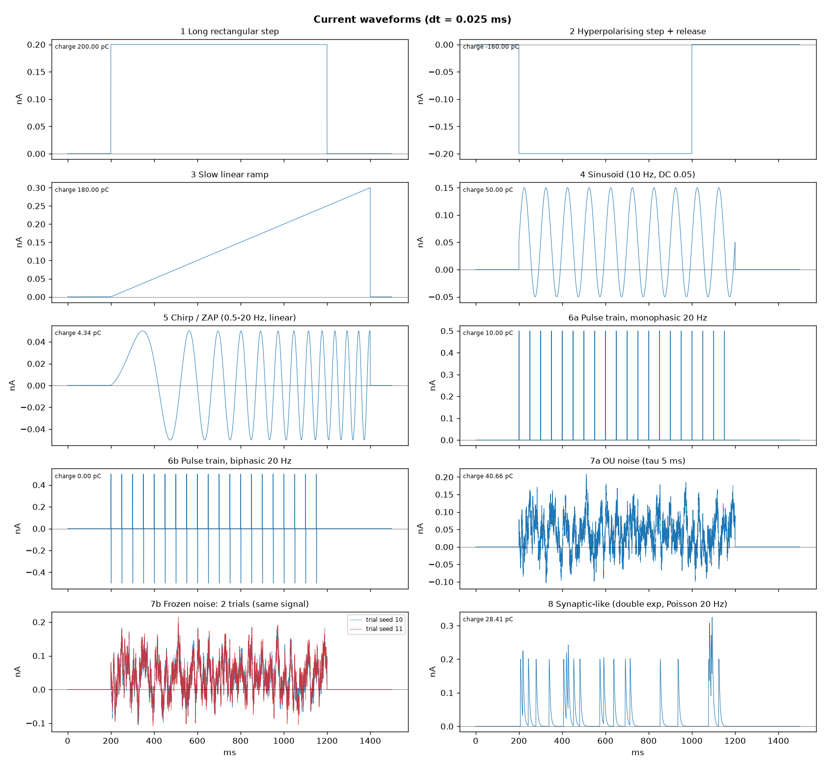
Figure 1. Examples of the eight waveform families as generated (amplitudes illustrative). Two frozen-noise trials share the same signal but carry independent small background noise.
Table 4. Waveforms and experimental design (amplitudes in units of the cell's rheobase unless stated).
# | Waveform | Settings | Main metrics
1 | Long step | 0.8, 1, 1.25, 1.5, 2, 2.5, 3×; 1 s | f–I, latency, adaptation index, spike threshold
2 | Hyperpolarising step + release | −0.5, −1, −2, −3×; 800 ms | Sag ratio, rebound spikes, latency, burst rate
3 | Ramp | 0 → 3× over 2 s (slow) and 0.5 s (fast) | Threshold current (accommodation)
4 | Sinusoid | 1, 2, 4, 7, 10, 20, 50, 100 Hz × 1, 1.5, 2×; 2 s | Vector strength (Rayleigh test), entrainment
5 | Chirp (ZAP) | 0.5–50 Hz log sweep, 15 s; ≈ ±5 mV, ≤ 0.5× rheobase | |Z(f)|, resonance frequency fR, Q
6 | Pulse train | 5, 20, 60, 130, 200 Hz; mono/biphasic; 0.5 ms; 1.2 and 2× single-pulse threshold; 1 s | Following fidelity
7 | Noise (Ornstein–Uhlenbeck, τ 5 ms) | Mean 1×, SD 0.4×, 2 s; 20 seeds (variability) and 20 frozen-noise trials (reliability) | ISI CV, reliability R, jitter, spike-triggered average
8 | Synaptic-like (double exponential, 0.5/5 ms) | 5 events, peaks 1, 2, 4×; 20 trials with small background noise | Spike probability, latency jitter

The full set was run at the soma of every cell (STN in the held condition) and, without the chirp, for native STN with a random start delay per trial so that stimuli arrived at random pacemaker phases. A reduced set was run with dendritic injection for Purkinje (100 µm) and CA1 (300 µm, apical trunk), with amplitudes scaled to the dendritic rheobase. For in-silico pharmacology, key protocols were repeated with one channel removed: T-type Ca²⁺ and Ih in STN; P-type Ca²⁺ and D-type K⁺ in Purkinje; Ih and M-current in CA1. In total 979 simulations were run in about 70 min on 10 parallel processes.

2.6 Analysis
Spikes were detected at the soma by an upward rate of rise ≥ 20 mV/ms with a peak above −20 mV and a 1 ms refractory period, which also catches small spikes near depolarisation block; Purkinje dendritic Ca²⁺ spikes were counted separately (dendritic V ≥ −10 mV for ≥ 3 ms). Impedance was estimated from the chirp with a cross-spectral FFT (Hann window, 60 log-spaced bins) and accepted only if the cell did not spike. Phase locking used the vector strength with a Rayleigh test. Following fidelity was the fraction of pulses followed by a spike within min(period, 5 ms). Reliability across frozen-noise trials used the Schreiber correlation measure (Gaussian σ = 3 ms) with a bootstrap 95 % CI; spike probability used Wilson 95 % CIs; ISI CV across seeds is reported as mean with a t-based 95 % CI.

3. Results
Figure 2 shows the STN's responses to all eight waveforms; equivalent panels for the other cells are in Appendix A. Figure 11 summarises the main metrics across cells.
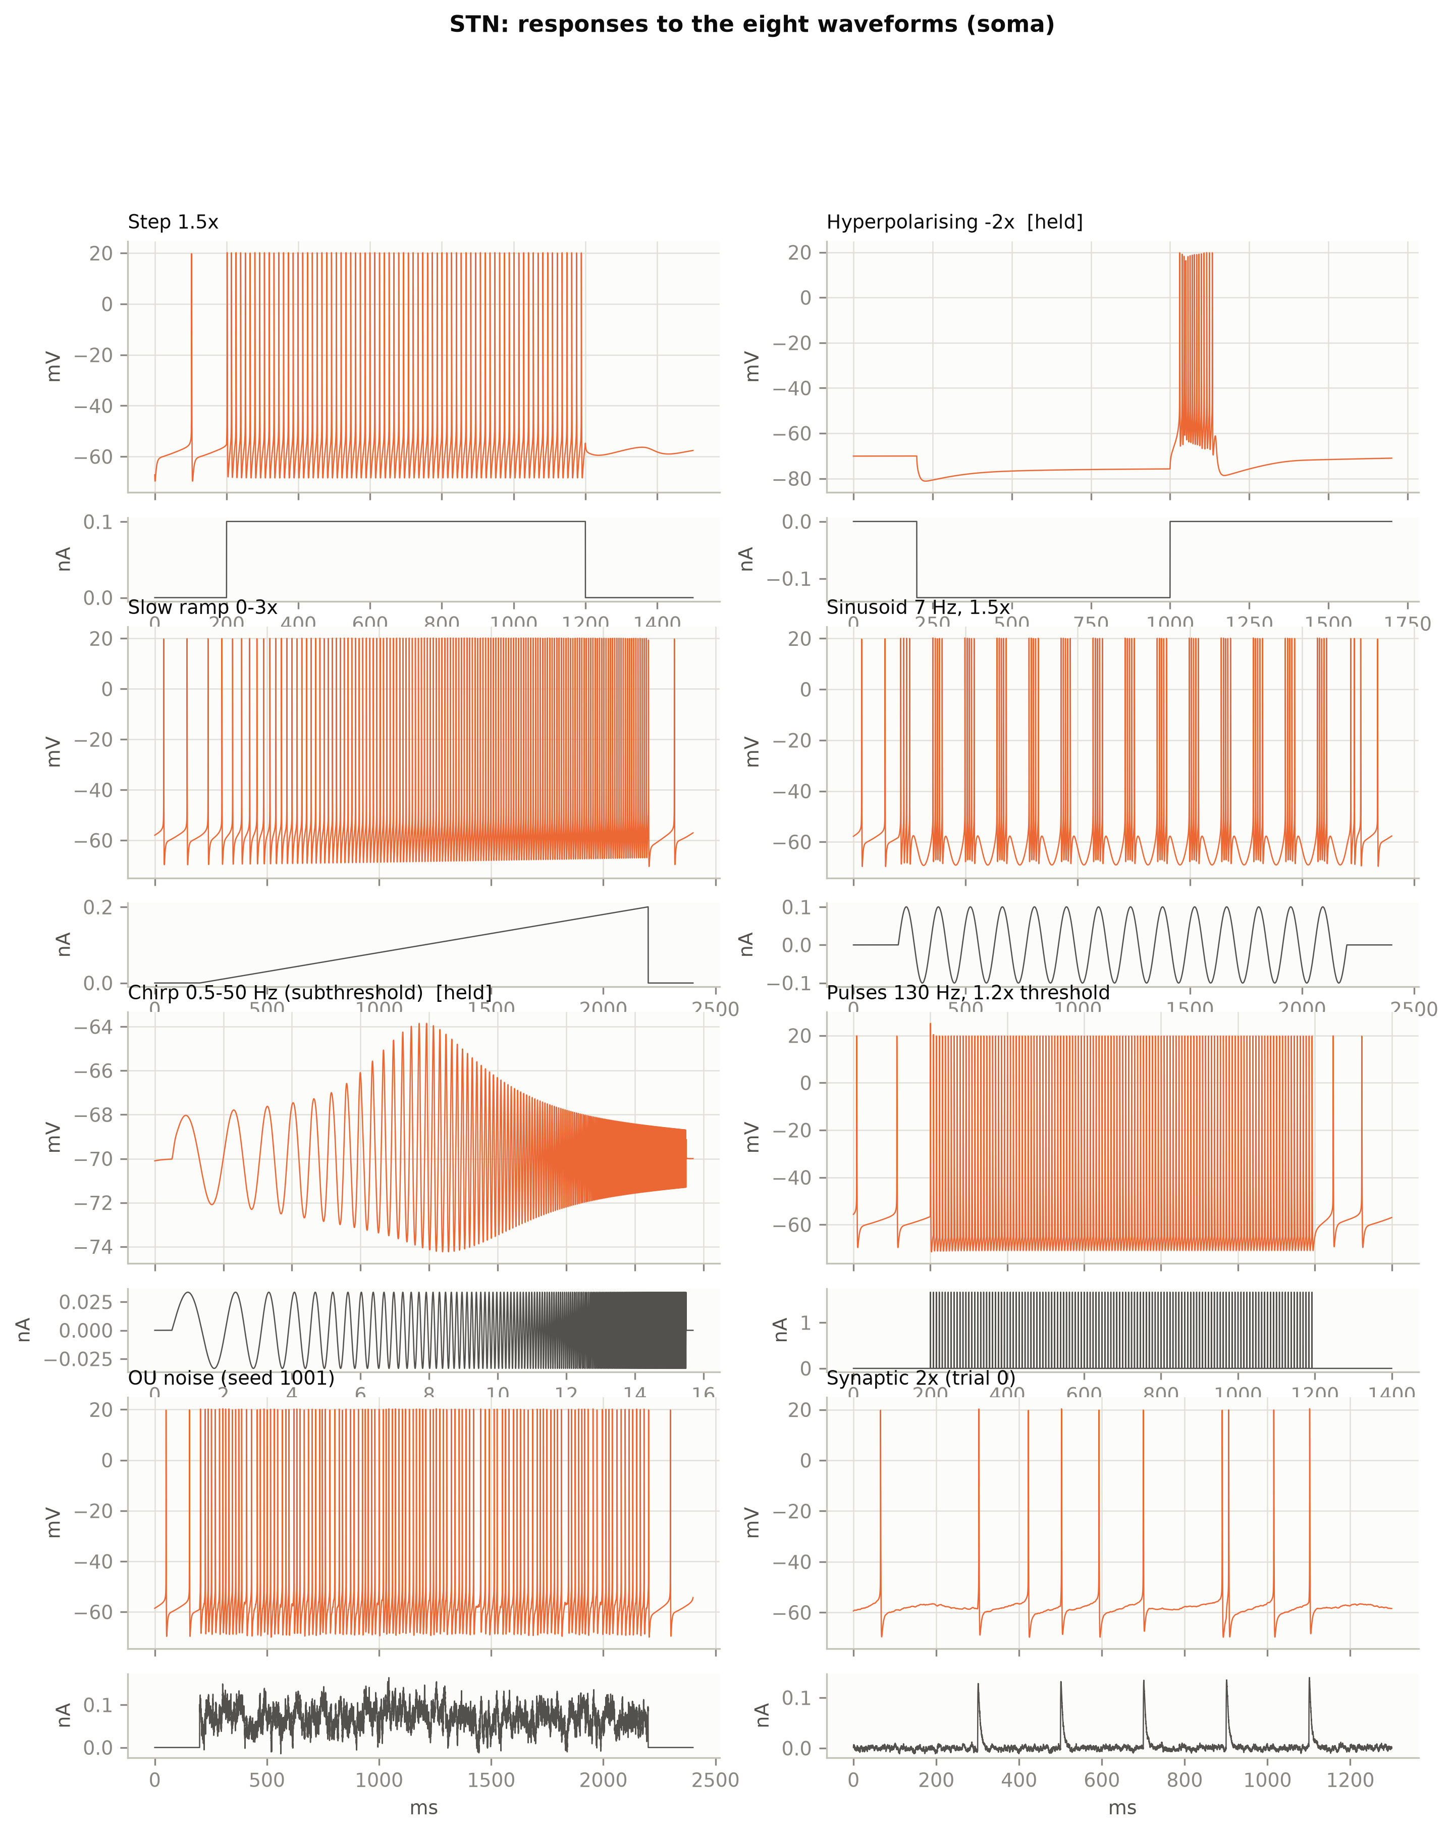
Figure 2. STN responses (voltage, coloured; injected current, grey) to the eight waveforms. Hyperpolarising step and chirp in the held condition, others native. Note the rebound burst after release and the 1:1 following of 130 Hz pulses.

3.1 Excitability and f–I relations
Normalising to rheobase revealed very different gains (Figure 3). Native STN increased its rate linearly from 52 to 109 Hz over 0.8–3× without adaptation (index 1.07–1.14). The Purkinje cell fired only an onset spike up to 1.5× and then jumped to 86–122 Hz once dendritic Ca²⁺ spikes were recruited (17–18 per second). CA1 stayed low (17–25 Hz) with the strongest adaptation (index ≈ 3). HH fired only one onset spike until it crossed its repetitive-firing threshold, then jumped to 57 Hz – the abrupt onset typical of class-2 excitability. In held STN, sustained firing needed ≈ 3× the transient rheobase because the holding current must first be overcome. Slow ramps separated integrators from accommodating cells: CA1 fired at 1.4–1.5× rheobase, Purkinje at 2.0× and held STN at 2.8×, whereas HH never fired on ramps up to 3×.
Somatic and dendritic injection differed in opposite ways in the two large cells. Purkinje dendrites had a lower step rheobase than the soma (0.72 vs 0.85 nA) but responded with delayed (200–570 ms) bursts driven by dendritic Ca²⁺ spikes (ISI CV 1.41), and needed far more current than the soma for a brief pulse (6.8 vs 1.9 nA). The CA1 trunk had a higher step rheobase but a lower brief-pulse threshold than the soma (1.4 vs 2.8 nA), reflecting its high local input impedance.
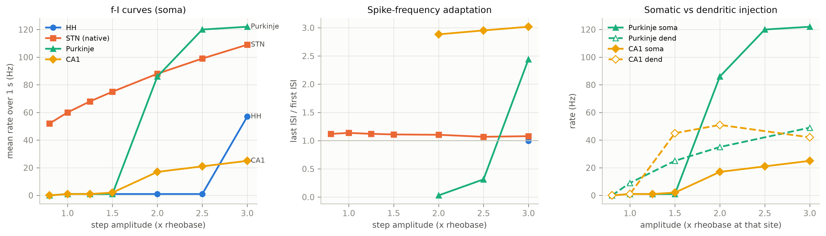
Figure 3. Left: f–I curves (soma; STN native). Middle: adaptation index (last/first interspike interval). Right: somatic (filled) vs dendritic (open) injection in Purkinje and CA1.

3.2 Sag and rebound
Sag ratio ranked STN (0.52) < CA1 (0.76) < Purkinje (0.89), following Ih density (Figure 4). Only STN produced a substantial rebound: 15 spikes at 170–200 Hz after −2× or −3× steps, but none after −1×. The burst appeared only when the trough passed ≈ −78 mV (no burst at −76 mV, full burst at −81 mV). HH fired a single anode-break spike after strong hyperpolarisation; its apparent sag at small steps is relaxation of its own gating variables, not Ih.
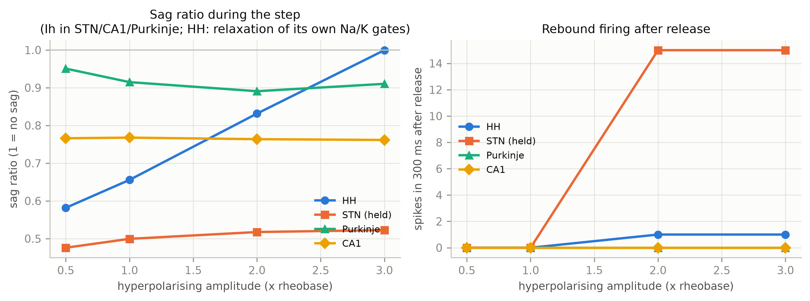
Figure 4. Sag ratio (1 = no sag) and number of rebound spikes in the 300 ms after release, against hyperpolarising amplitude (STN in the held condition).

3.3 Subthreshold resonance
Chirp impedance profiles (Figure 5) showed band-pass behaviour at theta frequencies for STN (fR 5.2 Hz, Q 2.53 – the strongest of all cells) and CA1 (10 Hz, Q 1.39), a high-frequency resonance in HH (43 Hz, Q 2.38), and pure low-pass filtering in the Purkinje cell. In CA1 the dendrite had higher impedance and higher fR (13.4 Hz) than the soma. Removing Ih collapsed CA1 resonance to 3.3 Hz / Q 1.08.
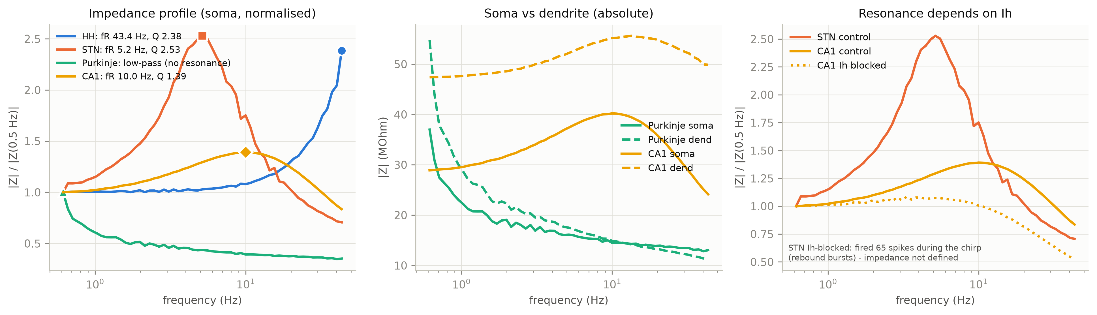
Figure 5. Left: normalised impedance at the soma (markers at the peak). Middle: soma vs dendrite. Right: resonance with and without Ih; the Ih-blocked STN chirp evoked spikes and is therefore excluded.

3.4 Phase locking to sinusoids
Each cell's spikes preferred its intrinsic band (Figure 6). CA1 fired exactly one spike per cycle at 4–10 Hz (vector strength 1.0) and stopped firing above 20 Hz; held STN locked at 2–10 Hz (VS 0.85–0.92); HH and Purkinje fired only for inputs of 20 Hz and above. In native STN the pacemaker competed with slow inputs (VS 0.6–0.8 at 1–20 Hz), while 50 Hz input entrained it 1:1.
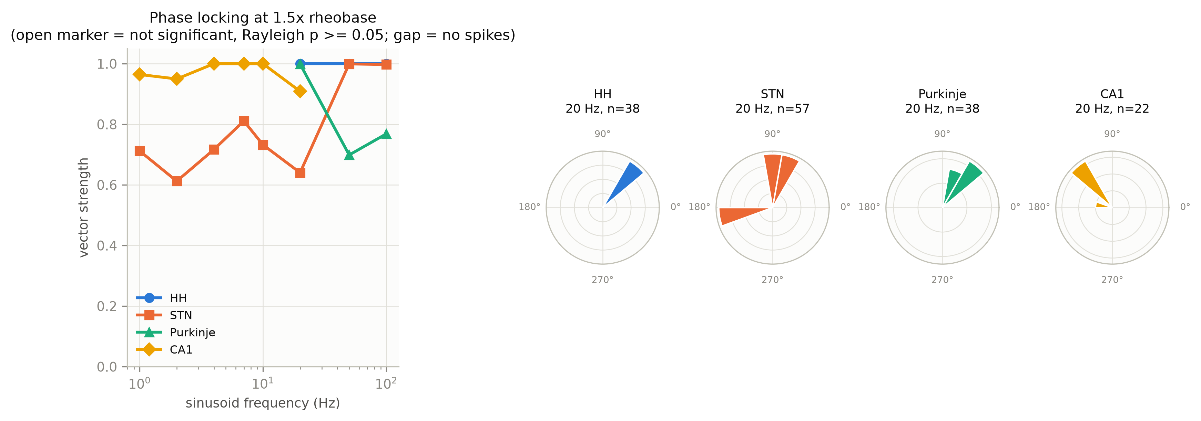
Figure 6. Vector strength against sinusoid frequency at 1.5× rheobase (gaps: no spikes) and spike-phase histograms at 20 Hz.

3.5 Pulse trains
At 2× single-pulse threshold most cells followed most rates, so the 1.2× level separated the cells (Figure 7). Native STN followed 1:1 up to 200 Hz with either polarity, with no depolarisation block and an unchanged firing rate after the train (5–20 Hz vs a 10 Hz baseline). Purkinje followed 88 % of pulses at 130 Hz, whereas CA1 (16 %) and HH (12 %) failed in the DBS range. Charge-balanced biphasic pulses were less effective: at 1.2× threshold they never fired HH and roughly halved following in held STN (100 % → 53 % at 130 Hz).
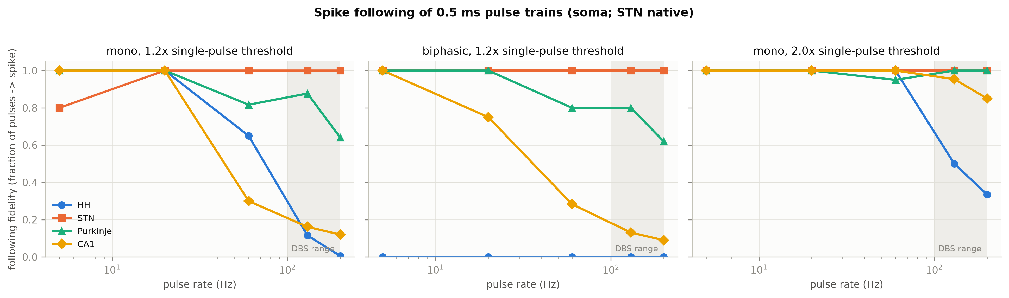
Figure 7. Following fidelity (fraction of pulses evoking a spike) against pulse rate. The shaded band marks the clinical DBS range.

3.6 Variability and reliability under noise
With the same relative drive, firing rates differed about twenty-fold (HH 3.4 Hz, CA1 5.2 Hz, STN 58 Hz, Purkinje 66 Hz; Figure 8). STN was the most regular cell (ISI CV 0.22, 95 % CI 0.21–0.23) and HH the most irregular (0.73, 0.61–0.86), yet HH was the most reliable across repeated frozen-noise trials (R = 0.87, jitter 0.5 ms), followed by STN (0.85), Purkinje (0.76) and CA1 (0.75). Spike-triggered averages were biphasic for HH and Purkinje – a hyperpolarising lobe followed by a brief depolarisation – but monophasic and slowly rising (~20 ms) for CA1.
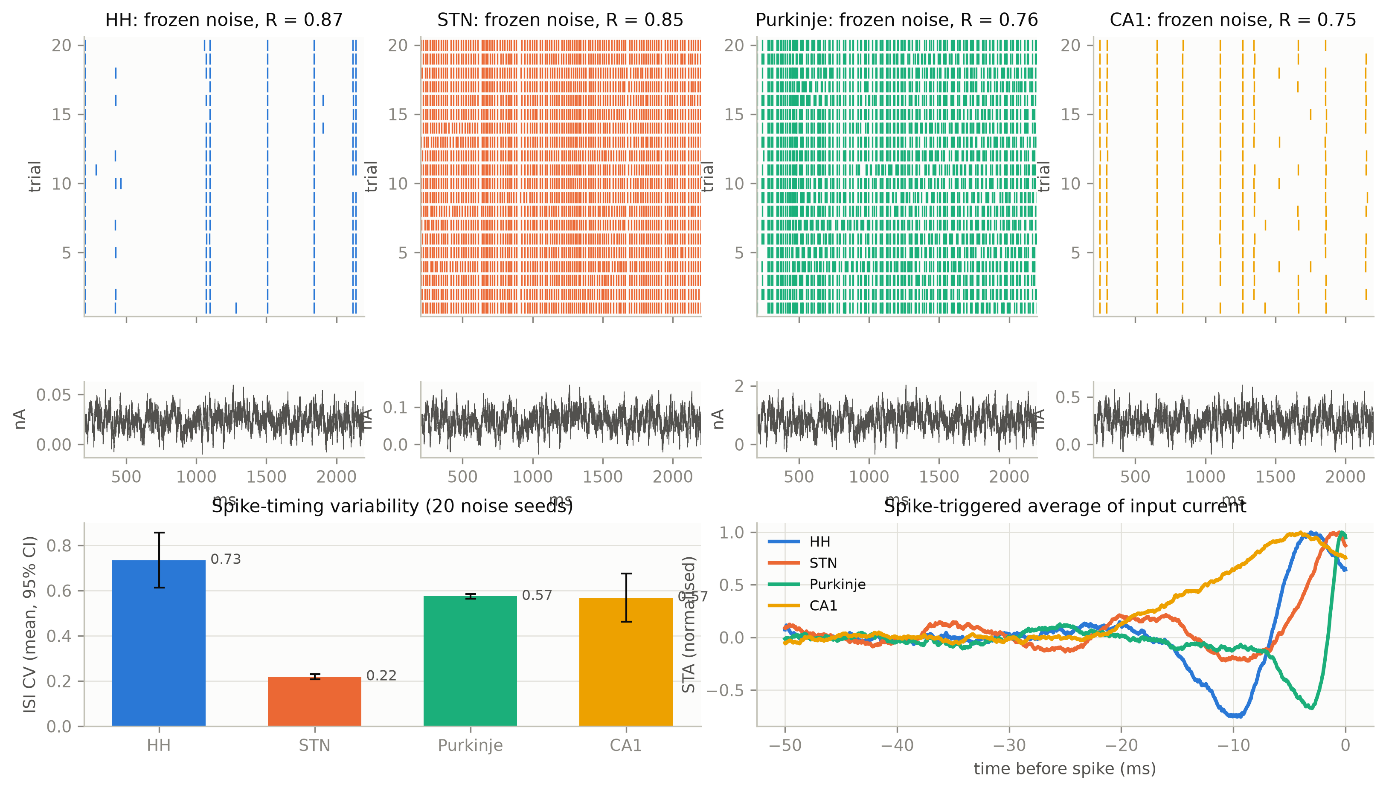
Figure 8. Top: spike rasters for 20 frozen-noise trials with the input below. Bottom left: ISI CV across 20 noise seeds (mean, 95 % CI). Bottom right: normalised spike-triggered average of the injected current.

3.7 Synaptic-like input
Brief synaptic-like currents needed more than step rheobase (Figure 9). HH, Purkinje and native STN responded reliably at 2× rheobase, but CA1 only at 4×, consistent with its low input resistance and fast apparent time constant. Native STN was the only cell to respond below rheobase (spike probability 0.76 at 1×), because its pacemaker keeps it near threshold, but it was also the least precise (jitter 1.9 ms at 1×, 0.5 ms at 4×). Held STN never responded.
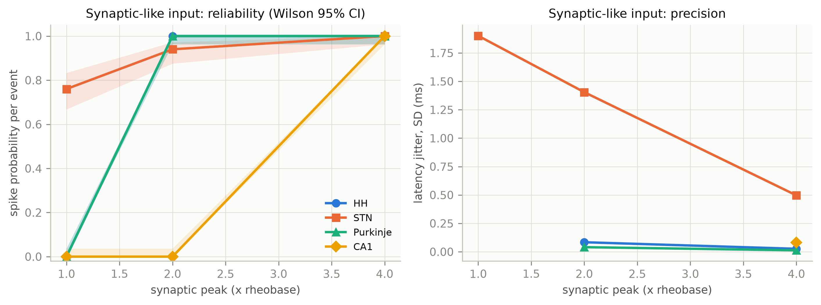
Figure 9. Spike probability per synaptic event (Wilson 95 % CI) and latency jitter against synaptic peak amplitude.

3.8 In-silico channel blockade
Blocking T-type Ca²⁺ abolished the STN rebound burst (15 → 0 spikes) and halved its resonance (Q 2.53 → 1.23), whereas blocking Ih left the rebound intact (Figure 10). Blocking P-type Ca²⁺ reduced Purkinje firing at 2× rheobase from 86 Hz to a single spike; blocking the D-type K⁺ current made the cell fire spontaneously at 50 Hz with about 30 dendritic Ca²⁺ spikes per second. In CA1, Ih block removed sag and most of the resonance, and M-current block raised the firing rate at 2× from 17 to 29 Hz, reduced adaptation (3.0 → 2.3) and lowered Q to 1.19.
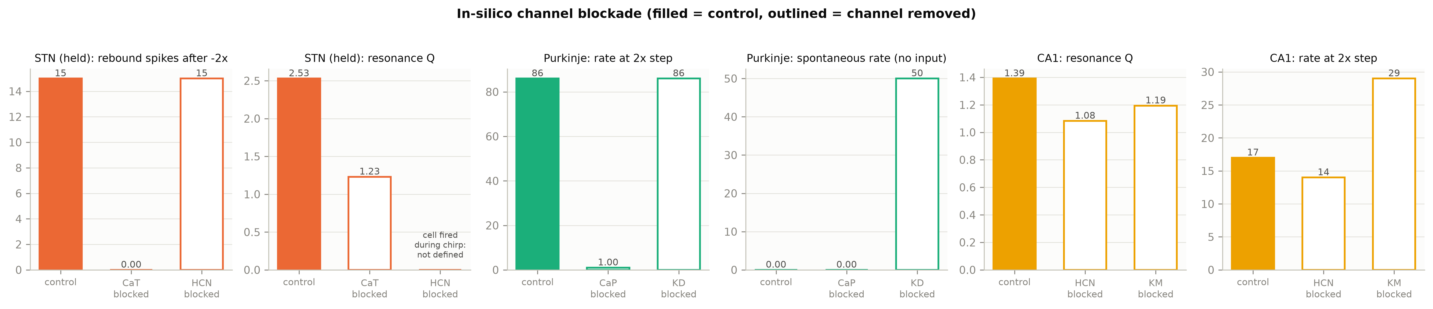
Figure 10. Control (filled) vs channel blocked (outlined). The Ih-blocked STN chirp evoked spikes, so its impedance is undefined.

3.9 Summary across cells and waveforms
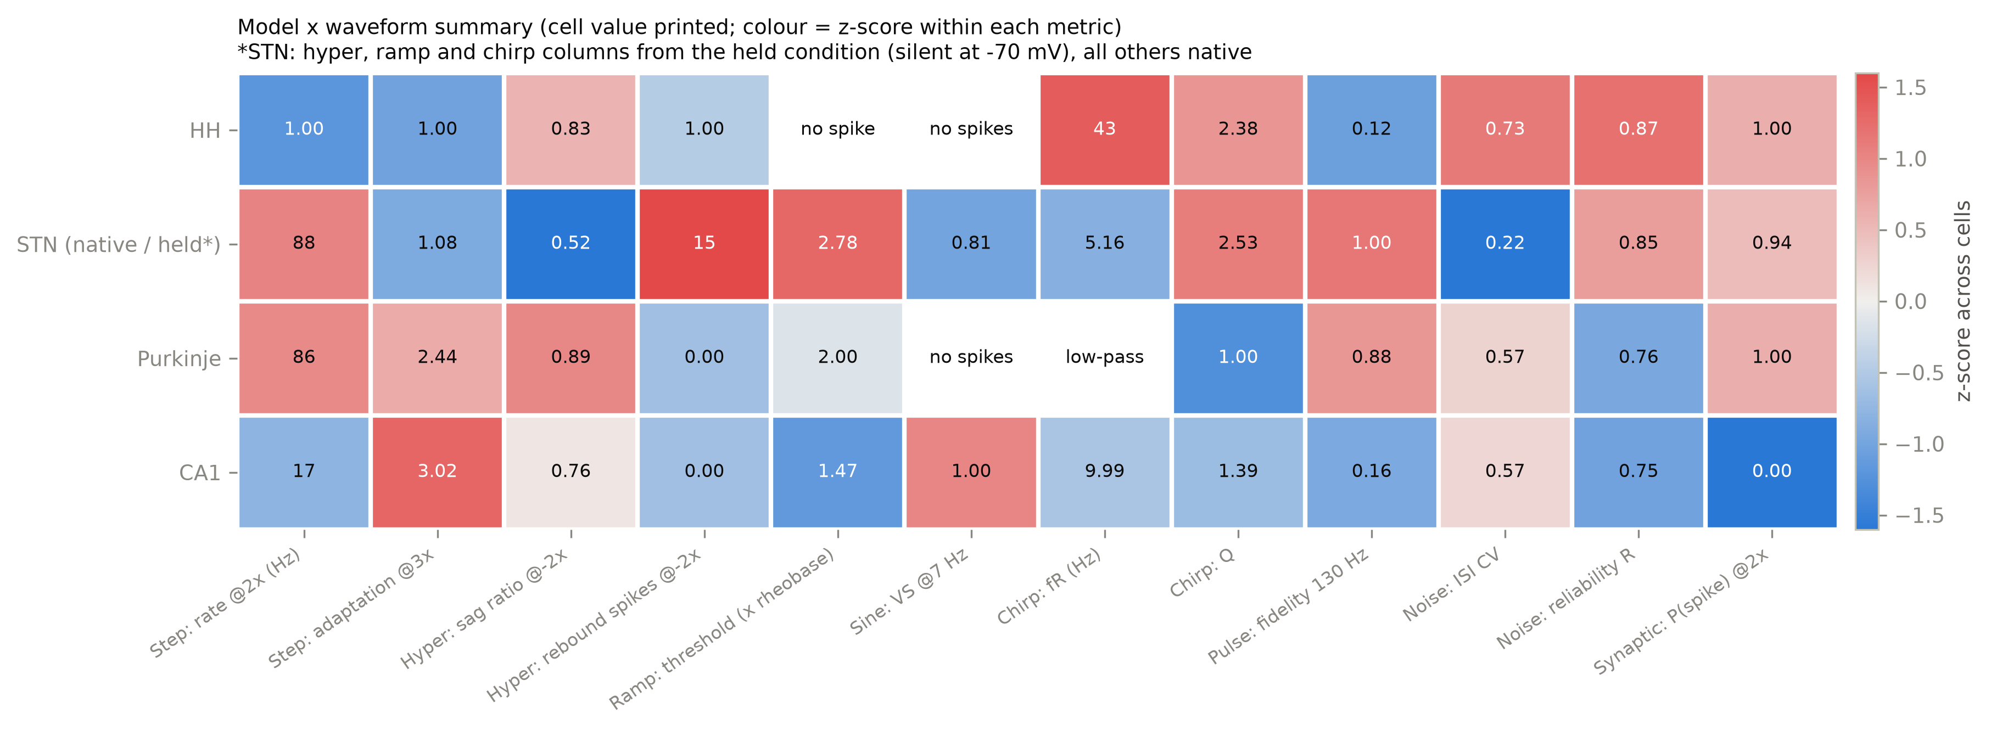
Figure 11. Model × waveform summary. Cell values are printed; colour is the z-score of each metric across cells. STN hyperpolarising, ramp and chirp columns use the held condition, all others the native condition.

4. Discussion

4.1 Linking responses to channels
The waveform battery separated the cells along mechanistic lines that the channel-block experiments confirmed. In STN, the T-type Ca²⁺ current is the signature: it generates the rebound burst and amplifies Ih-based resonance, making the cell most sensitive to hyperpolarising and low-frequency input. Its persistent Na⁺ and Kv3 currents give regular pacemaking, a linear, non-adapting f–I curve and the ability to follow high-frequency pulses. The Purkinje cell's behaviour is dominated by dendritic P-type Ca²⁺ spikes held in check by a D-type K⁺ current; with Ih confined to the soma, it has no resonance. CA1 combines Ih (sag, theta resonance) with M-current and Ca²⁺-activated K⁺ currents (adaptation, low gain); its spike-triggered average and graded f–I curve identify it as an integrator. HH, with only fast Na⁺ and delayed-rectifier K⁺, shows the type-II signature: abrupt f–I onset, accommodation to slow ramps, anode-break excitation, high-frequency resonance and a biphasic spike-triggered average.
Two less obvious results deserve emphasis. First, variability and reliability are distinct: HH is the most irregular cell under noise but the most reliable to repeated identical input, because it fires only on particular fast transients. Second, the somatic and dendritic sites of the large cells rank oppositely for sustained and brief inputs, so 'dendritic excitability' depends on the time scale of the stimulus.

4.2 Comparison with published data
Table 5. Agreement with published data.
Cell | Measure | This study | Published | Verdict
HH | Repetitive-firing onset | 6.5 µA/cm², abrupt (56 Hz) | ≈ 6.3 µA/cm² (Rinzel & Miller 1980) | Agrees
STN | Spontaneous firing | 9.6 Hz, regular | ~10 Hz pacemaking (Gillies & Willshaw 2006) | Agrees
STN | Rebound threshold | −76 to −81 mV | −78 ± 3 mV (Bevan et al. 2000) | Agrees
Purkinje | Dendritic Ca²⁺ spikes | P-type dependent | Llinás & Sugimori 1980; Miyasho et al. 2001 | Agrees
Purkinje | D-type (Kv1) K⁺ block | Spontaneous Ca²⁺-spike bursting | Kv1 prevents dendritic hyperexcitability (Khavandgar et al. 2005) | Agrees
Purkinje | Activity at rest | Silent | Spontaneously active in vitro | Disagrees (model limitation)
CA1 | Somatic resonance frequency | 10 Hz | 2–5 Hz (Hu et al. 2002); ~3–5 Hz (Narayanan & Johnston 2007) | Model ≈ 2× high
CA1 | Dendritic vs somatic fR | 13.4 vs 10 Hz | ~9–11 vs ~3–5 Hz (Narayanan & Johnston 2007) | Trend agrees
CA1 | Ih / M dependence of resonance | Both contribute | H- and M-resonance (Hu et al. 2002) | Agrees
All | Spike-time precision (noise) | Jitter 0.5–1.3 ms | Precise timing for fluctuating input (Mainen & Sejnowski 1995) | Agrees
HH vs CA1 | Spike-triggered average | Biphasic vs monophasic | Type II vs type I (Mato & Samengo 2008) | Agrees

4.3 Implications for DBS waveform design
Brief intracellular pulses drove the STN soma 1:1 up to 200 Hz even close to threshold, without depolarisation block and without suppression of firing after the train. Slice experiments, by contrast, report silencing of STN neurons during high-frequency stimulation (Beurrier et al. 2001), and modelling shows that extracellular stimulation can drive axons at the stimulus rate while the soma is suppressed (McIntyre et al. 2004). Together with our results, this suggests that STN silencing during DBS arises from mechanisms absent from single-site intracellular injection – extracellular fields acting on axons, synaptic GABA release and ionic accumulation – rather than from an intrinsic inability of the soma to follow.
Charge-balanced biphasic pulses, used clinically to protect tissue, were markedly less effective at a given amplitude, quantifying the extra current they require. Finally, the STN's T-type-dependent rebound and its 5 Hz resonance make it especially responsive to hyperpolarising and low-frequency input, which may favour pathological low-frequency bursting; regular high-frequency drive, which the STN follows faithfully, overrides this intrinsic pattern.

4.4 Limitations
- Intracellular somatic injection is not DBS: clinical DBS uses extracellular 60–90 µs pulses that preferentially activate axons; our 0.5 ms pulses probe somatic excitability only.
- Models ran at their published temperatures (HH 6.3 °C, others 34–37 °C), so absolute frequencies of HH are not comparable with the mammalian cells.
- The Purkinje model is silent at rest, and the CA1 model's resonance frequency is about twice the experimental value.
- A 1 s step rheobase is not the relevant threshold for brief inputs; for held STN it reflects a transient onset spike, and sustained firing needs about 3×.
- Channel blocks used the control holding current and amplitudes; two blocked chirps evoked spikes and were excluded from the impedance analysis.
- The models are deterministic, so trial-to-trial variability came only from the added background noise and reliability values depend on its size; single morphologies were used without population variability.

5. Conclusion
A common battery of eight waveforms, normalised to each cell's own thresholds and combined with in-silico channel blockade, linked the response repertoire of four neuron types to their ion channels: T-type Ca²⁺ shapes STN rebound and resonance, P-type Ca²⁺ dendritic spikes and D-type K⁺ govern Purkinje firing, Ih and M-current set CA1's theta resonance and adaptation, and HH displays canonical type-II dynamics. Key results agree with published experimental data, with two documented model limitations. For DBS, the STN soma follows high-frequency pulses faithfully and charge-balanced pulses need more current, pointing to extracellular and network mechanisms for the silencing observed during stimulation.

References
- Bevan MD, Wilson CJ, Bolam JP, Magill PJ (2000) Equilibrium potential of GABA-A current and implications for rebound burst firing in rat subthalamic neurons in vitro. J Neurophysiol 83:3169–3172.
- Beurrier C, Bioulac B, Audin J, Hammond C (2001) High-frequency stimulation produces a transient blockade of voltage-gated currents in subthalamic neurons. J Neurophysiol 85:1351–1356.
- Ermentrout GB, Galán RF, Urban NN (2007) Relating neural dynamics to neural coding. Phys Rev Lett 99:248103.
- Gillies A, Willshaw D (2006) Membrane channel interactions underlying rat subthalamic projection neuron rhythmic and bursting activity. J Neurophysiol 95:2352–2365.
- Hodgkin AL, Huxley AF (1952) A quantitative description of membrane current and its application to conduction and excitation in nerve. J Physiol 117:500–544.
- Hu H, Vervaeke K, Storm JF (2002) Two forms of electrical resonance at theta frequencies, generated by M-current, h-current and persistent Na+ current in rat hippocampal pyramidal cells. J Physiol 545:783–805.
- Khavandgar S, Walter JT, Sageser K, Khodakhah K (2005) Kv1 channels selectively prevent dendritic hyperexcitability in rat Purkinje cells. J Physiol 569:545–557.
- Llinás R, Sugimori M (1980) Electrophysiological properties of in vitro Purkinje cell dendrites in mammalian cerebellar slices. J Physiol 305:197–213.
- Mainen ZF, Sejnowski TJ (1995) Reliability of spike timing in neocortical neurons. Science 268:1503–1506.
- Masoli S, Solinas S, D'Angelo E (2015) Action potential processing in a detailed Purkinje cell model reveals a critical role for axonal compartmentalization. Front Cell Neurosci 9:47.
- Mato G, Samengo I (2008) Type I and type II neuron models are selectively driven by differential stimulus features. Neural Comput 20:2418–2440.
- McIntyre CC, Grill WM, Sherman DL, Thakor NV (2004) Cellular effects of deep brain stimulation: model-based analysis of activation and inhibition. J Neurophysiol 91:1457–1469.
- Migliore R, Lupascu CA, Bologna LL, et al. (2018) The physiological variability of channel density in hippocampal CA1 pyramidal cells and interneurons explored using a unified data-driven modeling workflow. PLoS Comput Biol 14:e1006423.
- Miyasho T, Takagi H, Suzuki H, et al. (2001) Low-threshold potassium channels and a low-threshold calcium channel regulate Ca2+ spike firing in the dendrites of cerebellar Purkinje neurons: a modeling study. Brain Res 891:106–115.
- Narayanan R, Johnston D (2007) Long-term potentiation in rat hippocampal neurons is accompanied by spatially widespread changes in intrinsic oscillatory dynamics and excitability. Neuron 56:1061–1075.
- Rinzel J, Miller RN (1980) Numerical calculation of stable and unstable periodic solutions to the Hodgkin–Huxley equations. Math Biosci 49:27–59.

Appendix A. Responses of HH, Purkinje and CA1
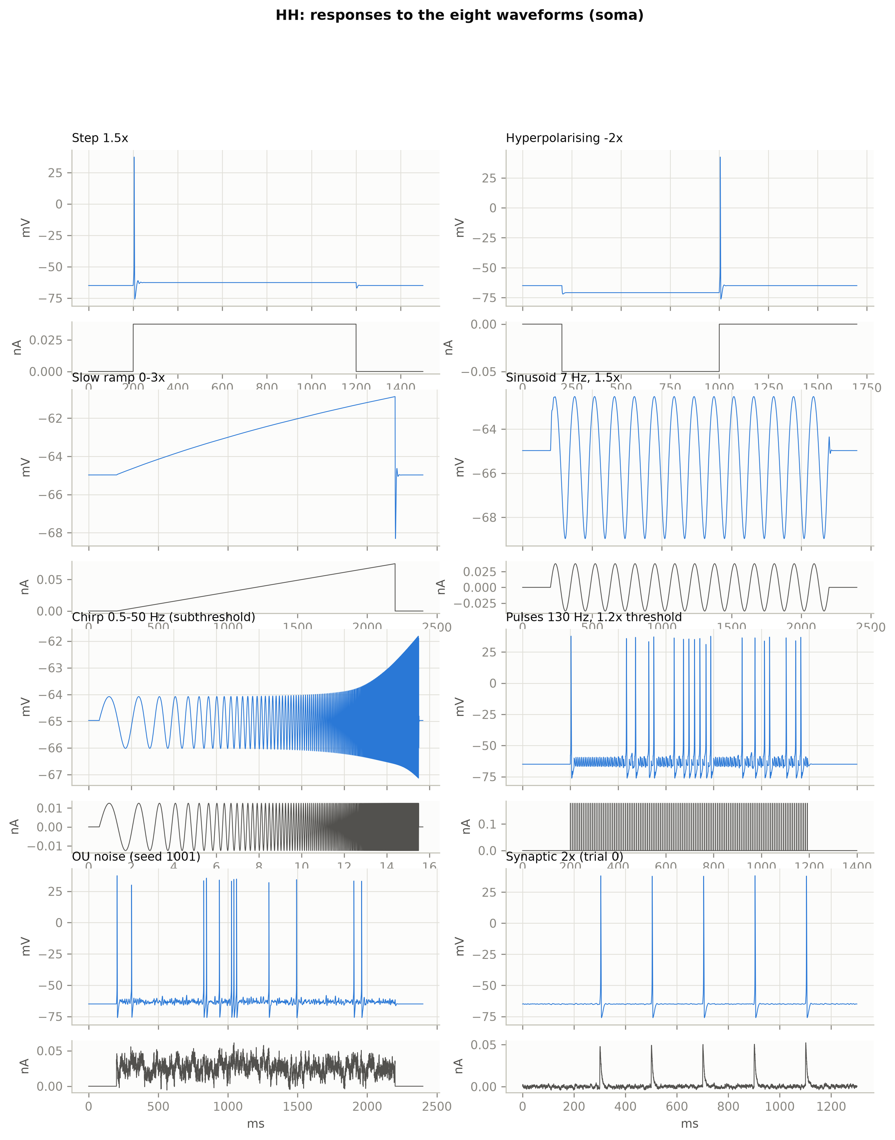
Figure 12. HH responses to the eight waveforms (soma).
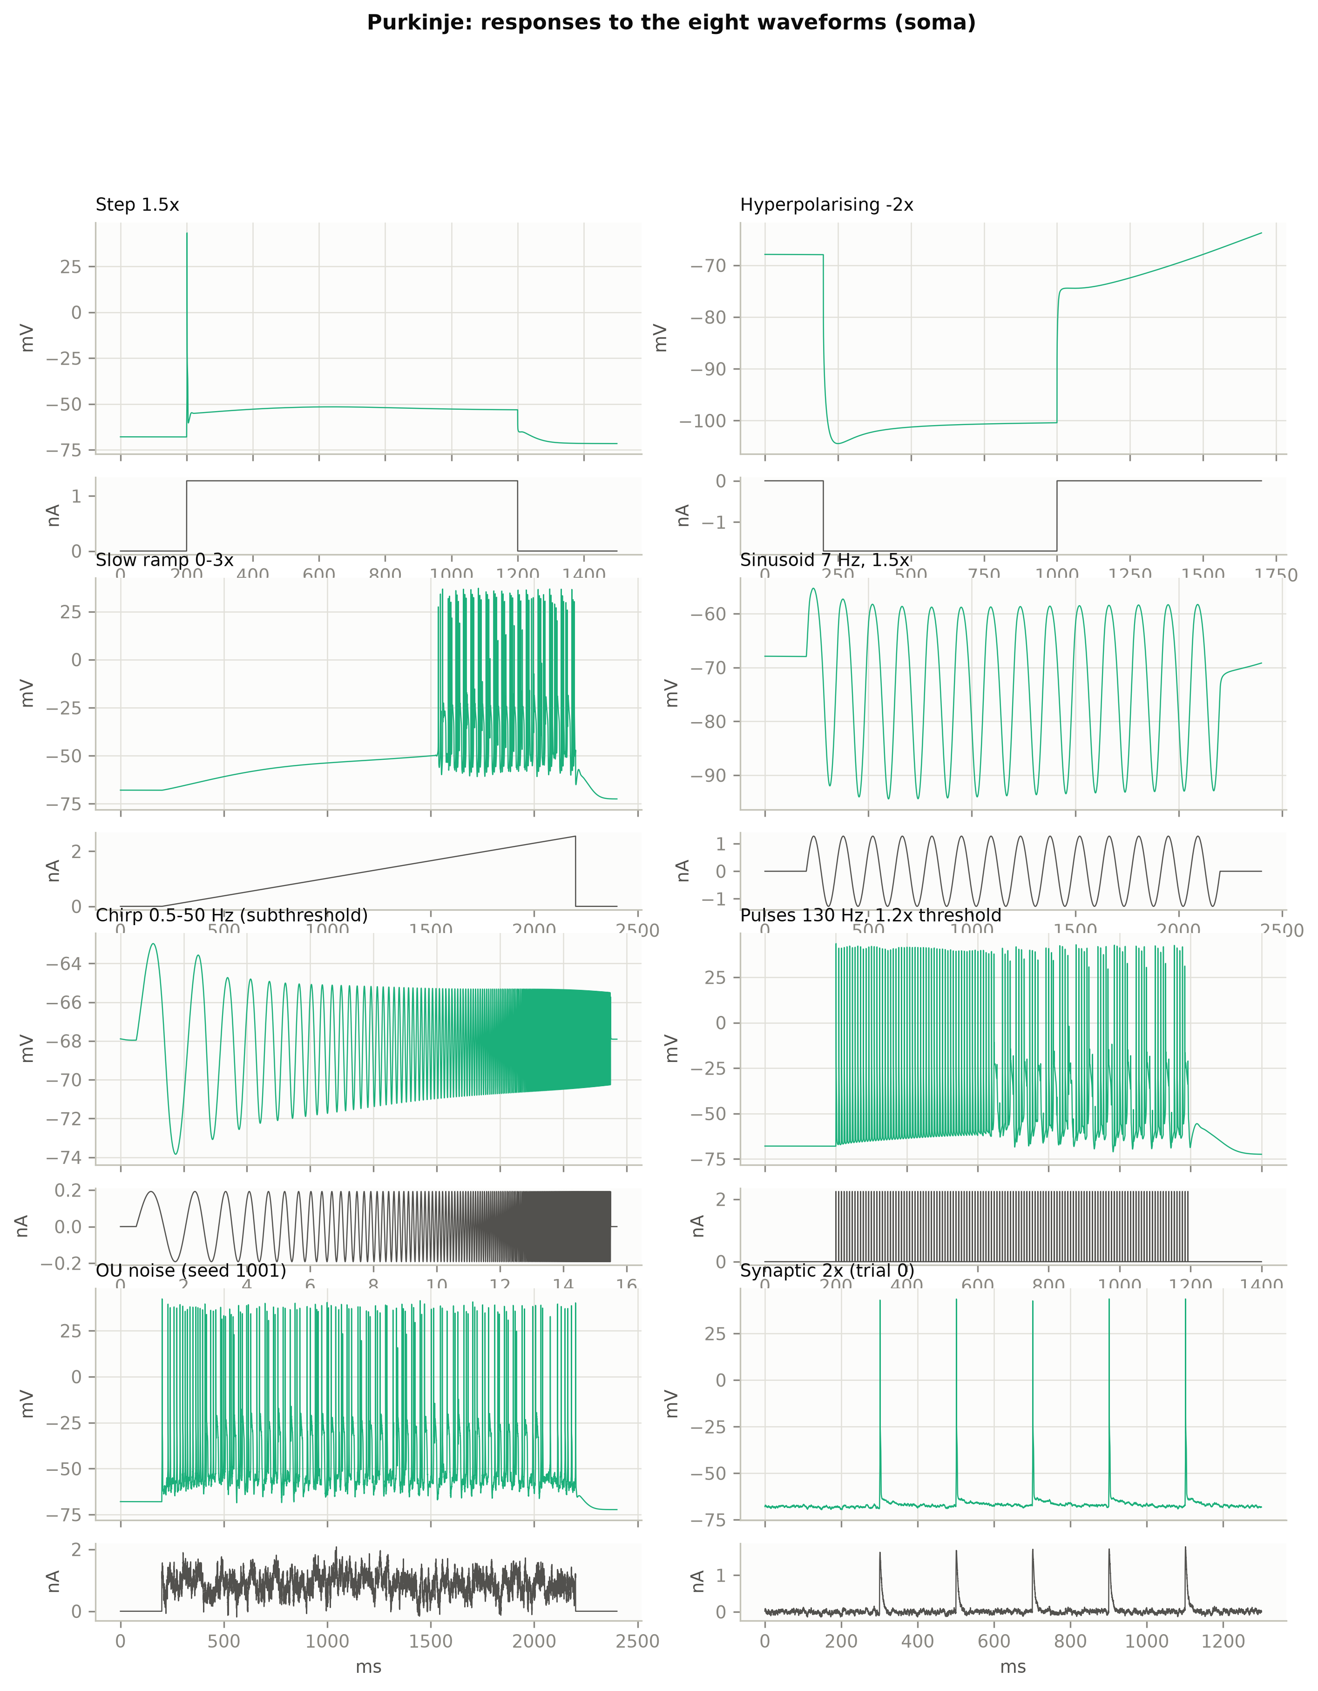
Figure 13. Purkinje responses to the eight waveforms (soma).
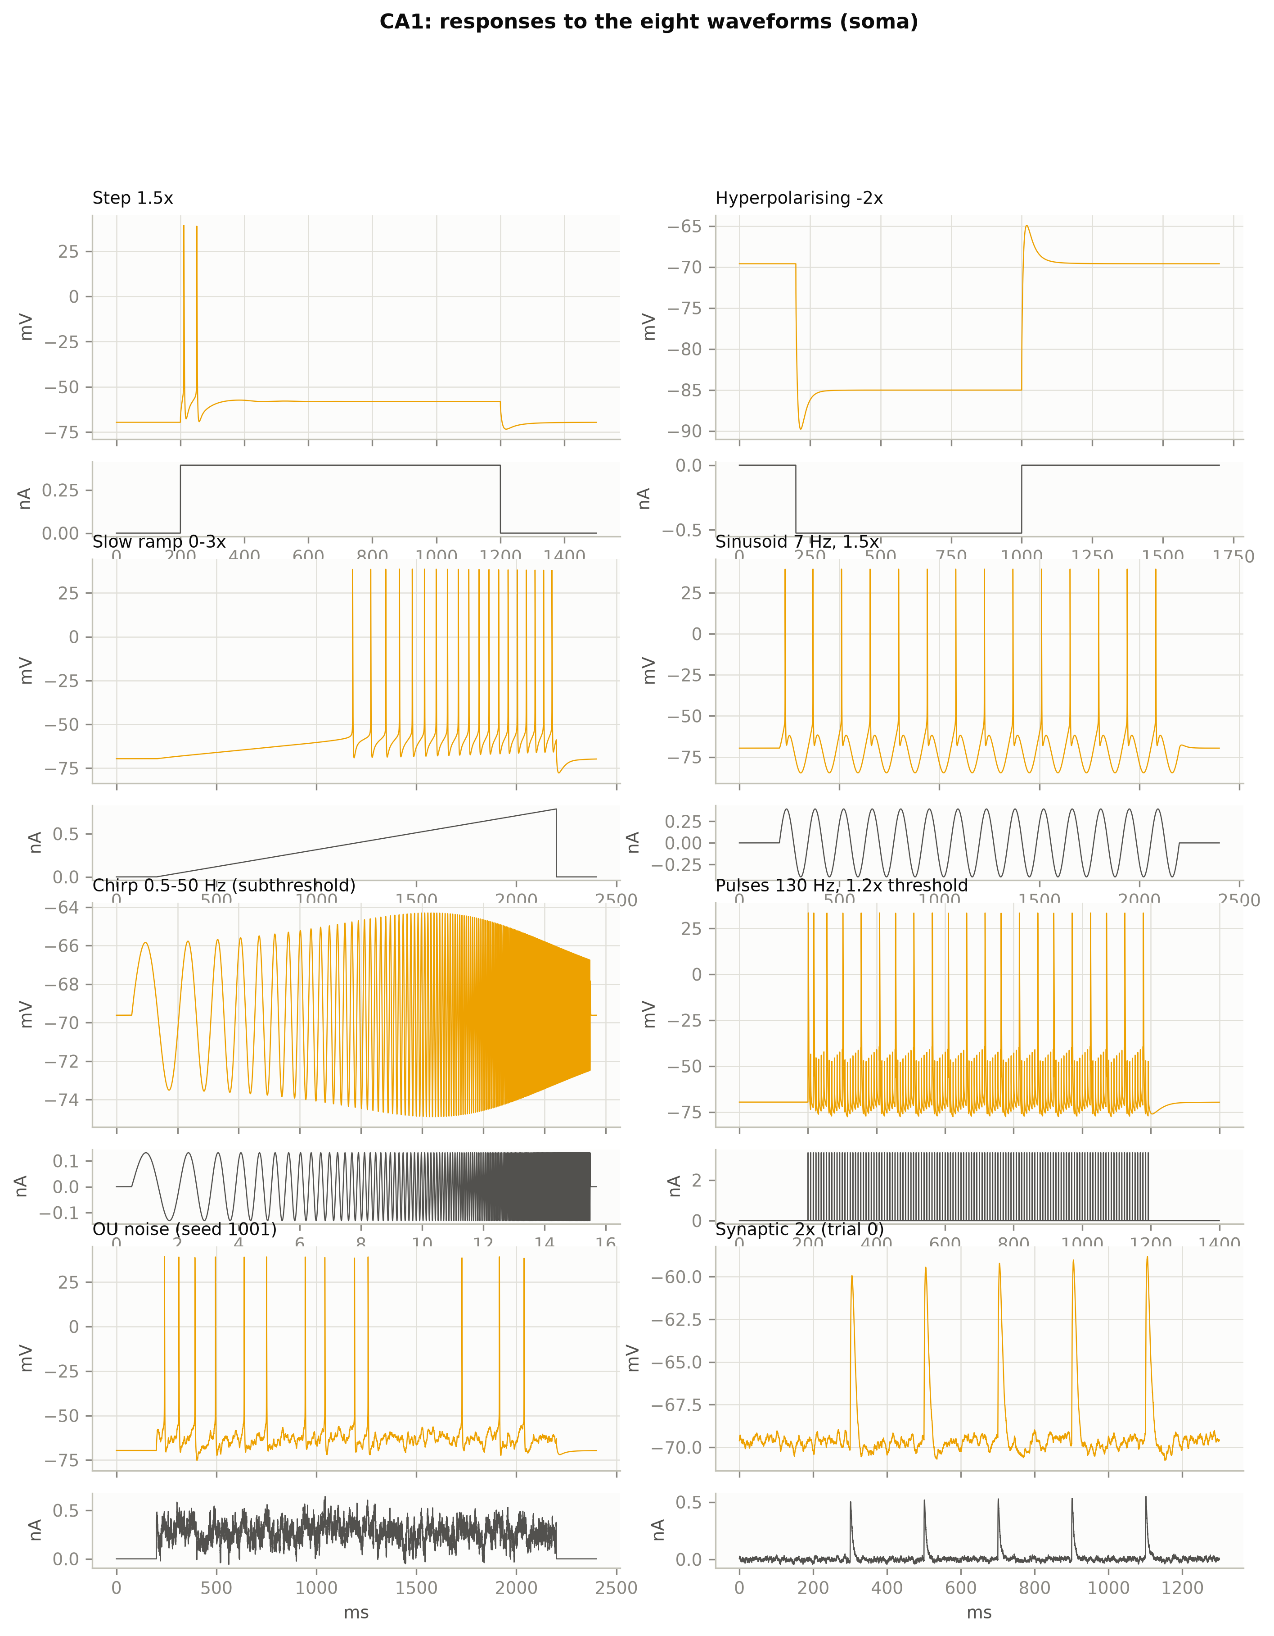
Figure 14. CA1 responses to the eight waveforms (soma).

Appendix B. Reproducibility
- Code: project folder with one script per step; python main.py runs the full pipeline (≈ 1.5 h on a 12-core PC under WSL2). Step 7 (979 simulations) is resumable.
- Software: NEURON 9.0 (Python interface), numpy, scipy, matplotlib, pandas; exact versions, platform and MD5 checksums of every model file are recorded in results/logs/provenance.md.
- Numerics: fixed step dt = 0.025 ms (verified against 0.0125 ms); states settled once and restored with SaveState before each run.
- Random seeds: OU noise seeds 1001–1020 (variability); frozen-noise signal seed 2000 with trial seeds 3001–3020; synaptic background seeds 4001–4020; random pacemaker phase per task from a hash of the task identifier; numpy PCG64 generator.
- Data: every simulation is saved as a compressed .npz with its full metadata (results/data/runs/); metric definitions are in analysis/README.md and all derived metrics in results/data/analysis/.

