Game Information Document

Game Title: Flack Squad | Genre (assigned by Microsoft):
Xbox 360 titleID: 58410953
Developer: Signature Devices Inc. | Est Release Date: 08/08/2008

Game Synopsis:

Please use this section to give a brief overview of what the game is about.
FlackSquad is a World War II arcade turret-shooter game. Although the timeline is set in the 1940’s, the player has a variety of high tech experimental weapons to protect various vehicles or ground points versus an onslaught of air, ground, and sea enemies. The player will also be able to fight from different unique weapons platforms. Such as a bunker, a B-17 ball turret, a battleship, and a Sherman Tank. Enemy attacks will become increasingly difficult to counter as the enemy begins to integrate more advanced aircraft, tanks and rocketry into their onslaught.

Levels/Stages:
Total number of levels/stages: 30 | Number of levels/stages in Trial: 1

Achievements:
Achievement name: | Steps necessary to reach Achievement: | Gamer Points awarded
Bronze Completion | Complete the game on Easy Difficulty | 10
Silver Completion | Complete the game on Normal Difficulty | 15
Gold Completion | Complete the game on Hard Difficulty | 25
Bronze Ace | Defeat 100 Enemies | 10
Silver Ace | Defeat 250 Enemies | 15
Gold Ace | Defeat 500 Enemies | 25
Bronze Sniper | Complete a mission with >50% Accuracy | 10
Silver Sniper | Complete a mission with >75% Accuracy | 15
Gold Sniper | Complete a mission with >90% Accuracy | 25
Captain | Score over 10,000 points | 10
Major | Score over 50,000 points | 15
Colonel | Score over 100,000 points | 25

Please consider this feedback when designing your achievements
https://arcadedeveloperforum.team.partners.extranet.microsoft.com/Lists/Developer%20Support/DispForm.aspx?ID=296&Source=https%3A%2F%2Farcadedeveloperforum%2Eteam%2Epartners%2Eextranet%2Emicrosoft%2Ecom%2FLists%2FDeveloper%2520Support%2FAllItems%2Easpx

https://arcadedeveloperforum.team.partners.extranet.microsoft.com/Lists/Developer%20Support/DispForm.aspx?ID=283&Source=https%3A%2F%2Farcadedeveloperforum%2Eteam%2Epartners%2Eextranet%2Emicrosoft%2Ecom%2FLists%2FDeveloper%2520Support%2FAllItems%2Easpx

Showcase features:
Please use this area to list out or describe the things that make this game special. If this game is already released in other mediums, what makes this version different/better than the original? What graphical enhancements are being made?
Detailed Terrain and Ocean Rendering
Post-Process Special Effects
Realistic Physics

5 Exciting Weapon Types: Machine Gun, Rapid-Fire Chain Gun, Flack Gun, Testla Coil, Missle Launcher

Moving Weapon Platforms: Battleship, B-17 bomber, Sherman Tank.

Trial Version Info:

Please fill in the below based on which type of Trial experience is implemented.

What type of trial experience will you be using in your title?
Limited functionality Timed demo

Limited Functionality (please fill out this section if you have implemented a limited functionality based demo):

What is available during demo mode?

A single mission on the boat

What is not available during demo mode?
All other missions on land, boats, and tanks.

What is the users experience when they access the unlocked features?

What is the users experience when they access locked features?
Additional scenarios, enemies, and levels.

What functionality have you implemented to encourage the user to purchase the full version of the game?

Timed Demo (please fill out this section if you have implemented a time based demo):

Amount of time?

What functionality is available?

What is the user experience when time expires?

Note: You should not save any user information and should not upload any scores while in Demo mode. All Demos must be Live Aware and users should be able to view leader boards.

Controller Layout:

This image can be used to diagram what controls your game is going to use and what they do:
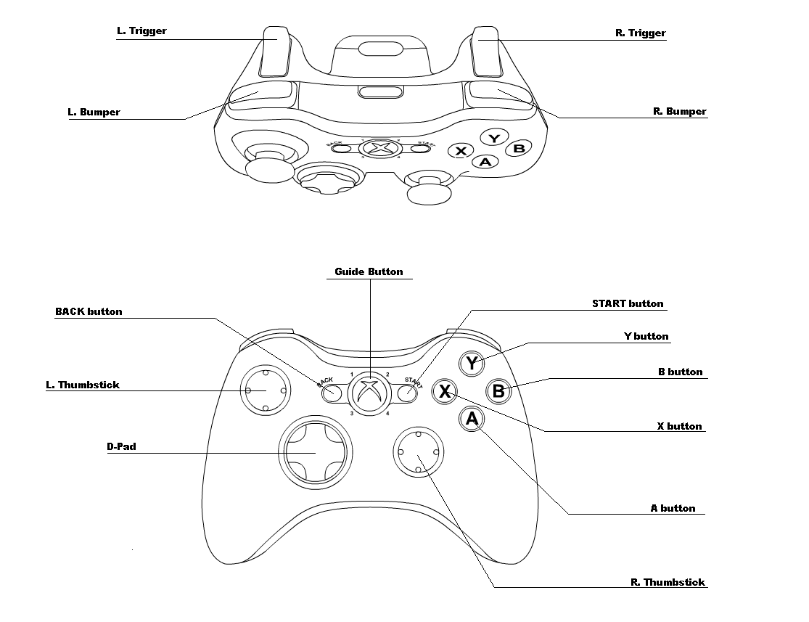
L. Trigger: Progressive Zoom
R. Trigger: Fire Primary Weapon
Start Button: Pause Menu
L. Thumbstick Direction: Aim Crosshair/Move Camera
L. Thumbstick Click: Fire Missle w/ Missle Cam
A Button: Lock Missile / Fire Missile / Initiate Missile Barrage
B Button: Cycle Next Primary Weapon
X Button: Cycle Previous Primary Weapon

Leader Board usage description:

Leaderboard name: | What data is stored/displayed: | Arbitrated | How are players ranked/rated: | When is data posted:
Campaign | Score Value | Y N | Highest to Lowest | At the completion of a mission or end-game.
Survival | Time Value | Y N | Highest to Lowest | When player’s health is zero.
Time-Attack | Number of Kills Value | Y N | Highest to Lowest | When time runs out.

Singleplayer:
Number of players:
Indicate the number of players the submission supports on one Xbox 360:
1 1-2 1-3 1-4 Other:
Explain the different singleplayer gameplay modes:
This title supports only the Campaign setting for singleplayer gameplay modes.

Multiplayer:
Xbox Live: multiplayer support
Does the submission support multiplayer sessions on Xbox Live? Y N
Indicate the maximum number players per session on Xbox Live: 2
Indicate the maximum number of players per console when playing on Xbox Live: 1
If there are different numbers for different session types, please describe: No
Does the submission support cooperative gameplay? Y N
Does the submission support tournament gameplay? Y N
Explain the different multiplayer gameplay modes: Only Co-Op 2-Player Multiplayer.
Does the submission support Host migration? Y N
Does the submission support join in progress? Y N
What type of network implementation will you be using in your title?
Microsoft provided Self-built Other: QNet with internal library.

Save System:
Will your title have saves? Y N
Manual Autosave Both
Save location:
Profile Save file
What information is being saved:
This title does not support saving progress.

Settings:
Profile (preferred) Save file
What settings are being saved:
This title does not save any setting in either the player’s profile or in a save file.

Additional Downloadable Content:
Please explain plan and details of what additional downloadable content will be made available for your title:
At this moment, there are no plans to provide additional downloadable content. In the future, additional missions (using current levels) may be added.

Cheats/Easter Eggs:
Please use this section to list out any cheat codes and/or easter eggs you plan to release in the game. Cert requires all Easter Eggs to be disclosed.
There are no truly hidden easter eggs in this game. As the player shoots down target they will randomly get bonus upgrades to their health, ammo supply, and weapons. These bonuses appear as crates attached to color-coded parachutes that fall from a downed enemy plane.

There are no cheat-codes in this game.

Please provide other documentation:
Technical Development Description
Game Design Document
Test tools and debug hooks

