GDS Technical Design Document
GDS – Game Development System
Draft
Author: Kenneth L. Hurley
Scheduled Release: 1.0

Revision History
The following revisions have been made to this document:
Date | Revision | Developer | Summary of Changes
2002-04-30 | .1 | KLH | Started Document

Contents
1 Executive Summary 1
2 Owners of Key Product Areas 1
3 Design Overview 1
4 Architectural Design 2
5 Design Criteria and Constraints 2
6 Components 3
6.1 gds.h 3
6.2 Extension DLLS 4
6.3 CFileManager 5
6.4 CObjectManager 5
6.5 CBaseObject 6
6.6 CRenderer 7
6.7 CMesh 8
6.8 CHardwareStream 9
6.9 CCamera 10
6.10 CLight 11
6.11 CConfig 12
6.12 CVector3 13
6.13 CVector4 14
6.14 CMatrix3 15
6.15 CMatrix4 16
6.16 CTexture 17
6.17 CTransform 18
7 Data Structures 18
8 Error and Exception Handling 18
9 Application Programming Interface (API) 19
9.1 Extension DLL resource conventions 19
10 Tools 19
11 Feature Operation 19
12 Internationalization 20
13 Other Considerations 20
14 Performance/Resources Impact 20
15 Portability 20
16 Consistency 20
17 Compatibility 20
18 Important Issues 20
19 Related Documentation 20

Executive Summary

Owners of Key Product Areas
<Identify owners in the key product areas.>
Product Area | Owners
Marketing | <name(s)>
Development | Cédric Guillemet, Kenneth L. Hurley
Development Leader | Cédric Guillemet
Supporting Developers | N/A
Supporting Development Leaders | <name(s) or none>
Quality Assurance | <name(s)>
Documentation | <name(s)>
Online Help | <name(s)>

Design Overview
GDS Application
CMainFrame
CObjectBar
CObjectPages
CBaseObjectDLL
CDLLInterface
CDLLInterface
CBaseDLL
Plugin Directory
COpenGLRender
CDX8Render
CHierarchy
CTextureDLL
CSoundDLL
CBSPMap
CWorldEditor
Message Direction
Derived From
Searches

Architectural Design

Design Criteria and Constraints

Components

gds.h
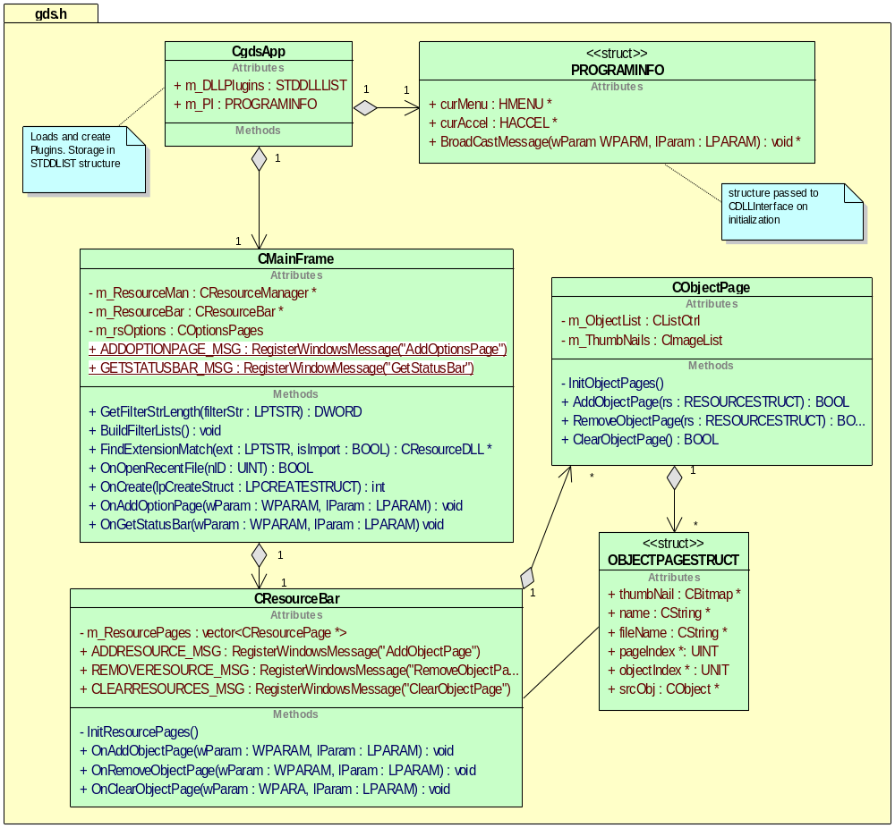
The key design philosophy of GDS is to keep the API as simple as possible and to document the major functions with a header and description. The description also includes input parameters and output parameters. Additional design philosophies for GDS include using comments that will automatically generate documentation through the program doxygen. GDS is plugin based. This means that GDS should have plugins that are interchangeable with other programs. In order to facilitate this, GDS was designed to pass messages between plugins and the main application. The plugins should treat themselves as a stand-alone application with no interaction to other plugins or the GDS application with pointers. Instead of pointers to other plugins, the plugin should broadcast a message on an event. For example, when the texture plugin loads a texture, it should broadcast a message to add a resource. The resource manager will process the message and add the object to its list. After that, the resource page manager will also get the message and add the thumbnail to the resource page. This is also beneficial in that a plugin that is using MFC can have a “CView” or “Cdocument” class get a message that was broadcast.

Extension DLLS
Extension DLLS use the MFC Extension DLL interface. This interface allows a DLL to have access to the main applications MFC controls and data. The extension DLLS are designed in such a way that they shouldn’t know which application they are running in. Program info is passed into the DLL upon initialization, which gives pointers to the main applications elements that need to be passed back and forth. The UML Diagram is as follows:
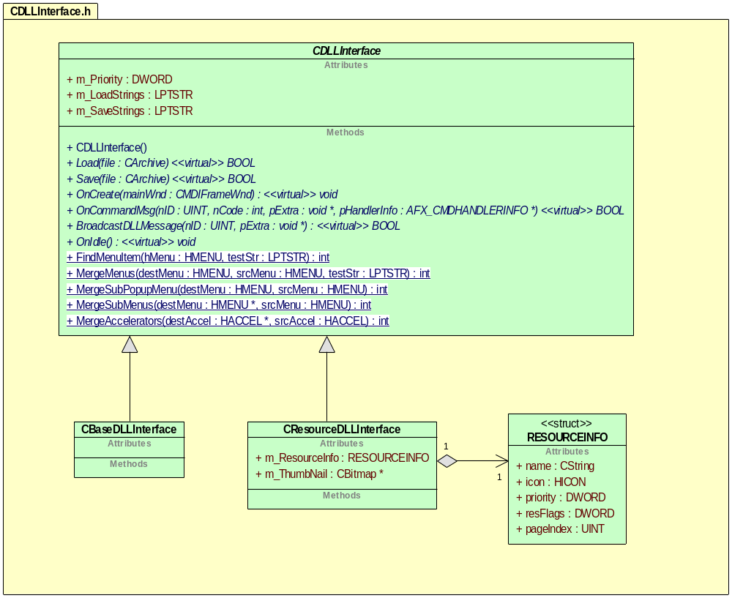
Extension DLLS should be one of two types, CBaseDLLInterface or CResourceDLLInterface. The CBaseDLLInterface class is used for DLLS that are essential to the operation of Kapsul. For example, the hierarchy window is defined in CBaseSceneDLL, which is derived from CDLLInterface. In addition, the render class and controller class should be derived form CBaseDLLInterface. Controller classes should be defined with a higher priority than the render class so that they will be called first. Calls are made to each of the DLLS when the application is idle through the virtual function OnIdle().

CFileManager
The File Manager will be responsible for calling the Load and Save functions for a resource. The resource .dll file will be responsible for processing two calls.

BOOL Load(CArchive &file) - Loads the resource into memory - for example of resource see CMesh in document
BOOL Save(CArchive &file) - Saves the resource in memory.
Resource .dlls are responsible for getting windows messages, except Load/Save.

CObjectManager
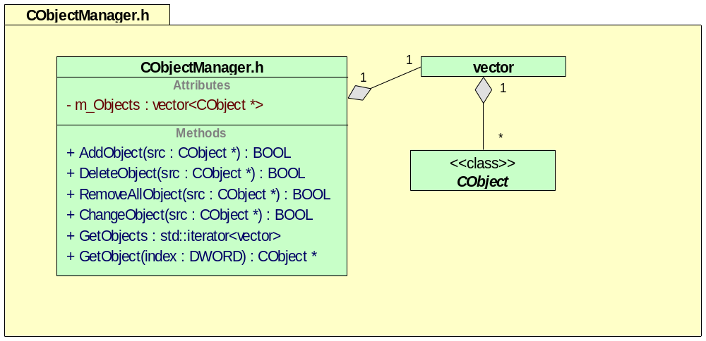
The object manager is responsible for holding all the resources that are loaded. When a DLL loads in a object, it calls the ObjectManager that was passed in the PROGRAMINFO structure when the DLL was initialized. When an object DLL file changes an object, it calls the object manager with the changes for the object. The m_Objects is the variable that holds a “vector map” of all the objects in the system that are currently loaded.

CBaseObject
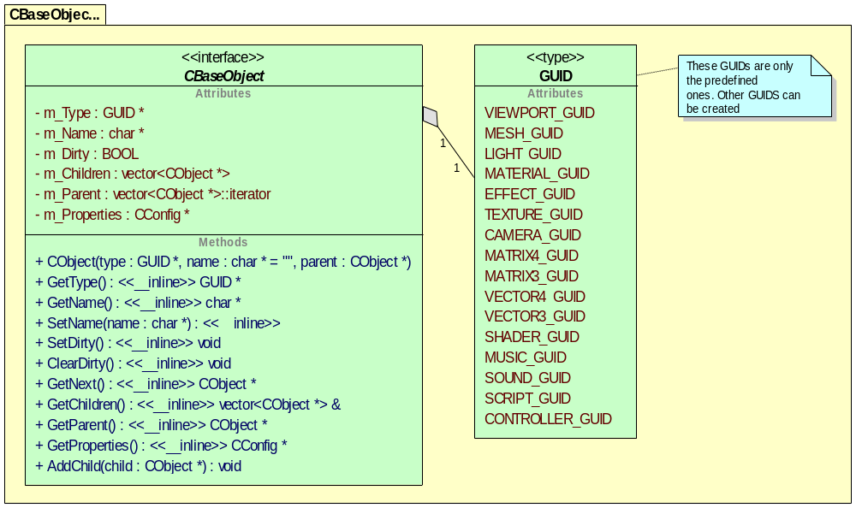
The CBaseObject class is a general class that is used by the object manager. The object manager doesn’t know or care what types of objects are being managed. The m_Type is a GUID that allows for communicating the type between plugins. The name field is the textual representation of the object. The m_Dirty flag gets set when the object has been modified and cleared when all plugins have had a chance to see the change. The m_Parent is a pointer to the parent object in the hierarchy. The m_Next pointer is a pointer to the next sibling object. The m_Children is a pointer to any child objects in the hierarchy. The m_Properties attribute is a pointer to the Cconfig class. An example of a configuration for this object is the “Visible” flag. If the configuration has the “Visible” flag set then the render would render the object. All attributes are private and are accessed through inline functions. This is to protect the object and for error checking.

CRender
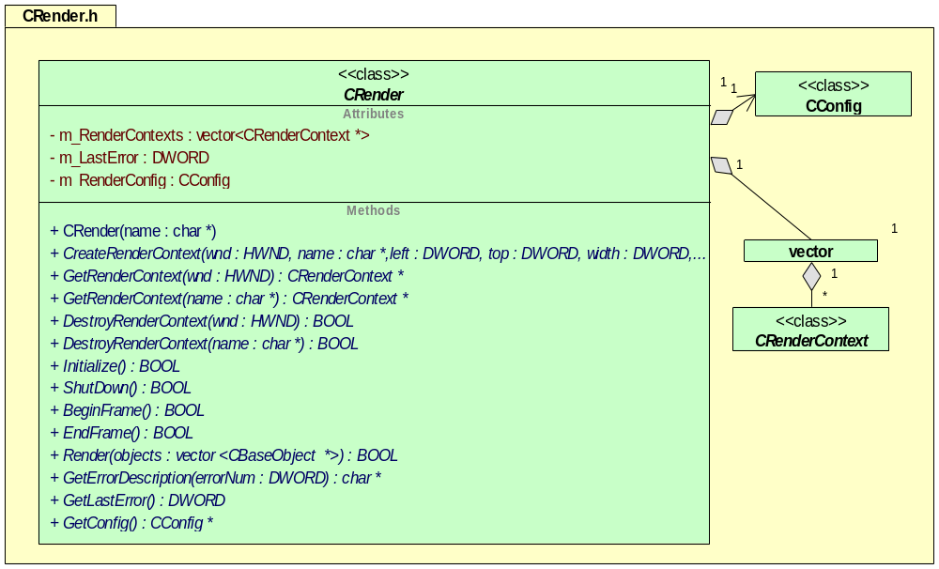
All renders are derived from the CRender class. This is so that any number of renders may be developed as plug-ins. A CRender class must be capable of creating multiple windows. The derived render class is responsible for determining if it understands the object type within the Render() function. The GetConfig function allows the application to set configuration parameters for the render class. One example would be “RenderMode” and the enumerate MODE_WIRE_FRAME. This is useful for controllers that want to animate a mesh or for a plug in that generates procedural textures.

CMesh
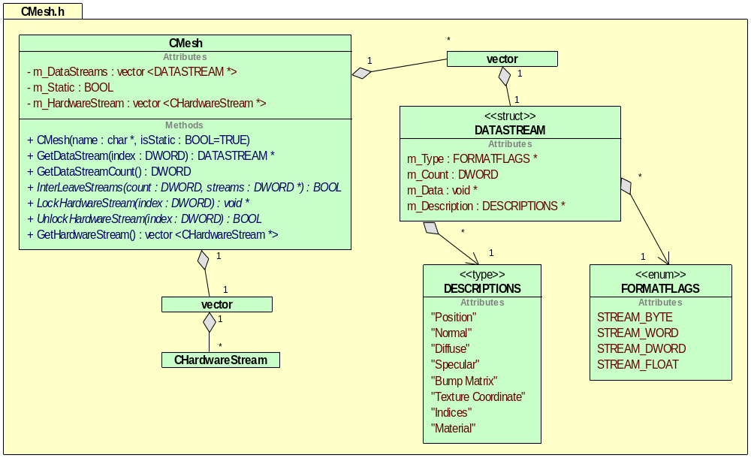
The CMesh class is a generic class that holds mesh data. The data can include any sort of data. The data that the mesh does include is specified by the DataStream structures. Each structure holds the description of the stream and the format of the data in the stream. This data is located in system memory and may not be hardware friendly. There is also a link to a hardware stream class. This stream is more hardware friendly. There are several functions for interleaving the data so that it can be packed into one stream. This may be useful for hardware. The m_Static flag is used to specify if this mesh is static or may have to be updated. Updated mesh examples would be DX7 or CPU bone animated meshes, or a dynamic LOD terrain system like ROAM. The GetHardwareStream is useful for Renderers as they can directly access the stream data.

CHardwareStream
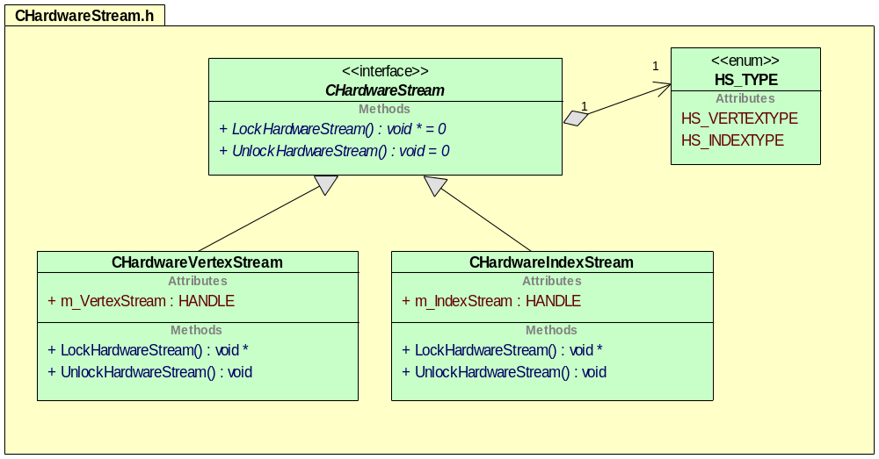
The CHardwareStream class is an interface class. Sub-classes in this diagram include a CHardwareVertexStream, which is used as a container for vertex data. The CHardwareIndexStream is used as a container for an index stream.

CCamera
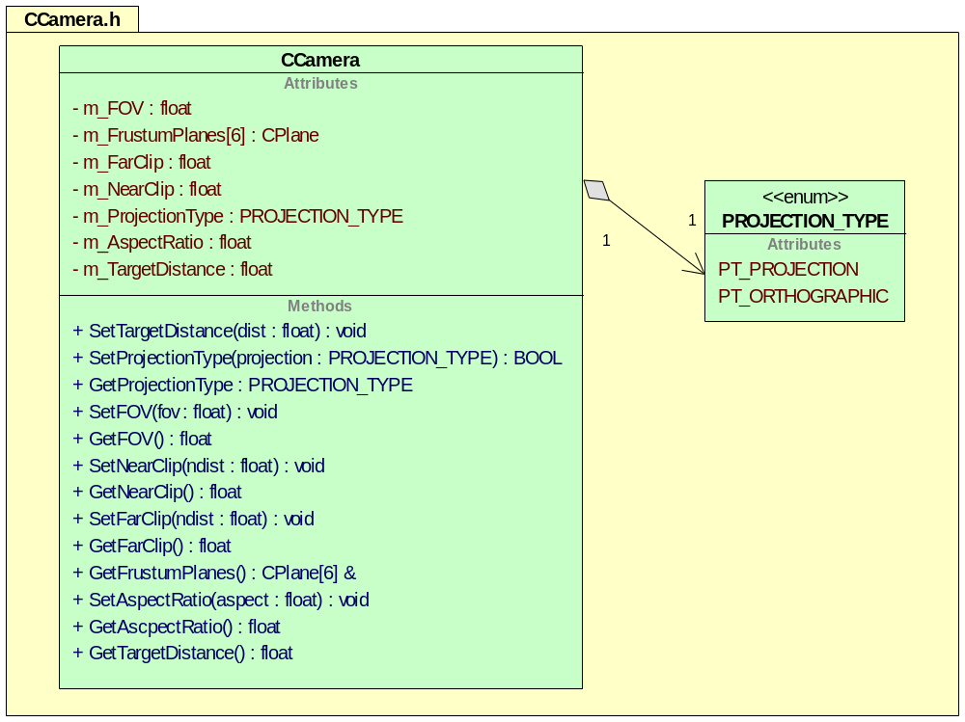

CLight
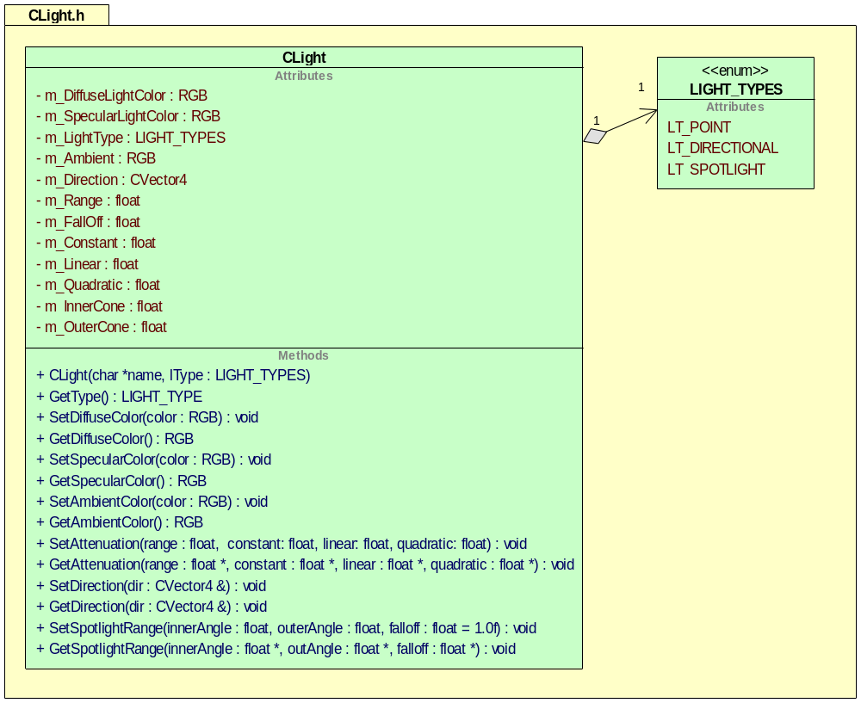

CConfig
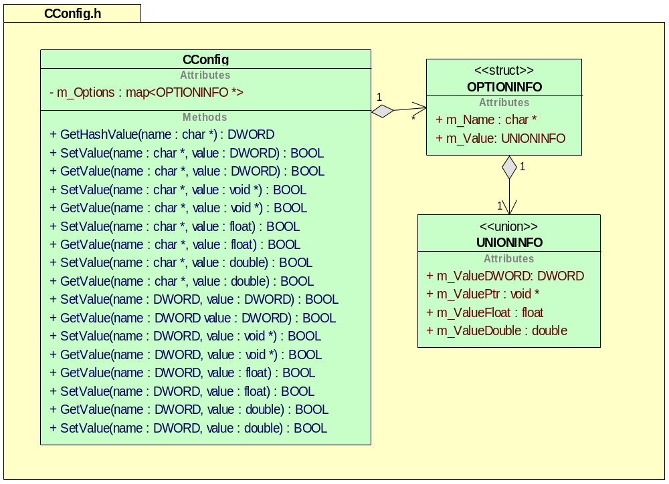

CVector3
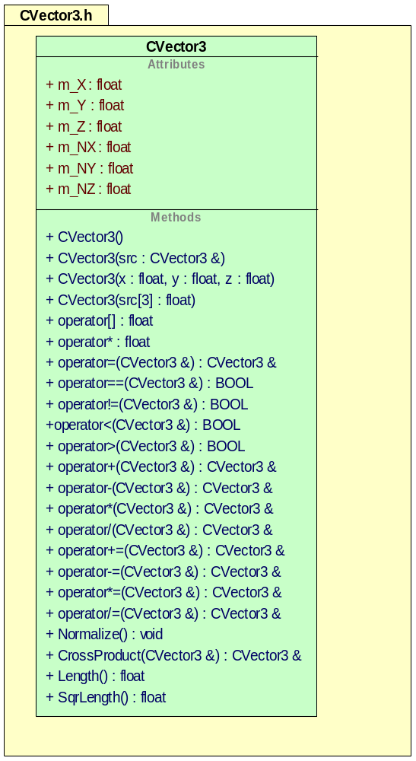

CVector4
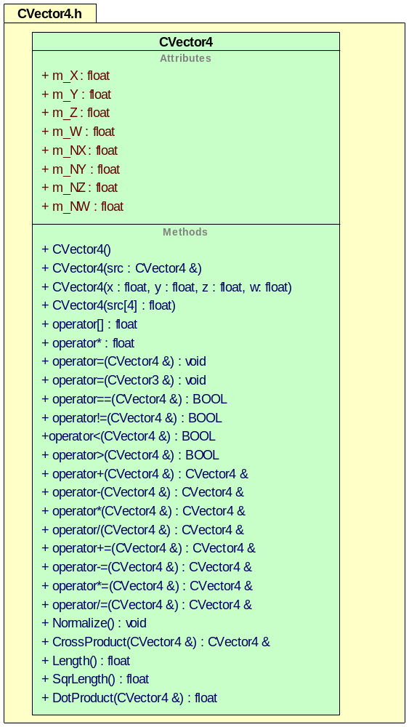

CMatrix3
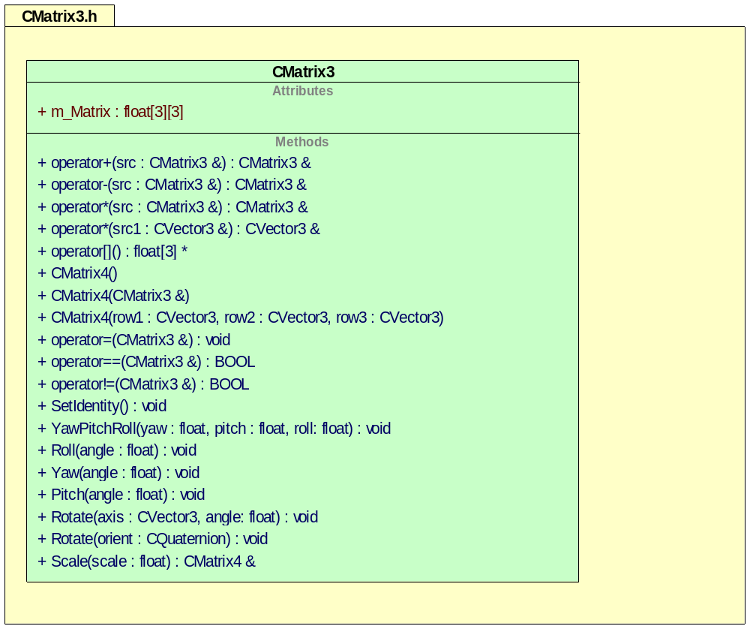

CMatrix4
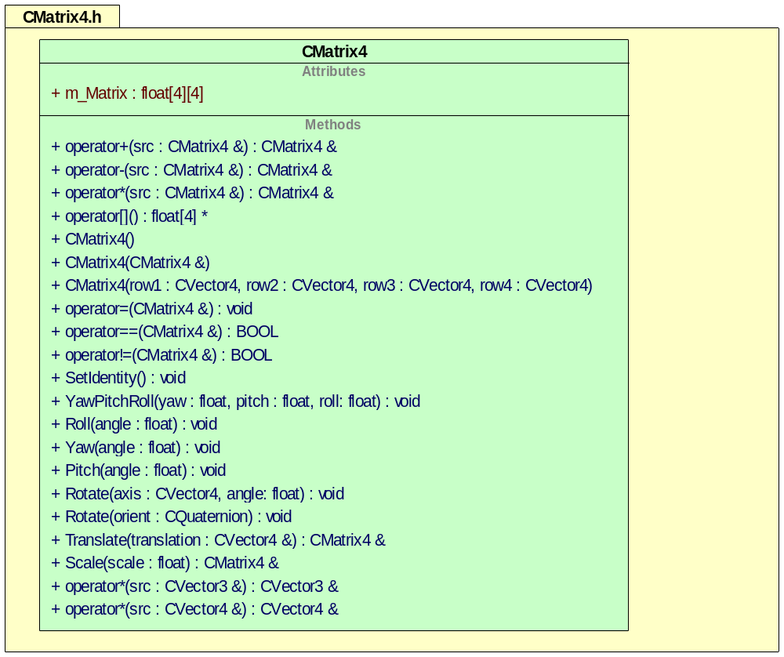

CTexture
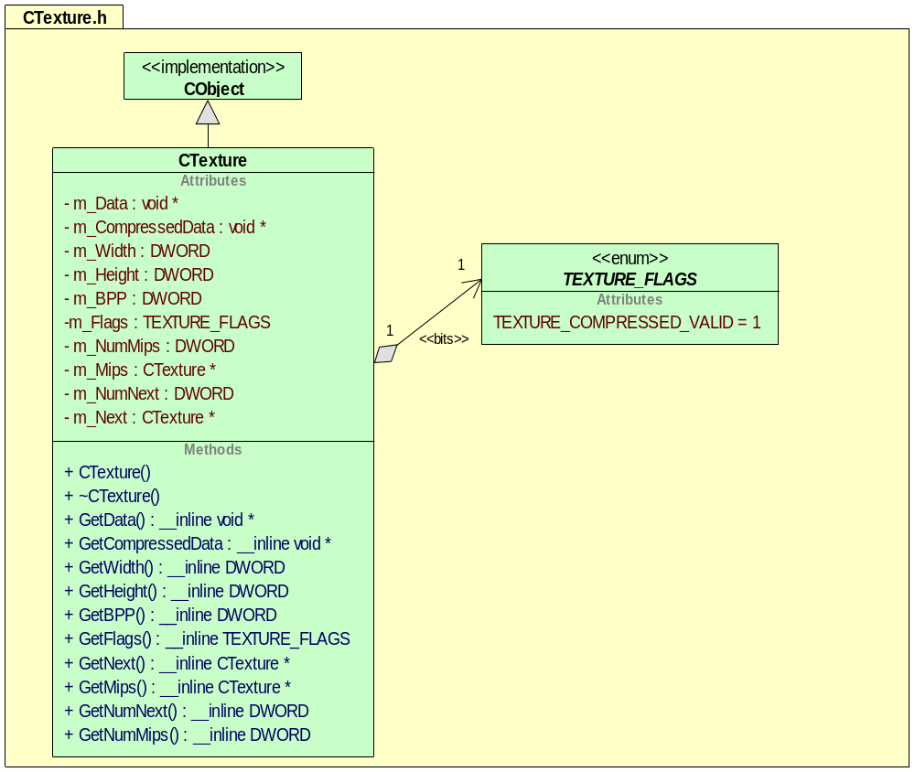

CTransform
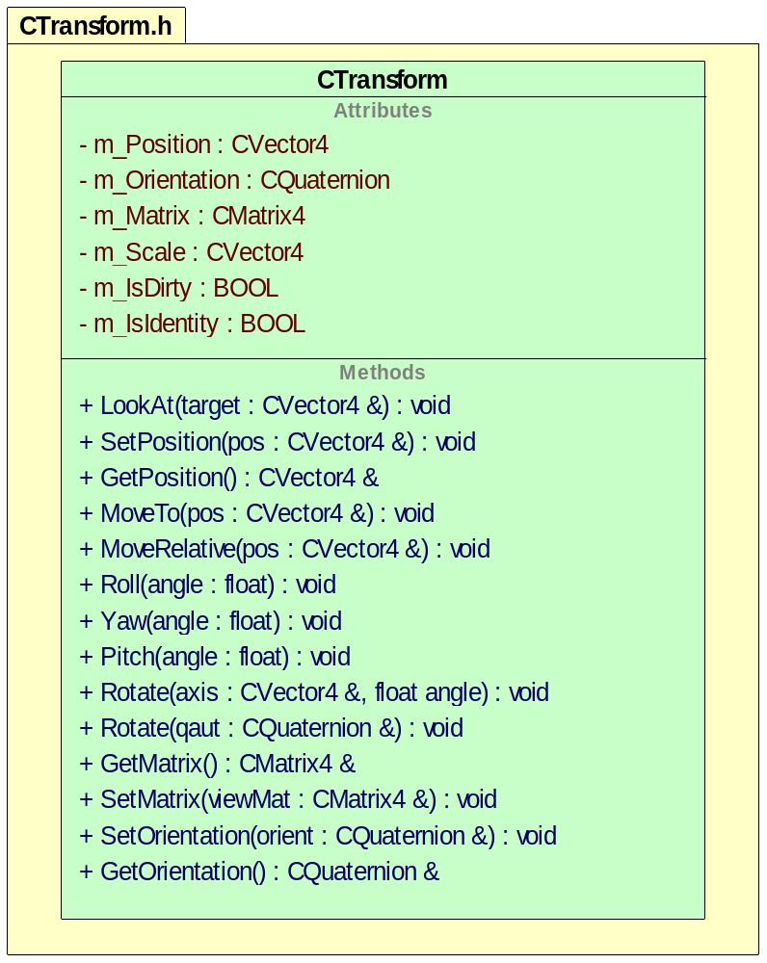
The CTransform object is used to set the position in the 3D world. This is also used by the controller class, AI class, etc. to update the object that is attached to the transform object.

Data Structures
<Identify and describe the data structures used by this feature.>

Error and Exception Handling
Structured Exception Handling (SEH) will be trapped by the application so that a log file may be created. This will allow the debugging process of an offsite client much easier.

Application Programming Interface (API)

Extension DLL resource conventions
Microsoft’s DLL extension mechanism is a great idea, but there are still issues with resource IDS. If you want to use IDS in the resource DLL, they will have to be unique. With this in mind the follow, conventions for IDS are proposed. Each extension DLL must modify the resource.h file to setup the unique IDS for that DLL. The modification only has to be done once when the project is created.
Extension DLLS are loaded by priority when passed back to the application that has loaded them. There is usually a menu, an icon and an ID associated with the document/view architecture. This is the starting point for the ID specification. Change this number to a number between 1000 and 20000. Then for controls, start the IDS at this number + 100. For IDS for menu items and buttons, add 40,000 to this number. Finally, for symed values, add 200. At the end of a resource file there are four values that need to be modified, APS_NEXT_RESOURCE_SYMBOL, APS_NEXT_COMMAND_SYMBOL, APS_NEXT_CONTROL_VALUE and APS_NEXT_SYMED_VALUE. These should be set to the last symbol defined for these types + 1. Here is an example implementation

//{{NO_DEPENDENCIES}}
// Microsoft Developer Studio generated include file.
// Used by ResourceShader.rc
//
#define IDR_SHADER_TYPE 2000 // Second Highest Priority loaded DLL
#define IDR_SHADER_TOOL_PALETTE 2000
#define IDS_SHADER 2000
#define IDS_RESOURCE_NAME 2001
#define IDD_SHADER_TOOL_PALETTE 2002
#define IDB_SHADER_TOOL_PAL 2005
#define IDB_SHADER_TOOL_PAL_DISABLE 2006

#define IDC_COMBO1 2100
#define IDC_SEARCHBUTTON 2101
#define IDC_EDIT_WATCH_VAR 2102
#define ID_TOOLBAR_COMPILE 2103

#define ID_SHADER_CHECK_SYNTAX 42001

// Next default values for new objects
//
#ifdef APSTUDIO_INVOKED
#ifndef APSTUDIO_READONLY_SYMBOLS
#define _APS_NEXT_RESOURCE_VALUE 20007
#define _APS_NEXT_COMMAND_VALUE 42002
#define _APS_NEXT_CONTROL_VALUE 2104
#define _APS_NEXT_SYMED_VALUE 2200
#endif
#endif

Tools
UML Diagrams were generated with UML Sculptor (http://umlsculptor.sourceforge.net)

Feature Operation
<Describe the feature in action. That is, describe how the pieces function together.>

Internationalization
<Identify and describe any internationalization requirements for this feature.>

Other Considerations
<Identify and describe any functional aspects of this feature not covered elsewhere in this document.>

Performance/Resources Impact
<Describe this feature's impact on system performance and resources.>

Portability
<Identify and describe any portability requirements for this feature.>

Consistency
<Identify and describe any consistency aspects of this feature relative to the tool. That is, consider how the feature conforms to the overall design of the tool in architecture, user interface characteristics, functionality, and so on.>

Compatibility
<Describe how this feature fits into the overall product.>

Important Issues
<<insert coding guidelines here>>

Related Documentation
<Identify other documents related to this feature.>
Document | Location/Filename
Marketing Requirements Document | <filename or none>
<Feature> Functional Specification | <filename or TBD>
<Feature> Test Plan | <filename or TBD>
Progress User Documentation
Other Documents

