**Knowledge Capture Document**

**Prospect Client Registration (PCR) Application**



**Document Record List:**

|  |  |  |  |  |  |
| --- | --- | --- | --- | --- | --- |
| **Version**  **No** | **Version Date** | **Modified By**  **Modified Dt.** | **Reviewed By**  **Reviewed Dt.** | **Authorized By**  **Authorized Dt.** | **Remarks** |
| 1.0 | 06/11/2010 | Piyush Pawar  06/07/2010 | Vishwas Gupta | Milind Patel | Created |
| 2.0 | 05/05/2015 | Taranjitkaur Gill  05/05/2015 | Piyush Pawar | Yogesh Sahasrabudhe | Update |
| 3.0 | 08/03/2017 | Hasnain Kothawala | Taranjitkaur Gill | Piyush Pawar | Update |
|  |  |  |  |  |  |

**Table of Contents**

1. Scope of the Document 4

2. Application overview 4

2.1. Terms Definition 4

2.2. Roles: 4

3. Application Functions 4

3.1 Company: 5

3.1.1 View Company: 7

3.1.2 Create Client Prospect Request: 8

3.1.3 PCR Workflow: 10

3.2 Register the Client/Prospect 13

3.2.1 Workflow on request status: 16

3.3 Inbox Screen: 19

3.3.1 Various Events on Inbox: 20

3.3.1.1 Request: 20

3.3.1.2 Closed Request: 25

3.3.1.3 Error Admin: 26

3.4 Update the records: 27

3.4.1 Auto Update: 27

3.5 Integration with marsh force: 29

3.7 Registration Conflicts: 32

3.7.1 Company Information Changes 33

3.7.2 Move Registration 34

3.8 Batch Process: 35

4. Technical Architecture 36

5. System Information 36

5.1. Database 36

5.2. Batch 36

5.3. Screen Flow 36

5.4. Transaction Flow 36

5.5. Typical Problem Areas and Troubleshooting 36

6. Interfaces 36

7. Tools 36

8. Environments 36

9. Testing 37

10. Processes 37

11. Security 37

11.1. User Roles and Responsibilities 37

12. Reports 37

13. References 37

# Scope of the Document

The scope of this document is to capture the technical and functional knowledge for PCR application. It covers:

* Thorough Application understanding
* Functionality overview
* Integration with various systems
* Details of environments where application is deployed

# Application overview

PCR is the gateway where DMG user registers an entity. This application is used to create and register Prospect/Client in the system. PCR shares the gateway with ATM. Roles in PCR application are assigned through ATM application(Account, MANAGE Teams, Manage colleagues {First3 tabs in PCR application} ).

**PCR Tabs:**

***Company* : *Appears for all roles.***

***Inbox* : *DMG and Full Access User.***

**Registration Conflicts : DMG**

**My Requests : DMG and Full Access User**

**Batch Process : DMG and Full Access User**

**DMG admin : DMG**

## Terms Definition

1. *Prospect: Any company with whom the deal is in process (Not finalized).*
2. *Client: Already in business with Marsh (Deal is finalized).*

## Roles:

1. *DMG Access*
2. *PCR Full Access User*
3. *Limited Access User*

# Application Functions

*PCR is used to create and register the prospect/client in the system. After registration data saves into MINA. Within the Prospect/Client Registration System (PCR), authorized Data Coordinators across the globe may submit requests to create or modify the Marsh Relationship with a given company.*

*Data Coordinators generally act only upon company’s within their own region, and these requests generally do not require any additional approvals from the Data Management Group.*

***MINA***

*MINA comes at the Very starting level of the G20 application, which is very important with the business perspective. Any system work with any client for the first time will send the Client’s Name and Address to MINA system. MINA validates and verifies the names & address so that there will not be any duplicate entry for the same client as well as there should not be any erroneous data.*

***Lucene Search Engine***

*PCR uses Lucene Search Engine for the faster search retrieval.*

## Company:

*A request for new Prospect/Client or registration can be created inside “****Company”*** *tab.*

*In the application, before create and update we need to perform search. To prevent duplicate entities, search is provided at the very first step. After login the default tab selected as “Company”*

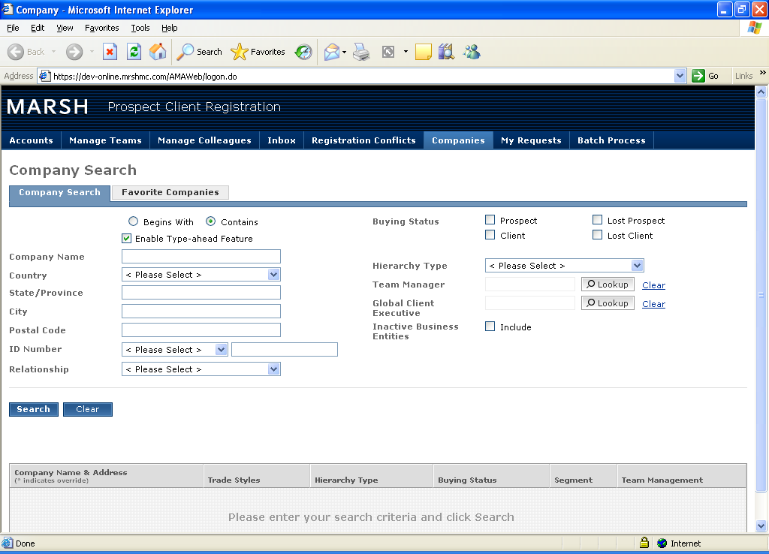

***Fig: Company Search Screen***

*The application is having Type-ahead feature. After Search* ***Add Prospect/Client*** *and* ***Actions*** *buttons appear. If the search is performed with Company name and then system selects all the records where search string is matching with Company name or trade style. System also fetches the records having secondary address matching with the search string even though the primary company name and trade style are not matching. User can select multiple companies i.e. checkbox fields from search page and Action button allows user to perform certain actions on selected companies such as update account owner, update GCE etc.*

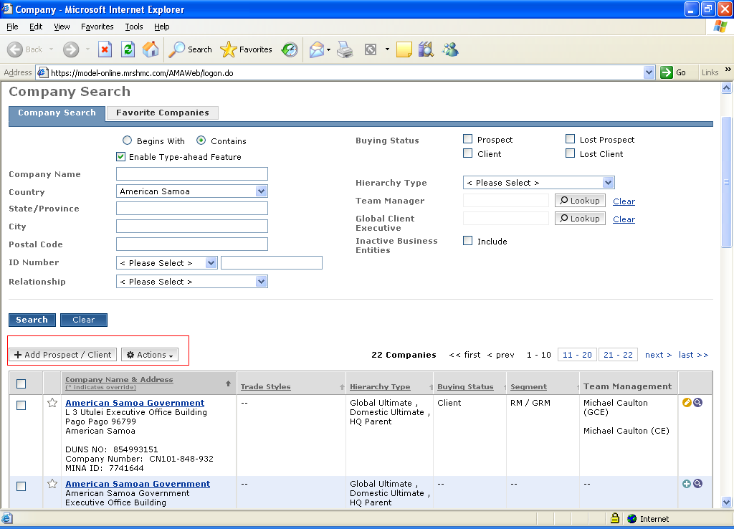

***Fig: Company Search Screen with Search Results***

From the search results user can mark a company as favorite by selecting respective star icon. These companies then would appear in the “favorite companies” tab.

IMP: Many other application shares company search functionality with PCR.

## View Company:

*Click on Company Name:*

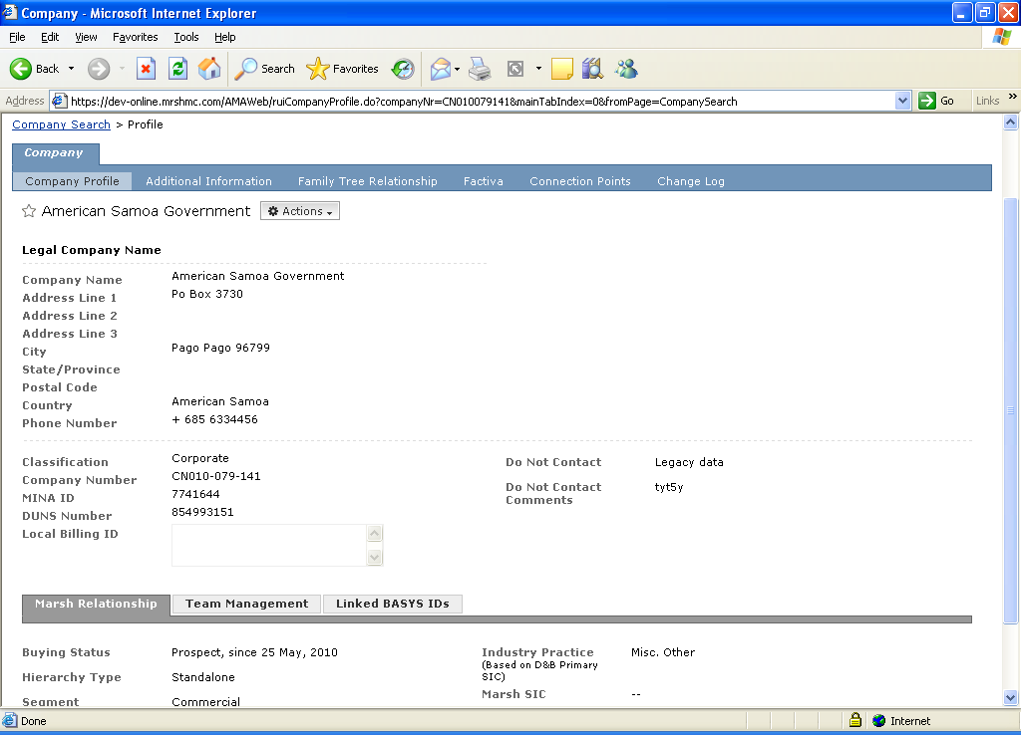

*This screen consists of following:*

*-****Company Profile****: Company’s name and address*

*-****Additional Information****: D&B Information*

*-****Family Tree Relationship****: Company hierarchy (i.e. Parent child companies)*

*-****Factiva****: Third party provider for financial information, Industry Information*

*-****Connection Point****: Page which tells how the selected company related to downstream application (i.e. MF, CAR etc.) in the Marsh.*

*-****Change Log****: Audit trail. Logs about company information change or update etc.*

*Company profile also shows Marsh relationship information (Registration information), Team management information and Linked Basys id and global relationship information.*

## Create Client Prospect Request:

*After clicking Add Prospect/Client buttons following screen appears:*

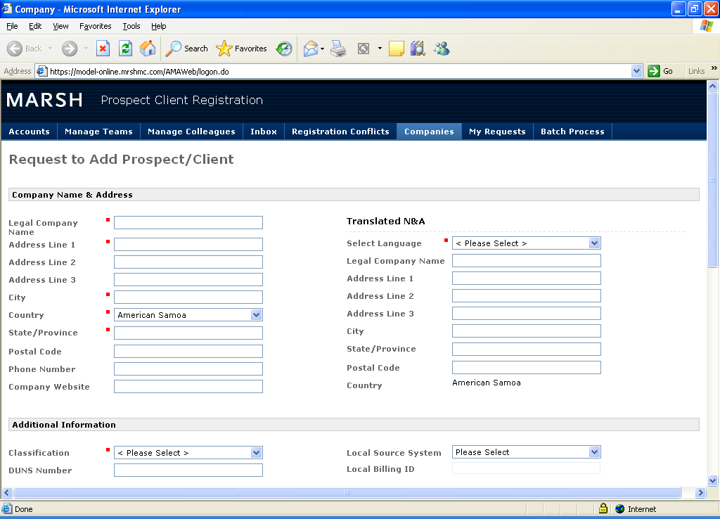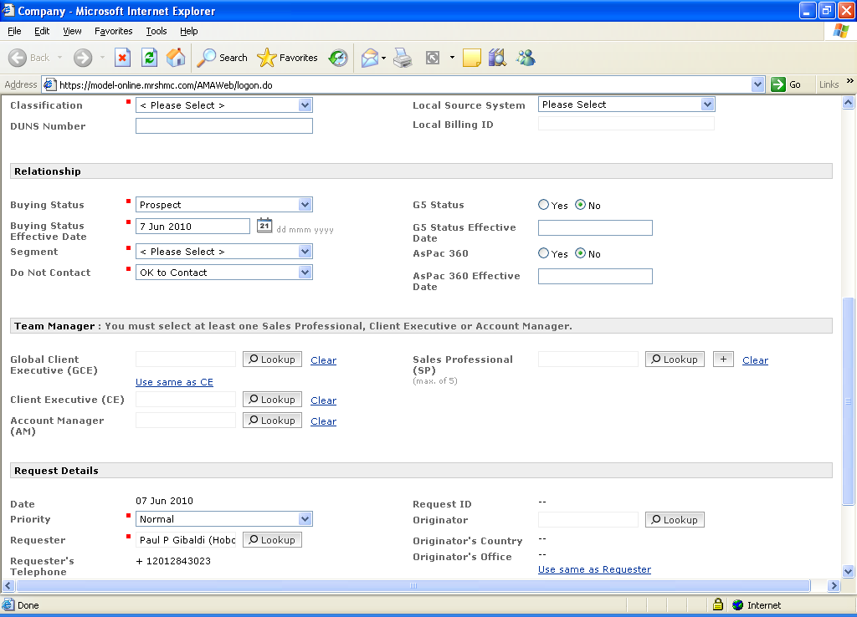

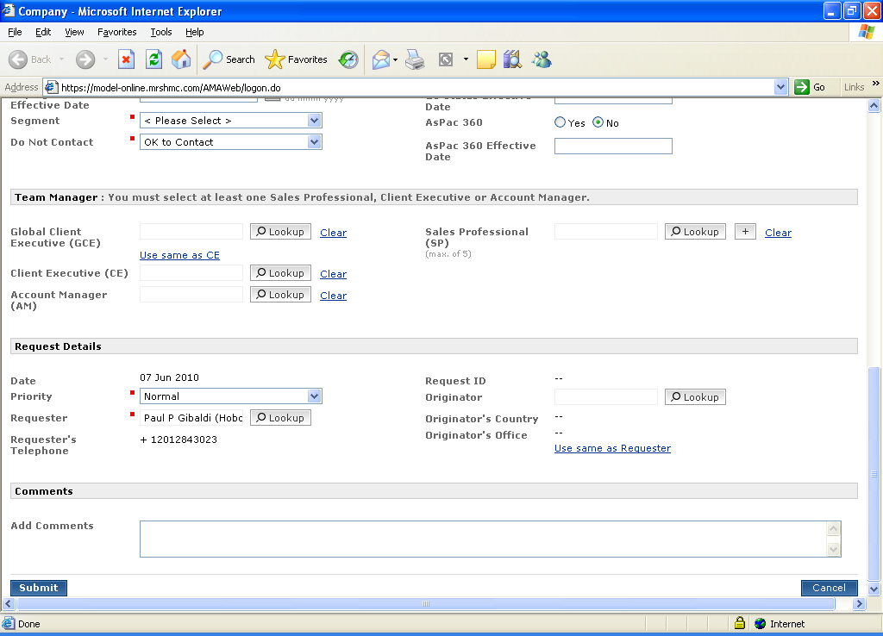

***Fig: Create Client/Prospect Screen***

## PCR Workflow:

*PCR workflow is based on the following principles:*

*In order to successfully register a record, the following data is required:*

|  |  |  |  |  |
| --- | --- | --- | --- | --- |
|  | **Buying Status** | | | |
|  | **Prospect** | **Lost Prospect** | **Client** | **Lost Client** |
| **Effective Date** | Required | Required | Required | Required |
| **Segment** | Required | Optional | Required | Optional |
| **Team Manager** | GCE Required | Optional | GCE and AO Required | Optional |
| **Downgrade Reason** | - null - | Required | - null - | Required |

* *Only 1 GCE (Global Client Executive), 1 AO (Account Owner) and up to 5 SP’s(Sales Professionals) can be assigned to each record*

***Additional information*** *is the Subscription information. Subscription provide information about who is the owner of the record i.e. in which application record was created. For example: MFuk i.e. the record was created from MF and domain was Marsh UK.*

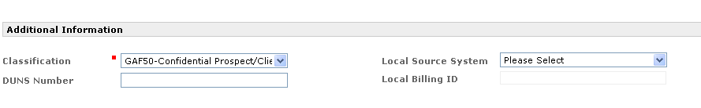

***Fig: Additional Information Section***

***Team Managers/Account Owner*** *are marsh employee, who initiating this business. They are marsh colleagues and sales professional.*

*After filling all the details when user clicks on Submit button, the PCR application calls the Address Doctor service to standardize the N&A(Name&Addresss) data. Standardizing address deals with writing address fields in standard way i.e. proper subscript information or automatically finding postal code based on provided address etc.*

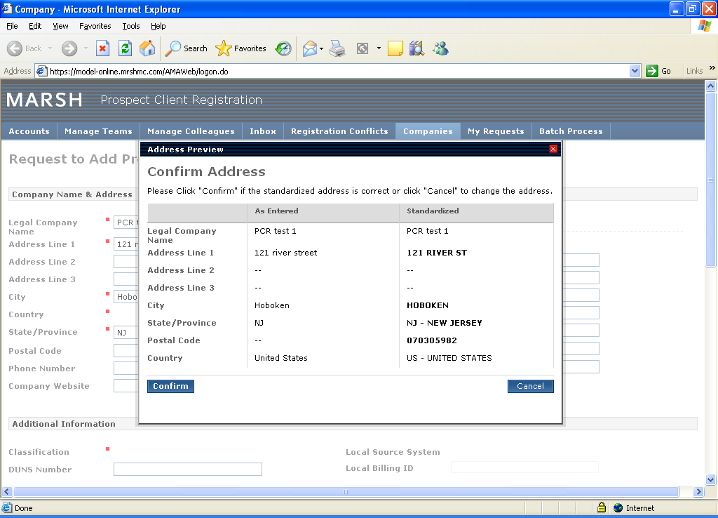

***Fig: Trillium Page with Filtered Data***

*Address Doctor application gets the standardize N&A and shows it with the input record. If the Address Doctor verifies the name and address, application will allow user to store the record by enabling the Accept button at the bottom of the page. If the Address Doctor does not verify the record, then application disables the Accept button so that the record should not get entered into the database.*

*When user confirms the address on this page, a request no is generated.*

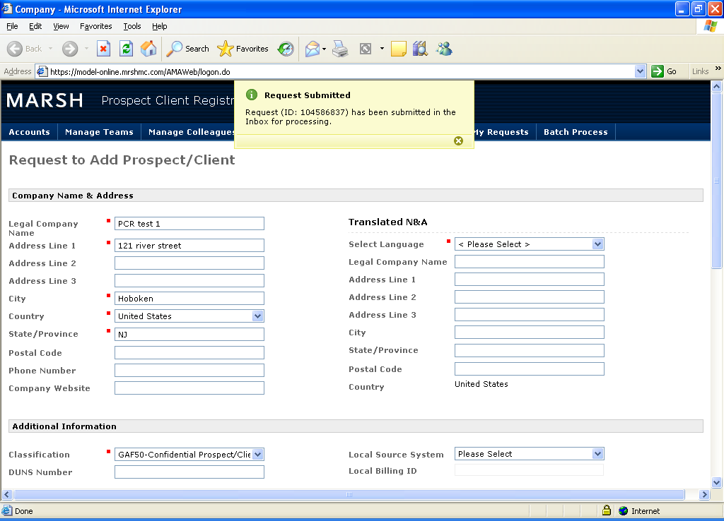

***Fig: Successful Request Creation***

*The request for client/prospect has been generated and submitted into the system.*

*After submission of the Request, A DMG user can accept and register the request inside “Inbox”* tab.

## Register the Client/Prospect

***Inbox:*** *This tab appears for DMG and PCR full access role user.*

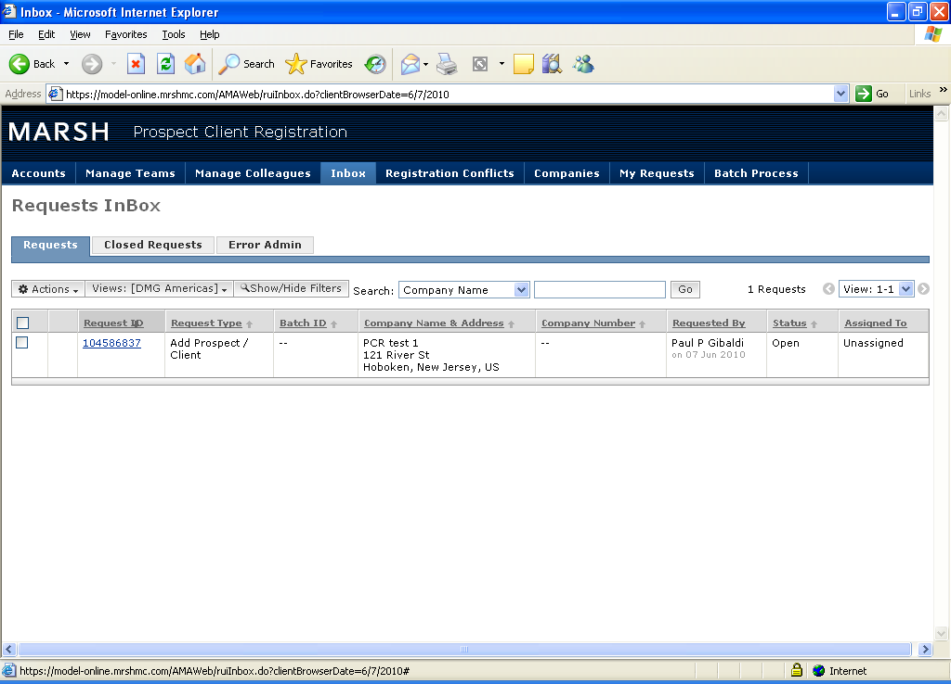

***Fig: Inbox Screen***

*The submitted request appears in this tab. clicking on the Request id takes us to following screen :*

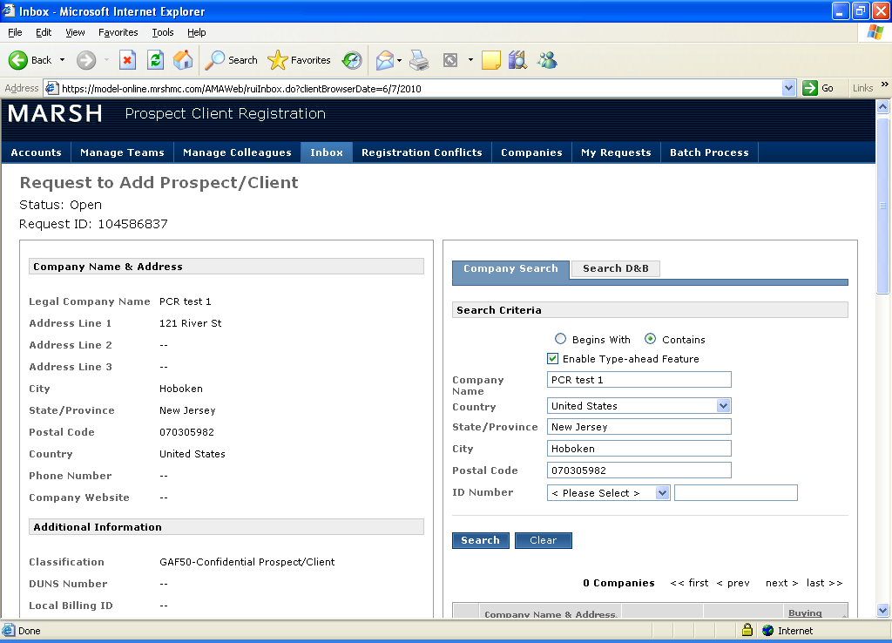 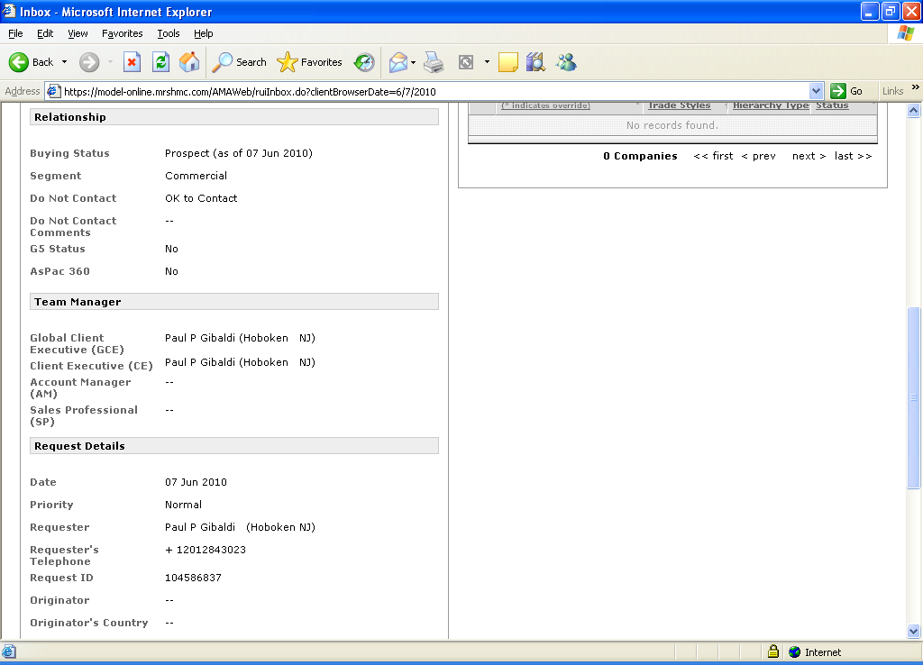 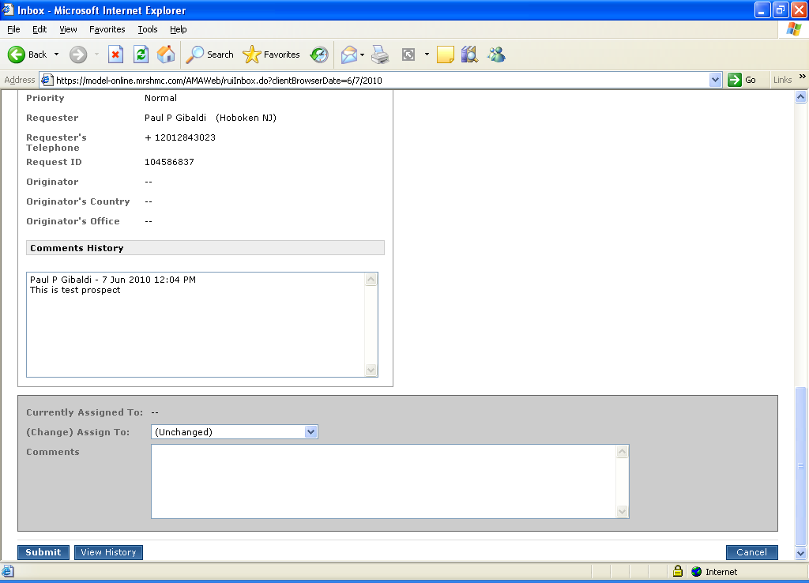

***Fig: View Client/Prospect Request***

*Here user can select* ***assign to me*** *or Assign to* ***colleague****.*

*If assign to colleague is selected, then user must provide the email id of the assigned colleague.*

*Multiple request status:*

1. *Accept*
2. *Match with selected Company*
3. *Pending*
4. *Promote to BE*
5. *Reject.*

## Workflow on request status:

1. ***Accept:***
2. *Name and Address send to MINA (Through Web Service Call). It returns MINA Party Id*
3. *Call AMA Stored Procedure to create an account.*
4. *Call the registration procedure*

*3.1 Create the Company record for MINA ID generated from step 1.*

*3.2 Create the registration record (Buying status, Segment Code, Other Information)*

1. *Create the TEAM*

***Note****: Company no is created after “Accept”.*

1. ***Match with selected company:***

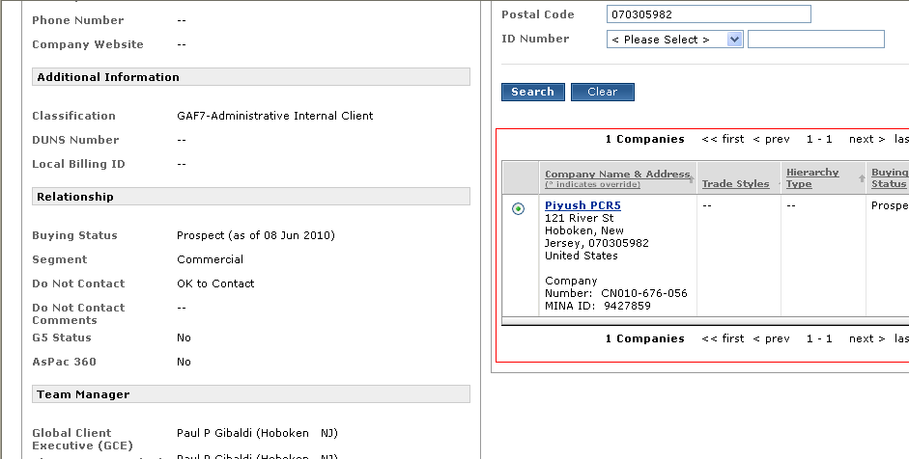

***Fig: View Client/Prospect Request, with company search***

* 1. *In this action system matches selected company (left-hand side company) with the right-hand side company as indicated in the screen above. This company must be a non-registered company i.e. prospect.*
  2. *If user selects the “****Match with selected company”*** *and select one non-registered company from the right-hand side and clicks on submit, then name & address provided by user will be overwritten by name and address DMG user has selected. i.e. incoming address is ignored and the buying status (Registration information) is added to the selected company along with team manager.*

***Note:*** *if user selects Retain detail as secondary address checkbox then incoming address submitted by user saves as secondary address. When user clicks on submit then Address Doctor service gets called. So, any entity goes to MINA has to go through this address standardization process.*

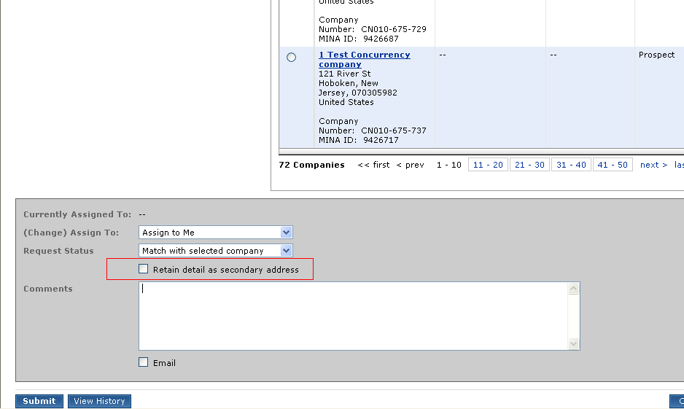

***Fig: View Client/Prospect Request***

*PTP table is the table where we store the secondary address as BR(Business record) verified and it is associated with Primary Id.*

1. ***Pending:***

*This selection is made if DMG user wants to put this request on hold. At the same time, he /she does not want anyone else to work on the same.*

1. ***Promote to BE:***

*If DUNS (*[*Data Universal Numbering System*](https://www.dnb.com/duns-number.html)*) information is not available and DMG user knows that the authenticity of the record, then DMG user selects this option. The entity goes as BE (Business Entity) – Verified.*

*Note: In MINA if confidence level is <7, then record submitted to ICM queue and then DMG user investigates the ICM queue. And if user finds this record as authentic then he can promote the incoming record as BE – Verified. The above scenario is similar to this.*

1. ***Reject:***

*This selection takes the record out of the Inbox.*

1. ***Update selected with MF****:* ***Marsh Force Request)***

*PCR is integrated with MF. MF will be the starting point for the names and addresses which are created going forward. The communication between PCR and MF is asynchronous or fail proof communication. Batch processes and MQs are setup between these two applications. Batch process is run on a scheduled period. All the requests which are newly created will be put on MQ. There is an MDP configured in PCR environment which will listen on these MQ listener and any request coming from MF, it is created in the inbox.*

*When DMG folks look at this request and they have same set of actions they can act on the MF requests but there is an addition action that they can perform on MF request is “****Update selected with MF”.*** *This sounds like match with selected company.*

*Marsh Force selected company option allows to select registered company. The major difference between* ***Update selected with MF*** *and* ***Match with selected company*** *is that the U****pdate selected with Mf*** *enables DMG to select the registered company.*

*It will ignore incoming company’s name and address and it will update the selected company with incoming company’s details like MF id, incoming relationship information, team management information.*

*We can select registered and non- registered company but not any marsh Force Company.*

## Request to Investigate

*This Request is raised when there is any change in name or address to be requested.*

***Ways to raise an investigate request.***

1. *From the Company search Page*

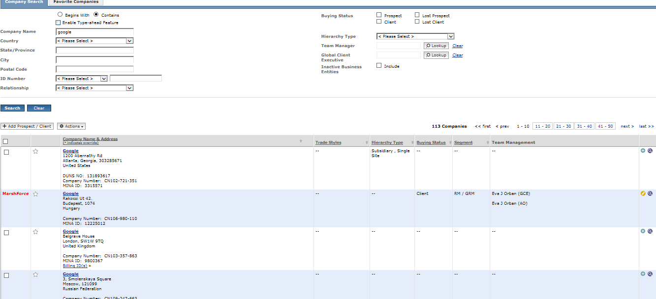

1. *From the Profile Page*

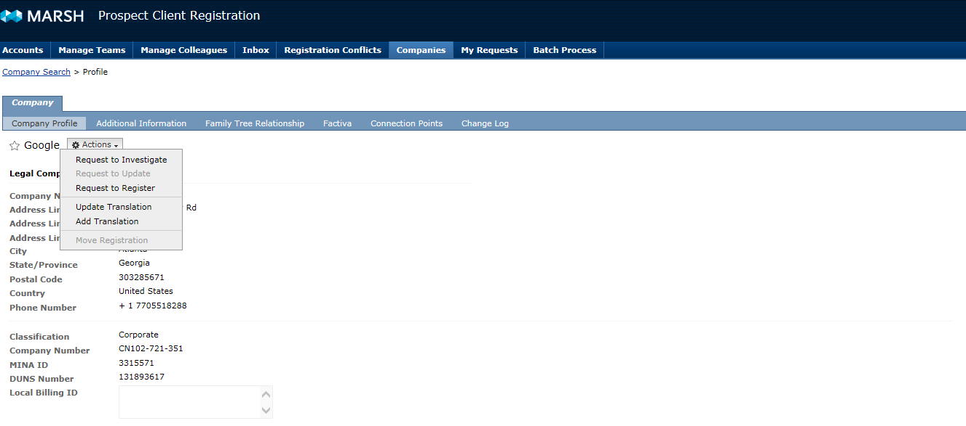

*Request to Investigate Page*

*While requesting an Investigate following fields are mandatory:*

* *Investigation type*
* *Comments*

*While uploading the documents following are the validations;*

* *Only .pdf files can be uploaded*
* *Max size: 1.5MB*

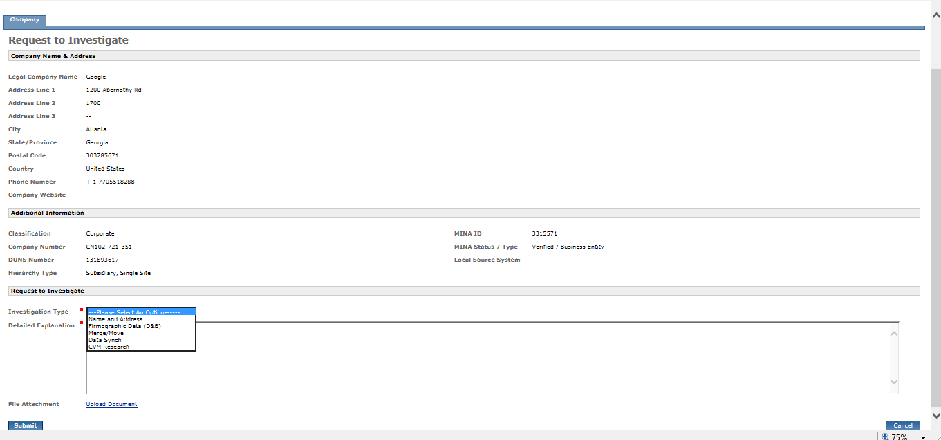

***Inbox View:***

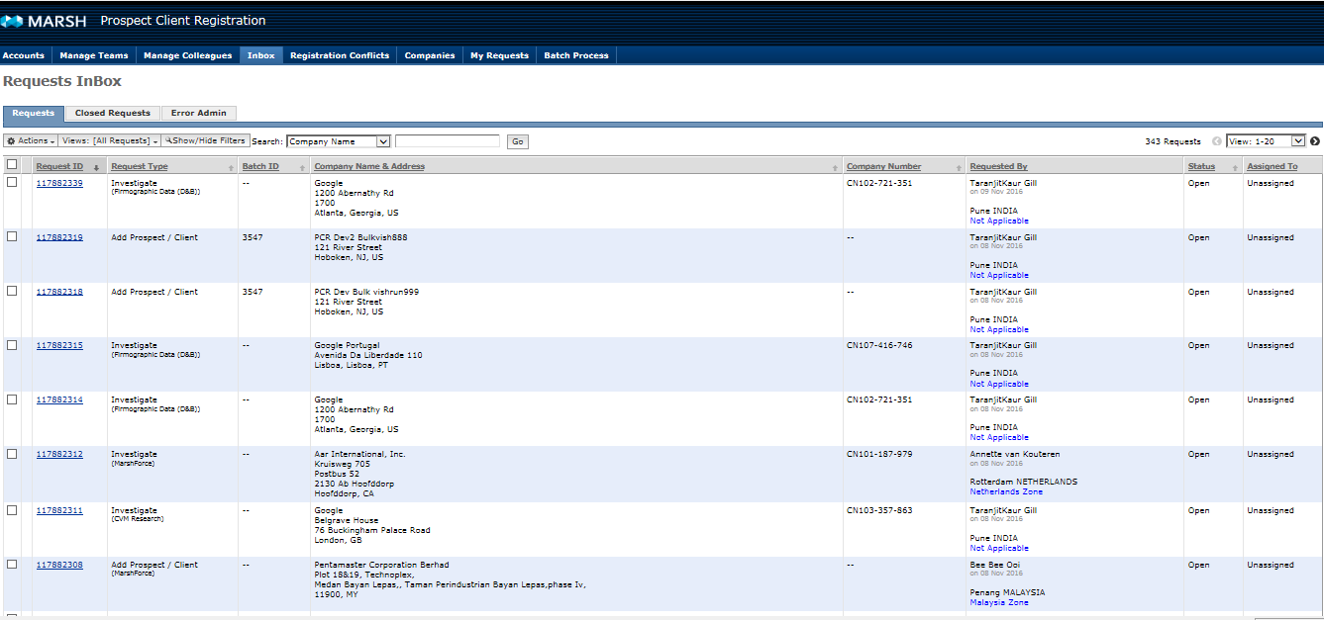

***View Investigate Request (If there is no file attached):***

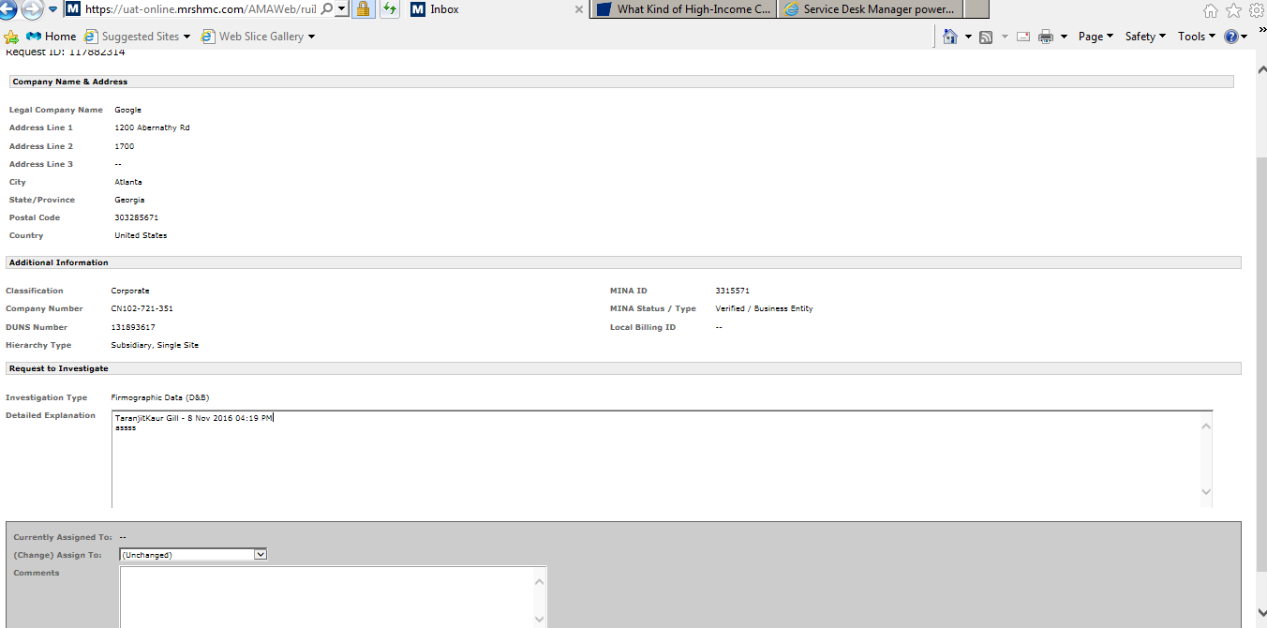

***View Investigate Request (If there is a .pdf file attached)***

*The download link would appear only if there is a document attached to the request.*

*On Clicking the Download file link you can either open/save/save As the file ,the file will be saved with the file name as of the request ID.*

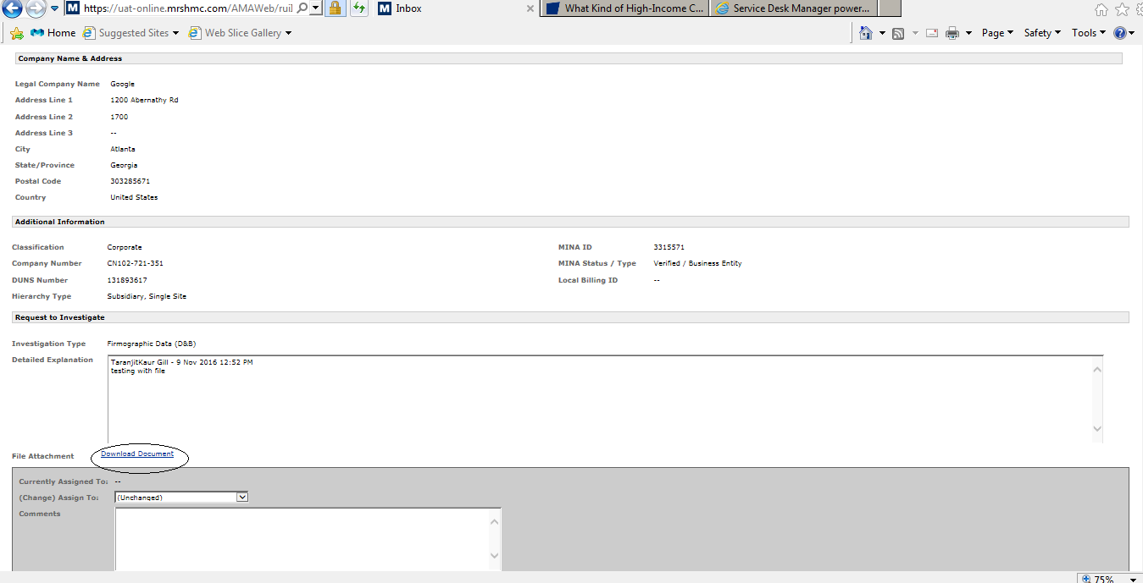

## Inbox Screen:

*This screen is visible to PCR DMG user and PCR Full Access User. By default, all the request**s not more than one week older and having status as “open” will appear in the “Request” tab.*

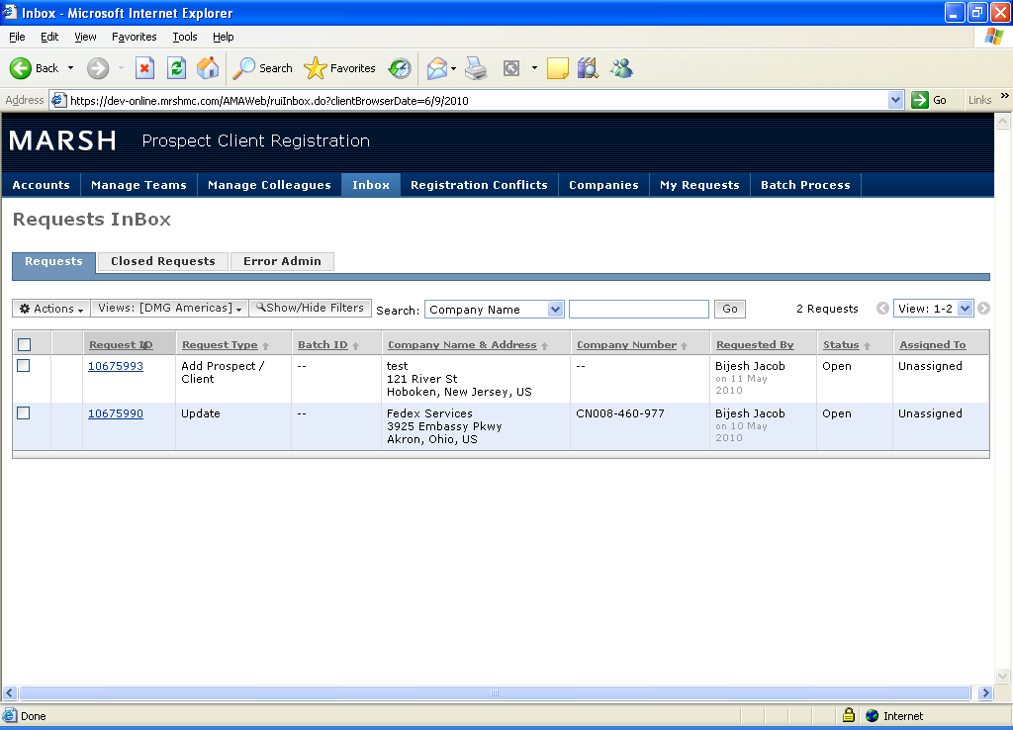

***Fig: Inbox Screen***

## Various Events on Inbox:

There are three tabs available on Inbox:

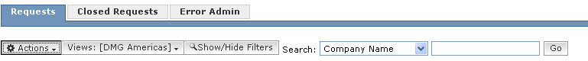

***Fig: Tabs on Inbox***

1. ***Request:*** *The default**selected tab.*
2. ***Closed Request***
3. ***Error Admin***

## Request:

There are three buttons on this page.

1. ***Actions***
2. ***View DMG***
3. ***Show/Hide Filter***

* ***Actions:***

*Pre-requisite: User selects the record.*

*When user clicks on this button, a Menu appears with 4 different events:*

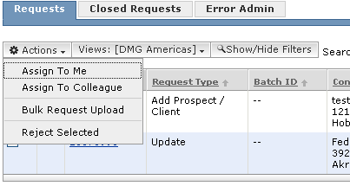

***Fig: Request Tab***

1. ***Assign to Me****: If user clicks on “Assign to Me” then this request assign to the logged in user and the status of the request will be changed to “In Process”.*

*(II)* ***Assign to Colleague****: If user selects this option then system asks the user to select the assignee of this request.*

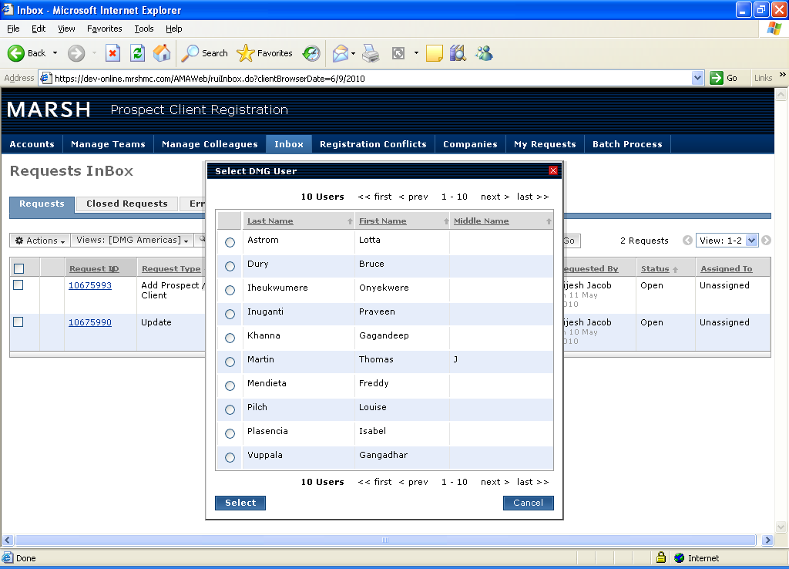

***Fig: DMG User List on Assign to Colleague***

*The user can select the user appears on the page. After that the request is assigned to the selected user only. The selected user can login and check this request in his/her inbox. The status of the record will be “In Process”.*

*(III)* ***Bulk Request Upload****: When user clicks on this option then following pop -up appears.*

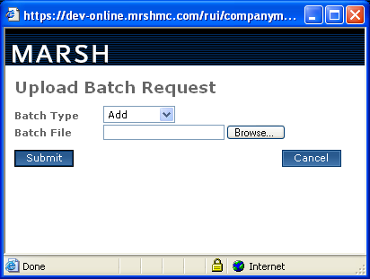

***Fig: Bulk Upload***

* *Here the Batch type can be “****Add****”, “****Update****” and “****Register****”.*

*This option is used by the user to upload multiple requests at the same time to save the time.*

*While uploading the request the system will not call Address doctor to filter the data however system validates the mandatory fields.*

* *The file after filling the information is uploaded to MQ. An MQ listener executes for every hr(Batch Process) and pulls the file from MQ. Then it performs the thorough validation mostly for code values.*
* *It will provide one Batch Id for all these records which are added/registered or updated by the bulk upload.*

*(IV)* ***Reject Selected:*** *If user knows that this request is not valid then he/she can reject the request after clicking this option. The system then moves the record from* ***Inbox*** *to* ***Closed Request*** *tab.*

*--* ***View DMG:***

1. ***Queue****: A menu appears with three different queues name after clicking this action.*

*A DMG user can select the queue to see the request falls inside the corresponding queue.*

*By default, the selected queue depends on the logged in user ‘s region. However, a user can switch from one queue to another.*

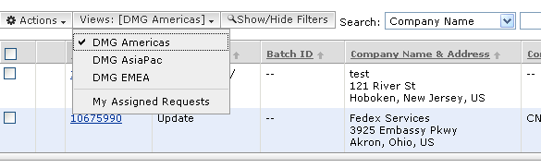

***Fig: DMG Queue***

1. ***My assigned Requests****: Inside this tab user can see all the requests assigned to him.*

*--* ***Show/Hide Filter:***

*-By default, all the records appear inside inbox are one-week older records having status as “Open”. If user wants to see records older than that or wants to search the records with different search criteria, then user can click on this button to see all the search criteria available.*

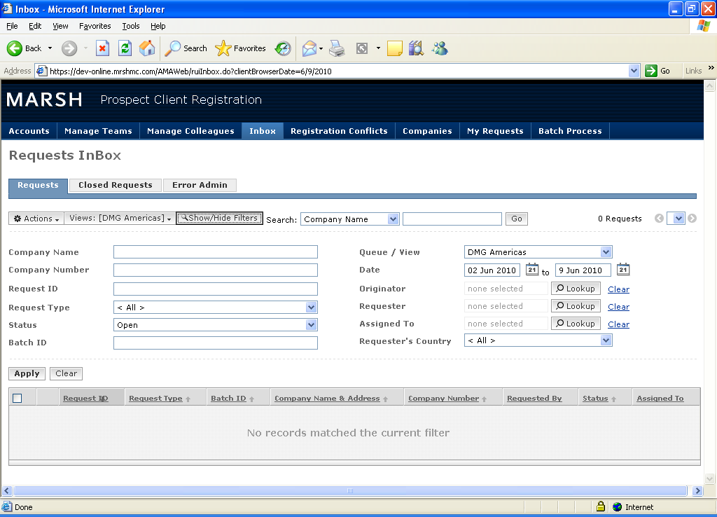

***Fig: Show/Hide Search***

## Closed Request:

*System shows all the Closed Requests (Decision has been made) inside this tab. These records are having status either as “Accepted” or Rejected”. A user can click on the request id to see the details of this request. and it will be read-only.*

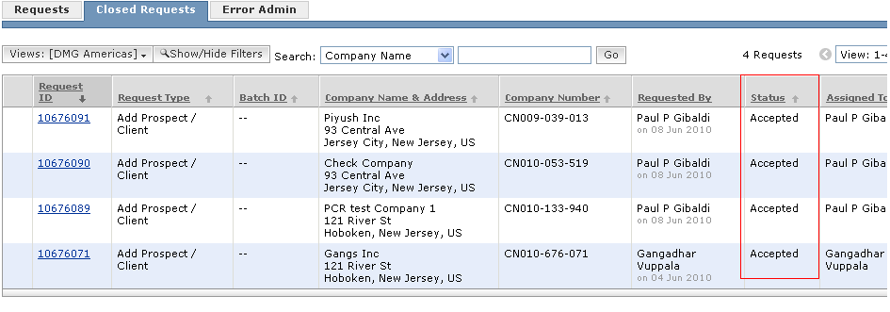

***Fig: Closed Request Tab***

## Error Admin:

*PCR is having integration with Marsh Force/Sales Force. If a record inserted in the system from the Marsh force fails due to some un expected error or some un checked exception occurs during add/updates (i.e. data base down, system crashes) then this record moved to this tab.*

*There is no dialog setup in the MF to tell them this is failed, they cannot receive this conversation. To not to lose these requests we are showing them in error/admin page.*

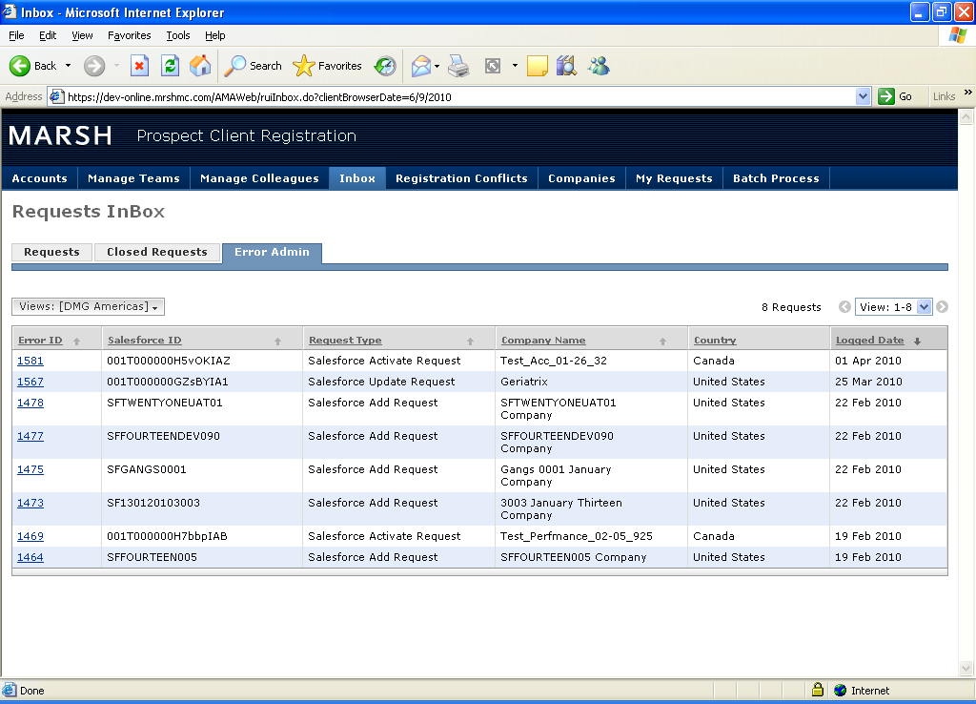

***Fig: Error Admin***

***Note:*** *A user can see the error record with the exception occurred in this process after clicking on the error id.*

*Two Actions:*

1. ***Mark as resolved****: DMG is having the administrative privileges on both PCR and MF. They will go and correct this record in MF. When they click on this button and that record will go out of this queue and this record will move to* ***error-log*** *table. System simply marks that record as completed.*
2. ***Re-Process Request****: If request comes in second flow so all information comes all over again to PCR and this time if something is missing from MF then all such errors also logged in this queue. PCR must be in synch with MF. If validation request comes and while validating this request if unexpected event occurs like data base down, app server issue etc. then we can re process these kinds of request when the system is restored. For the activation request we also provide “Re –Process request”. When issue has been resolved then the DMG user can click on this button and system will treat as if the request is coming at that point in time*

## Update the records:

*The basic intention to search the records prior to create is to avoid the duplicate records in the system.*

## Auto Update:

*Auto update is based on the logged in user and the segment code present on this company. Only DMG user can perform auto update.*

1. ***Registered Company:***

*Two ways:*

1. *After search, click on the yellow icon appear at the right-hand side for update:*

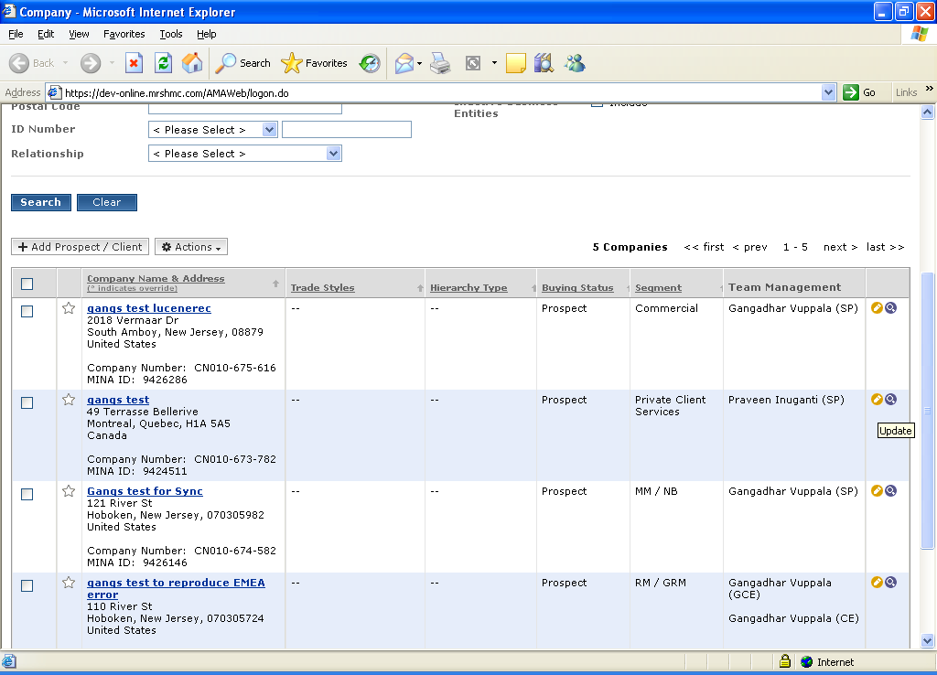

***Fig: Search result with update option***

1. *Click on the company name to see the details. And click on Action button, “Request to update “option appears in the menu.*

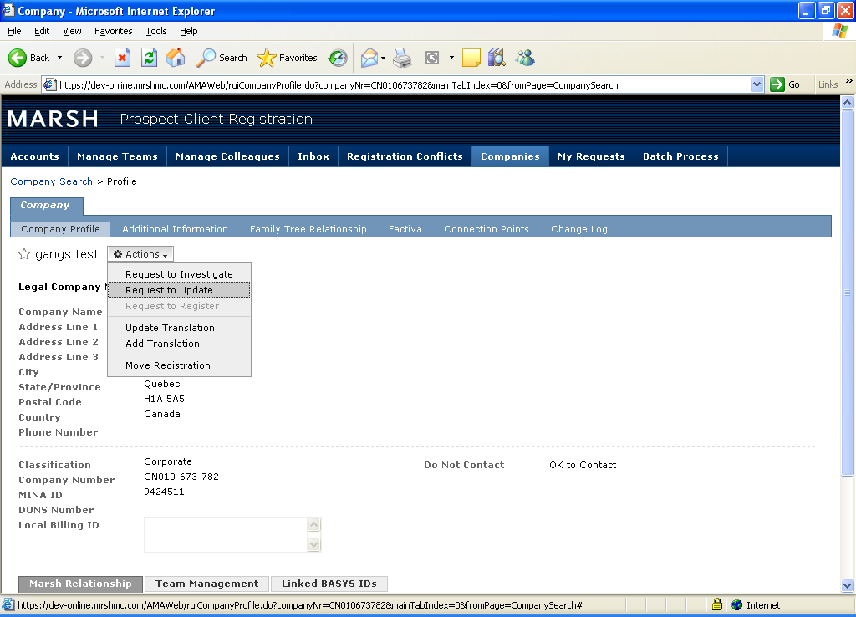

***Fig: View Profile with update option***

*After clicking on that option Update screen will appear where Company Name & Address information will be read-only. User can change the Relationship information (Registration information) and can select the Team Manager depending on the Buying status selected.*

*For example, if the registered company is a prospect then user can change the status as Client and then can select the team information as per the selection. If the registered company is Client, then user can change the buying status to only Lost Client.*

*After that the registered company is updated and the request will be accepted automatically and moves to Closed Request.*

*If the user is not a DMG user, then the request will be created inside Inbox. And the remaining flow will be same as create request.*

***Note:*** *In MINA a user can change the name and address of the record which will be reflected in PCR, however there is no functionality in PCR to update the name and address.*

1. ***Non -Registered Company:***
2. *A non – registered company cannot be updated directly. The Company has to be registered for auto update.*

## Integration with marsh force:

*PCR has an integration with Marsh Force/Sales Force. A record can be inserted into the system from the Marsh force as well. These two systems communicate in form of XML (SOAP Communication). A request created in marsh force comes to PCR. Then the request will reside in Inbox and Marsh Force keyword will be mentioned in the Request type.*

*There are two kinds of request come from Marsh Force.*

* *Sales force Add Request*
* *Sales Force Activate Request*

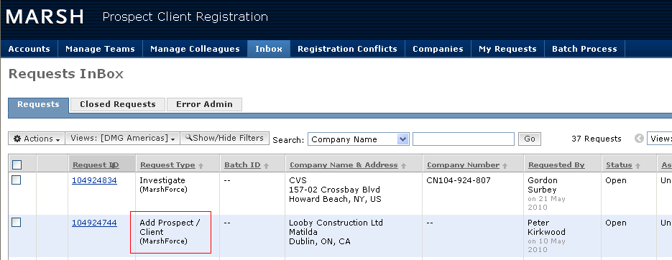

***Fig: Request from Marsh Force***

* ***Sales force Add Request***

1. *When request comes for the very first time for a record in PCR then this request will be “Sales force Add Request “.*
2. *DMG user can process the record (i.e. Select the request status as “Accept”, Match with selected Company” and clicks on “Submit”) then the request sends to Marsh force for Activation. And the status of the record in PCR will be “Pending Marsh Force response”.*

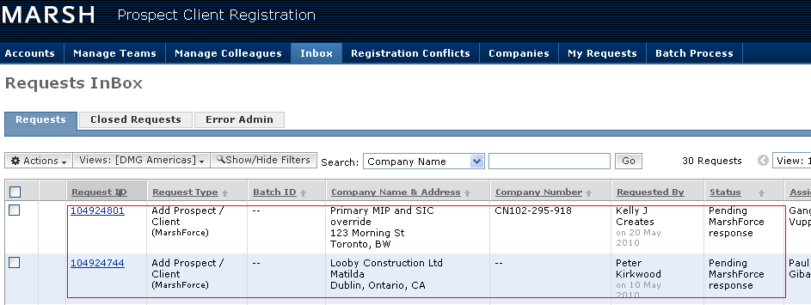

***Fig: Request sent to Marsh force for Activation***

* ***Sales Force Activate Request:***

1. *Once Marsh Force activates the record it sends the record to PCR with the request status as “****Sales Force Activate Request****”.*
2. *PCR performs necessary action on the record and then the request moves to “Closed” request tab.*
3. *Marsh force can modify the record before sending it to PCR and then updated information comes to PCR.*

*The flow of operation: MF --> PCR -->MINA*

*Step1: Account creation in MF. User creates new account. Here two things are important. Status must be “pending data validation” and the default account owner which is PCR administrator should be changed to another user.After submission data goes to PCR in form of xml.*

*Step2: The request comes into the inbox tab of PCR. Request is displayed in the inbox with an additional Marsh Force tag.*

*DMG user selects one of the processing options and submit the request.*

*Step3: Request comes to MINA.A dummy mina id and company number gets attached to the record and an acknowledgement is sent to the marsh force.*

*Step4: After receiving the ack MF will activate the record by changing the status as Activate. Response is generated in form of xml which contains company id, mina party id, account owner info etc. and sent back to PCR.*

*Step5:After receiving the response in PCR new record gets created.*

*IMP: Subscription information is only generated and stored into MINA.*

* 1. ***My Request***

*Easier way to find out what is the status of user’s request*

## Registration Conflicts:

*A request comes as duplicate (Unverified BR) and the record gets registered in PCR. If DNB finds that this name and address matches with duns no which is already existed and registered in PCR then..*

*Here old entity already registered and may have revenue and policies associated with it in and new entity also may have some policies and revenue associated with it (Time between it has been created and noticed by DNB). In PCR we cannot directly discard one and take up the other one as we do in MINA. We need some merge process that is what registration conflicts queue is.*

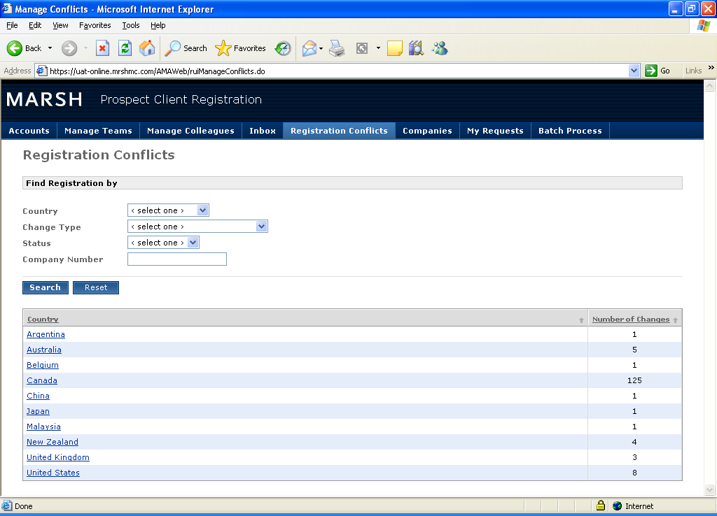

***Fig: Registration Conflicts***

*So, both these two entities are kept in this queue. This functionality is divided based on the country (country of team manager not domicile country).*

*Two kinds of Change type:*

## Company Information Changes

*Conflicts generated due to DNB process.*

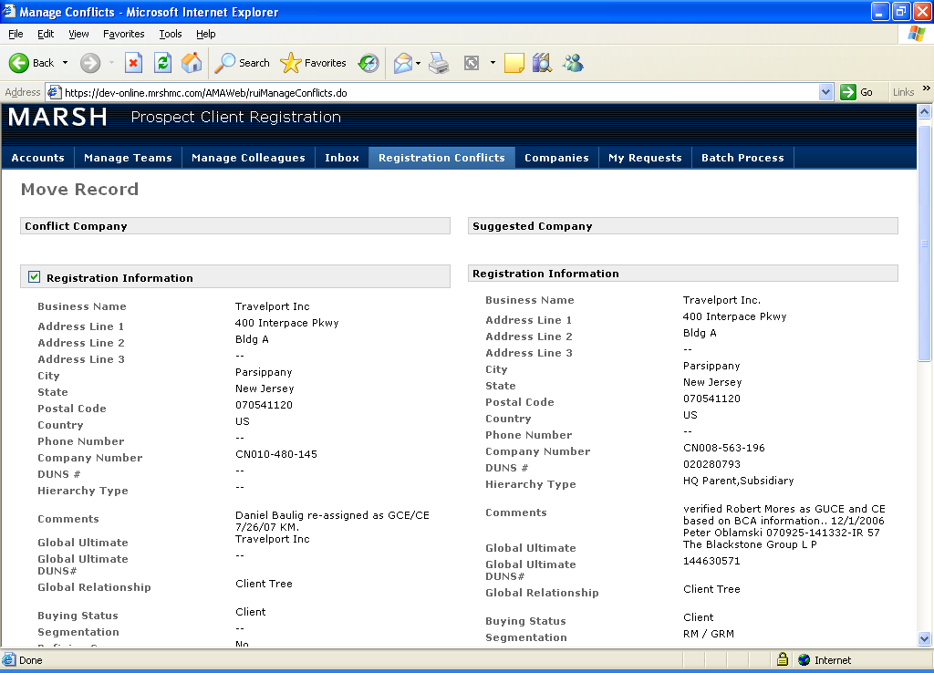

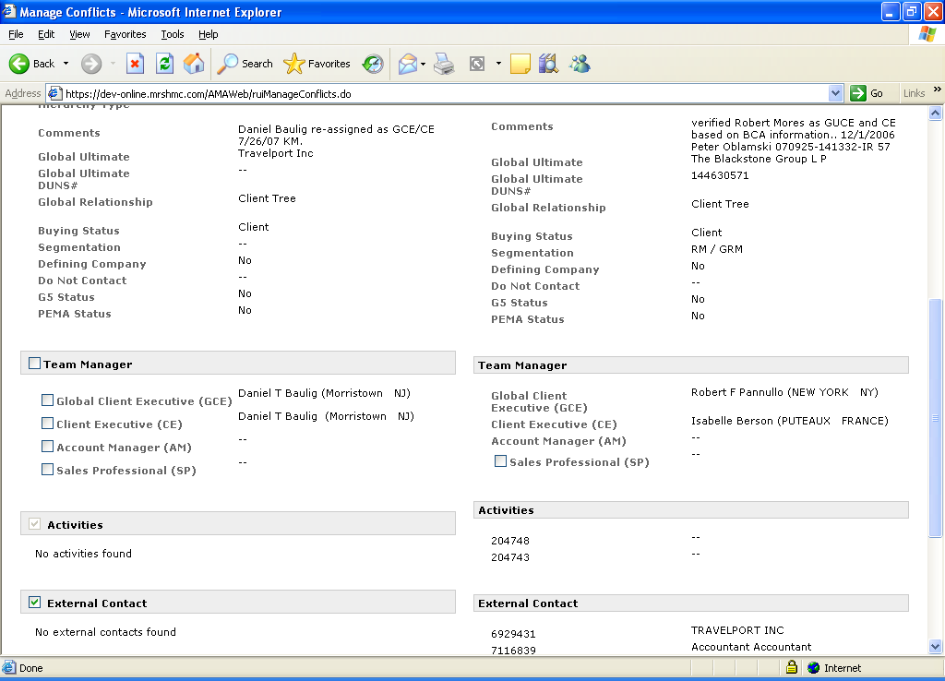 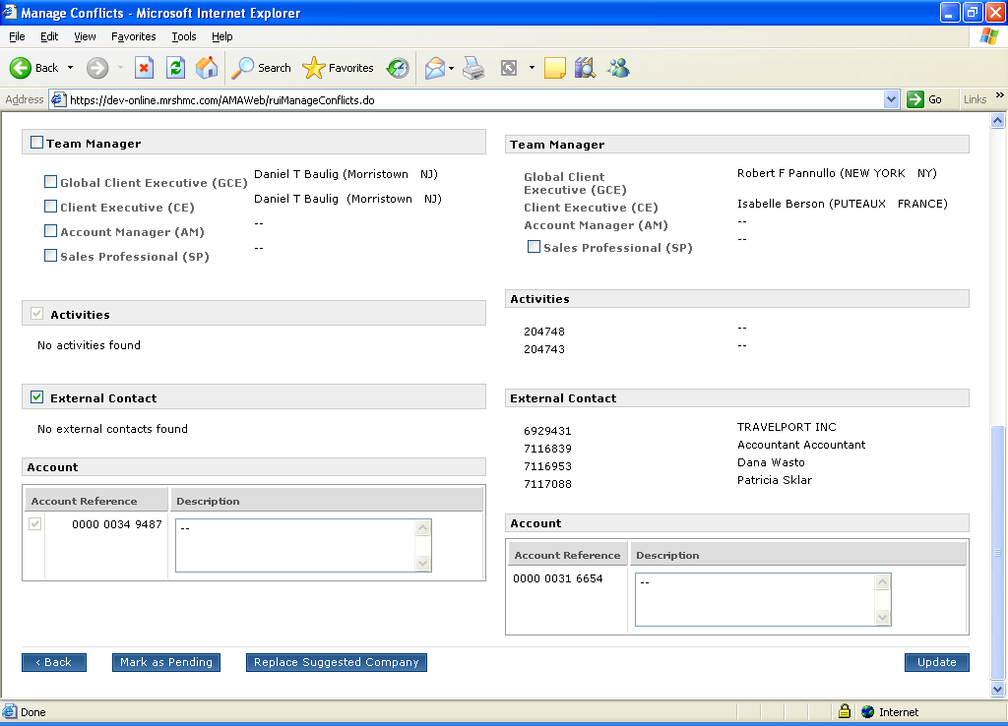

***Fig: Submitted and Selected Company in Registration conflicts***

*Left hand side: Submitted Company*

*Right hand side: Existing Company*

*DMG can merge these two records. The decision they made is the previously existing company will continue to exist.*

*They have to choose if they want to move the highlighted information (Registration information, Team information, External contact) to the existing record or they want to keep the existing details as it is. Application facilitated by providing checkbox to them.*

*If checkbox is not selected then upon submission the selected record will be intact from the highlighted information, or else the highlighted information will be replaced for the selected company.*

*Account cannot be changed. A default account is created when company is created.*

*Checkbox with Sales Professional at submitted company and selected company.*

*Application DMG user can select the sales professional from both LHS and RHS. So, for example if left hand side having five SPs selected and Right-hand side is having five SPs selected then the total will be ten SPs after merge.*

## Move Registration

*If somebody registered a company erroneously*

*In this case DMG users can use “move registration” option. Here user will be having the conflicted company, but user has to search the suggested company. It is a manual process where as Company Information Changes process is a batch process.*

*If user selects registered company: Flow same as “Company Information Changes” process.*

*If user selects non-registered company: No team mangers will be available in the selected company, so user can choose or select entire team information from submitted company.*

## Batch Process:

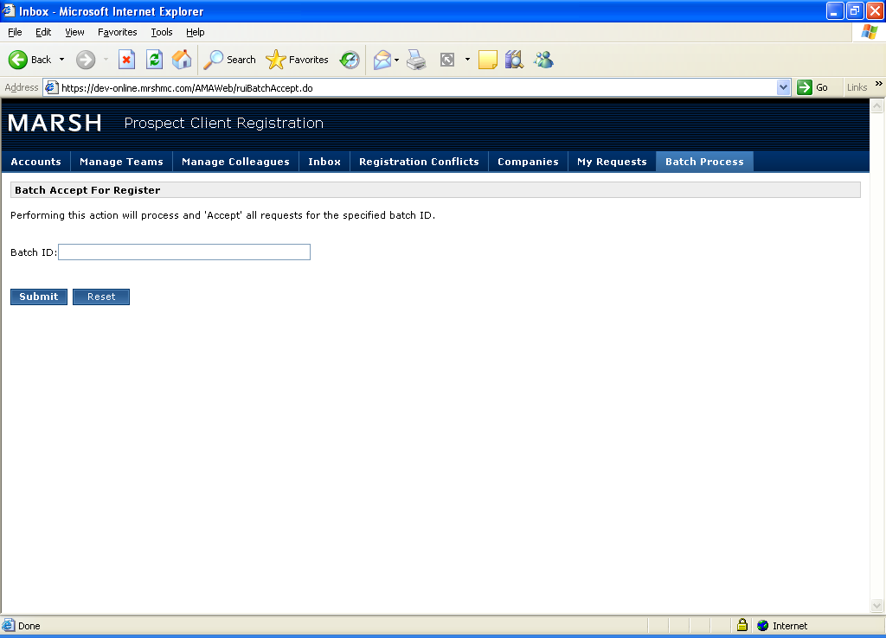

***Fig: Batch Process***

*-**Bulk Request Upload event provides a unique Batch id for the whole group.*

*After giving the batch id and clicking on submit all requests belong to that batch id will be accepted.*

## DMG Admin:

DMG can remove MF flag from a company i.e. Subscription information will be deleted.

***Integration With MART:***

MART application uses Company master RUI for its ERTR functionality for uploading files and creating some records. Once the file is submitted the request flows through cefcompanymaster.jar to PCR and then is serviced accordingly. So, wherever there are changes in CEF Company master project /cefcompanymaster.jar please ensure that MART team is aware of the changes and they test there ERTR integration.

MART Team uses below url:

<https://dev-online.mrshmc.com/mart/martweb/upoadECOverrideClientlist.do>  which redirects to <https://dev-online.mrshmc.com/rui/companymaster/jsp/upload/uploadTemplate.jsp>

**NOTE:**

# Never test directly with the second URL as the application would not find the user name in the request context and the ERTR functionality would fail.Technical Architecture

*Architecture diagram is awaited from Marsh SMEs*

**4.1 Set Up**

*Application setup in local environment – Document is attached under References section.*

# System Information

## Database

*Please find attached “PCR Data Model.pdf” as Data Model for PCR under section 13 “References”.*

## Batch

*Batch process is covered under various sections above.*

## Screen Flow

*Screens for major functionalities have been explained in section 3 “Application Functions”.*

## Transaction Flow

*Application functionality is explained in above sections.*

## Typical Problem Areas and Troubleshooting

*To be discussed with Marsh SMEs.*

# Interfaces

# Tools

*Following tools and software are required*

1. *IBM Rational Application Developer (RAD)*
2. *IBM WebSphere Application Server*
3. *TOAD*
4. *IBM Rational ClearCase*

# Environments

*There are 5 environments for PCR:*

1. *Development*

[*https://dev-online.mrshmc.com/AMAWeb/logon.do*](https://dev-online.mrshmc.com/AMAWeb/logon.do)

1. *QA*

[*https://qa-online.mrshmc.com/AMAWeb/logon.do*](https://qa-online.mrshmc.com/AMAWeb/logon.do)

1. *Model*

[*https://model-online.mrshmc.com/AMAWeb/logon.do*](https://model-online.mrshmc.com/AMAWeb/logon.do)

1. *UAT*

[*https://uat-online.mrshmc.com/AMAWeb/logon.do*](https://uat-online.mrshmc.com/AMAWeb/logon.do)

1. *Production*

[*https://online.mrshmc.com/AMAWeb/logon.do*](https://online.mrshmc.com/AMAWeb/logon.do)

# Testing

# Processes

*Standard G20 roll-out process is followed for pushing changes/fixes into the production environment.*

# Security

## User Roles and Responsibilities

*TAM system is used for user authentication and authorization.*

# Reports

*NA*

# References

*Please refer following documents for setting up the application in local environment. Also, PDF talks about the PCR Data Model.*

 