**Nuvoton ISP Firmware update on the Android**

Thomas Park ([minamjungho@gmail.com](mailto:minamjungho@gmail.com))

**Intro**

You can ISP firmware update to Nuvoton MCU on the Android with this project. I will use USB HID in Android Device for this. USB HID protocol is follow to “NuMicro ISP Programming Tool version 4.03 for Windows OS” provided by Nuvoton. So if you programed ISP firmware for USB HID in Nuvoton SDK to your Nuvoton parts, your Nuvoton parts can connect to Android app in this project with USB HID.

If you use Bridge firmware in this project, you can ISP firmware update to MCU not support USB. In fact, Bridge firmware is not required if you will use USB CDC in Android. But if you want to implement another function in Bridge firmware, it would be better choice.

**Development environment**

*For Android app*

|  |  |  |  |
| --- | --- | --- | --- |
| **N** | **Name** | **Description** | **Note** |
| 1 | Android OS | Version 6.0 - Marshmallow (API level 23) |  |
| 2 | Android Studio | Version Bumblebee 2021.1.1 Patch2 | IDE |

*For Bridge firmware*

|  |  |  |  |
| --- | --- | --- | --- |
| **N** | **Name** | **Description** | **Note** |
| 1 | ARM MDK | Keil uVision Version 5.34.0.0 | IDE |
| 2 | Nano100B SDK | Version 2021.9.23 |  |
| 3 | Nu-LB-NANO130 | REV 1.2 | Hardware |

*For ISP Test*

|  |  |  |  |
| --- | --- | --- | --- |
| **N** | **Name** | **Description** | **Note** |
| 1 | UDOO Dual | with Android 6.0 - Marshmallow | Hardware |
| 2 | Nu-LB-NANO130 | REV 1.2, with Bridge firmware | Hardware |
| 3 | NuTiny-SDK-Mini54FDE | V1.0, with ISP_UART firmware in LDROM | Hardware |

**System Overview(used Bridge firmware)**

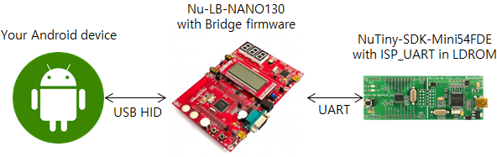

Your Android device and Nu-LB-NANO130(CON2) are connected by USB. Nu-LB-NANO130(PD0, PD1) and NuTiny-SDK-Mini54FDE(P12, P13) are connected by UART.

**How to ISP Firmware update on the Android(used Bridge firmware)**

1. Please select that which item will try to connect USB you want in USB list. For your information, Vendor ID is 1046 and Product ID is 20512 of USB information for Bridge firmware.

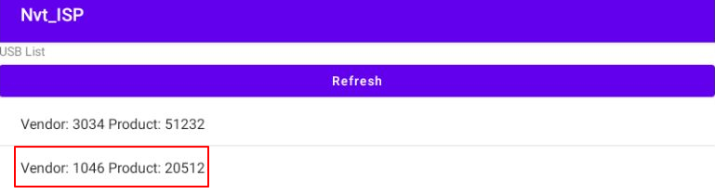

2. Please approve about USB permission of app.

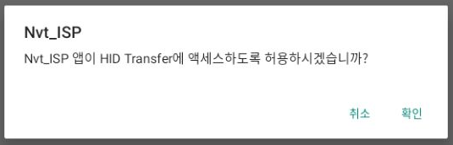

3. Please press the connect button. Then Bridge firmware will try to connect target board. After then target board must be reset. Then target board will be boot up from LDROM, it can be processing packet for ISP connect.

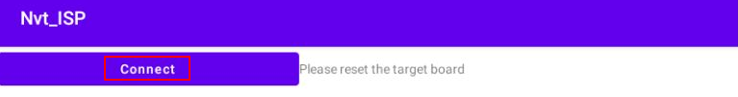

4. If connect is successful, you can see the text of "USB Connected" and parts number. Please refer that if there no have your parts information in android app, it will be failed about connection. As you know, most embedded device maybe not enough resource. So I didn’t do add to this which parts information of all from Nuvoton. If you want add to your parts information, Please refer here.

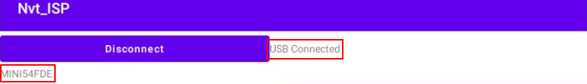

5. Please select binary file for APROM of target board after press APROM button. And then please press the program button. Then file you selected will be program to APROM of target board.

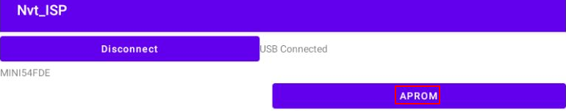

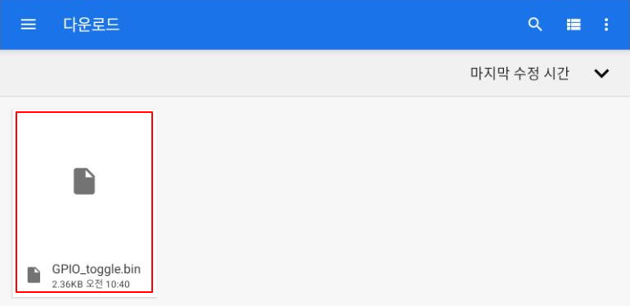

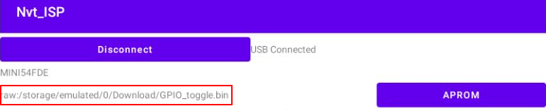

6. If you get alert message about successful, you can confirm that whether target board is work well after reset the target board.

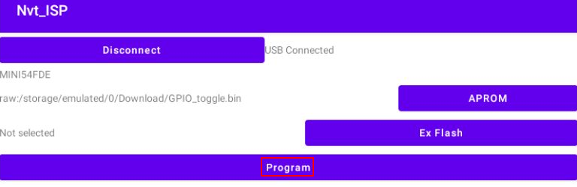

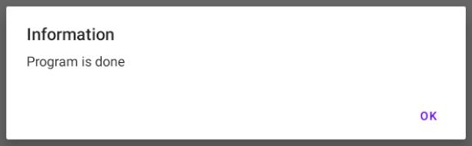

**Document History**

|  |  |  |  |
| --- | --- | --- | --- |
| **Date** | **Writer** | **Contents** | **Note** |
| 2022/08/02 | Thomas Park | Created document |  |