# Web Application Installation

The instructions provided below in each subsection are made with the assumption that the product developed is already in possession of the reader (in the form provided initially by the author).

## Prerequisites

To be able to install and execute the developed web application, several technologies and additions must first be installed. Specifically, the technologies which are needed and must be previously installed are:

* **Eclipse IDE**
* **Node Package Manager (NPM)**
* **Angular CLI (installed via NPM)**
* **XAMPP**
* **Java (15)**

## Eclipse Project Importation

### Microservices Installation

To install all the independent microservices of the web application into an Eclipse workspace, follow the steps below:

1. Create a new empty Eclipse workspace
2. From the “File” tab above, press the “Import” option
3. From the import wizard window, import a project as a “Projects from Folder or Archive” as shown in the image below.

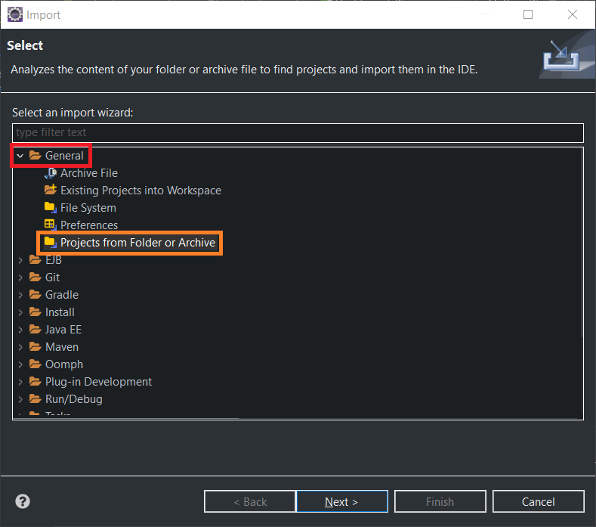

1. From the new window in the “input source” field, set the directory of the “Eclipse” folder found inside the source code files provided.
2. After inputting the directory where the “Eclipse” folder is found, select all the projects to be imported, this is shown in the image below. Press finish and the installation process is complete.

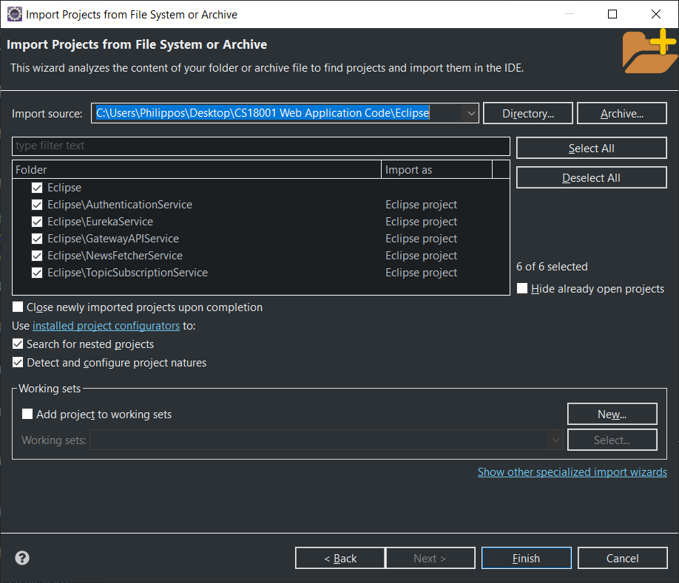

### Plugin Installations

To remove any Java errors shown by Eclipse and execute each Spring-Boot microservice with ease, two plugins are needed, a Spring-Boot and Lombok plugin. To install a Spring-Boot plugin in Eclipse follow the steps bellow:

1. From within Eclipse, open the “Help” tab from above and select the “Eclipse Marketplace” option.
2. From the new window, search for “Spring-Boot” and install the plugin called “Spring-Boot Tools 4 (aka Spring Tool Suite 4) 4.10.0 RELEASE” by “VMware”. The desired plugin is shown below.

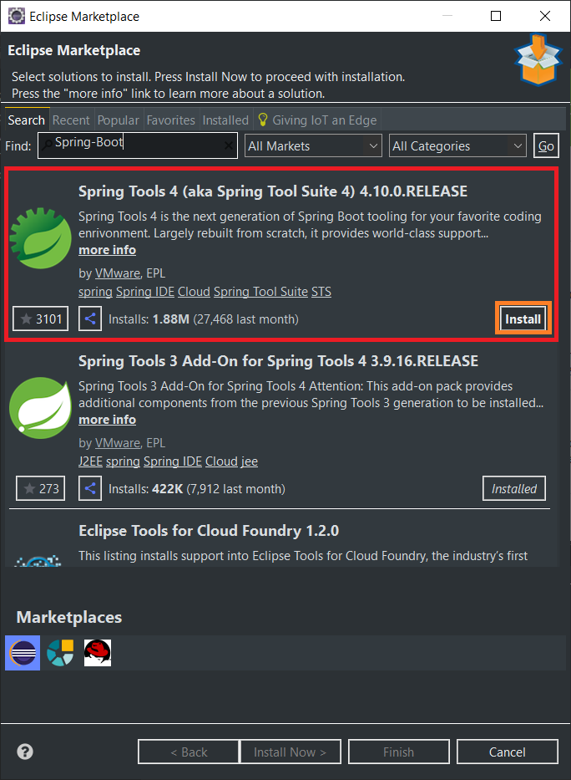

1. After pressing “install’ on the desired plugin, accept, and confirm all the window prompts that appear and fully install the plugin. If necessary, accept the terms of conditions provided.

To install Lombok (as errors may appear in code that Eclipse believes to be legitimate), follow the steps below:

1. Within Eclipse, open the “Help” tab above and select the option “Install New Software”.
2. Inside the new window, enter in the field “Work With” the URL “https://projectlombok.org/p2”.
3. From a view within the same window, select the package “Lombok” and press “Next”. This process is shown in the image below.

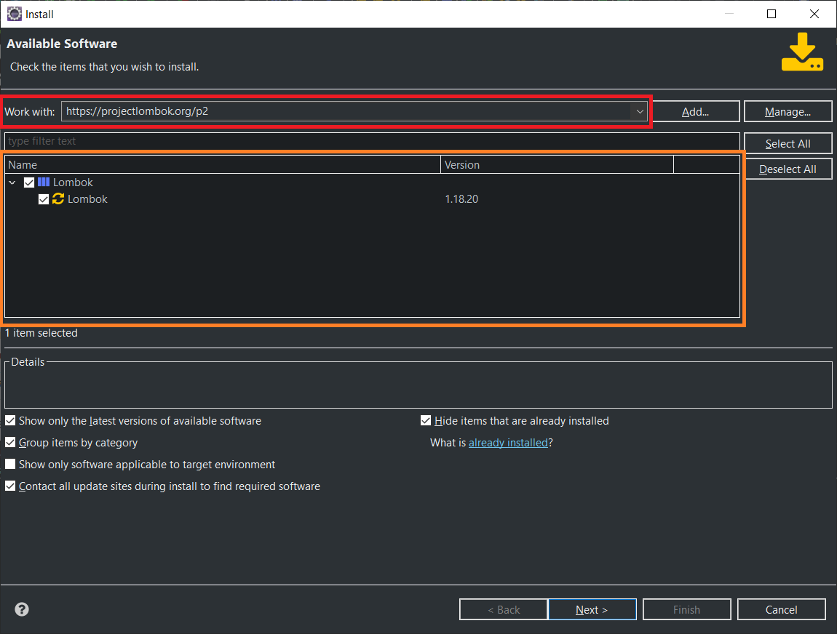

From the next appearing windows, press “Next” and accept any terms of agreement or certificates if necessary. By the end of the process the plugin should be fully installed in Eclipse and any Java errors if encountered should have disappeared.

### Microservice Execution

To execute any of the Spring-Boot based microservices, simply press on any of the Java projects (e.g., “AuthenticationService”), right click on one and run as “Spring-Boot App”. To guarantee correct microservice execution (for more immediate results as the gateway microservice may delay) and run all microservices, execute each microservice in the following order:

1. EurekaService
2. GatewayAPIService
3. NewsFetcherService
4. AuthenticationService
5. TopicSubscriptionService

### Troubleshooting

Because the “EurekaService” and “GatewayAPIService” may delay in updating their known lists of microservices instances, in the event of microservice communication errors, simply restart the “GatewayAPIService”. If the issue persists, restart the “EurekaService” as well. If an error is still persisting, then it is likely unrelated and unique.

## Angular (Front-End) Installation

### Installation

Regarding the installation of the Angular front-end, there is no need for the movement or copying of files as the front-end solution can be executed from within any folder. To install the front-end, follow the steps below:

1. From the files in possession, look for a folder name “Front-End”.
2. From within the folder, find another folder called “news-web-app-front”
3. Open a new command prompt window at the directory of the “news-web-app-front” folder.
4. From the command prompt, type and execute the code “npm install”, this will install any missing dependencies of the web application.
5. If necessary, the command prompt window may indicate that an “npm audit fix” command should be used. In this event, execute the command.

### Execution

To execute and run the front-end server, simply open a command prompt window in the directory of the “news-web-app-front” folder and execute the code “ng serve”. After a certain amount of time, command prompt windows will indicate the running status of the front-end. To visit the homepage of the web application, simply enter in the URL field of a web browser the address “http://localhost:4200/homepage” and enter. In the event of errors, check the port number of the running web application through the command prompt window used to run it and compare with the provided URL.

## Apache Kafka

### Installation

To install the configured Apache Kafka implementation, follow the provided steps below:

1. Look for a folder named “Apache Kafka” in the source code folder provided.
2. The folder “Apache Kafka” must be moved to the root folder where the operating system is installed on the local machine, otherwise certain commands used later will not execute and show unrelated errors. For example, move the folder from “C:\Users\User1\Downloads\Apache Kafka” to “C:\Apache Kafka”.

### Execution

To execute Apache Kafka when installed, follow the steps below:

1. Navigate inside the “Apache Kafka” folder found in the root of the file system, open a new command prompt window and execute the following code:
2. .\bin\windows\zookeeper-server-start.bat .\config\zookeeper.properties

Alternatively, open a new command prompt window and navigate to the “Apache Kafka” folder in the root of the file system and then execute the provided code.

1. Open again a new command prompt window in the “Apache Kafka” folder as before but instead running the following code:
2. .\bin\windows\kafka-server-start.bat .\config\server.properties
3. Leave both command prompt windows open (as one is executing ZooKeeper and another Apache Kafka itself) and check if both processes are running with no errors. If no errors have occurred, the execution of Apache Kafka is complete.

### Warning

In the current system set up, each time Apache Kafka is restarted (following the same process as instructed in the execution section) two folders must be emptied in content. In the “Apache Kafka” folder in the root of the file system, all the contents of the folders called “kafka-logs” and “zoo-logs” must be emptied. No files of any kind should be found within these folders. By doing this, Apache Kafka data stored is deleted (preventing any errors when restating Kafka again) and Zookeeper cannot restore any backups of the data.

## XAMPP Database Installation

Because the system developed features a singular functioning authentication microservice, the software solution XAMPP needs to be installed to host the database used. In this case assuming XAMPP has been already installed on the local machine, five steps are only required.

1. Start the “Apache” module in XAMPP.
2. Start the “MySQL” module in XAMPP.
3. Ensure that “MySQL” on XAMPP is running on port number “3306”.
4. Enter “phpMyAdmin” by pressing the “Admin” button for the “MySQL” module as shown below.

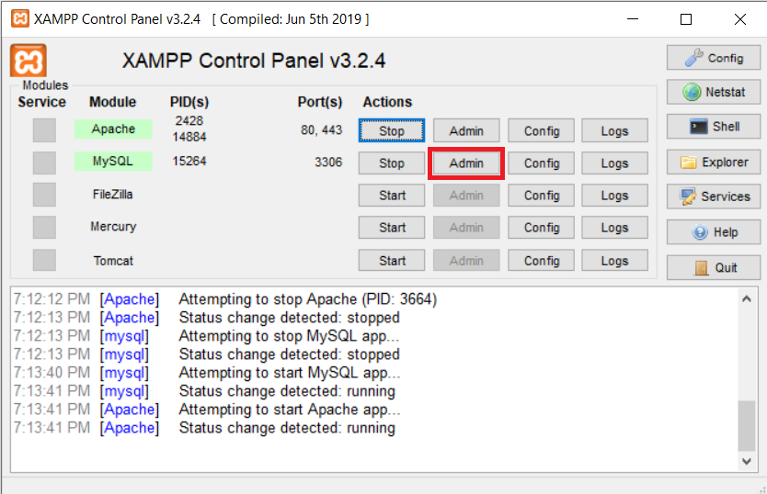

1. Within “phpMyAdmin” create a new database simply named “newssite”. This concludes the installation and configuration of the database to be used.

No SQL scripts need to be executed as the current state of the authentication microservice automatically creates and drops all database tables inside the database “newssite”.