**SABR #18 – Fútbol is Life Part Dos!**

**Monaco FC Method?**

We will be simulating the results of one team in a four-team, round-robin group like we analyzed in SABR#17. For reference, the Group Scoring Rules are summarized at the end.

1. Simulate (using the Monte Carlo Method and a data table) the results for one team and tabulate the points using P(W) = 41%, P(L) = 41% and P(D) = 18%. By the way, approximately 18% of World Cup games end in a tie. Be sure to put the probabilities in individual cells (not hard coded in formulas) so you can easily change them. Use **=countif(** to tabulate the number of points (similar to what you did with the NFL team in SABR#16) then calculate the probability for each of the outcomes.

|  |  |  |  |  |  |  |  |  |  |  |
| --- | --- | --- | --- | --- | --- | --- | --- | --- | --- | --- |
| **Points** | **0** | **1** | **2** | **3** | **4** | **5** | **6** | **7** | **8** | **9** |
| **Probability** |  |  |  |  |  |  |  |  |  |  |

In Excel, your set up should look something like this:

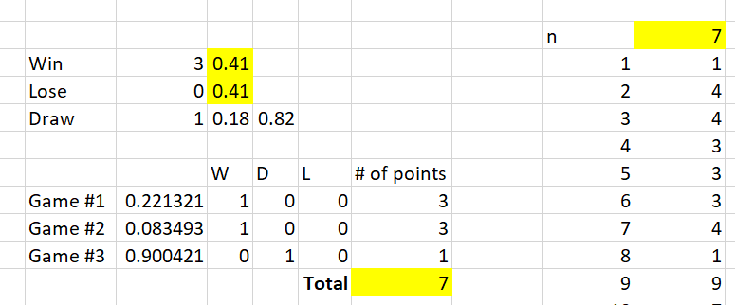

2. Next, simulate the results for one team and tabulate the points with DIFFERENT probabilities then W, L and D from #1. List 5 interesting things that you found.

|  |  |  |  |  |  |  |  |  |  |  |
| --- | --- | --- | --- | --- | --- | --- | --- | --- | --- | --- |
| **Points** | **0** | **1** | **2** | **3** | **4** | **5** | **6** | **7** | **8** | **9** |
| **Probability** |  |  |  |  |  |  |  |  |  |  |

**Group Scoring Rules**

For each win a team earns 3 points, a tie earns them 1 point and a loss zero points. For example, if the USA Wins all three group-stage matches they would earn 9 points. At the end of the round robin, the two teams with the most points advance to the knockout round.

Also, ties in the standings traditionally have been broken by goal difference then in order goals scored, points in matches between tied teams, goal difference matches between tied teams, goals scored in matches between tied teams, then usually lots (although FIFA now uses Fair Play points).