**Elements of a Successful Open Source: Github**

### Identify MS’s recommended approach to open-source projects

Q: What are elements of a successful open source project?

* Ability to download Github through Microsoft App Store
* In-Context conversation and requests across [repositories](https://docs.google.com/document/d/1ic28GASSMyIfBENmK1riVUSIi8_wEKajbvutD5YlKqM/edit#heading=h.gf35nyt6vcjo)

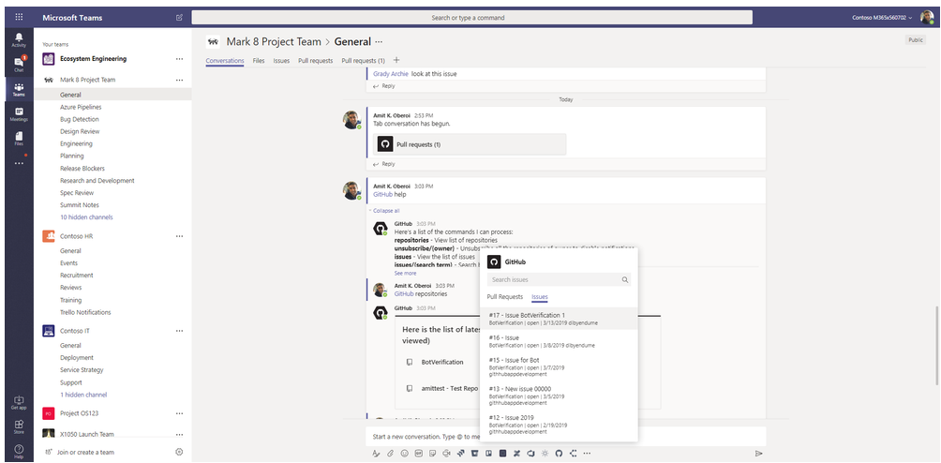

* 35000 Internal user at Microsoft are using Github to release open-source projects

Recommended Open Source Website: <https://opensource.microsoft.com/projects>

* VFS, Github, VisualStudios, Terminal, Blazor, etc.

**Blazor**: Code development platform capable of being used on multiple web browsers and mobile browsers.

**Bond**: Cross-platform framework that supports “cross-language [serialization/deserialization](https://docs.google.com/document/d/1ic28GASSMyIfBENmK1riVUSIi8_wEKajbvutD5YlKqM/edit#heading=h.gf35nyt6vcjo)”. Compatible for every code under the sun

**PWA Builder**: Web-based application platform to test, manage, package and perform other functions

Find one hosted through MS store

[Github Best Practices](https://www.datree.io/resources/github-best-practices): Data collected from interviewing hundreds of software developers

1. Do not push code to thew platform until it is ready i.e. do not commit right away
2. Always set up a user profile before uploading code
3. Remove [dependencies](https://docs.google.com/document/d/1ic28GASSMyIfBENmK1riVUSIi8_wEKajbvutD5YlKqM/edit#) before publishing

### **Creating Your First Project: Github**

Most of the work being completed by each team member will be done in a local repository.

1. Create a Github account and wait for the home page to appear

You will notice that you currently do not have any repositories, this is the first thing that Team 03 will need to set-up as most of the data will be stored here

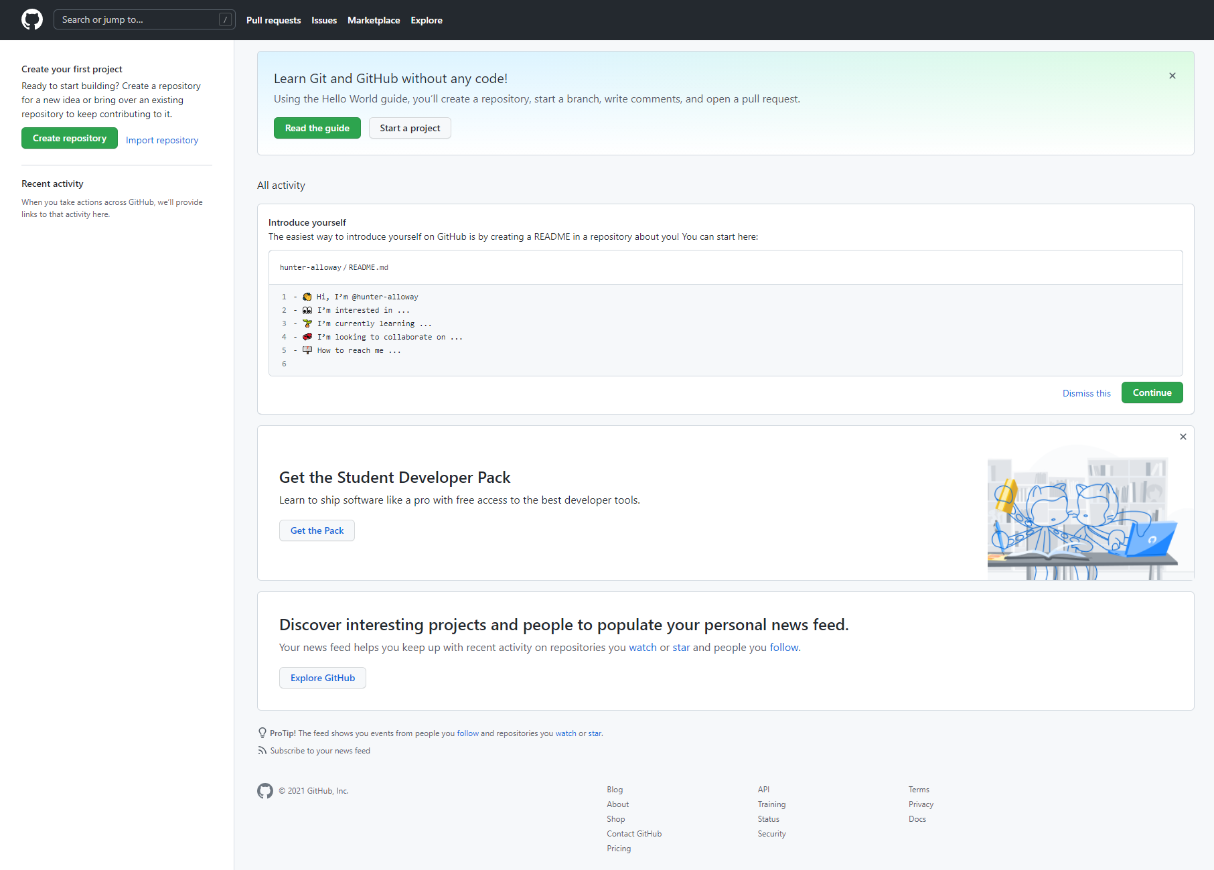

Q: What baseline can we set up?

When working in Github, there is no “[standard procedure](https://www.reddit.com/r/github/comments/jfyrom/newbie_question_should_you_upload_to_github_after/)” per-se as this platform is open to anyone willing to develop code, collaborate, and share ideas. If the code Team 03 has developed satisfies the stakeholder requirements, but there are a few issues that are suspected to appear in current or future patches, Github enables teams to create a private repository and transfer the code to a public repository when ready.

[**Changing Private Repository to Public**](https://positive-stud.medium.com/how-to-make-your-public-repository-as-private-and-vice-versa-in-github-39bd2dbfe0ff)

1. Select the repository you are working in and select settings →Danger Zone→Change Visibility→Make Public→I Understand Change Repository Visibility→Enter Credentials →Celebrate

Grand scope of this project: Theme of our team is to make an EKG on end-to-end IT service