**ENGR 481: Open Source Platform Compatibility**

| Look at MS documentation or other resources (stackOverflow, GitHub, googleScholar, etc.) for how MS-based teams have approached open-source projects.   1. Is there software that sticks out to you as you see examples? What tools/software have you noticed that support MS integration? 2. Is there a recurring method or process that you’ve noticed that you think might be valuable? Is/are there platform(s) that open source projects collaborate over? (i.e. a forum or blog or anything) | [Gain flexibility to run open-source applications your way with Microsoft Azure | Azure Blog and Updates | Microsoft Azure](https://azure.microsoft.com/en-us/blog/gain-flexibility-to-run-open-source-applications-your-way-with-microsoft-azure/) |
| --- | --- |

**Office 365 Product Description**

Included:

* Microsoft Office Suite
* Free through Liberty University
* Storage: 50Gb of outlook, 5TB of OneDrive, Microsoft Teams

# Microsoft Azure

Vulnerability:

* Data visualization-Jupyter Notebook left thousands exposed from hackers and third-parties looking to steal IP and other company software assets
* Third-party access to read, write and delete features of Azure client’s accounts

About:

* Public cloud computing platform
* Pay as you go-meaning you only pay monthly for what services your company has used
* Databases and virtual machines can be used including the ability to give third-parties access to software
* Run a virtual machine from Microsoft servers (cloud) that can be used for Domain Name System Servers, Internet Information Services and other third-party applications
* It can also support Linux! Many use Azure as a fail-safe for data recovery
* * The ability to log data from sensors and devices that generate field-data. The platform notifies the client when data is being provided from a device and sends analytics and support for coding and implementation for the data.*
* Collaboration devices to enable users to communicate when working on data from the cloud. The software provides a test lab to build and test software
* Machine learning, artificial intelligence and “cognitive computing capability into data sets”.

https://searchcloudcomputing.techtarget.com/definition/Windows-Azure

## Microsoft DevOps

* Microsoft DevOps is a platform within a platform. Specifically, Microsoft Azure offers features that enable users to collaborate within a virtual team setting
* Repos-Ability for users to share and manipulate code
* Pipeline-Extremely content rich application used to run, debug, test and analyze code and the data sent to it
* Boards-Very similar to Project in that this software enables users to track work completion through “stories” (essentially a task tracker)

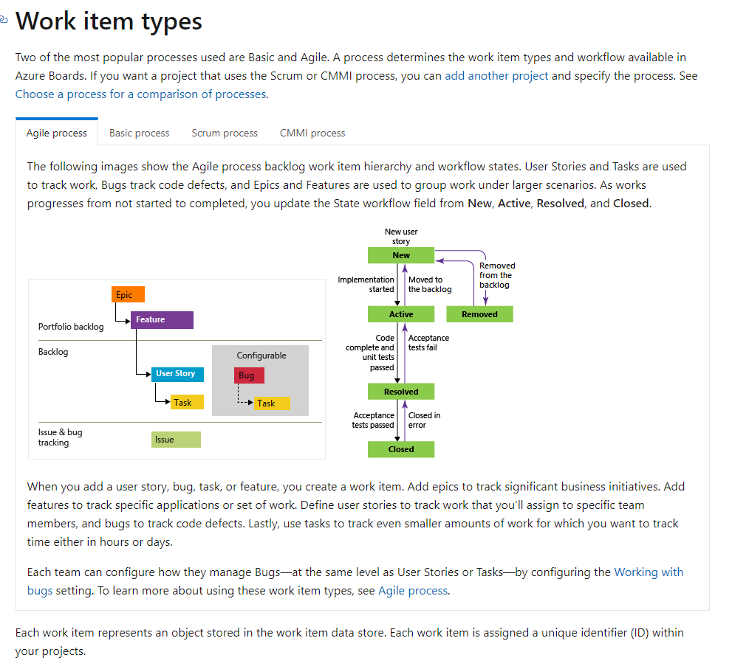

* Test Plans-The equivalent to ALM, where team members can complete tasks, create new test cases and organize test scenarios such as: manual testing, user acceptance testing, exploratory testing, stakeholder feedback, etc.
* List of Various projects within a development group/corporation:

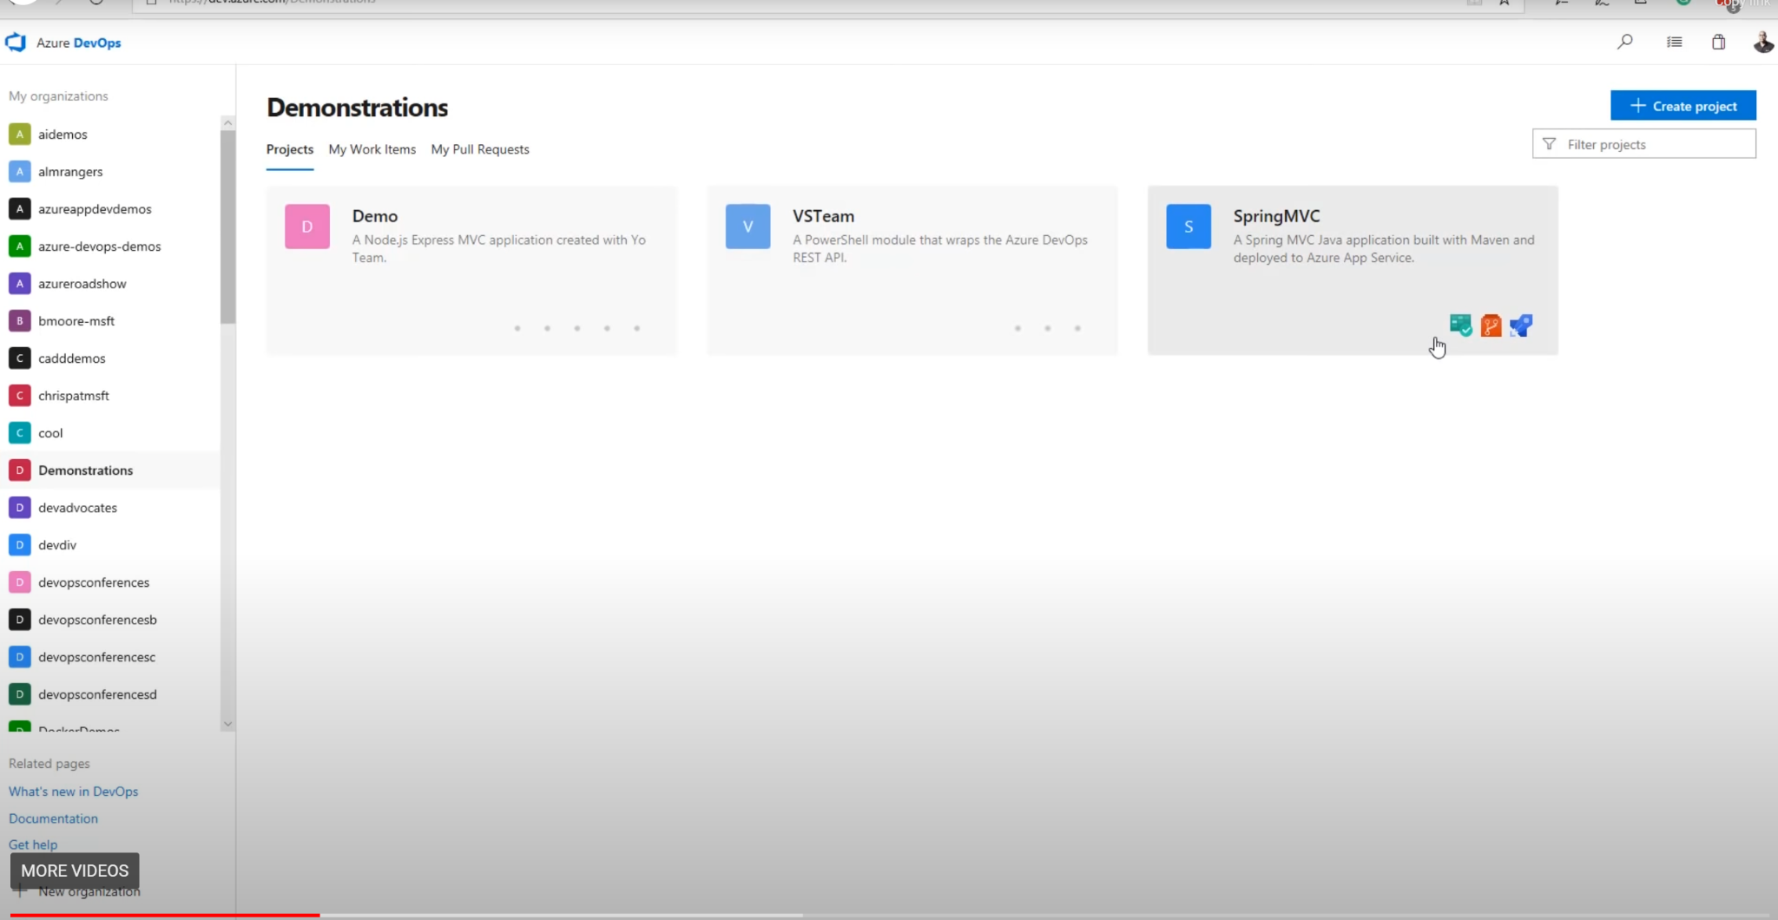

* Access to currently developed scripts between employees including planning sheets that allow each user to assign tasks to themselves or others and creates a clear work-flow

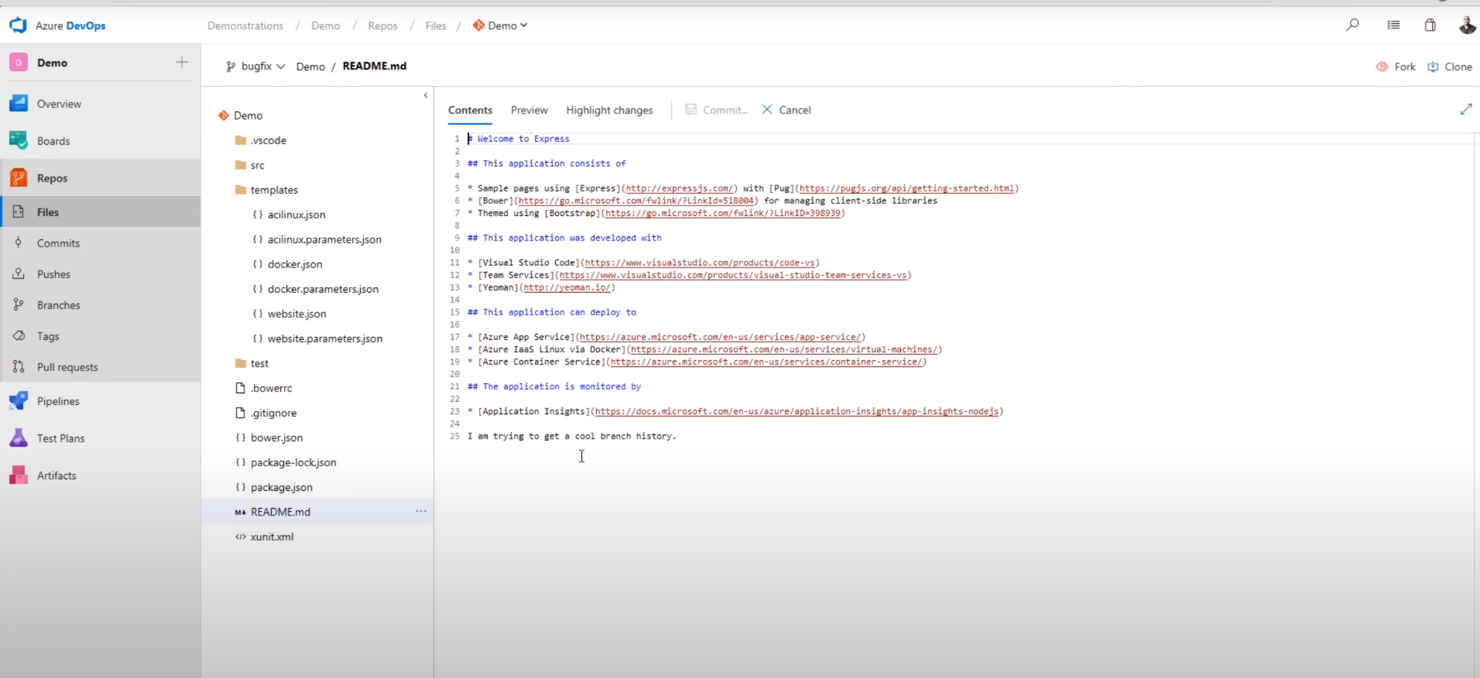

* Backlogs and boards allow users to see their tests and tasks for software, or code development
* Pipelines (which allow for approval of releases) and language development fields as well as a chat option for team messaging

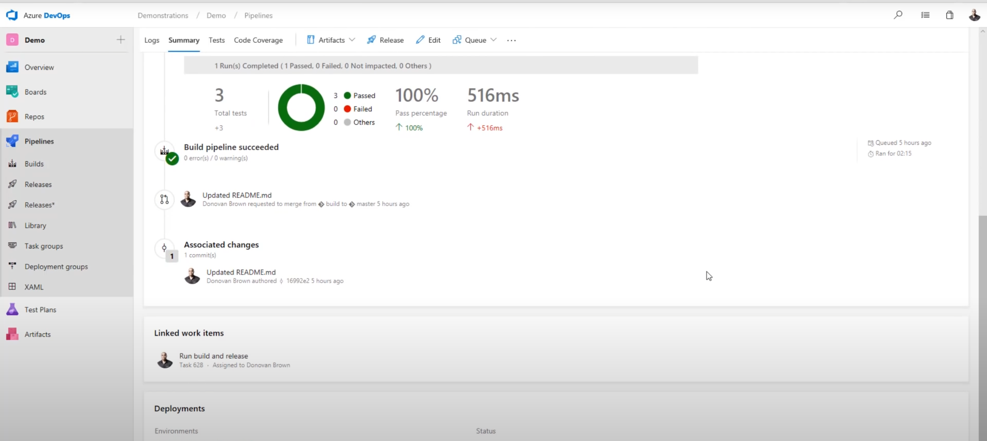

https://azure.microsoft.com/en-ca/overview/devops-tutorial/#videos

**Case Study: University of Sydney Covid Bot**

* University built a bot to answer student questions about Covid-19
* It took a week for them to create, but the updates they are currently making to the bot are growing and constantly changing during this period of change and transition
* They run their main covid-19 website through Azure
* “Highly scalable” and can take demands from multiple users and provide feedback within a reasonable time
* The analytics the bot collected from students was compiled to better improve the bots responses and also through analytics, was used to gain a better understanding of where student’s greatest concerns were focused during the pandemic

**https://customers.microsoft.com/en-us/story/823008-sydney-uni-bizapp-story**

**Product Pricing:**

Business

Developer $29/month

Standard $100/month

Professional Direct $1000/month

Premier N/A

Summary:

A storage platform that also works as a VM for organizing, encrypting and sharing information amongst co-workers and developers for software coding applications and data analytics.

**Github**

* A storage platform used for numerous applications and more than for just sharing code “A file system for every draft of a document”
* “Forking” a popular term in Github used to describe the process of sharing a file amongst team members. There will be one admin who has writing and publishing writes, but he/she can share the file with the rest of the team and they can all make adjustments for the admin to them publish to the main repository (fork, pull and merge processes)
* Github offers an integrated document sharing platform, but it is limited to the different facets it offers such as analytics and file storage

**Google Scholar**

* Google search engine that has access to over 160million scholarly journals, articles, abstracts technical reports, etc.
* INformation mostly up to date however, apparently not as reliable as some paid-subscription services