**Power BI**

**Main Download Informational Link:**

[**https://powerbi.microsoft.com/en-us/**](https://powerbi.microsoft.com/en-us/)

[**https://powerbi.microsoft.com/en-us/why-power-bi/**](https://powerbi.microsoft.com/en-us/why-power-bi/)

**Microsoft Documentation Links:**

[**https://docs.microsoft.com/en-us/power-bi/fundamentals/power-bi-overview**](https://docs.microsoft.com/en-us/power-bi/fundamentals/power-bi-overview)

[**https://docs.microsoft.com/en-us/power-bi/**](https://docs.microsoft.com/en-us/power-bi/)

**Power BI Trainings:**

[**https://docs.microsoft.com/en-us/learn/modules/introduction-power-bi/1-introduction**](https://docs.microsoft.com/en-us/learn/modules/introduction-power-bi/1-introduction)

[**https://www.tutorialspoint.com/power_bi/power_bi_introduction.htm**](https://www.tutorialspoint.com/power_bi/power_bi_introduction.htm)

[**https://data-flair.training/blogs/power-bi-tutorial/**](https://data-flair.training/blogs/power-bi-tutorial/)

**What is Power BI?**

* Collection of software services, apps, and connectors that work together to turn your unrelated sources of data into coherent, visually immersive, and interactive insights
* Power BI is a Data Visualization and Business Intelligence tool that converts data from different data sources to interactive dashboards and BI reports
* Provides multiple software, connector, and services - Power BI desktop, Power BI service based on Saas, and mobile Power BI apps available for different platforms

**Parts of Power BI**

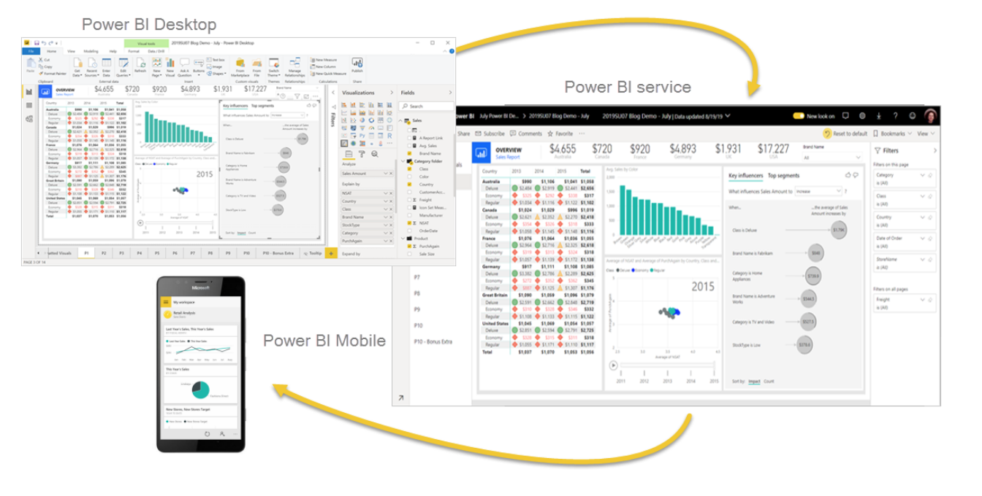

* Power BI consists of:
  + A Windows desktop application called **Power BI Desktop**
    - Power BI desktop app is used to create reports
  + An online SaaS (*Software as a Service*) service called the **Power BI service**
    - Power BI Services (Software as a Service - SaaS) is used to publish the reports
  + Power BI **mobile apps** for Windows, iOS, and Android devices
    - Power BI mobile app is used to view the reports and dashboards
  + **Power BI Report Builder**, for creating paginated reports to share in the Power BI service.
  + **Power BI Report Server**, an on-premises report server where you can publish your Power BI reports, after creating them in Power BI Desktop.
* Different platforms to help create and share data insights

**Power BI Architecture**

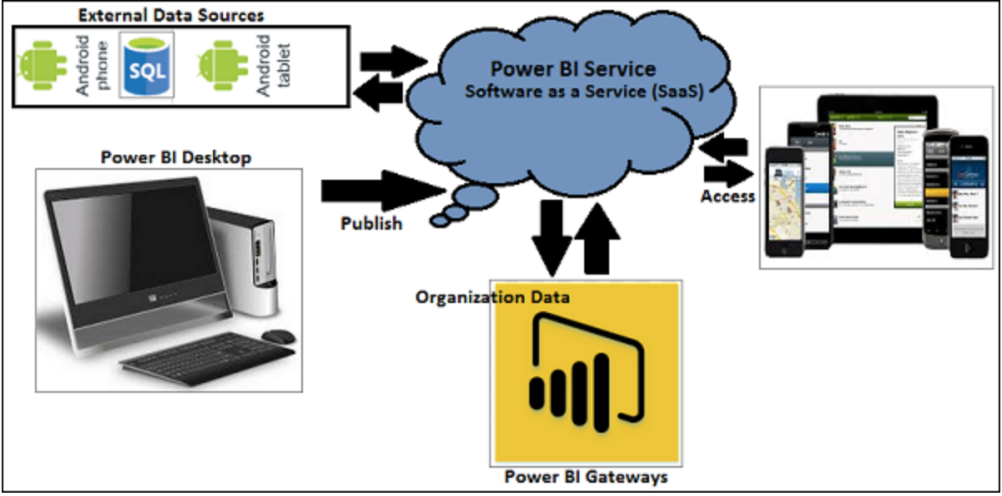

* **Power BI Desktop** − This is used to create reports and data visualizations on the dataset.
* **Power BI Gateway** − You can use Power BI on-premises gateway to keep your data fresh by connecting to your on-premises data sources without the need to move the data. It allows you to query large datasets and benefit from the existing investments.
* **Power BI Mobile Apps** − Using Power BI mobile apps, you can stay connected to their data from anywhere. Power BI apps are available for Windows, iOS, and Android platform.
* **Power BI Service** − This is a cloud service and is used to publish Power BI reports and data visualizations.

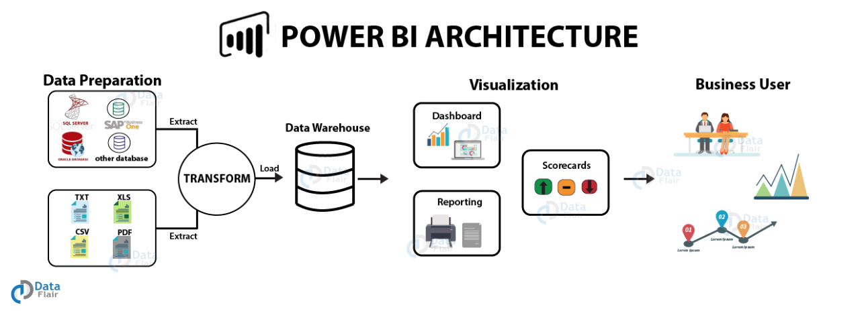

**1. Data Integration**

- Import data from different kinds of data sources in different formats.

- Bring data together (extracted) from different data sources and converts it into a standard format.

- Stored in a common storage area known as the **staging area**.

**2. Data Processing**

- Raw data requires some processing

- Several processing or cleansing operations transform the raw data such as removing redundant values, etc.

- Apply relevant business rules on the processed data that transforms it according to our business needs.

- Transformed data is loaded into the data warehouses. This

- Completes a full process of ETL (**extract, transform and load)**

**3. Data Presentation**

* Processed data moves from the warehouse and goes into the Power BI platforms like Power BI Desktop to*create reports, dashboards, and scorecards.*

**Power BI Supported Data Services**

* supports large range of data sources
* allows you to connect to different flat files, SQL database, and Azure cloud or even web platforms such as Facebook, Google Analytics, and Salesforce objects
* includes ODBC connection to connect to other ODBC data sources
  + Open Database Connectivity (ODBC) is **a protocol that you can use to connect a Microsoft Access database to an external data source** such as Microsoft SQL Server
* Available data sources in Power BI:
  + **File:** Excel, Text/CSV, XML, PDF, JSON, Folder, SharePoint.
  + **Database:** SQL Server database, Access database, Oracle database,***SAP HANA database***, IBM, MySQL, Teradata, Impala, Amazon Redshift, Google BigQuery, etc.
  + **Power BI:** Power BI datasets and Power BI dataflows.
  + **Azure:** Azure SQL, Azure SQL Data Warehouse, Azure Analysis Services, Azure Data Lake, Azure Cosmos DB, etc.
  + **Online Services:** Salesforce, Azure DevOps, Google Analytics, Adobe Analytics, Dynamics 365, Facebook, GitHub, etc.
  + **Others:** Python script, R script, Web, Spark, Hadoop File (HDFS), ODBC, OLE DB, Active Directory, etc.

**Work Flow in Power BI**

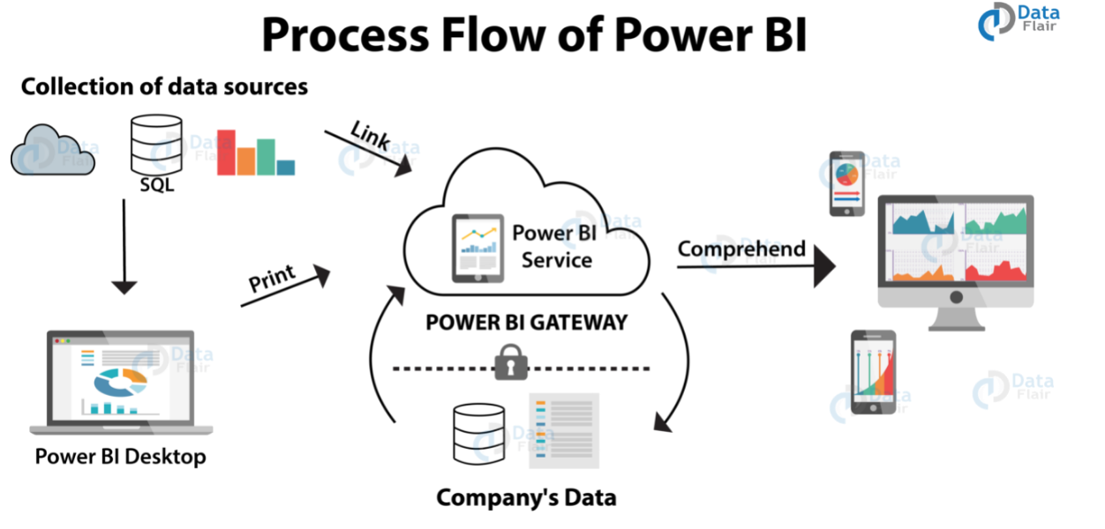

* Connecting to data sources in Power BI Desktop and building a report
* Publish that report from Power BI Desktop to the Power BI service
* Share it so business users in the Power BI service and on mobile devices can view and interact with the report

**How Power BI can integrate into Cadence**

* **Real-time analysis** in Power BI can be done by establishing direct connections to the data sources.
  + keeps data updated to the latest second by data refreshing
* Quickly search for important insights and datasets within your data by using the **Quick Insights** option.
* Establish a live or non-live connection to on-premises data sources like SQL Server, and use a secure channel to access data through **data gateways**
  + makes Power BI enterprise-ready as on-premises connections make data transfer secure and the technology scalable and reliable
* Use Power BI APIs to push data into datasets or to embed dashboards and reports into your own custom applications
* **Power BI API:** [**https://docs.microsoft.com/en-us/power-bi/developer/automation/overview-of-power-bi-rest-api**](https://docs.microsoft.com/en-us/power-bi/developer/automation/overview-of-power-bi-rest-api)
  + Using Power BI REST API, you can create apps that integrate with Power BI reports, dashboards, and tiles
  + possible to perform management tasks on Power BI objects like reports, datasets, and workspaces.
  + As developers, you can embed Power BI content in applications, develop Power BI visuals, and automate Power BI processes
  + GitHub Repository Developer Sample: <https://github.com/Microsoft/PowerBI-Developer-Samples>
  + Power BI Developer Documentation: <https://docs.microsoft.com/en-us/power-bi/developer/>