BLE File Transfer SOP
Version 1.0

Author: Sophia J Anderson
Date: June 6th 2026

Bluetooth Data Collection – SOP
Before starting, ensure the Bluetooth library is installed on the Pico Pi W and that your main script includes the required Bluetooth initialization lines.

Step 1:
Download Serial Bluetooth Terminal from the App Store.
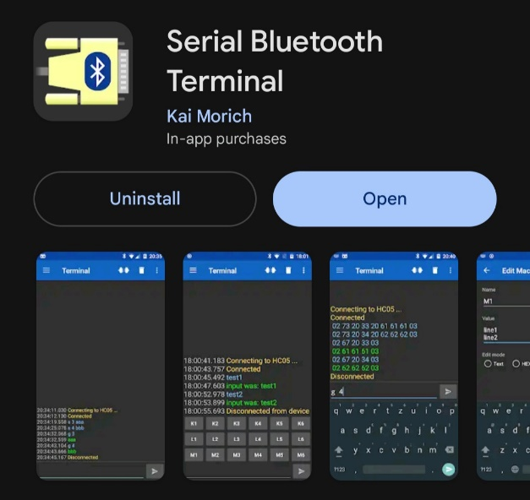
Step 2:
Open Serial Bluetooth Terminal.
Step 3:
Tap the three-line menu in the upper-left corner.
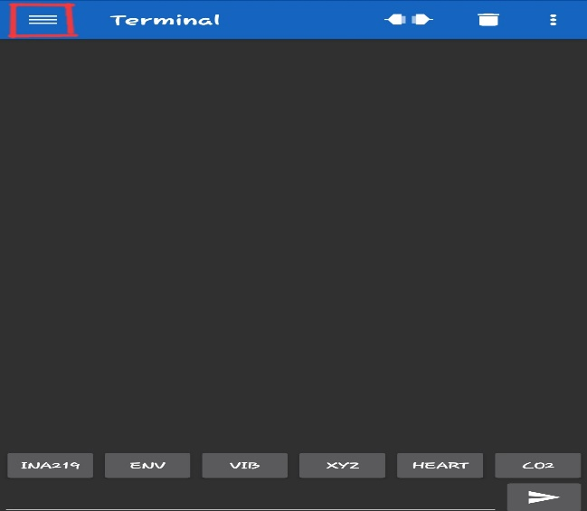
Step 4:
Select the Devices tab.
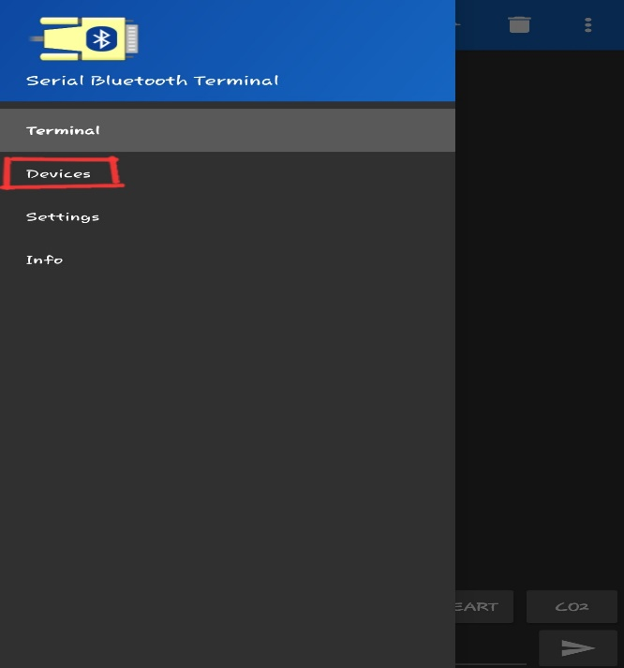
Step 5:
Choose Bluetooth LE, then press Scan.
– Your Pico device should appear after the scan completes.
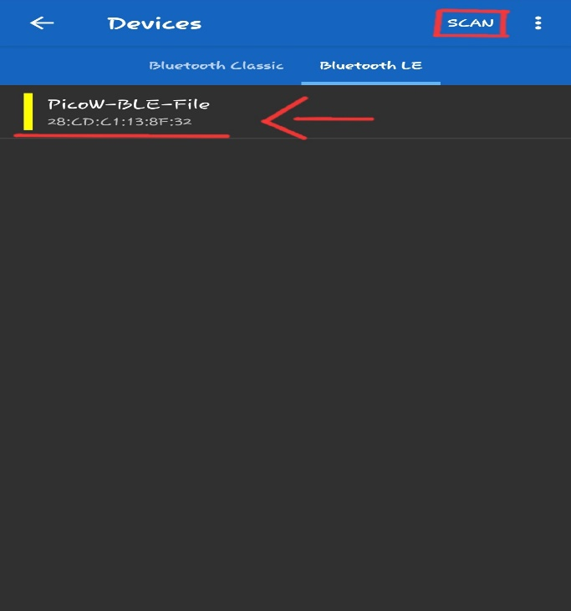

Step 6:
Return to the Terminal screen and choose one of the macro buttons above the input line.
– Hold down on the macro to edit it.
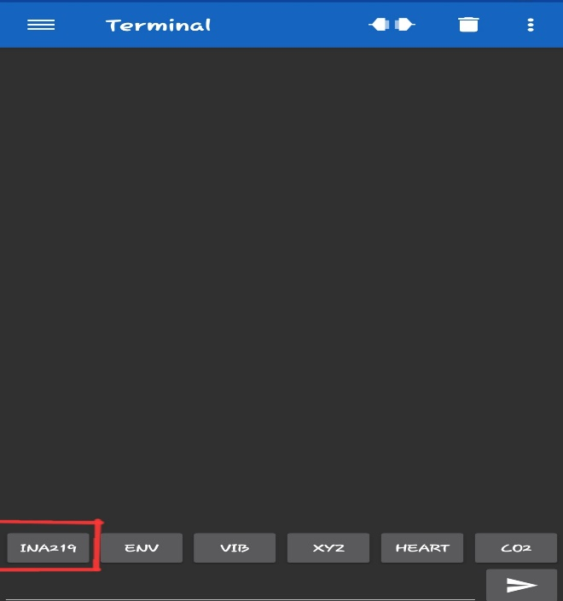
Step 7:
Rename the macro based on the data you are collecting.
Update the macro value to match the password you assigned for that data type.
– The password can be edited inside the Bluetooth script.
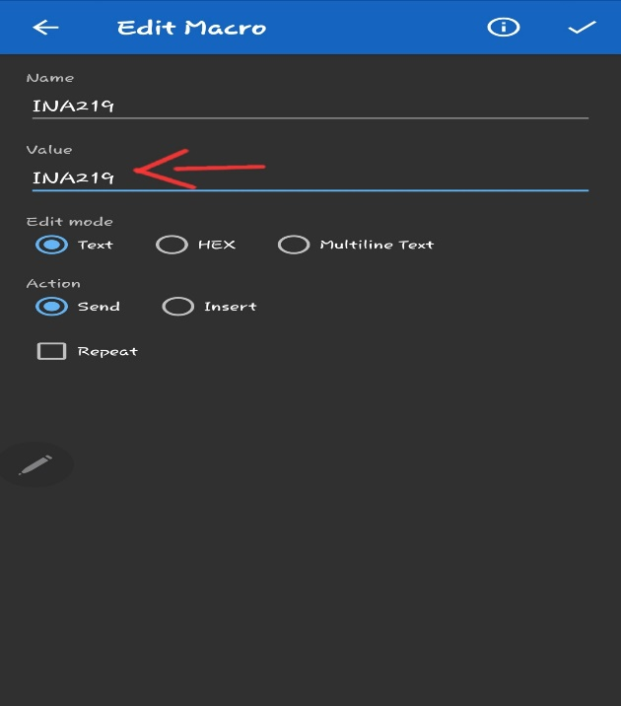
Step 8:
Go back to the Terminal and tap your newly labeled macro once (do not hold).
– Data will only appear after it has been written to the Pico’s log file.
– If the log file has no data yet, the macro command will not return anything.
Step 9:
Once you have collected your data, tap the three horizontal dots in the upper-right corner of the Terminal page.
You have two options:
- Data Tab:
– Tap Save to store the file in your phone’s default location.
– Tap Export to choose a specific folder or app to save your data.
- Configuration Tab:
– Allows you to adjust app settings if needed.
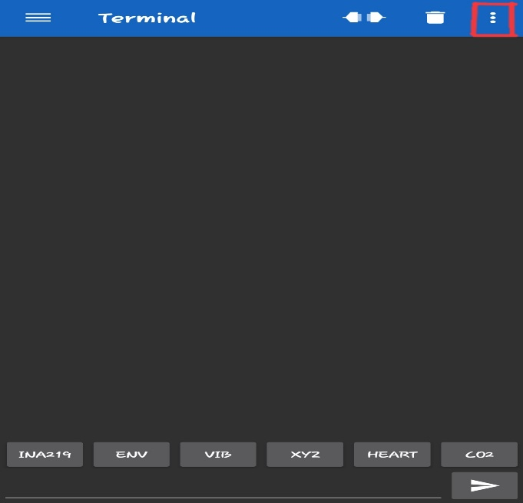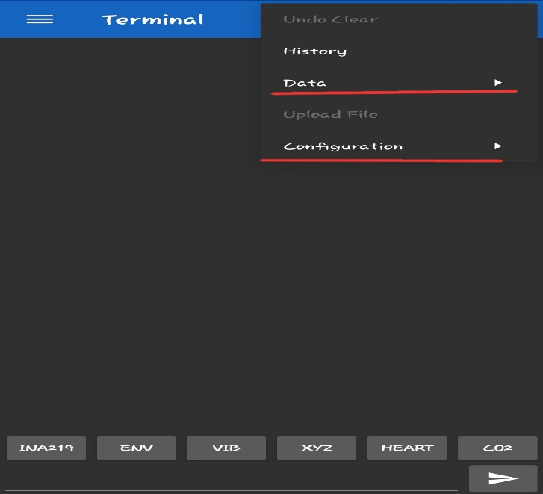

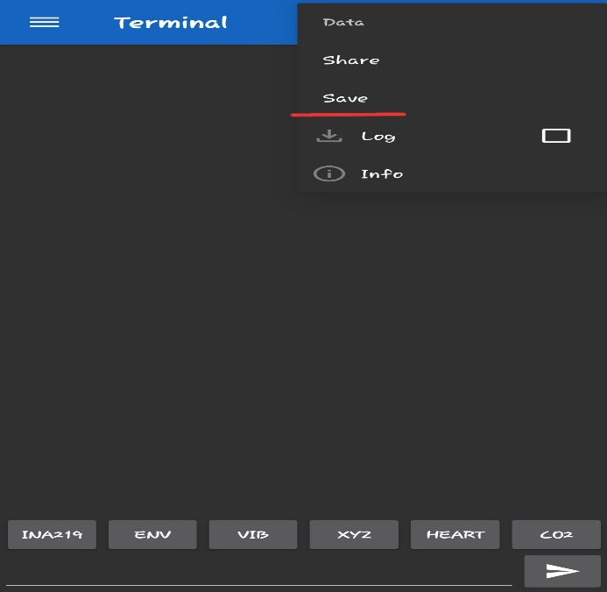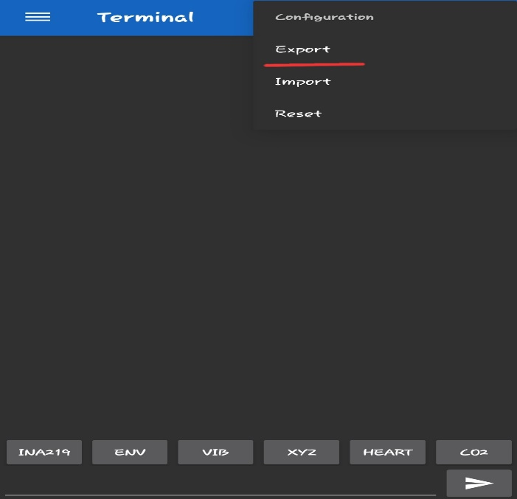

Code needed:
- ble_manager.py
Then place this code at the beginning of the main.py file (aka after all the imports)

from ble_manager import BLEManager

# SPI setup (matches your existing wiring)
spi = SPI(1,
baudrate=1_000_000,
polarity=0,
phase=0,
bits=8,
firstbit=SPI.MSB,
sck=Pin(10),
mosi=Pin(11),
miso=Pin(8))

cs = Pin(9, Pin.OUT)

file_passwords = {
"INA219": "/sd/ina219_log.csv",
"ENV": "/sd/environment_log.csv",
"VIB": "/sd/vibration_log.csv",
"XYZ": "/sd/xyz_log.csv",
"HEART": "/sd/heartbeat.txt",
"MEM": "/sd/mem_log.txt",
}

ble_mgr = BLEManager(spi, cs, file_passwords)

Then place this in the main loop before the comment “check for restart request”. Make sure it is lined up with the code below that comment.
# Update BLE Manager
if ble_mgr:
try:
ble_mgr.update() # This handles file transfers
except Exception as e:
log_sensor_error("BLE_UPDATE", e, context="main_loop")

