**Manufacturing Readiness Assessment**

**1. FUNDAMENTALS OF MRAs**



**1.1. Introduction to MRAs**

The objective of this lesson is for each student

to comprehend the MRA architecture.

**1.1.1. MRA Definition**

A Manufacturing Readiness Assessment (MRA) is a formal structured evaluation of a technology, component, manufacturing process, weapon system, or subsystem. It uses Manufacturing Readiness Levels (MRLs) as a standard to measure that level of readiness.

The MRA is performed to define and identify manufacturing maturities.

**1.1.2. MRA Purpose**

The purpose of a MRA is to evaluate a program’s ability to produce on-schedule while meeting cost and performance requirements, and to develop and implement manufacturing risk mitigation plans and business strategies.

 2009 Government   
 Accountability Office  
 (GAO) Report to   
 Congressional Committees*

Without measuring the maturity of the production processes:

• 42% cost increase

* $296 billion estimated total cost growth
* 22 month average schedule delay

*Defense Acquisitions: Assessments of Selected Weapon Programs, GAO-09-326SP, March 2009

In the Science and Technology environment, the purpose is to successfully transition to a weapon system application. This environment is active during the Capabilities Based Planning / Concept Development and Materiel Solution Analysis (MSA) phases, although it may be active during the Technology Development phase also.

In the Acquisition environment, the purpose is to ensure the industrial base to provide the vital components and materials for the weapon system application. This environment is primarily active beginning with the MSA phase and continues through the Production and Deployment / Operations and Support phase.

**1.1.3. MRA Benefits**

There are two main benefits that the Air Force realizes by conducting MRAs. They include:

* Improving confidence in weapon system development
* The weapon system:
* Meets performance requirements
* Is built at predictable cost
* Is built on a predictable program schedule
* Has suppliers ready to provide materials and parts
* Managing cost, schedule, and performance risk
* By examining:
* Design producibility and stability
* Manufacturing processes and tooling
* Workforce skills and training
* Supply chain capabilities
* Key materials and components
* Production test methods and equipment

**1.1.4. MRA Drawbacks**



MRA Drawbacks include:

* MRAs are perceived as using limited resources and unnecessary time
* MRAs may find unwanted new or hidden issues in the program
* MRAs cost money, as do the solutions to new issues they may find

Minimize MRA drawbacks by:

* Knowing and having a good relationship with your Procuring Contracting Officer (PCO)
* Building a well-rounded MRA team

**1.1.5. MRA Report Results**

GAO Report knowledge points include:

* Are the product’s technologies mature at the start of development?

This point is achieved when it has been demonstrated that the company can manufacture the product within cost, schedule, and quality targets.

A best practice is to ensure that all key manufacturing processes are in statistical control—that is, they are repeatable, sustainable, and capable of consistently producing parts within the product’s quality standards—at the start of production.

* Is the product design stable at the design review?
* Are manufacturing processes mature prior to production start?

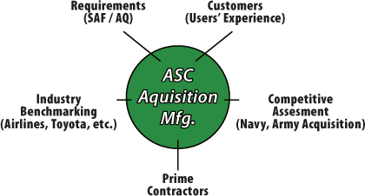

ASC 360° Study: 5 Big Industry Messages:

1. Government acquisition strategies do not require an in-depth risk analysis for manufacturing during product design.
2. Government acquisition does not specify the right deliverables in contracts.
3. Benchmarking other industries will give a better picture of manufacturing-related issues during product development and risk mitigation plans.
4. Production readiness must be assessed in a meaningful way.
5. Put more emphasis on suppliers during product development.

**1.1.6. Characteristics of MRA Steps**

***Step 1 – Identify the need for an MRA***



The triggers for a Program Management Office (PMO) MRA are:

* An approaching milestone review
* Policy
* A request from Program Executive Officer (PEO) / Office of the Secretary of Defense (OSD), etc.
* Contract issues
* Good business sense
* Using draft DoD criteria:
* Cost
* Design
* Manufacturing Process
* Quality
* Schedule
* Facilities
* Supplies / Materials
* Industrial Base

NOTE: MRAs can occur at any stage of a program.

***Step 2 – Plan for the MRA and identify team members***The PMO, or office that chartered MRA, designates an MRA Team Lead and identifies members of the MRA.

* A team typically has 2-6 members.
* Best practice dictates selecting some members from outside the PMO.
* Subject Matter Experts should be utilized.
* Provide training for team members, if needed**.**
* Contact Defense Contract Management Agency (DCMA).
* Notify contractor(s) and send orientation package(s).
* Schedule on-site assessments.
* Conduct a team orientation prior to the on-site assessment.

***Step 3 - Define the objectives / scope for the MRA***The MRA team and the PMO develop the MRA plan.

* The MRA plan consists of:
* A program description and acquisition strategy
* The manufacturing elements under consideration
* Focus areas
* Identification of target MRL
* Planned MRA schedule
* Funding considerations (TDY, labor, etc.)
* Prior to conducting an on-site MRA the PMO collects and provides data for the MRA team to use in the assessment.

***Step 4 - Perform the assessment***

* Contractor welcome, review of agenda, and orientation to facility
* Introduction of assessment team and contractor personnel
* Government team led briefing to contractor
* Purpose of MRA and how results will be used
* Objectives of assessment process
* Expectations
* Contractor overview
* Highlight responsibilities of contractor participants
* Results of their self-assessment
* Provide detailed responses to questions in the orientation package
* Shop-floor visits to key areas by individuals or small groups
* One-on-one or small group discussions between assessment team members and contractor subject matter experts; discussions focused on key areas
* Private meeting of Government assessment team to:
* Prepare feedback and identify any action items
* Utilize the MRA Tool (MRAT)
* Initial assessment of current MRL
* Key strengths / risks / issues
* Key missing data (if any)
* Proposed action items
* Out-briefing by Government team to contractor

***Step 5 – Document the results***

* MRA Team documents its assessment, including:
* A description of the technology that identifies the key elements; the key objectives of the technology development effort; and a discussion of the current state of the art
* Identification of the current TRL of the key technology elements
* A discussion of the companies who are responsible for the key technology elements
* A list of team members
* Dates and locations of site visits
* A description of the manufacturing processes for the key technology elements
* The assessed MRL for each key process or hardware element
* Areas where manufacturing readiness falls short of target MRL
* Identification of programs and plans to reach target MRL
* Assessment of the type and significance of risk to cost, schedule, or performance
* Assessment of the effectiveness of current risk mitigation plans
* Follow-on activities:
* Gather any key missing data
* Convene a team meeting within 2 weeks of the on-site assessment
* Discuss and finalize the assessment
* Examine the current program and manufacturing risk reduction plans
* Agree on likely MRL at the completion of milestone, if the plan is followed
* Share results with the contractor
* Identify the specific risk reduction activities necessary to reach the next milestone
* Identify the funding, time-phasing, and approach to carrying out each activity
* Prepare and submit the final report
* For MRAs conducted to support a milestone decision:
* PMO will create manufacturing risk mitigation plans and manufacturing maturation strategies
* PMO will provide a report to DoD at least one month prior to milestone

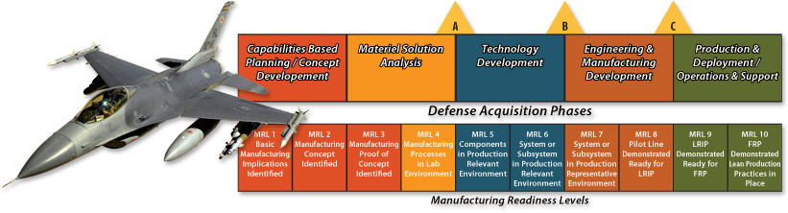

***Step 6 – Manage manufacturing risk items***

* MRLs that do not meet the necessary readiness level will have Manufacturing Maturation Plans (MMPs) created
* The MRA Team documents the shortfalls
* Plan and execute MMPs
* Measure mitigation effectiveness on a continuing basis
* Update MMPs, as needed