**Manufacturing Readiness Assessment**

**1. FUNDAMENTALS OF MRAs**  
  
**1.2. MRA Support Structure**



The objective of this lesson is for each student to comprehend the support structure associated with the MRA process.

**1.2.1. MRA Process Roles and Responsibilities**

The roles and responsibilities for each stakeholder include:

***SAF / AQR***

The SAF / AQR is also known as the Component Service [Air Force (AF)] Science and Technology (S & T) Executive.

The SAF / AQR serves as AF lead for Manufacturing Readiness Assessment (MRA) policy, guidance, and oversight. The SAF / AQR also directs and endorses the MRAs required for acquisition programs.

***PM at PMO***

An individual designated by Department of Defense Directive (DoDD) 5000.01 who has the authority to accomplish program objectives for development, productions and sustainment to meet user’s operational needs. The PM has total lifecycle system management authority.  
  
The PM is directly responsible for the MRA process, as the process directly relates to the a comprehensive integrated risk analysis for the acquisition program. The PM also identifies members of the MRA Team and designates the Team Lead.

***Aeronautical Centers***Each Aeronautical Center has specific policies in place regarding mandatory MRA activities.  
  
Currently, Air Armament Centers (AACs) require MRAs prior to Milestones B and C and prior to a Full Rate Production (FRP) decision. Aeronautical Systems Centers (ASCs) do not currently share this requirement, but a policy letter is in the works to do so.

***Team Lead***

The Team Lead is responsible for the actions of the MRA Team Members and the administration of the MRA process. Specific activities for the Team Lead include:

* Evaluating and adjusting the MRA scope, as necessary
* Scheduling on-site assessments with the contractor(s)
* Sending the orientation package to the contractor(s)
* Defining the deliverables of the assessment
* Conducting the on-site assessment with the contractor(s)
* Delivering the final report / briefing

***MRA Team Members***

The MRA Team is identified to perform an MRA. The team composition will normally lean heavily toward program office and service manufacturing subject matter experts (SMEs).

**1.2.2. MRA Policies and Directives**

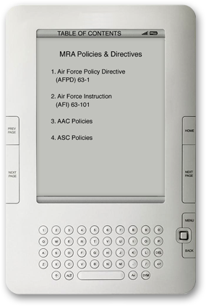

MRA policies and directives include:

* Air Force Policy Directive  
  (AFPD) 63-1
* Air Force Instruction  
  (AFI) 63-101
* AAC Policies
* ASC Policies

**1.2.3. MRA Acquisition Lifecycle Activities**

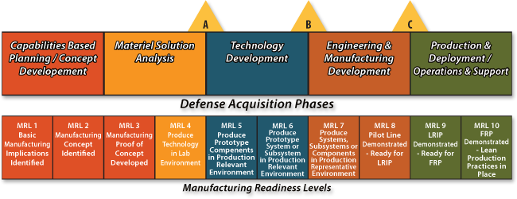

**1.2.4. MRA Contract Language Integration**

Suggested best practices for effectively integrating MRA into contract language:

* Place MRLs and MRAs into the contract at the start of the program
  + Clearly define the MRL and MRA parameters before the program begins or as close to the beginning of the program as possible.
* Define the MRLs needed to execute the program
  + Clearly delineate what MRLs must be in place before the program can be started or move to the next milestone.
* Require the contractor to perform assessments
  + Include in the contract, the scope and requirements of assessments, including when they will be performed and how the results will be reported.
* Monitor the performance of assessments on a continuing basis
  + Include in the contract, the Air Force oversight of the performance of the assessments.
* Connect MRL / MRA activity to formal reviews
  + MRL and MRA assessment results will be stated in the contract as expectations at key points in the program. When a formal review of the program is done, those MRL and MRA results from the assessment will be reviewed and compared to the expectations.
* Incorporate MRAs into existing contracts
  + Pay for the MRA effort in modifications to the existing contract.
  + If PPRs are already in the contract, tailor them to the MRA approach.
  + Incorporate MRL / MRA methodology into existing program review criteria.
  + Utilize existing contractor operating procedures to have MRL / MRA methodology reviewed.
* Specify the right deliverables
  + Verify that the contractor has the right processes in place to deliver the right product.
  + Use the right metrics to measure performance.
  + State that the contractor demonstrate that they have a solid production plan.
  + Require the prime contractor to demonstrate control of manufacturing processes during development.