**Manufacturing Readiness Assessment**

**2. MRA PROCESS**



**2.4. Perform the Assessment**

The objective of this lesson is for each student to comprehend the process for performing the assessment.

**2.4.1. Describe the steps associated with performing the assessment.**

**Initial meetings at the contractor**

There are two parts to the initial meetings at the contractor site. First, the contractor leads a welcome to the facility, a review of the agenda, and conducts an orientation of the facility. He/she will also introduce the assessment team and the contractor personnel.

The second part of the initial meetings is led by the MRA team leader. She/he briefs the contractor by explaining the purpose of the MRA, how the results will be used, the objectives of the assessment process (any risk issues), and sets expectations for the assessment.

The contractor then briefs the MRA team by highlighting the responsibilities of any MRA participants who are employed by the contractor, detailing any self-assessment results, and providing detailed responses to any questions that were in the orientation package.

**Shop floor visits.**

Shop floor visits are used to look for physical evidence that the self-assessment is valid, true, or accurate. The assessment team members will observe actual processes and procedures as they take place on the shop floor.

**One-on-one or small group discussions between assessment team members and contractor SMEs.**

You will remember in step three the MRA team defined the objectives and scope for the MRA. The team prepared themselves by reviewing existing briefing materials, contracts, and progress reports. They made sure they understood the purpose of the MRA, the objectives and status of the program, any Critical Technology Elements, configuration of hardware, and roles and locations of key contractors and suppliers.

During the assessment team members engage in one-on-one or small group discussions with contractor SMEs. These discussions are focused on the key areas determined in step three and give team members a different level of understanding beyond the floor visits.

**Private meeting of MRA team.**

After the on-site assessment, but before they leave, the MRA team prepares feedback and identifies any action items from the MRA. This feedback will cover two areas. It will:

* Validate any areas of excellence
* Validate any areas of shortfall

Also during this meeting, the MRA team will utilize the Manufacturing Readiness Assessment Tool (MRAT), discuss the initial assessment of the current MRL, the key strengths / risks / issues, any key missing data, and any proposed action items.

**Out Briefing**

The last item in the on-site assessment is the out briefing. During this time the MRA team meets with the contractor. The MRA report has yet to be finalized, but the team gives a preliminary report that includes key findings to the contractor.

**2.4.2. Recall the definition of an MRL.**

* Manufacturing Readiness Levels are a common language and standard for assessing the manufacturing maturity of a technology or product and the plans for its future maturation.

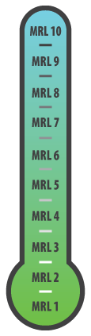

* Manufacturing Readiness Levels are a common language and standard for understanding the level of manufacturing risk in the production of a weapon system or the transition technology to a weapon system application.

**2.4.3. Recall the importance of MRLs.**

MRLs reduce:

* Technical problems
* Cost increases
* Schedule slippage

MRLs assure:

* Mature technology
* Stable product design
* Mature production processes

**2.4.4. Explain the importance for having MRLs in contract language.**

MRLs in Contract Language:

* Assist the evaluation process
* State measurable, specific objectives

**2.4.5. Interpret the 3 MRL production environments.**

**Production Relevant Environment**

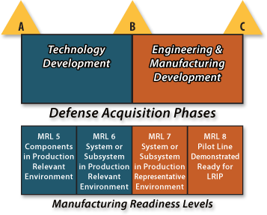

Normally found during MRL 5 and 6. Contains the key elements of production realism not normally found in the laboratory environment.

**Production Representative Environment**

Normally found during MRL 7. Contains most of the key elements that will be present on the shop floor production areas when low rate production takes place.

**Pilot Line Environment**

Normally found during MRL 8. Contains all of the key elements required to produce production configuration items, subsystems or systems that meet design requirements in low rate production.

**2.4.6. Explain the importance of knowing the TRLs during a MRA.**

Technology Readiness Levels provide significant insights into potential program problems and risks with technology maturity and design stability.

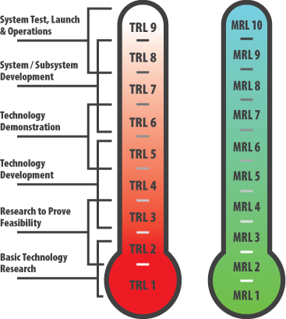

They provide a systematic metric / measurement system to assess the maturity of a particular technology and allow a consistent comparison of maturity between different types of technology. Once the technology, and any accompanying issues, has been identified we can determine if the manufacturing processes needed to produce it are in place and are mature.



**2.4.7. Differentiate between the 10 MRLs.**

MRL 1 - Manufacturing Feasibility Assessed

MRL 2 - Manufacturing Concepts Defined

MRL 3 - Manufacturing Concepts Developed

MRL 4 - Capability to produce the technology in a laboratory environment

MRL 5 - Capability to produce prototype components in a production relevant environment

MRL 6 - Capability to produce a prototype system or subsystem in a production relevant environment

MRL 7 - Capability to produce systems, subsystems or components in a production representative environment

MRL 8 - Pilot line capability demonstrated, Low Rate  
 Initial Production begins

MRL 9 - Low rate production demonstrated,   
 Capability in place to begin Full Rate Production

MRL 10 - Full Rate Production demonstrated and   
 lean production practices in place

**2.4.8. Interpret the 9 threads of evaluation criteria.**

**Technology and the Industrial Base**

This thread requires an analysis of the capability of the national technology and industrial base to support the design, development, production, operation, uninterrupted maintenance support, and eventual disposal (environmental impacts) of the system.

**Design**

This thread requires an understanding of the maturity and stability of the evolving system design as well as any related impact on manufacturing readiness.

Materials

The requirement for this thread is an analysis of the risks associated with materials (including basic / raw materials, components, semi-finished parts, and subassemblies).

**Cost and Funding**

This thread requires an analysis to be sure the funding is adequate to achieve target manufacturing maturity levels. It also examines the risk associated with reaching manufacturing cost targets.

**Process Capability and Control**

The requirements for this thread are a risk analysis of the manufacturing processes, to ensure they are able to reflect the design intent (repeatability and affordability) for key characteristics.

**Quality Management**

This thread requires an analysis of the risks and management efforts to control quality and to foster continuous improvement.

**Manufacturing Personnel**

The requirements for this thread are an assessment of the required skills and availability in necessary numbers of personnel to support the manufacturing effort.

**Facilities**

The requirements for this thread include an analysis of the capabilities and capacity of key manufacturing facilities (prime, subcontractor, supplier, vendor, and maintenance / repair).

**Manufacturing Management**

This thread requires an analysis of the orchestration of all elements needed to translate the design into an integrated and fielded system (meeting Program goals for affordability and availability).

**2.4.9. Describe the phases of the MRAT tool.**

**Plan / Customize / Set-up**

The tool’s setup screen is used to input the information used by MRAT for creating tailored folders and assessment files for a specific MRA. The team Lead completes the initial MRAT set-up worksheet and assigns threads / questions to evaluators and the contractor.

The MRAT creates a folder with a customized tool and sub-folder with evaluator and contractor workbooks.

**Individual Evaluation**

The Team Lead disseminates the workbooks to the evaluators and contractor, who answer their assigned questions. When complete, the evaluators and contractor return the workbooks to the Team Lead who then saves them in the evaluator sub-folder.

**Consensus**

The Team Lead imports the individual scores from the workbooks into the customized tool and completes the scores on the consensus sheet.

The MRA Team evaluates the answers to the questions and come to a final consensus.

**Reporting**

The Team Lead produces and distributes the MRA MRAT report. The MRAT can be used to find out what needs to be addressed to raise the MRL value.