**Technology Readiness Assessment**

**1. FUNDAMENTALS OF TRAs**  
  
**1.2. TRA Support Structure**

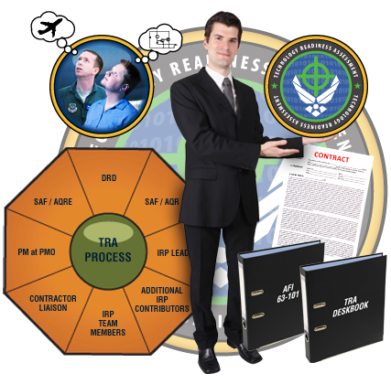

The objective of this lesson is for each student to comprehend the support structure associated with the TRA process.

**1.2.1. TRA Process Roles and Responsibilities**

The roles and responsibilities for each stakeholder include:

***DRD***The DRD is the principal staff advisor to the USD (AT&L) and to the Secretary and Deputy Secretary of Defense for research and engineering matters. As such, he/she monitors and evaluates the TRA process. Oversight responsibilities include:

* Approving the TRA schedule
* Reviewing the candidate Critical Technology Element (CTE) list and making necessary changes
* Approving the IRP Lead and IRP Team Members
* Reviewing the TRA report and sending results to the appropriate Overarching Integrated Product Team (OIPT) and / or the Defense Acquisition Board (DAB)
* Providing DDR&E recommendations concerning certification
* Recommending technology maturity language for an Acquisition Decision Memorandum (ADM), noting, in particular, conditions under which new technology can be inserted into the program

***SAF / AQR***The SAF / AQR brings AF technical expertise to the project. He / she is responsible for:

* Directing and supporting the TRA process   
   for Major Defense Acquisition Program   
   (MDAP) and other Defense Acquisition   
   Executive / Service Acquisition Executive   
   (DAE / SAE) programs

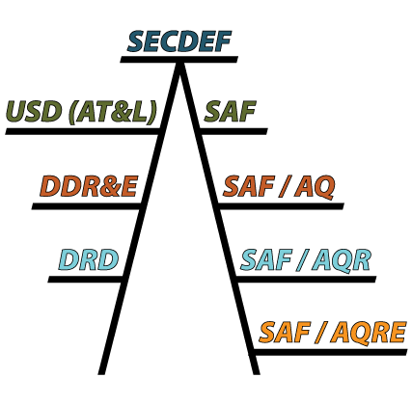

* Developing and modifying the TRA plan,   
   as necessary
* Selecting the IRP Lead and Team   
   Members
* Coordinating IRP membership with the   
   DRD
* Modifying and approving the final CTE   
   list, as necessary
* Coordinating the CTEs with the DRD
* Performing a peer review on the TRA   
   Report
* Coordinating TRA activities with DRD for   
   DAE programs
* Reviewing and validating MDAP TRAs one month prior to milestone decision (MD) date and forwarding endorsement to the Component Acquisition Executive (CAE) for Milestone B and C. Additionally, transmitting ACAT ID and IAM endorsements through the CAE to DRD.
* Reviewing MDAP TRAs and ACAT II TRAs for which the CAE has retained responsibility as the MDA one month prior to the Milestone review date, and forwards a recommendation to the CAE.

***SAF / AQRE***

The SAF / AQRE brings AF process expertise to the project. He / she is responsible for TRAs, Manufacturing Readiness Assessments (MRAs), and Systems Engineering Plans (SEPs). Specific responsibilities include:

* Reviewing MDAP TRA plans for Milestones B and C, to include the program office identification of critical technologies and technical experts to perform the TRA.
* Reviewing MDAP TRAs one month prior to scheduled MD date.

***PM at PMO***The PMO has direct responsibility for the TRA process. Specific responsibilities of the PM at the PMO include:

* Accountability for credible cost, schedule, and performance reporting to the MDA
* Initiating TRA process with SAF / AQR
* Developing the plan, including the TRA schedule
* Providing biographies of candidate IRP Lead and members to SAF / AQR
* Training the IRP. This task may also be performed by SAF / AQR, SAF / AQRE. Either way, the PM funds the TRA (including training), while the SAF / AQR owns the AF TRA process and coordinates TRA.
* Identifying a candidate CTE list per work breakdown structure (WBS)
* Collecting and providing data for the IRP to use in assessing CTE maturity
* Providing a facility for the IRP
* Building the final TRA Report (responsible for Section 1, Purpose; Section 2, Program Overview; Section 4, PMO Response to IRP Assessment) and coordinating it with SAF/AQR
* Overall responsibility: Ensuring the use of mature technologies demonstrated in a relevant environment at Milestone B and an operational environment at Milestone C.

***IRP Lead***The IRP Lead coordinates the efforts of the IRP. He / she must ensure the fair, accurate and on time delivery of the TRA report, to include:

* Managing assessment efforts in accordance with (IAW) TRA Deskbook and PMO schedule
* Obtaining additional expertise and artifact information, as needed
* Striving for consensus in assessment
* Signing final TRA document
* Communicating progress and outbriefing TRA results to SAF / AQR

***IRP Team Members***

The IRP brings subject matter expertise to the process. Panel responsibilities include:

* Completing DAU CLE 021 *Technology Readiness Assessment* (3-hour online course)
* Keeping the Component S&T Executive and the DRD informed on progress throughout the entire TRA process
* Developing a list of final CTEs in conjunction with the program and recommending it to SAF / AQR
* Assessing the TRLs for all CTEs. The assessment must be based on objective evidence gathered during events such as tests, demonstrations, pilots, or physics-based simulations.
* Preparing elements (Section 3) of the TRA report including the deliberations, findings, conclusions, and supporting evidence; and submitting assessment to PMO and SAF / AQR

***Contractor Liaison***The Contractor Liaison, where applicable, is the conduit for attaining technical or CTE data for TRA.

***Additional IRP Contributors***A Cockpit Review Team, battlefield airmen, warfighters from other services, maintenance personnel, or logistics personnel may be participants within an IRP or act as SMEs to IRP team members.

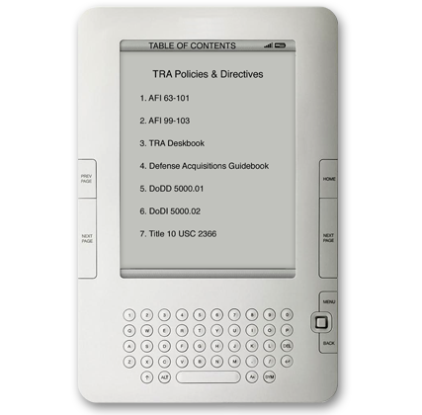

**1.2.2. TRA Policies and Directives**

TRA policies and directives include:

* AFI 63-101
* AFI 99-103
* TRA Deskbook
* Defense Acquisition Guidebook
* DoDD 5000.01
* DoDI 5000.02
* Title 10 United States Code (USC) 2366

**1.2.3. TRA Acquisition Lifecycle Activities**

|  |  |  |  |  |  |
| --- | --- | --- | --- | --- | --- |
| 12 to 24 months prior to MD | 12 months prior to MD | 11 months prior to MD | 10 months prior to MD | 9 months prior to MD | 8 months prior to MD |
| **PM requests TRA** | **AQR & PM develop plan** | **AQR coordinates IRP team** | **PM identifies candidate CTEs** | **AQR & IRP review CTE list** | **AQR coordinates plan with DRD**  **(ACAT ID & IAM only)** |

|  |  |  |  |  |  |
| --- | --- | --- | --- | --- | --- |
| 8 to 6 months prior to MD | 6 months prior to MD | No later than 3 months prior to MD | No later than 2.5 months prior to MD | No later than 2 months prior to MD | **Milestone Decision** |
| **PM collects data for CTE assessment** | **IRP assigns TRLs** | **PM & IRP Lead document TRA findings & coordinate with AQR; & for ACAT ID & IAM, with DRD.** | **PM submits TRA to AQR** | **AQR submits TRA to CAE; & for ACAT ID & IAM, with DRD.** |

**1.2.4. TRA Contract Language Integration**

AFI 63-101, Section 3.16, contains the contracting language requirements for integrating the TRA.

***AFI 63-101, Section 3.16***

IAW with AFI 63-101, 3.16, the source selection approach, as part of the acquisition strategy, shall be developed to reduce risk over the life cycle of the program. This includes identifying the strengths, weaknesses, domain experience, process capability, development capacity, and past performance for all developer team members with significant development responsibilities. Source selection guidance and procedures are contained in FAR Part 15, DFARS Part 215, AFFARS 5315.3 and AFFARS Mandatory Procedure 5315.3. Request for proposal (RFP) and source selection approach should require the following TRA information, so that it can be integrated into contracts:

* Expectations for warfighters, users, decision-makers, evaluation teams, and industry from the outset of the source selection. This includes an understanding by all of the desired end-state and clear expectations to industry on proposal requirements and timelines.
* A clear understanding of the methods of estimating costs for the program including uncertainty analysis and verification requirements. The government most probable cost estimate may need to be verified by a certified cost estimator IAW SAF / FM policy / guidance.
* Identification of the key discriminators from among the mission requirements. These must represent the key areas of importance and emphasis to be considered in the source selection decision and support meaningful comparison and discrimination between and among competing proposals.
* Establishment of the minimum performance or capability requirements against which offers will be judged. For contracts after MS B this includes minimum prototype performance. The PM shall address technology maturity in the solicitation supporting source selections conducted in conjunction with a MS / KDP B. The measure of merit that the technology in a program has been demonstrated in a relevant environment is that all CTEs are at TRL 6 or greater.
* The PM shall include language in solicitations for the EMD phase advising offerors that (1) the government will not award a contract to an offeror whose proposal is based on CTEs that have not been demonstrated in a relevant environment, and (2) that offerors will be required to specify the technology readiness level of the CTEs on which their proposal is based and to provide reports documenting how those CTEs have been demonstrated in a relevant environment.

**1.2.5. How Perpetual Lens Affects the TRA**

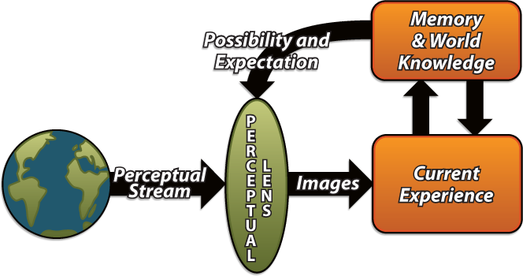

The TRA process can be viewed differently by different players in the process. Remember, each person will bring their own experiences and their own perceptions to the table. This can cause them to view aspects of the TRA process through their own unique *filter* or lens of perception.

Since TRAs are one-dimensional, it is important to take the experiences, knowledge, and perceptions of all of the IRP Team Members and focus them toward the performance of the TRA process. The IRP Lead is responsible for delivering a fair and accurate TRA. To ensure that this happens, he or she must see that all of the team members combine their expertise, but do not diminish their individual strengths and differences, which provide for a more comprehensive assessment. The end result should be a team consensus that the program’s technology maturity was thoroughly and accurately assessed.

We all come from different corporate cultures which also influence our perceptions. Corporate culture infers different informational silos or disparate thinking with different things being measured. When different corporate cultures are properly brought together, they create a balance and produce a Common Operational Picture (COP).