**Technology Readiness Assessment**

**2. TRA PROCESS**  
  
**2.10. Staff the TRA**

The objective of this lesson is for each student to comprehend the process for staffing the TRA.

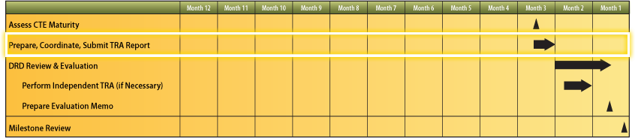

**2.10.1. Steps Associated with Staffing the TRA**

The steps associated with staffing the TRA are:

1. PM submits signed TRA Report to Component S & T Executive
2. Component S & T Executive performs peer review and submits TRA Report and cover letter to CAE
3. CAE reviews and submits TRA Report, Component S & T Executive cover letter, and his / her cover letter to DRD
4. DRD reviews and submits TRA Report, the two cover letters, and his / her Evaluation Memorandum to MDA

