**Technology Readiness Assessment**

**2. TRA PROCESS**  
  
**2.1. Initiate a TRA**



The objective of this lesson is for each student to comprehend the process for initiating a TRA.

**2.2.1. Steps Associated with Initiating a TRA**

**Step 1:**

The PM initiates the TRA effort by contacting the SAF / AQR (Component S&T Executive) and making him / her aware of prospective technologies that might be integrated into the Acquisition Program which require the TRA. This is done no later than 12 months prior to Milestones B or C.

**Step 2:**

The PM and Component S&T Executive work together to establish the schedule and budget for the TRA.  
  
The TRA schedule:

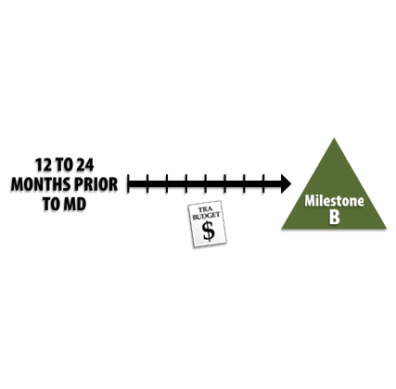

* Varies with the program’s acquisition strategy and takes into account any source selection or down-select activity
  + Activity start points and duration may vary greatly
* Varies as a function of Component procedures
  + Larger programs typically take a full year or more. Smaller, less complex programs normally require less time.

The TRA budget must consider:

* IRP member support
* Travel
* Contractor support
* Technology demonstrations
* Assessment functional costs
* Conference fees
* Critical Technology Element (CTE) briefings
* Other costs that vary from program to program

**Step 3:**



The Component S&T Executive identifies the program action officers.

* Deputy Assistant Secretary for Engineering and Technical Management (SAF / AQRE) – TRA process co-owner
* Deputy Assistant Secretary for Science and Technology (SAF / AQRT) – Air Force Research Laboratory (AFRL) interface

**Step 4:**

Based upon the technological subject matter to be assessed, the PM provides recommendations for potential Independent Review Panel (IRP) candidates to the SAF / AQRE.

The best practice states that it is important to build an IRP team comprised of unbiased and diverse subject matter experts.



**Step 5:**

The SAF / AQRE reviews the PM’s IRP recommendations, and then compiles the SME biographical information.