**Technology Readiness Assessment**

**2. TRA PROCESS**  
  
**2.2. Plan a TRA**

The objective of this lesson is for each student to comprehend the process for planning a TRA.

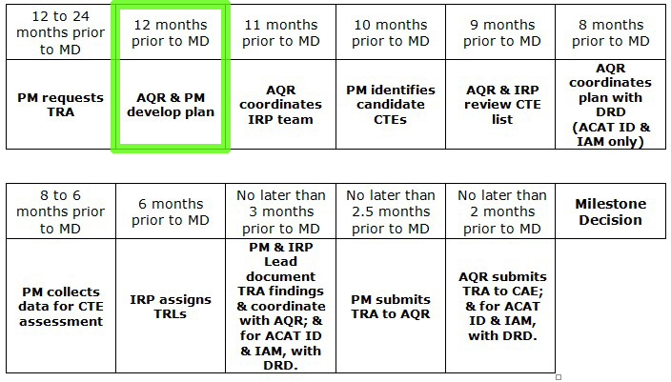

**2.2.1. Steps Associated with Planning a TRA**



**Step 1: Host Kick-off Teleconference**

In addition to the Program Manager (PM) and the Component Science and Technology (S&T) Executive, the teleconference includes:

* Secretary of the Air Force (SAF) Capability Directorate Representative
* SAF Acquisition Center of Excellence (ACE) Representative
* Any other pertinent parties

**Step 2: Determine Technologies to be Assessed**

The benefits of using a Work Breakdown Structure (WBS) and System and Software Architectures to determine technologies to be assessed include that they are:

* Readily available
* Evolve with the system concept and design
* Composed of all the products that constitute a system
* Relate to the functional architecture and system design, as well as the system deployment environment
  + These are important when identifying potential Critical Technological Elements (CTEs).



**Step 3: Determine IRP**

Considerations when determining an Independent Review Panel (IRP):

* Select potential members
* Select a facility
* Determine the materials needed
* Determine the schedule

**2.2.2. The 6 Sections of the TRA Plan**

**Section 1: Introduction**

The Introduction section of the TRA Plan book should describe who requested the TRA, what organization is responsible for conducting the TRA, and what technology is to be assessed.

It also includes a description of where the technology is being developed, such as a government agency, university, or private company.

**Section 2: Purpose**

The objective of the TRA is to ensure the compatibility and operability of the previously indicated technologies with the weapon system in question.  
  
The purpose of this objective is to ensure the availability of the system in order to maintain warfighter capability once the overhaul is complete.

**Section 3: Technology Background**

The Technology Background section of the TRA Plan book includes a general description of the technology and the project supported by the technology.

The description itself should include function-related details as they relate to the project and the current status of the technology development. If any previous TRAs were conducted on the technology, a summary of the results should also be included in this section.

**Section 4: IRP Table**

|  |  |  |  |  |
| --- | --- | --- | --- | --- |
| **Position** | **Title** | **Organization** | **Name** | **Area of Expertise** |
| Team Leader | Major | USAF | Dale Cooper | Radio Frequency Transmitters/Receivers |
| Team Member | Captain | USAF | Albert Rosenfield | Control and Display Technology |
| Team Member | First Lieutenant | AFRL | Lucy Moran | Data and Information Processor Technology |
| Team Member | GS-15 | A&AS | Andy Brennan | Decision-making Technology |
| Team Member | GS-15 | FFDRC | Laura Palmer | Digital Signal Processing |

The IRP table in the TRA plan book includes a list of the potential IRP candidates including their position on the team, title, organization, name, and area of expertise. At least one of the team members should be designated as a Team Leader.

**Section 5: Estimated Schedule**  
  
The Estimated Schedule section of the TRA Plan book is displayed in a table format that includes the task number, projected duration of the task, and a description of the task to be completed.

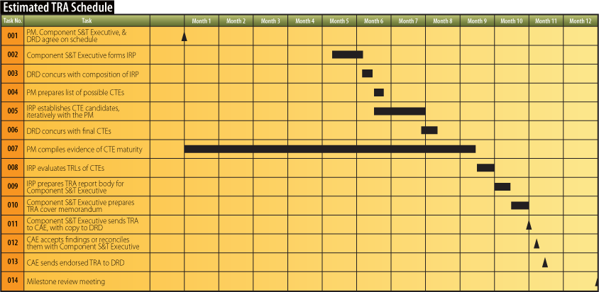

**Section 6: Estimated Cost**  
  
The Estimated Cost section of the TRA Plan book provides an estimate of the total man-hours and associated cost for conducting a TRA. Additionally, it identifies the organization responsible for funding the TRA.