**Technology Readiness Assessment**

**2. TRA PROCESS**  
  
**2.3. Identify an IRP**

The objective of this lesson is for each student to comprehend the process for identifying an IRP.



**2.3.1. Activities Associated with Identifying an IRP**

**Match potential IRP Team Members to specific attributes:**

* Possess subject matter expertise
* Contribute in-depth knowledge of a technological capability area
* Enhance team’s understanding of new and legacy processes
* Eliminate bias thinking by being independent of the program’s technology development



**Match potential IRP Lead to specific attributes:**

* Provides technical experience and authority in the technology element being evaluated and is from outside of the PEO chain of command
* Possesses an ability to provide foresight
* Carries out activities in an organized fashion
* Possesses leadership skills with the ability to be empathetic
* Provides good communication
* Contributes a pragmatic approach to the TRA process

**Use appropriate sources to locate potential IRP candidates:**

* Product Center-Engineering Directorate
* Air Force Research Laboratory (AFRL)
* Federally Funded Research and Development Centers (FFRDC)
* Advisory & Assistance Services (A&AS)
* Other Service branches

**2.3.2. Roles and Responsibilities of the IRP Members and the IRP Lead**

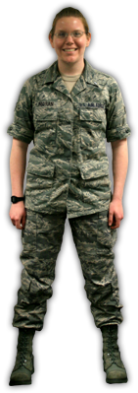

**Responsibilities of IRP Team Members include:**

* Complete the DAU CLE 021 *Technology Readiness Assessment* course (online).
* Recommend to Deputy Assistant Secretary of the Air Force / Science, Technology, and Engineering Executive (SAF / AQR) a final Critical Technology Element (CTE) assessment list.
* Perform the Technology Readiness Level (TRL) assessment for all CTEs, and include the basis for assessment.
* Document and submit the assessment to the Program Management Office (PMO) and SAF / AQR.

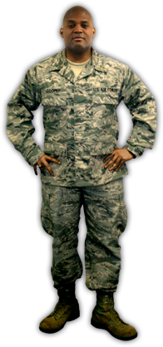

**Responsibilities of an IRP Lead include:**

* Manage the assessment effort and PMO

schedule

* Obtain additional expertise and artifact

information, as needed

* Strive for consensus in the assessment
* Sign the final TRA document
* Communicate progress and outbrief the

TRA results to SAF / AQR