**Technology Readiness Assessment**

**2. TRA PROCESS**  
  
**2.4. Train the IRP**

The objective of this lesson is for each student to comprehend the process for training an IRP.



**2.4.1. Steps Associated with Training an IRP**

***Initial IRP Training***

The Component Science and Technology (S&T) Executive and the Program Manager (PM) initiate the IRP training by providing a training briefing.

* The Component S&T Executive trains the IRP members on the TRA process.
* The PM provides a program description that includes a potential list of technologies.

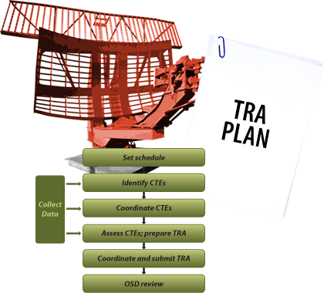

***Pre-Assessment IRP Training***

After the initial training, the IRP Lead conducts pre-assessment training that provides the IRP with the following information:

* An overview of the TRA Process
* A review of the TRA Plan
* A review of the subject technologies
* A tutorial provided by researchers for   
   the subject technologies



***TRA Training Courses***

TRA training courses include:

* DAU CLE-021 Technology Readiness Assessment
* SYS-109 Technology Readiness Assessment
* SYS-209 Technology Readiness Assessment