**Technology Readiness Assessment**

**2. TRA PROCESS**  
  
**2.5. Create a Candidate CTE List**

The objective of this lesson is for each student to comprehend the process for creating a candidate CTE List.

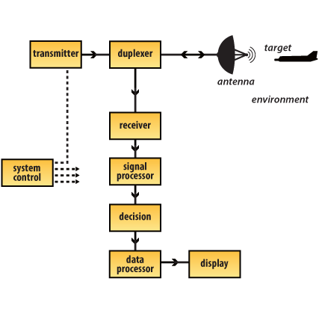

**2.5.1. CTE Definition**Critical Technology Element (CTE): A technology element is critical if the system being acquired depends on it to meet operational requirements, and it or its application is new or novel or in an area that poses major technological risk during detailed design or demonstration.

**2.5.2. CTE Classification**There are two classifications that apply to CTEs:

* Hardware
* Software

Technology readiness levels are not assessed the same for hardware and software elements.

When you are comparing the technology readiness levels for hardware and software elements, there are similarities in the technology readiness level definitions; however, the differences are shown in their descriptions and in the supporting information required for each technology readiness level.

**2.5.3. Steps for Creating a Candidate CTE List**

***Step 1: Create an initial list of possible CTEs*  
 *Process****:* This involves applying the definition of a CTE to the system’s technical Work Breakdown Structure (WBS) or system and software architectures.

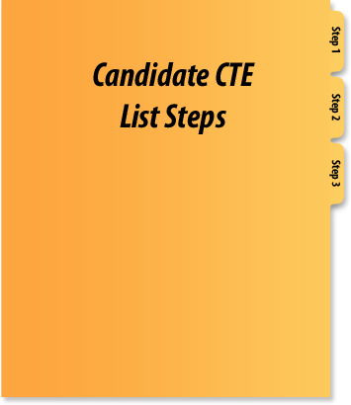

***People****:* The program manager (PM), the government program office staff, Component Science & Technology (S&T) Executive, and the system contractors

***Note to Self****:* It is important that this process be thorough, disciplined, and inclusive. Any questionable technology should be identified as a possible CTE. The information required to resolve their status should also be documented.

***Step 2: Develop a list of CTE candidates*  
  
*Process:*** An IRP, in conjunction with the program office, resolves any issues from Step 1 and makes additions and deletions to the initial list, as needed. The initial list is also reviewed by the Director, Research Directorate (DRD).  
  
***People****:* IRP, program office, and DRD

***Note to Self****:* Additions may include technologies that warrant the rigor of the formal TRA process.

***Step 3: The coordination process*  
  
*Process****:* Any disagreements for identifying CTEs should be resolved.  
  
***People****:* The IRP, the PM, the Component S&T Executive, and the DRD

***Note to Self****:* DRD concurrence should be obtained in order to address concerns early and in a timely manner.

**2.5.4. CTE Questions Framework**



If you can answer yes to the first question and to any of the five remaining questions, then the technology is a Critical Technology Element.

1. Does the technology have a significant impact on an operational requirement, cost, or schedule?
2. Does this technology pose a major development or demonstration risk?
3. Is the technology new or novel?
4. Has the technology been modified from prior successful use?
5. Has the technology been repackaged such that a new relevant environment is applicable?
6. Is the technology expected to operate in an environment and / or achieve a performance beyond its original design intention or demonstrated capability?

**2.5.5. Systems Engineering Framework**Systems engineering is an interdisciplinary approach encompassing the entire technical effort to evolve and verify an integrated set of system, people, and process solutions that satisfy customer needs across the lifecycle of a system, and Critical Technology Element identification applies to the Functional Analysis and Allocation component of the systems engineering framework approach because it uses the Requirements Analysis output to ensure the development of the appropriate technologies.

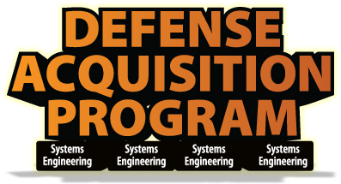

**2.5.6. Systems Engineering Approach Outcomes**

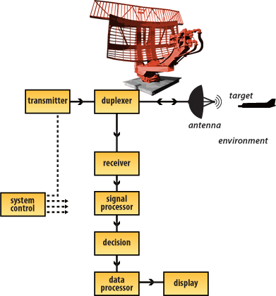

Functional Architecture: The functional architecture describes what the system accomplishes in quantitative terms; “What does it do?” It provides the framework around which the physical architecture is designed and serves as the basis against which the system and its various sub-elements are tested.  
  
Physical Architecture: The physical architecture identifies the subsystems and components, both hardware and software, necessary to realize the system concept and functional architecture. It is also the basis for design definition documentation such as specifications, baselines, the system and software architecture, and the technical WBS; items which serve the needs of the IRP during CTE identification.

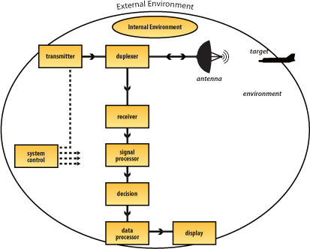

**2.5.7. Environment Affects on CTE Identification**

An internal environment is derived from the performance requirements of the system and is the primary environment used for identification and evaluation of CTEs.

An external environment is natural or man-made, friendly or hostile environment in which the system operates and is the secondary environment used for identification and evaluation of CTEs.

**2.5.8. The Five Environment Categories**

**Physical environment**Mechanical components, processors, servers, and electronics; kinetic and kinematic; thermal and heat transfer; electrical and electromagnetic; threat (e.g., jammers); climatic—weather, temperature, particulate; network infrastructure

**Logical environment**

Software interfaces; security interfaces; Web-enablement; operating systems; service oriented architecture(s); communication protocols; layers of abstraction; virtualization; coalition, federation, and backward compatibility

**Data environment**Data formats, structures, models, schemas, and databases; anticipated data rates latency, jitter, transit loss, synchronization, and throughput; data packaging and framing

**Security environment**  
  
Connection to firewalls; security protocols and appliqués; nature of the cyber adversary, methods of attack, and trust establishment; security domains

**User and use environment**  
  
Scalability; ability to be upgraded; user training and behavior adjustments; user interfaces; organizational change / realignments with system impacts; implementation plan