**Technology Readiness Assessment**

**2. TRA PROCESS**  
  
**2.6. Finalize the CTE List**

The objective of this lesson is for each student to comprehend the process for finalizing the CTE list.

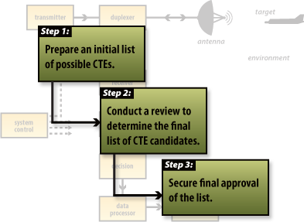

**2.6.1. Steps Associated with Finalizing the CTE List**

The steps associated with finalizing the CTE list are:

1. IRP Team submits the finalized candidate CTE list to the IRP Lead
2. IRP Lead submits the finalized candidate CTE list to the Component S & T Executive for approval
3. Component S & T Executive submits his approved candidate CTE list to the DRD for approval