**Technology Readiness Assessment**

**2. TRA PROCESS**  
  
**2.7. Collect Data**

The objective of this lesson is for each student to comprehend the process for collecting data.

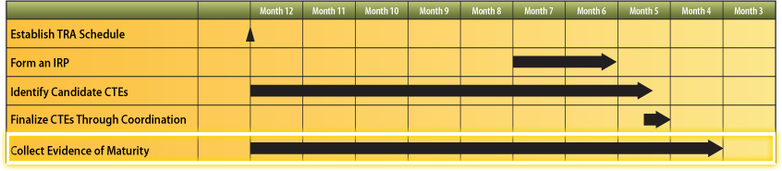

**2.7.1. Steps Associated with Collecting Data**

The steps associated with collecting data are:



1. After the identification of the initial CTE list, the PM collects data related to tests conducted on the component or subsystem to include descriptions, environments, and results within the context of the system’s operational requirements.
2. The PM briefs the IRP Lead about the data collected for the CTEs prior to the CTE maturity pre-assessment kick off meeting.
3. The data collected by the PM is supplied to the IRP at a pre-assessment kick off meeting that is held at the assessment site location.