**Technology Readiness Assessment**

**2. TRA PROCESS**  
  
**2.8. Perform the Assessment**

The objective of this lesson is for each student to comprehend the process for performing the assessment.

**2.8.1. Describe the steps associated with performing the assessment.**



The steps associated with performing the assessment are:

1. The IRP participates in pre-assessment meetings.
2. The IRP meets to review and analyze the data and artifacts to determine each element’s technology readiness level and document the results and rationale.
3. The IRP meets in a closed door session to score the CTEs and record the information on score sheets.
4. The IRP Lead promotes discussions to achieve consensus on the final score and supporting rationale for a technology.

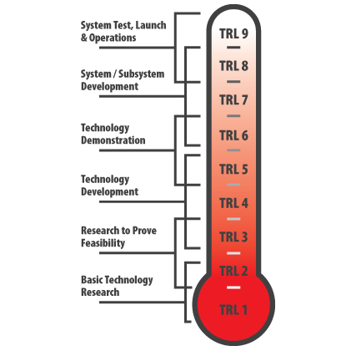

**2.8.2. Explain the uses for TRLs.**

Several uses for TRLs include:

* Provide a common understanding of technology maturity status
* Convey what has been accomplished / demonstrated with the technology
* Contribute as a factor in technical risk management
* Provide decision points concerning the transition of technology
* Provide scope for acquisition programs and their requirements
* Provide a basis for MDA certification

**2.8.3. Describe the requirements for Title 10, USC MDA certification.**

Title 10, USC Section 2366b states that the milestone decision authority must certify that:

* The appropriate market research has been conducted prior to technology development to reduce duplication of existing technology and products.
* The technology in the program has been demonstrated in a relevant environment to receive Milestone B approval.

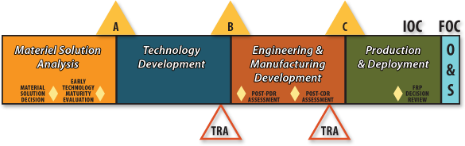

**2.8.4. Explain the importance for having TRLs in contract language.**

Important reasons for having TRLs in contract language include:

* Program managers are able to weigh several options in terms of cost and time, while ensuring that the CTEs meet adequate requirements.
* Including the TRLs in the contract language allows for the communication of concerns regarding issues of deficiency, ambiguity, and non-compliance.