**Technology Readiness Assessment**

**2. TRA PROCESS**  
  
**2.9. Document the TRA**

The objective of this lesson is for each student to comprehend the process for documenting the TRA.

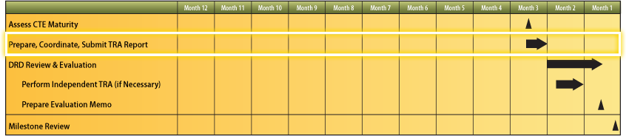



**2.9.1. Describe the steps associated with documenting the TRA.**

The steps associated with documenting the TRA are:

1. IRP documents its assessment
2. IRP Lead submits the assessment to the PMO, with a copy to the Component S & T Executive
3. PMO builds the TRA Report around the IRP’s assessment
4. PMO and IRP Lead sign the TRA Report

**2.9.2. Describe the TRA Report sections, components, and OPRs for each section.**

***An outline of the TRA Report sections:***

**1.0 Purpose of this document**

2.0 Program overview

**2.1 Program objective  
2.2 Program description**

**2.3 System description**

3.0 Technology Readiness Assessment

**3.1 Process description**

**3.2 Critical Technology Elements**

3.3 Assessment of maturity

**3.3.1 First CTE**

3.3.1.1 CTE description

a. Technology description

b. Function performed

c. Synopsis of development history

3.3.1.2 Environment description

3.3.1.3 Criteria for TRL assigned, including rationale

3.3.1.4 References to supporting data  
3.3.2 Second CTE (same subtopics as first CTE)

**3.4 Summary of TRLs by technology**

**4.0 Summary containing PMO’s response to IRP’s assessment**

***1.0 Purpose of this document***

This section provides a short introduction that includes the program name, the system name if different from the program name, and the milestone or other decision point for which the TRA was performed.

For example, “This document presents an independent TRA for the UH-60M helicopter program in support of the Milestone B decision. The TRA was performed at the direction of the Army S & T Executive.”

***Office of Primary Responsibility (OPR):*** PMO

***2.1 Program objective***

This section provides information for section 2.0 Program Overview. It states what the program is trying to achieve (e.g., new capability, improved capability, lower procurement cost, reduced maintenance or manning, and so forth). It refers to the Capability Development Document (CDD) (for Milestone B) or the Capability Production Document (CPD) (for Milestone C) that details the program objectives.   
  
***OPR:*** PMO

***2.2 Program description***This section provides information for section 2.0 Program Overview. It briefly describes the program or program approach—not the system. It also explicitly identifies the increments covered by the TRA, if relevant.



This section answers the following questions:

* Does the program provide a new system or a modification to an existing operational system?
* Is it an evolutionary acquisition program? If so, what capabilities will be realized by increment?
* When is the Initial Operational Capability (IOC)?
* Does it have multiple competing prime contractors?
* Into what architecture does it fit?
* Does its success depend on the success of other acquisition programs?

***OPR:*** PMO

***2.3 System description***

This section provides information for section 2.0 Program Overview. It describes the overall system, the major subsystems, and components to give an understanding of what is being developed and to show what is new, unique, or special about them.

This information should include the systems, components, and technologies that will later be declared CTEs. It also describes how the system works, if this is not obvious.

***OPR:*** PMO

***3.1 Process description***

This section provides information for section 3.0 Technology Readiness Assessment. It tells who led the TRA and what organizations or individuals were included as part of the IRP. It identifies the special expertise of these participating organizations or individuals. This information should establish the subject matter expertise and the independence of the IRP.   
  
Members should be experts in relevant fields and should be sufficiently independent of the developers (government or industry) as to not be unduly influenced by their opinions or have any actual or perceived biases. To avoid being influenced by the PM, an IRP member should not be directly working for or matrixed to the program. Usually, the PM will provide most of the data and other information that form the basis of a TRA. Nevertheless, the *assessment* should be *independent* of the PM.  
  
This section alsotells how CTEs were identified (i.e., the process and criteria used and who identified them). It states what analyses and investigations were performed when making the assessment (e.g., examination of test setups, discussions with test personnel, analysis of test data, review of related technology, and so forth).  
 ***OPR:*** IRP

***3.2 Critical Technology Elements***

This section provides information for section 3.0 Technology Readiness Assessment. It shows the technical work breakdown structure (WBS) or systems architecture and software architecture and the CTEs. It lists the technologies included in the TRA, and it explains the criterion for technologies that were included on the list of CTEs. It describes the environment that surrounds each CTE.

It can include a table that lists the technology name and includes a few words that describe the technology, its function, and the environment in which it will operate. The names of these CTEs should be used consistently throughout the document.

It also includes any additional technology elements that the Component S & T Executive considers critical.

***OPR:*** IRP

***3.3.1 First CTE***This section provides information for section 3.0 Technology Readiness Assessment and its subsection 3.3 Assessment of Maturity. It describes the technology (subsystem, component, or technology), the function it performs and, if needed, how it relates to other parts of the system. It provides a synopsis of development history and status. This synopsis can include facts about related uses of the same or similar technology, numbers or hours breadboards were tested, numbers of prototypes built and tested, relevance of the test conditions, and results achieved. If the CTEs presented are in categories (e.g., airframe or sensors), the information specified should be provided for each CTE within a category.

It describes the environment in which the technology has been demonstrated and provides a brief analysis of the similarities between the demonstrated environment and the intended operational environment.

This section applies the criteria for Technology Readiness Levels (TRLs), assigns a readiness level to the technology, and states the rationale for choosing this readiness level. It describes differing opinions for arriving at a particular TRL and the method of adjudication.

It provides extensive references to papers, presentations, data, and facts that support the assessments. It includes data tables and graphs that illustrate the appropriateness of key facts. These references / tables / graphs can be included as an appendix.

***OPR:*** IRP

***3.4 Summary of TRLs by technology***

This section provides information for section 3.0 Technology Readiness Assessment. It includes a summary table listing the CTEs, assigned TRLs, and a short list of explanatory factors

***OPR:*** IRP

***4.0 Summary containing PMO’s response to IRP’s assessment***

This section provides the PMO’s thoughts concerning the information provided in the assessment by IRP.

**OPR:** PMO

**2.9.3. Describe the DoDI 5000.02 acquisition phases which outline the framework for technology development.**

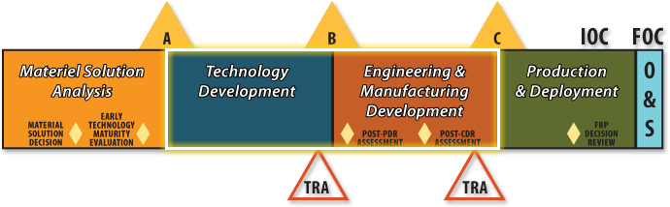

**Technology Development (TD) Phase**

The purpose of this phase is to reduce technology risk, determine and mature the appropriate set of technologies to be integrated into a full system, and to demonstrate CTEs on prototypes. This allows less costly and less time-consuming systems development. It is an iterative process designed to assess the viability of technologies while simultaneously refining user requirements.

Entrance into this phase depends on the completion of the Analysis of Alternatives (AoA), a proposed materiel solution, and full funding for planned TD Phase activity. The Technology Development Phase begins after Milestone A, when the Milestone Decision Authority (MDA) has approved a materiel solution and the Technology Development Strategy (TDS), and has documented the decision in an Acquisition Decision Memorandum (ADM).

The project shall exit the TD Phase when an affordable program or increment of militarily useful capability has been identified; the technology and manufacturing processes for that program or increment have been assessed and demonstrated in a relevant environment; manufacturing risks have been identified; a system or increment can be developed for production within a short timeframe (normally less than 5 years for weapon systems); or, when the MDA decides to terminate the effort. A Milestone B decision follows the completion of Technology Development.

**Engineering and Manufacturing Development (EMD) Phase**

The purpose of the EMD Phase is to develop a system or an increment of capability; complete full system integration; develop an affordable and executable manufacturing process; ensure operational supportability with particular attention to minimizing the logistics footprint; implement human systems integration (HSI); design for producibility; ensure affordability; protect critical program information (CPI) by implementing appropriate techniques such as anti-tamper; and demonstrate system integration, interoperability, safety, and utility.

Entrance into this phase depends on technology maturity (including software), approved requirements, and full funding. Unless some other factor is overriding in its impact, the maturity of the technology shall determine the path to be followed. EMD begins at Milestone B, which is normally the initiation of an acquisition program.

EMD has two major efforts: Integrated System Design, and System Capability and Manufacturing Process Demonstration. Additionally, the MDA shall conduct a Post-Preliminary Design Review (PDR) Assessment when consistent with the Acquisition Strategy, and a Post-Critical Design Review (CDR) Assessment to end Integrated System Design.

EMD effectively integrates the acquisition, engineering, and manufacturing development processes with Test and Evaluation (T & E). Evaluations shall take into account all available and relevant data and information from contractor and government sources.

The completion of this phase is dependent on a decision by the MDA to commit to the program at Milestone C or a decision to end this effort.