Data Analysis Report on Queensland Deaths from Circulatory and Respiratory

System Diseases and Cancers

Report prepared for lecturer

Word count: 2052 (excl. code)

Referencing Style: Harvard

Table of Contents

1. Introduction 1

1.1 Purpose and Use 1

1.2 Limitations 1

1.3 Scope 1

1.4 Methodology 1

2. Data Setup 2

2.1 Cleaning in Microsoft Excel 2

2.2 Cleaning in Notepad 2

2.3 Setting up the data in R 2

3. Exploratory Data Analyses 3

3.1 One-variable analyses 3

3.1.1 Bar graph for Cancer Death Types in 2010 3

3.1.2 Pie graph for Cancer Death Types in 2010 4

3.2 Two-variable analyses 5

3.2.1 Scatter plot of circulatory and respiratory diseases 5

3.2.2 Bar plot for Circulatory and Respiratory Diseases over 20 Years 6

4. Advanced Analyses 7

4.1 K-means Clustering 7

4.1.1 Explanation 7

4.1.2 Clustering Cancer Deaths 8

4.2 Linear Regression 9

4.2.1 Linear Regression Explanation 9

4.2.2 Linear Regression for Circulatory Deaths 10

4.2.3 Linear Regression for Respiratory Deaths 12

5. Conclusion 14

6. Reflections 14

Appendices 16

A. Excel CSV Comparison 16

Before cleaning 16

After cleaning 16

**ii**

# 1. Introduction

### 1.1 Purpose and Use

The report explores and analyses the causes of deaths in Queensland and visualises the data in an understandable and meaningful form. This is useful to researchers, business representatives, and government agencies.

### 1.2 Limitations

The report relies on the accuracy, range, and detail of the information provided by the Queensland Government, and collected by the Australian Bureau of Statistics. The dataset contains deliberately omitted information for privacy concerns, and the results for 2016 and 2017 are preliminary.

### 1.3 Scope

The report will only investigate human deaths from cancer and diseases from the circulatory and respiratory systems in Queensland between 1997 and 2017. The report will use one-variable, two-variable, k-means clustering, and linear regression analyses, with explanations on k-means clustering and linear regression.

### 1.4 Methodology

The report will use one and two-variable analysis, clustering with K-means, and linear regression data analyses and a range of data visualisation techniques, and will be performed in R. The report will use academic texts and peer-reviewed journal articles from the field of data science.

# 2. Data Setup

### 2.1 Cleaning in Microsoft Excel

The dataset is stored as a comma separated value. Prior to being analysed in R, the file was duplicated as “deaths.csv” and cleaned in Excel. Several rows were deleted so that the 4th row containing the headings was on top. Then the cells were given the general number format, removing the commas in the figures over 999. This allows R to read them as integers instead of strings. Saving the csv file with Excel also removes blank columns that were present in the original csv file as a series of additional commas (See Appendix A for comparison). This will make the table that R creates significantly easier to setup and use.

### 2.2 Cleaning in Notepad

The dataset was then opened in notepad, where the data was further cleaned to remove “–” and “(c)” values. The “–” text was replaced with 0 in line with the file information below the data. The “(c)” text was replaced with 1 since it is a non-zero small value according to the file, and figures 3 and 4 were not redacted, meaning the text must represent either 1 or 2 (See Appendix A for comparison).

### 2.3 Setting up the data in R

Prior to analysing the data, the data needed to be properly set-up in a data frame with the following code.

|  |
| --- |
| #R code  #This code is required for all other code sections  #Set working directory to the folder containing the csv file #note: This path will differ in other computer setups  setwd("C:\\Users\\Xtra1\\OneDrive\\Documents\\BU381\\All Courses\\ICT 110\\Task  2")  #Load the csv file to data frame deaths <- read.csv("deaths.csv")    deaths <- na.omit(deaths) #Done as a precaution, does not affect this set of data # Removes all unnecessary rows by finding if they have a value in the 1997 column deaths <- deaths[deaths$X1997 != "", ] # Remove unnecessary name column  deaths[1] <- NULL    # Create a transposed table to graph the rows tdeaths <- t(deaths)  # create a list of all the years to use for some analyses  yearList <-c(1997,1998,1999,2000,2001,2002,2003,2004,2005,2006,  2007,2008,2009,2010,2011,2012,2013,2014,2015,2016,2017) |

# 3. Exploratory Data Analyses

### 3.1 One-variable analyses

##### 3.1.1 Bar graph for Cancer Death Types in 2010

This report will look at the data for cancer deaths in 2015, as it is the latest non-preliminary data available. A pie graph is effective for showing general relation in magnitude between elements of a dataset and the entire dataset itself. However, it is ineffective at representing exact figures and confusing for datasets with more than 2 elements (Klein and ProPublica 2018), so a column graph will be used instead to compare each specified cancer type.

|  |
| --- |
| #R code  # get data for cancer subcategories in 2015. data <- deaths$X2015r[3:7]  # find the unaccounted total by finding the difference between the total cancer count and the sum of the subcategories.  data <- c(data, deaths$X2015r[2]-sum(data))    #Setting up the list of cancer names  names <- c("Trachea, bronchus and lung", "Melanoma of skin", "Breast", "Female genital", "Male genital", "Other")    # creates the bar plot  barplot(data, main="Types of Fatal Cancers in 2015", names.arg=names, xlab="Cancer Type", ylab="Number of Deaths") |

**Types of Fatal Cancers in 2015**

Trachea, bronchus and lung

Melanoma of skin

Breast

Female genital

Male genital

Other

Number of Deaths

0

1000

2000

3000

4000

5000

Cancer Type

The column graph provides a visual representation of the actual mortality figures allowing researchers to better comprehend the scale of the disease. The graph demonstrates that the cancers from the respiratory system has an annual death count above one thousand, while the other specified categories fall below. The other cancers sum to over five thousand deaths.

##### 3.1.2 Pie graph for Cancer Death Types in 2010

After creating the bar graph, the “other” category was noted to be significantly higher than all the specified types, so a pie graph was created to compare the total specified and total unspecified counts.

|  |
| --- |
| #R code  # The sum of the specified types, and the remainder data <- c(sum(data[1:5]), data[6]) labels <- c("Specified", "Other")    # creates the pie graph  pie(data, labels=labels, main="Types of Fatal Cancers in 2015") |

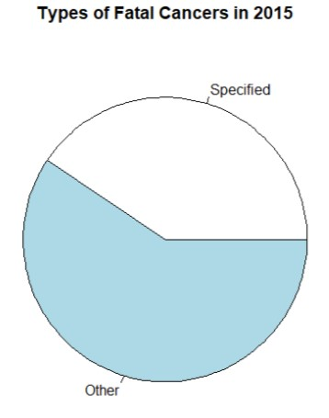

The pie graph helps visualise the relative scale of the deaths by unspecified cancers to the specified cancers. This demonstrates that over half the reported cancer deaths was caused by a type of cancer unlisted in this dataset and highlights the need for further research and data collection.

### 3.2 Two-variable analyses

##### 3.2.1 Scatter plot of circulatory and respiratory diseases

The scatter plot of circulatory and respiratory diseases helps to determine if there is a relationship between the two types of diseases. If there is a correlation, this could potentially assist doctors in diagnosing their patients.

|  |
| --- |
| #R code  # get data for circulatory and respiratory disease totals (column16=circulatory, column19=respiratory) data <- tdeaths[,c(16,19)] # plot the data in a scatter plot  plot(data, main = "Respiratory and Circulatory Deaths Each Year in Queensland", xlab = "Circulatory Diseases", ylab = "Respiratory Diseases") |

###### **Respiratory and Circulatory Deaths Each Year in Queensland**

4000

4500

5000

300

400

500

600

700

Respiratory Diseases

Circulatory Diseases

This scatter plot demonstrates that there is no clear correlation between respiratory diseases and circulatory diseases. It also demonstrates that deaths from circulatory diseases are much more common than from respiratory diseases by the figures on the axes.

##### 3.2.2 Bar plot for Circulatory and Respiratory Diseases over 20 Years

Even though there is no correlation between circulatory and respiratory diseases, the scatter plot does not show how the deaths change over time. A bar graph that displays the death count over time can be used to demonstrate if there are any trends in the number of fatalities from these diseases.

|  |
| --- |
| #R code  # get data for circulatory and respiratory disease totals (column16=circulatory, column19=respiratory) data <- tdeaths[,c(16,19)]  # transpose the data back to having the years as columns data <- t(data)    # plot the bar chart  barplot(data, main = "Queensland Deaths from Diseases in the Circulatory and  Respiratory System", xlab="Year", ylab = "Deaths", beside = TRUE, names.arg = yearList, legend=c("Circulatory", "Respiratory")) |

**Queensland Deaths from Diseases in the Circulatory and Respiratory System**

1997

1998

1999

2000

2001

2002

2003

2004

2005

2006

2007

2008

2009

2010

2011

2012

2013

2014

2015

2016

2017

Circulatory

Respiratory

Year

Deaths

0

1000

2000

3000

4000

5000

The bar graph demonstrates that the number of deaths from circulatory diseases is steadily decreasing over time, while the number of deaths from respiratory diseases remains relatively steady. The two categories appear to fit a linear model. It also further demonstrates the difference in number and scale between diseases from the two biological systems, where circulatory diseases are far more prevalent than respiratory diseases.

# 4. Advanced Analyses

### 4.1 K-means Clustering

#### 4.1.1 Explanation

Clustering is the process of separating objects into groups based on similarity of various variables in the dataset (Provost 2013). K-means clustering is an iterative method of reducing the distance between all the data within a single group, for all groups (Trevino and Oracle 2018). It does this by assigning 𝑘 cluster positions and assigning each datapoint to its nearest cluster (Trevino and Oracle 2018). It then moves the cluster’s centroid to the average position of its assigned data (Trevino and Oracle 2018). This is repeated until a given criteria is reached, such as the centroids not moving between consecutive iterations (Trevino and Oracle 2018).

Although K-means clustering is guaranteed to give a local optimum, it is not guaranteed to find the global optimum on its first run (Trevino and Oracle 2018). To overcome this issue, multiple clustering runs with different starting centroids can be done, with the best fitting one being chosen (Trevino and Oracle 2018).

#### 4.1.2 Clustering Cancer Deaths

The k-means clustering will be done on the total cancer deaths between 1997 and 2017. Since the data set will be one dimensional (the count), the centroids will also be one dimensional, and thus will be the equivalent of lines on the plot below. This also means that the variables will not need to be weighted.

|  |
| --- |
| #R code  # A basic plot of the cancer deaths plot(tdeaths[,2])  # Cluster the cancer totals into 5 groups. Choose the best run out of 25.  fit <- kmeans(tdeaths[,2], 5, nstart=25)    # RESULTS  # The cluster centroids fit$centers  # The cluster of each datapoint  fit$cluster  # The Sum of Square Error fit$tot.withinss |

R Output

> # RESULTS

> # The cluster centroids

> fit$centers

[,1]

1. 6360.20
2. 8849.50
3. 7084.50
4. 9387.00
5. 8238.25

> # The cluster of each datapoint

> fit$cluster

X1997 X1998 X1999 X2000 X2001 X2002 X2003 X2004 X2005 X2006 X2007 X2008

X2009 X2010 X2011 X2012 X2013 X2014 X2015r X2016p X2017p

1 1 1 1 1 3 3 3 3 3 3 5 5 5 5 2 2 2 2

4 4

> # The Sum of Square Error

> fit$tot.withinss

[1] 461786

Clustered plot created using R plot and clustering results:

5

10

15

20

6000

6500

7000

7500

8000

8500

9000

9500

Index

tdeaths[, 2]



Group 1



Group 3



Group 5



Group 2



Group 4

The k-means clustering created 5 groups; two groups of containing 5 points each for the first 10 years, and three groups containing four, four, and two points respectively for the last 10 years. The sum of square errors for the best fitting cluster was 461786.

### 4.2 Linear Regression

##### 4.2.1 Linear Regression Explanation

Data scientists frequently create models to find the approximate relationship between multiple variables to discover trends and make predictions (Stanton 2013). Linear regression is a linear model of the relationship between a dependent and independent variable and is expressed using two constants: a magnitude and intercept (Encyclopædia Britannica 2019.

##### 4.2.2 Linear Regression for Circulatory Deaths

|  |
| --- |
| #R code  # Find a linear relationship between circulatory deaths and the year fit <- lm(tdeaths[,16] ~ yearList)  # Plot the deaths in relation to time with a red line for the linear regression model plot(tdeaths[,16] ~ yearList, main = "Circulatory Deaths", xlab = "Year", ylab = "Death Count")  abline(fit, col="red")    #RESULTS # Find model  fit  # Find Sum of Square Error sum(fit$residuals^2) |

R Output

> #RESULTS

> # Find model

> fit

Call:

lm(formula = tdeaths[, 16] ~ yearList)

Coefficients:

(Intercept) yearList

164078.49 -79.48

> # Find Sum of Square Error

> sum(fit$residuals^2)

[1] 343106.9

**Circulatory Deaths**

2000

2005

2010

2015

4000

4500

5000

Death Count

Year

The linear regression model found the relationship:

Circulatory Deaths = 164078.49 − 79.48 × Year

With and SSE of 343106.9

This shows a downwards trend in the number of deaths,

meaning the rate of deaths from circulatory diseases is decreasing over time

Based on the plot, the data appears to fit the linear regression model well, although the deaths for 2007 and 2008 diverge the greatest from the line. However, these points would not classify as outliers.

##### 4.2.3 Linear Regression for Respiratory Deaths

|  |
| --- |
| #R code  # Find a linear relationship between respiratory deaths and the year fit <- lm(tdeaths[,19] ~ yearList)  # Plot the deaths in relation to time with a red line for the linear regression model plot(tdeaths[,19] ~ yearList, main = "Respiratory Deaths", xlab = "Year", ylab = "Death Count")  abline(fit, col="red")    #RESULTS # Find model  fit  # Find Sum of Square Error sum(fit$residuals^2) |

R Output

> #RESULTS

> # Find model

> fit

Call:

lm(formula = tdeaths[, 19] ~ yearList)

Coefficients:

(Intercept) yearList

-9816.532 5.127

> # Find Sum of Square Error

> sum(fit$residuals^2)

[1] 255043.3

**Respiratory Deaths**

2000

2005

2010

2015

300

400

500

600

700

Death Count

Year

The linear regression model found the relationship:

Respiratory Deaths = −9816.532 + 5.127 × Year

With an SSE of 225043.3

This shows an upwards trend in the number of deaths,

meaning the rate of deaths from respiratory diseases is increasing over time.

Based on the plot, the data seems to fit a polynomial model rather than a line, with crests at 2004 and 2012, and troughs at 2001, 2009, and 2014. The data also contains an outlier in 2007 where the death count is much higher than the surrounding data and doesn’t follow the general trend.

These models show that while circulatory deaths are overall decreasing at about 80 deaths per year, respiratory deaths are overall increasing at about 5 deaths per year. Despite the circulatory death plot appearing to more closely follow the linear model, it has a higher SSE figure due to the higher figures, rather than the variance. By using both models, a prediction for when circulatory and respiratory deaths are equal.

Respiratory Deaths = Circulatory Deaths

−9816.532 + 5.127𝑥 = 164078.49 − 79.48𝑥

84.607𝑥 = 173895.022

𝑥 = 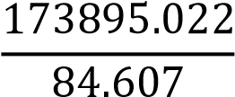 = 2055.326651

Therefore, the predicted year in which the number of respiratory deaths is above circulatory deaths is 2056.

Respiratory Deaths = −9816.532 + 5.127 × Year

= −9816.532 + 5.127 × 2055.32651

= 721.12701677

Therefore, when the circulatory and respiratory deaths are predicted to be equal, they are also predicted to have 721 deaths each.

# 5. Conclusion

This data analysis has found several trends in the number of deaths from cancer and diseases from the circulatory and respiratory systems. The single variable analyses found most of the cancer deaths in 2015 were not included in the data file. The scatter-plot demonstrated that there was no simple relationship between circulatory and respiratory disease deaths, and the double bar graph helped visualise the difference in scale between the death frequencies and the linear trends of the categories over time.

The clustering analysis divided the number of cancer deaths into 5 groups, with 2 groups for the lower half, and 3 groups in the higher half. The linear regression models for the circulatory and respiratory deaths over time confirmed the observations from the double bar graph plot that the circulatory deaths were decreasing, while the respiratory deaths were slowly increasing. By combining the two linear models, the respiratory deaths were predicted to overtake circulatory deaths in 2055-56 with 721 deaths.

# 6. Reflections

I encountered a lot of difficulty trying to plot the variable analysis in R without using Excel to pre-process the data. I encountered no issues with plotting the first one variable analysis, but the second one variable analysis required me to learn to transpose the table to access the csv rows as columns. I had trouble with the two variable analyses until I learned that you can specify rows and columns using a list of indexes. I had no troubles with k-means clustering and linear regression, although that could be because I attempted it last, and thus had learned the new techniques I needed from the previous analyses.

I tried to use a wide variety of graphs and plots to best show off my ability to use R. That is one reason why the first single variable analysis had both a bar graph and a bar chart. The other reason was that although the bar graph clearly compared the unspecified cancer deaths to the other categories, it was unclear how it compared to the total of cancer deaths. I was unable to plot the cancer deaths with the clusters being displayed from R in the k-means clustering analysis, so I created a regular plot and used Microsoft Word to draw the clusters on the plot myself.

I found cleaning the data in Excel and Notepad to be very useful and easy in making the data easy to use. However, by the time I learned about pre-processing in excel, in addition to data cleaning, I had nearly finished the analyses, so I continued without pre-processing. The next time I encounter a similar situation, I will be better prepared to know which tool to use and more flexible and approachable to try easier alternatives.

I learned a significant amount about how data frames work and how to use them to plot data. I also learned how useful non-R tools can be to cleanse and pre-process the data for R to plot, and that the correct tool should be used in data science for its appropriate task, or it will become significantly and needlessly harder.

References

Encyclopædia Britannica 2019, *linear equation*

Klein, S, ProPublica 2018, *ProPublica Data Style Guide*, viewed 29 May 2019, https://github.com/propublica/guides/blob/master/news-apps.md

Provost, F 2013, *Data science for business*, O’Reilly, Sebastopol, California

Stanton, J 2013, Version 3: a*n introduction to data science*, Syracuse University, Syracuse, New York

Trevino, A, Oracle 2018, *Introduction to K-means Clustering*, viewed 31 May 2019, https://www.datascience.com/blog/k-means-clustering

# Appendices

## A. Excel CSV Comparison

##### Before cleaning

Excel

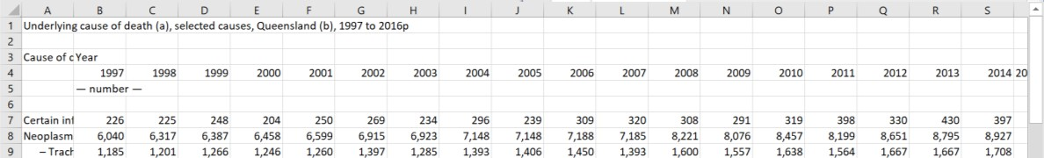

Notepad

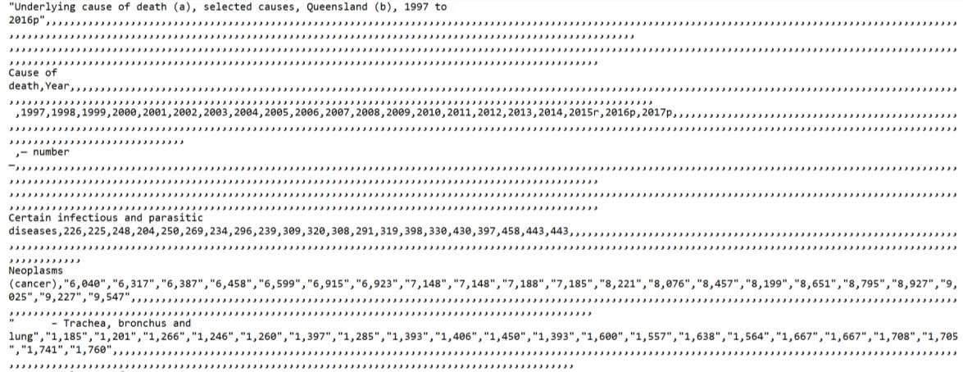

##### After cleaning

Excel

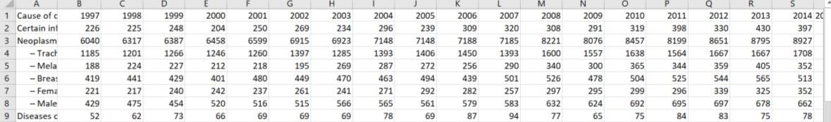

Notepad

