**Improved Algorithm for Occluded Object Selection in VR**

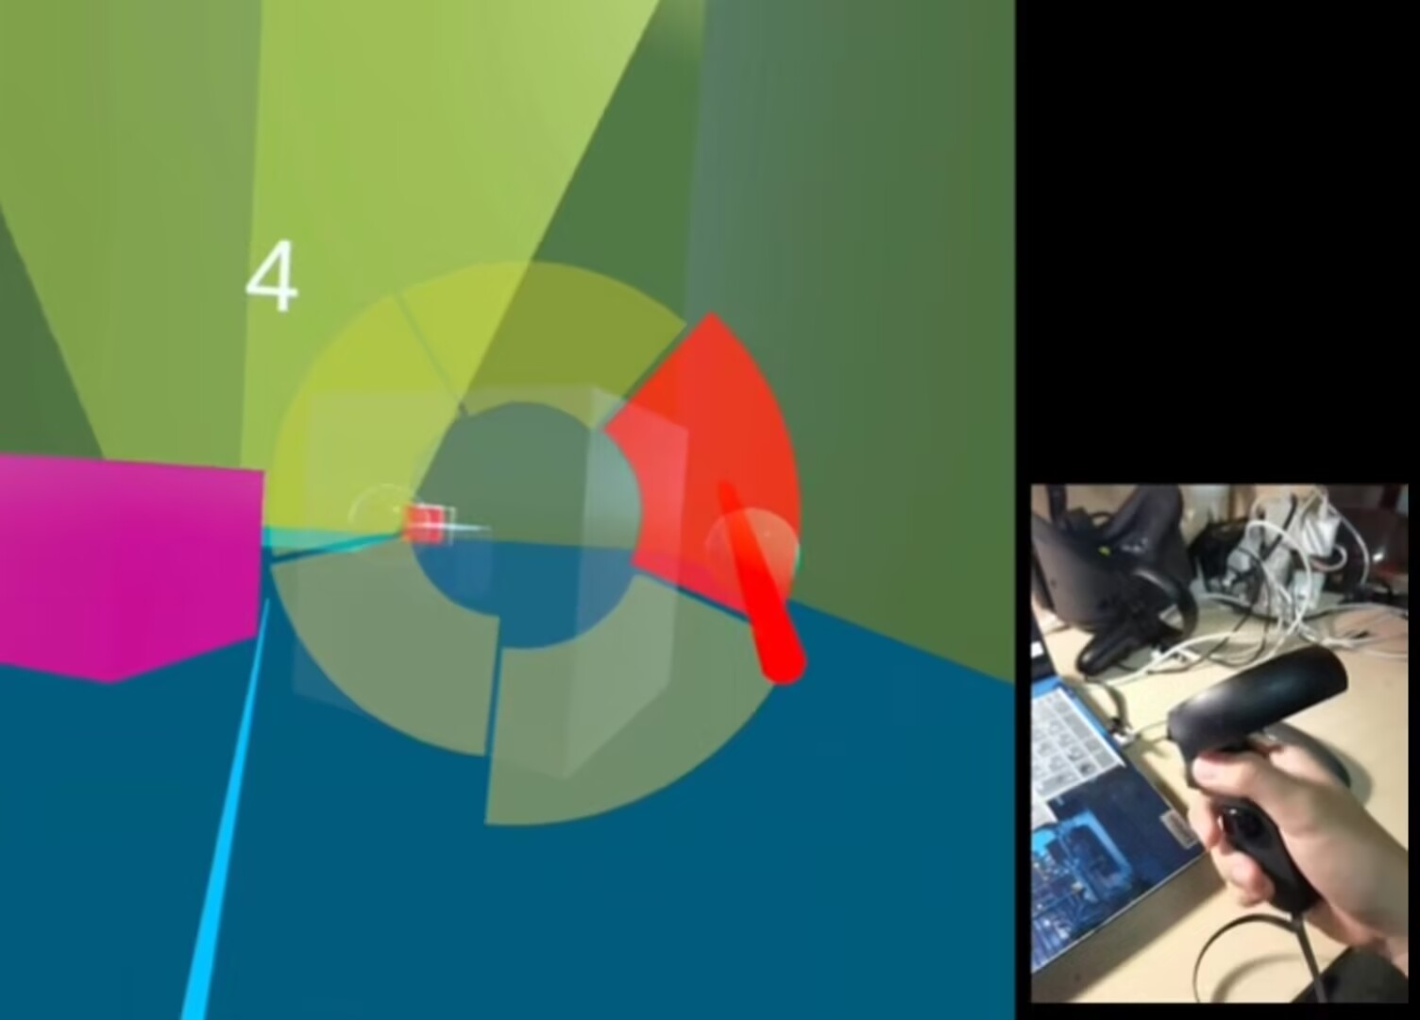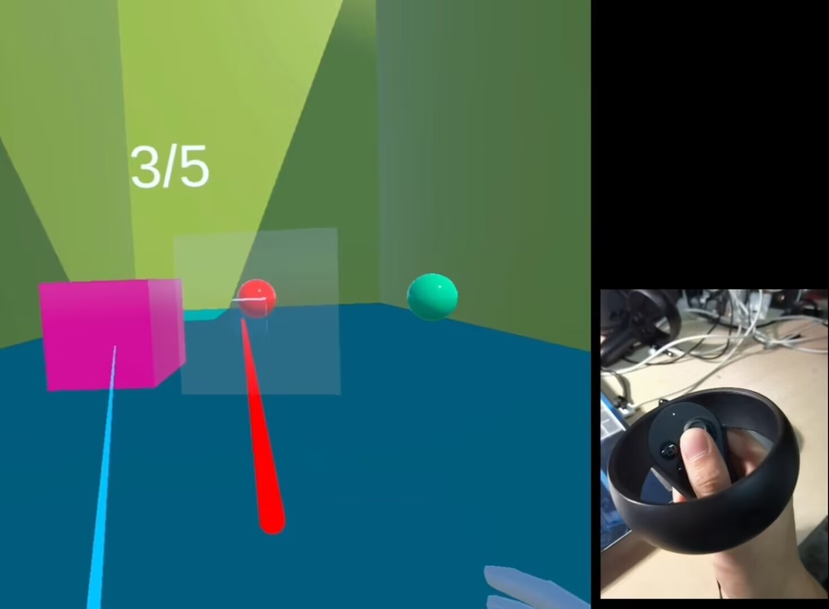

1. select occluded objects with UI panel (b) select occluded objects with joystick.

Figure 1: We have developed two different interaction methods in virtual environments: a): deciding the selected object utilizing a user interface which interacts with a ray emitted by the controller held in user’s hand. b): transform user’s input from the joystick into the index of the object that is selected by the user.

**ABSTRACT**

In present VR applications, when users need to select an object but confronted with a set of clustered objects that block each other, they need to move a certain angle in the physical space. Previous researches have displayed the possibility of the usage of advanced solutions. However, several optimizations can still be done. We explored an object selection method to cope with object occlusion in VR environments. We focus on simplifying the process of selecting the target object in a set of occluded objects, and maintaining the accuracy simultaneously.

**Author Keywords**

Occlusion, virtual reality, HCI

**INTRODUCTION**

VR(virtual reality) technology has enabled us to develop applications which bring our senses into an immersive world. Interaction with the virtual objects is the paramount element in the VR applications.

In many existing applications, users interact with virtual objects with rays emitted from handles. However, traditional rays won’t penetrate obstacles, and will stop while encountering the block of the first object on its trajectory. In such cases, users are unable to see and select the blocked objects. Moreover, the scope of radiographic testing is small, which makes it difficult to select small and medium objects. Users have to resort to moving mechanisms to find a appropriate position close to the target object where the object can be detected by the ray.

Therefore, we find it necessary to improve the algorithm for occluded object selection in VR. We need to implement a ray which can penetrate obstacles in the virtual scene, and collect the spatial information of the objects encountered by the ray along its trajectory.

Apart from the improvement of the ray algorithm, the interaction mechanism needs to be optimized. On the hand-held controller of various VR devices like Occlus Quest, there is a grip button on both controllers which is commonly utilized to convey the message of the grab motions. The orientation of the controller indicates the direction users point to. In order to read users decision of which object is to be selected in a set of candidates, we need to implement other input dimensions.

**INTERACTION METHODOLOGIES**

We implemented a spherical(cylindrical) ray emitted from the VR controller to penetrate and detect the objects in the virtual scene. The spherical ray extends the range of the detection from a single line to a tangible capsule space, making it easier to detect objects with smaller colliders. The objects collided with the ray can then be selected by the users before the ray exits them. We propose two ways of selection in the immersive 3D virtual environments.

* Selecting with UI panel: we display a panel consisting of interactive images for all the objects in collision with the ray. Users can point to the image on the panel by moving the wrist around and changing the orientation of the VR controller, and press the trigger to determine the selected object.
* Selecting with joystick: Users rotate the joystick on the controller with their thumbs. The input message will be converted from a Cartesian coordinate into the index of the object selected.

**RELATED WORK**

**RESULTS**

**CONCLUSION**

**REFERENCES**