西南大学人工智能学院

课程名称: 程序设计基础（Python）
作业位置 : 1.9章，p77
作业编号 : 01（次）

提交日期: 2020-10-20

提交截止日期: 2016-10-23

指导教师: 程静

学生学号: 222020335220177

学生姓名: 严中圣

作业成绩：

NOTES TO STUDENTS
- Check carefully the submission date and the instructions given with the assignment. Late assignments will not be accepted.
- If you are unable to hand in your assignment on time and have valid reasons such as illness, you may apply (in writing) for an extension.
- If you are caught plagiarizing, you could have your grade reduced to zero, or at worst, you could be excluded from the course.
- Your submission document should include screen shots of the Python IDLE showing your code and the output results of running your code.
- Complete your assignment in Word document and submit it to FTP server
- Your file name should start with your Reg. No, and then include your name, and assignment NO. for example “222012321062259_李丹_assignment1.docx”. Remember to link different fields together using the underscore character (_).

Formatting Concerns
#1: You should have a header that explains the program
#2: There should be a space between the prompt and the place where you type in the value.
#3: Your work should be formatted nicely as in the sample output.

STUDENT’S DECLARATION:

I confirm that this is all my own work.
Student Signature:

第1次作业
一、作业任务
- 在一英亩的土地上有×英寸的降雨，请问在这一英亩的土地上将积累多少加仑的降雨量？

二、解决方案
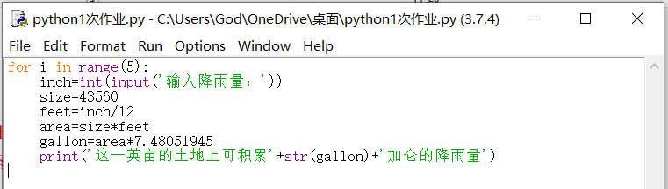

三、运行结果
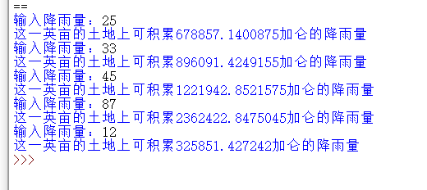

Date 2020-10-20

