西南大学人工智能学院

课程名称: 程序设计基础（Python）
作业位置 : 第2章，p150，题号project1
作业编号 : 0 2（次）

提交日期: 2020-11-22

提交截止日期: 2016-11-29

指导教师: 程静

学生学号: 222020335220177

学生姓名: 严中圣

作业成绩：

NOTES TO STUDENTS
- Check carefully the submission date and the instructions given with the assignment. Late assignments will not be accepted.
- If you are unable to hand in your assignment on time and have valid reasons such as illness, you may apply (in writing) for an extension.
- If you are caught plagiarizing, you could have your grade reduced to zero, or at worst, you could be excluded from the course.
- Your submission document should include screen shots of the Python IDLE showing your code and the output results of running your code.
- Complete your assignment in Word document and submit it to FTP server
- Your file name should start with your Reg. No, and then include your name, and assignment NO. for example “222012321062259_李丹_assignment1.docx”. Remember to link different fields together using the underscore character (_).

Formatting Concerns
#1: You should have a header that explains the program
#2: There should be a space between the prompt and the place where you type in the value.
#3: Your work should be formatted nicely as in the sample output.

STUDENT’S DECLARATION:

I confirm that this is all my own work.
Student Signature: 严中圣

第2次作业
一、作业任务
问题描述: What is the invention of chess worth?
There is a popular myth about the man who invented chess. The local ruler was sopleased with the invention that he offered the inventor a great reward in gold. The inventor suggested an alternative reward: he would get one grain of wheat on the f-irst square of the chess board, two grains on the second square, four on the third, eight on the fourth, etc., doubling the number of grains each time. The ruler saw th-at this must be a much better deal for him, and he accepted. The board has 64 sq-uares. Write a program to determine the following:
(a) How many total grains of wheat did the ruler have to pay the inventor?
(b) A wheat grain weighs approximately 50 mg. How much did the wheat weigh?
(c) Pick a region (state, country, etc.) and determine how deeply that region would be covered with that quantity of wheat. Prompt for the area of the region and thenoutput the depth, including the units you use.
二、解决方案
你的思路Code:
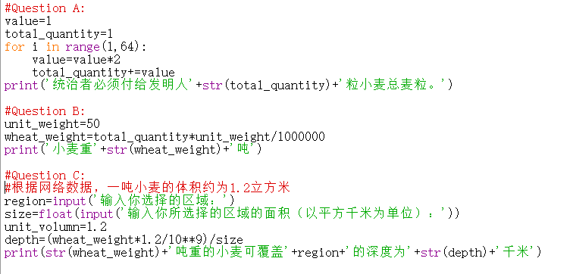
三、运行结果
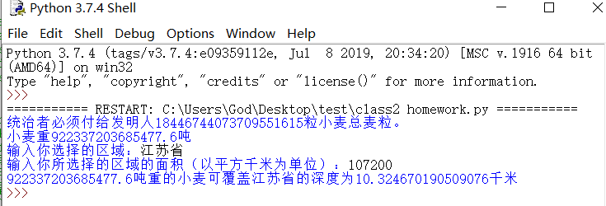

Date: 2020.11.22

