西南大学人工智能学院

课程名称: 程序设计基础（Python）
作业位置 : 第2章，p136，题号2.2.15
作业编号 : 0 2（次）

提交日期: 2020-11-22

提交截止日期: 2016-11-29

指导教师: 程静

学生学号: 222020335220177

学生姓名: 严中圣

作业成绩：

NOTES TO STUDENTS
- Check carefully the submission date and the instructions given with the assignment. Late assignments will not be accepted.
- If you are unable to hand in your assignment on time and have valid reasons such as illness, you may apply (in writing) for an extension.
- If you are caught plagiarizing, you could have your grade reduced to zero, or at worst, you could be excluded from the course.
- Your submission document should include screen shots of the Python IDLE showing your code and the output results of running your code.
- Complete your assignment in Word document and submit it to FTP server
- Your file name should start with your Reg. No, and then include your name, and assignment NO. for example “222012321062259_李丹_assignment1.docx”. Remember to link different fields together using the underscore character (_).

Formatting Concerns
#1: You should have a header that explains the program
#2: There should be a space between the prompt and the place where you type in the value.
#3: Your work should be formatted nicely as in the sample output.

STUDENT’S DECLARATION:

I confirm that this is all my own work.
Student Signature: 严中圣

第2次作业
一、作业任务

问题描述: 2.2.15 Hailstone Sequence Example
The Collatz conjecture is an unsolved mathematical conjecture from 1937 that makes for
an interesting programming example. The conjecture is that given the following formula
and an initial positive integer, the generated sequence always ends in 1. Although this has
been shown to be true for large initial integers (approximately 2.7× 10^16), it has not yet
been proven true for all. It is an active research area with a new proof recently submitted for
publication but later withdrawn. The sequence is also called the hailstone sequence because
the numbers bounce up and down like hail until they converge to 1. Our task is to write a
program to generate the hailstone sequence.
The hailstone formula is as follows:
1.If the number is even, divide it by 2.
2.If the number is odd, multiply by 3 and add 1.
3.When the number reaches 1, quit.
The sequence is formed by applying the formula to the initial number and then repeatedly to each number generated by the formula. The result is a sequence of integers ending at 1 (if you don’t stop at 1, what will happen?). For example, if you start with 5, you get the following sequence: 5, 16, 8, 4, 2, 1.
We will create a program so you can try your hand at it. We will also output the length
of the sequence.
二、解决方案
你的思路Code:
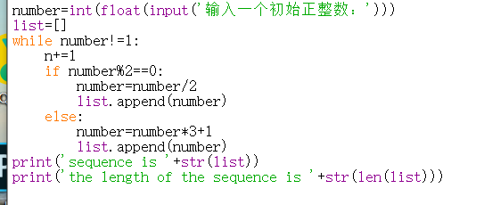
三、运行结果
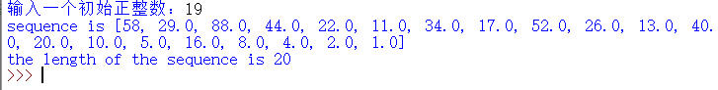

Date: 2020.11.22

