Chapter 3 Selections

1. <, <=, ==, !=, >, >=

2. No. Boolean values cannot be cast to other types.

3.

If number is 30,
(a) displays
30 is even
30 is odd

(b) displays
30 is even

If number is 35,
(a) displays
35 is odd

(b) displays
35 is odd

4. Note: else matches the first if clause. No output if x = 3 and y = 2. Output is “z is 7” if if x = 3 and y = 4. Output is “x is 2” if if x = 2 and y = 2.

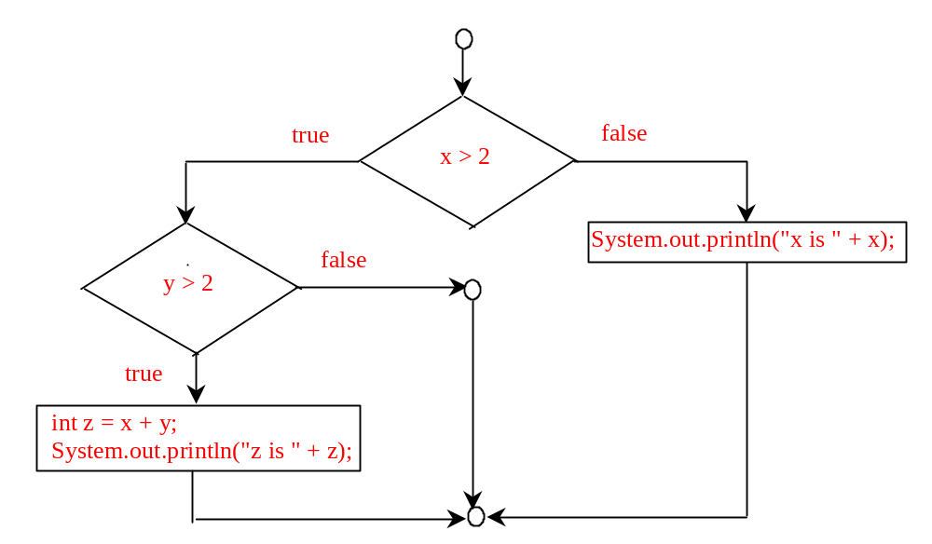
5. a, c, and d are the same. (B) and (C) are correctly indented.

- No output if x = 2 and y = 3. Output is “x is 3” if x = 3 and y = 2. Output is “z is 6” if x = 3 and y = 3.

- Yes.

8. 0.5, 0.0, 0.234

9. (int)(Math.random() * 20)

10 + (int)(Math.random() * 10)

10 + (int)(Math.random() * 41)

10.

if (y > 0)
x = 1;

11.

(a)
if (score > 90)
pay *= 1.03;

(b)
if (score > 90)
pay *= 1.03;
else
pay *= 1.01;

12.
Consider score is 90, what will be the grade?

13.

newLine = (count % 10 == 0);

14. (true) && (3 > 4)
false

!(x > 0) && (x > 0)
false

(x > 0) || (x < 0)
true

(x != 0) || (x == 0)
true

(x >= 0) || (x < 0)
true

(x != 1) == !(x == 1)
true

15. (x > 1) && (x < 100)

16. ((x > 1) && (x < 100)) || (x < 0)

17. x > y > 0
incorrect

x = y && y
incorrect

x /= y
correct

x or y
incorrect

x and y
incorrect

18.
a. x is 2.
b. x is 1.

19.
If ch is 'A', the expression is true;
If ch is 'p', the expression is false;
If ch is 'E', the expression is true;
If ch is '5', the expression is false;

20.

2.0
3.0
6.0
(x < y && y < z) is true
(x < y || y < z) is true
!(x < y) is false
(x + y < z) is true
(x + y < z) is true

21. age > 13 && age < 18

22.

weight > 50 || height > 160.

23.

weight > 50 && height > 160.

24.

weight > 50 ^ height > 160.

25. Switch variables must be of char, byte, short, or int data types. If a break statement is not used, the next case statement is performed. You can always convert a switch statement to an equivalent if statement, but not an if statement to a switch statement. The use of the switch statement can improve readability of the program in some cases. The compiled code for the switch statement is also more efficient than its corresponding if statement.

26. y is 2.

27. switch (a) {
case 1: x += 5; break;
case 2: x += 10; break;
case 3: x += 16; break;
case 4: x += 34;
}

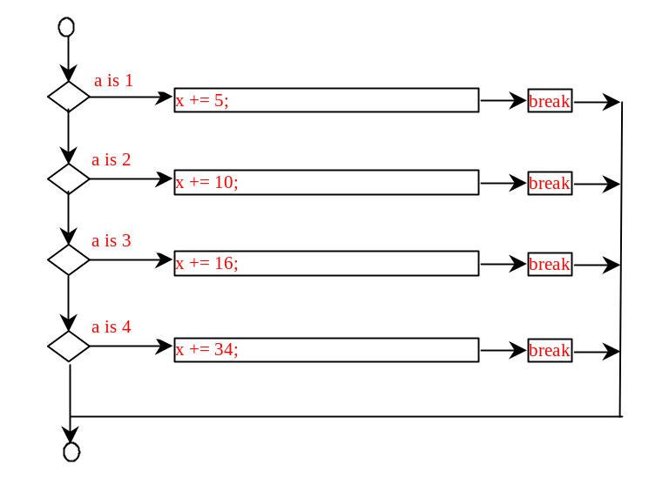
28. switch (day) {
case 0: dayName = "Sunday"; break;
case 1: dayName = "Monday"; break;
case 2: dayName = "Tuesday"; break;
case 3: dayName = "Wednesday"; break;
case 4: dayName = "Thurday"; break;
case 5: dayName = "Friday"; break;
case 6: dayName = "Saturday"; break;
}

29.
System.out.print((count % 10 == 0) ? count + "\n" : count + " ");

30.
pay = (temperature > 90) ? pay * 1.5 : pay * 1.1;

31.

The specifiers for outputting a boolean value, a character, a decimal integer, a floating-point number, and a string are %b, %c, %d, %f, and %s.

32.
  - the last item 3 does not have any specifier.
  - There is not enough items
  - The data for %f must a floating-point value

33.
- amount is 32.320000 3.233000e+01
- amount is 32.3200 3.2330e+01
- *false // * denote a space
- **Java // * denote a space
- false*****Java
- *falseJava

34. Use the String.format method to create a formatted string.

35. The precedence order for boolean operators is ^, &&, and ||

true || true && false is true

true && true || false is true

- True
- both are false
- Yes. Yes. Yes.
- To display a confirmation dialog box, invoke JOptionPane.showConfirmDialog(null, “Prompting message”). The method returns an int value: 0 if the Yes button is clicked, 1 if the No button is clicked, and 2 if the Cancel button is clicked,

