Chapter 5 Methods
1. At least three benefits: (1) Reuse code; (2) Reduce complexity; (3) Easy to maintain. See the Sections 5.2 and 5.3 on how to declare and invoke methods. What is the subtle difference between “defining a method” and “declaring a variable”? A declaration usually involves allocating memory to store a variable, but a definition doesn’t.

2. void

- Yes. return (num1 > num2) ? num1 : num2;

4. True: a call to a method with a void return type is always a statement itself.
False: a call to a value-returning method is always a component of an expression.

5. A syntax error occurs if a return statement is not used to return a value in a value-returning method. You can have a return statement in a void method, which simply exits the method. But a return statement cannot return a value such as return x + y in a void method.

6. See Section 5.2.

- Computing a sales commission given the sales amount and the commission rate
public static double getCommission(double salesAmount, double commissionRate)

Printing a calendar for a month
public static void printCalendar(int month, int year)

Computing a square root
public static double sqrt(double value)

Testing whether a number is even and return true if it is
public static boolean isEven(int value)

Printing a message for a specified number of times
public static void printMessage(String message, int times)

Computing the monthly payment, given the loan amount, number of years, and annual interest rate.
public static double monthlyPayment(double loan, int numberOfYears, double annualInterestRate)
Finding the corresponding uppercase letter given a lowercase letter.
public static char getUpperCase(char letter)

8. Line 2: method1 is not defined correctly. It does not have a return type or void.
Line 2: type int should be declared for parameter m.
Line 7: parameter type for n should be double to match method2(3.4).
Line 11: if (n<0) should be removed in method, otherwise a compile error is reported.

9.

public class Test {
public static double xMethod(double i, double j) {
while (i<j) {
j--;
}

return j;
}
}

10. You pass actual parameters by passing the right type of value in the right order. The actual parameter can have the same name as its formal parameter.

11. "Pass by value" is to pass a copy of the value to the method.

(A) The output of the program is 0, because the variable max is not changed by invoking the method max.

(B)
2
2 4
2 4 8
2 4 8 16
2 4 8 16 32
2 4 8 16 32 64
(C)
Before the call, variable times is 3
n = 3
Welcome to Java!
n = 2
Welcome to Java!
n = 1
Welcome to Java!
After the call, variable times is 3

(D)
1
2 1
2 1
4 2 1
i is 5

12.

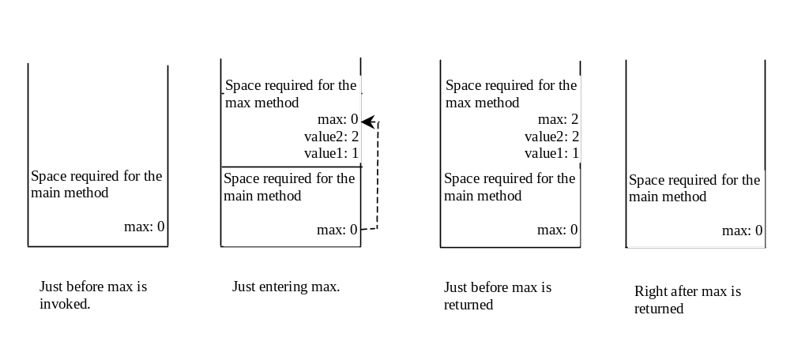
13. Two methods with the same name, defined in the same class, is called method overloading. It is fine to have same method name, but different parameter types. You cannot overload methods based on return type, or modifiers.

14. Methods public static void method(int x) and public static int method(int y) have the same signature method(int).

15. Line 7: int n = 1 is wrong since n is already declared in the method signature.

16. True

17. (a) 34 + (int)(Math.random() * (55 – 34))
(b) (int)(Math.random() * 1000)
(c) 5.5 + (Math.random() * (55.5 – 5.5))
(d) (char)(‘a’ + (Math.random() * (‘z’ – ‘a’ + 1))

18.

Math.sqrt(4) = 2.0
Math.sin(2*Math.PI) = 0
Math.cos(2*Math.PI) = 1
Math.pow(2, 2) = 4.0
Math.log(Math.E) = 1
Math.exp(1) = 2.718
Math.max(2, Math.min(3, 4)) = 3
Math.rint(-2.5) = -2.0
Math.ceil(-2.5) = -2.0
Math.floor(-2.5) = -3.0
Math.round(-2.5f) = -2
Math.round(-2.5) = -2
Math.rint(2.5) = 2.0
Math.ceil(2.5) = 3.0
Math.floor(2.5) = 2.0
Math.round(2.5f) = 3
Math.round(-2.5) = -2
Math.round(Math.abs(-2.5)) = 3

