Chapter 6 Single-dimensional Arrays
1. See the section "Declaring and Creating Arrays."

2. You access an array using its index.

3. No memory is allocated when an array is declared. The memory is allocated when creating the array.

x is 60
The size of numbers is 30

4. Indicate true or false for the following statements:

1. Every element in an array has the same type.
Answer: True

2. The array size is fixed after it is declared.
Answer: False

3. The array size is fixed after it is created.
Answer: True

4. The element in the array must be of primitive data type.
Answer: False

5. Which of the following statements are valid array declarations?

int i = new int(30);
Answer: Invalid

double d[] = new double[30];
Answer: Valid

char[] r = new char(1..30);
Answer: Invalid

int i[] = (3, 4, 3, 2);
Answer: Invalid

float f[] = {2.3, 4.5, 5.6};
Answer: Valid

char[] c = new char();
Answer: Invalid

6. The array index type is int and its lowest index is 0.

a[2]

7.
(a)
double[] list = new double[10];

(b)
list[list.length – 1] = 5.5;

(c)
System.out.println(list[0] + list[1]);

(d)
double sum = 0;
for (int i = 0; i < list.length; i++)
sum += list[i];

(e)
double min = list[0];
for (int i = 1; i < list.length; i++)
if (min > list[i]) min = list[i];

(f)
System.out.println(list[(int)(Math.random() * list.length));

(g)
double[] = {3.5, 5.5, 4.52, 5.6};

8. A runtime exception occurs.

9. Line 3: the array declaration is wrong. It should be double[]. The array needs to be created before its been used. e.g. new double[10]
Line 5: The semicolon (;) at the end of the for loop heading should be removed.
Line 5: r.length() should be r.length.
Line 6: random should be random()
Line 6: r(i) should be r[i].

10. System.arraycopy(source, 0, t, 0, source.length);

11. The second assignment statement myList = new int[20] creates a new array and assigns its reference to myList.

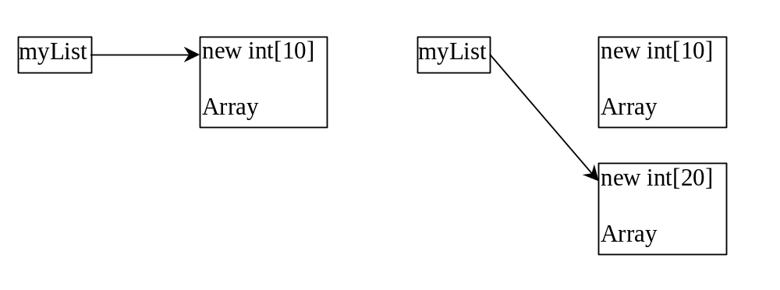

- False. When an array is passed to a method, the reference value of the array is passed. No new array is created. Both argument and parameter point to the same array.

numbers is 0 and numbers[0] is 3

14.

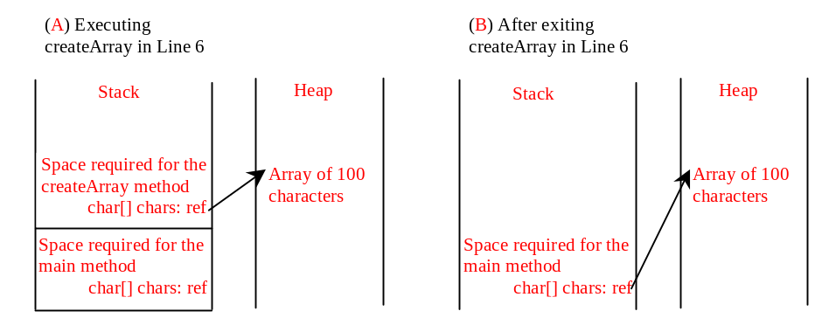
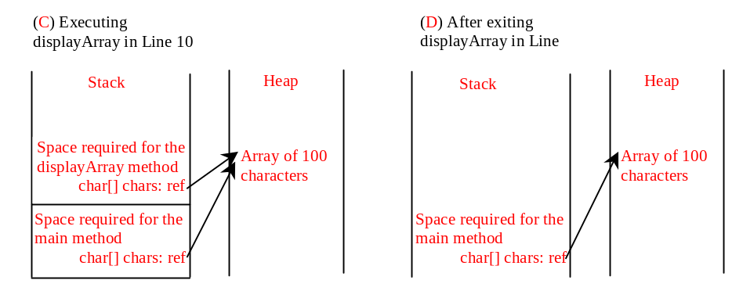
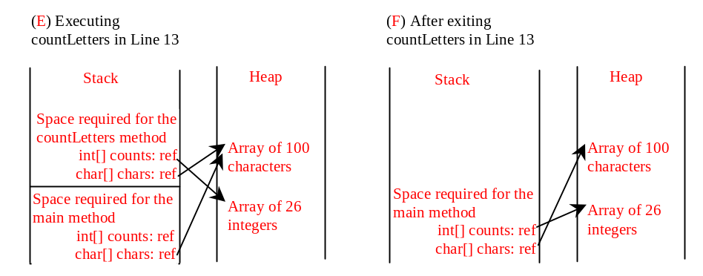
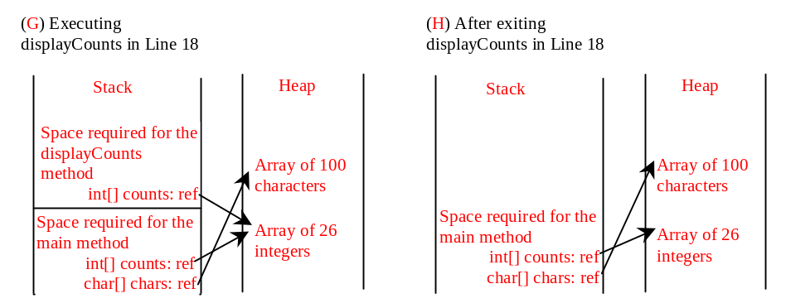
15. Only one variable-length parameter may be specified in a method and this parameter must be the last parameter. The method return type cannot be a variable-length parameter.

- The last one
printMax(new int[]{1, 2, 3});
is incorrect, because the array must of the double[] type.

17. Omitted

18. Omitted

19. Omitted

20 Simply change (currentMax < list[j]) on Line 10 to (currentMax > list[j])

21 Simply change list[k] > currentElement on Line 9 to list[k] < currentElement

- You can sort an array of any primitive types except boolean. The sort method is void, so it does not return a new array.

23. To apply java.util.Arrays.binarySearch(array, key), the array must be sorted in increasing order.

24. Line 1: list is {2, 4, 7, 10}
Line 2: list is {7, 7, 7, 7}
Line 3: list is {7, 8, 8, 7}
Line 4: list is {7, 8, 8, 7}

