Chapter 7 Multidimensional Arrays

1 int[][] m = new int[4][5];

2 Yes. They are ragged array.

3 array[0][1] is 2.

4.
int[][] r = new int[2];
Answer: Invalid

int[] x = new int[];
Answer: Invalid

int[][] y = new int[3][];
Answer: Valid
5.

Why does the is1To9 method need to copy list to temp? Because we need to sort list. Sorting list will change the contents of list. This will change the contents of grid after invoking is1To9(grid[i]).

What happens if you replace the code in lines 66-70 in Listing 7.4 with the following code:

java.util.Arrays.sort(list);

The contents in grid are changed. Consequently, you cannot check columns and small boxes using the altered grid.

6. int[][][] m = new int[4][6][5];

(Not in this edition) 7. False. Here is an example:

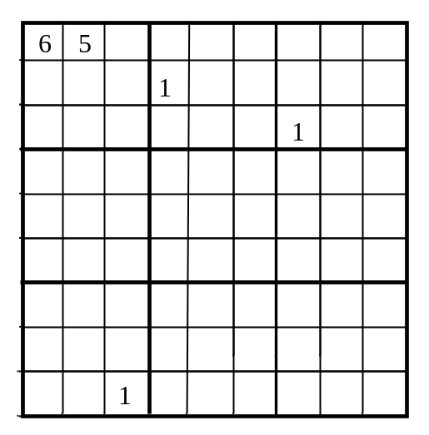
This input is valid, but there is no way to put 1 in the first 3 by 3 box.

