Chapter 23 Algorithm Efficiency
1.
500, 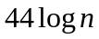, 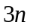, 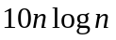, 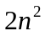, 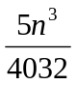, 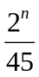

2.
(A)
5

(B)
1

(C)
The ceiling of log₂n times

(D)
The ceiling of log₃(n/15) times

3. if n is 10: (a) 10 (b) 10^2 (c) 10^3 (d) 10*10^2
if n is 20: (a) 20 (b) 20^2 (c) 20^3 (d) 20*20^2

Using Big-O notation:
O(n), O(n^2), O(n^3), O(n^2)

4. mA: O(n). mB: O(n^2). mC: O(n). mD: O(n)

- Adding two matrices: O(n*m). Multiplying two matrices: O(nmk)

- This is similar to bubble sort, but is a very inefficient. Whenever a swap is made, it goes back to the beginning of the loop. In the worst case, there will be O(n^2) of swaps. For each swap, O(n) number of comparisons may be made in the worst case. So, the total is O(n^3) in the worst case.

7.
result = a;
i = 2;

while (i <= n) {
result = result * result;
i *= 2;
}

for (int j = i / 2 + 1; j <= n; j++)
result = result * a;

Assume that 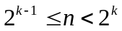. The while loop is executed k-1 times. The for loop is executed at most 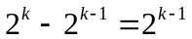 times. So, the total complexity is O(n).

Consider another implementation:

public static int f(int a, int n) {
if (n == 1) {
return a;
}
else {
int temp = f(a, n / 2);
if (n % 2 == 0) {
return temp * temp;
}
else {
return a * temp * temp;
}
}
}

This implementation results in O(logn) complexity.

